**DAILY ONLINE ACTIVITIES SUMMARY**

|  |  |  |  |  |  |  |  |  |
| --- | --- | --- | --- | --- | --- | --- | --- | --- |
| **Date:** | **08/06/2020** | | | | | **Name:** | **Varshitha V Makam** | |
| **Sem & Sec** | **8th B** | | | | | **USN:** | **4AL16CS118** | |
| **Online Test Summary** | | | | | | | | |
| **Subject** | | **SMS** | | | | | | |
| **Max. Marks** | | **60** | | **Score** | | | **60** | |
| **Certification Course Summary** | | | | | | | | |
| **Course** | Stp into robotic process automation | | | | | | | |
| **Certificate Provider** | | | **GUVI** | | **Duration** | | | **3 hours** |
| **Coding Challenges** | | | | | | | | |
| **Problem Statement:** | | | | | | | | |
| **Status: COMPLETED** | | | | | | | | |
| **Uploaded the report in Github** | | | | | **YES** | | | |
| **If yes Repository name** | | | | | **varshithamakam https://github.com/alvas-education-foundation/varshithamakam** | | | |
| **Uploaded the report in slack** | | | | | **YES** | | | |

Online Test Details:

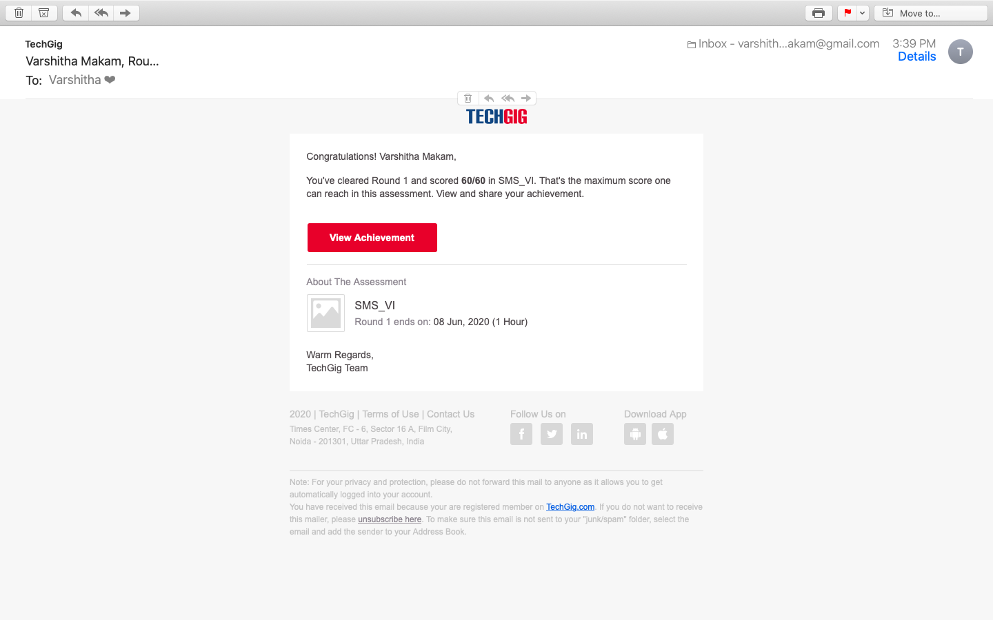

Certification Course Details:

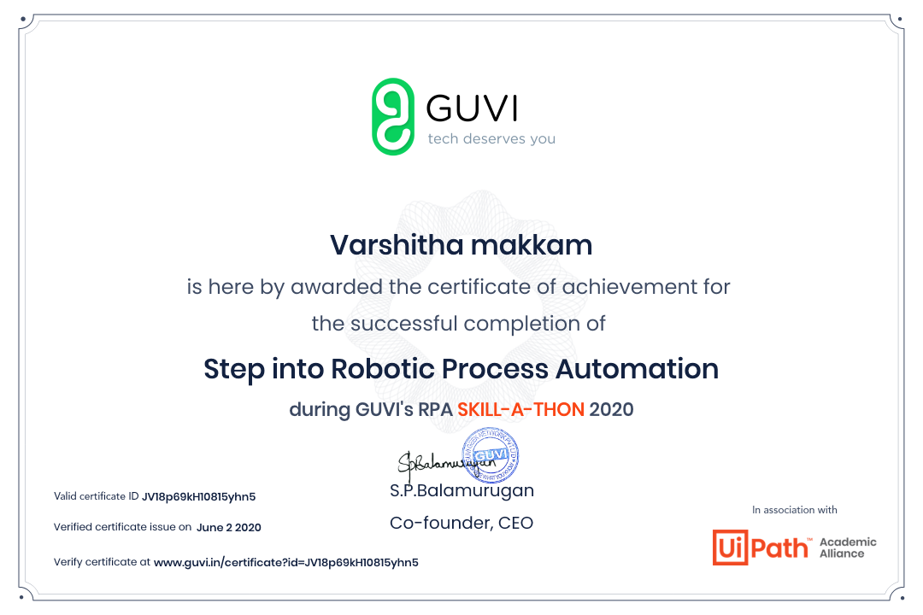

Coding Challenges Details

**Program no:1**

Coding Challenges Details: (Attach the snapshot and briefly write the report

for the same)

Coding was given and it was uploaded for github and slack

PROGRAM1

def add(x, y):

return x + y

def subtract(x, y):

return x - y

def multiply(x, y):

return x * y

def divide(x, y):

return x / y

print("Select operation.")

print("1.Add")

print("2.Subtract")

print("3.Multiply")

print("4.Divide")

while True:

choice = input("Enter choice(1/2/3/4): ")

if choice in ('1', '2', '3', '4'):

num1 = float(input("Enter first number: "))

num2 = float(input("Enter second number: "))

if choice == '1':

print(num1, "+", num2, "=", add(num1, num2))

elif choice == '2':

print(num1, "-", num2, "=", subtract(num1, num2))

elif choice == '3':

print(num1, "*", num2, "=", multiply(num1, num2))

elif choice == '4':

print(num1, "/", num2, "=", divide(num1, num2))

break

else:

print("Invalid Input")