**DAILY ONLINE ACTIVITIES SUMMARY**

|  |  |  |  |  |  |  |  |  |
| --- | --- | --- | --- | --- | --- | --- | --- | --- |
| **Date:** | **13/06/2020** | | | | | **Name:** | **Varshitha V Makam** | |
| **Sem & Sec** | **8th B** | | | | | **USN:** | **4AL16CS118** | |
| **Online Test Summary** | | | | | | | | |
| **Subject** | | **IOT** | | | | | | |
| **Max. Marks** | | **30** | | **Score** | | | **29** | |
| **Certification Course Summary** | | | | | | | | |
| **Course** | Stp into robotic process automation | | | | | | | |
| **Certificate Provider** | | | **GUVI** | | **Duration** | | | **3 hours** |
| **Coding Challenges** | | | | | | | | |
| **Problem Statement:** | | | | | | | | |
| **Status: COMPLETED** | | | | | | | | |
| **Uploaded the report in Github** | | | | | **YES** | | | |
| **If yes Repository name** | | | | | **varshithamakam https://github.com/alvas-education-foundation/varshithamakam** | | | |
| **Uploaded the report in slack** | | | | | **YES** | | | |

Online Test Details:

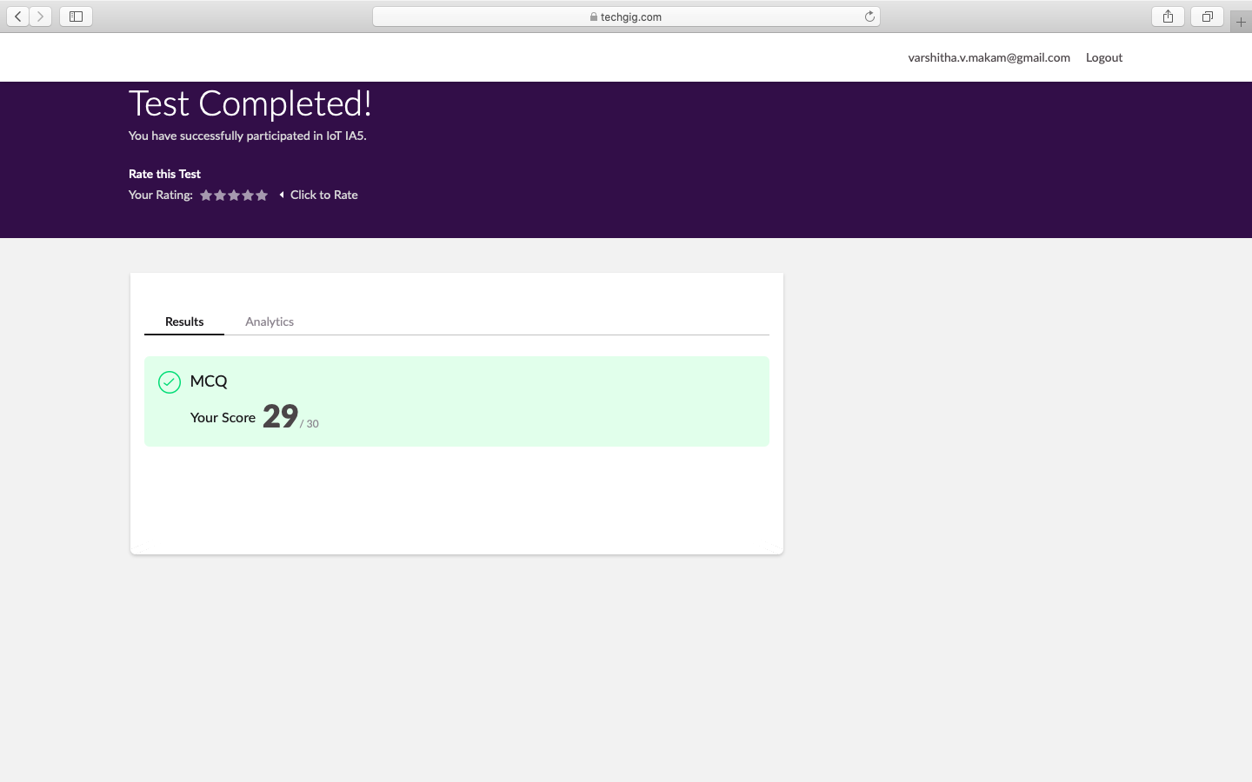

Certification Course Details:

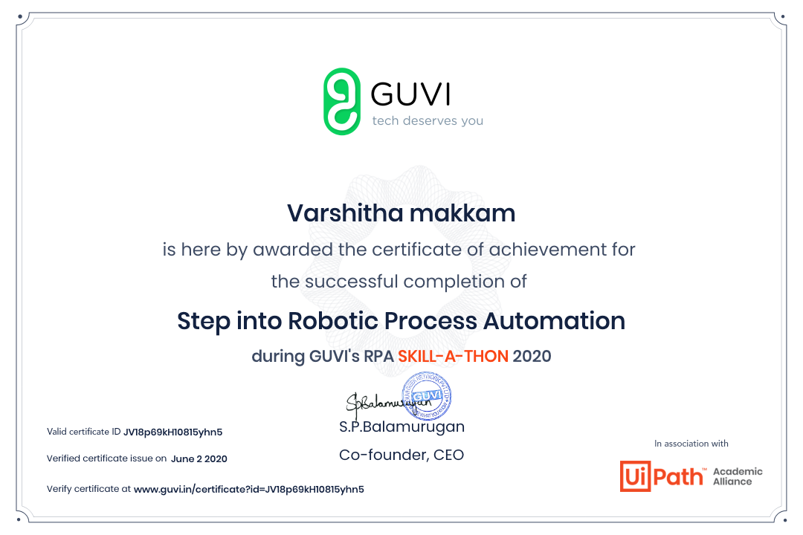

Coding Challenges Details

**Program no:1**

Function to print binary number using recursion

def convertToBinary(n):

if n > 1:

convertToBinary(n//2)

print(n % 2,end = '')

dec = 34

convertToBinary(dec)

print()