**DAILY ONLINE ACTIVITIES SUMMARY**

|  |  |  |  |  |  |  |  |  |
| --- | --- | --- | --- | --- | --- | --- | --- | --- |
| **Date:** | **4/06/2020** | | | | | **Name:** | **Varshitha V Makam** | |
| **Sem & Sec** | **8th B** | | | | | **USN:** | **4AL16CS118** | |
| **Online Test Summary** | | | | | | | | |
| **Subject** | | **SMS** | | | | | | |
| **Max. Marks** | | **60** | | **Score** | | | **30** | |
| **Certification Course Summary** | | | | | | | | |
| **Course** | Stp into robotic process automation | | | | | | | |
| **Certificate Provider** | | | **GUVI** | | **Duration** | | | **3 hours** |
| **Coding Challenges** | | | | | | | | |
| **Problem Statement:** | | | | | | | | |
| **Status: COMPLETED** | | | | | | | | |
| **Uploaded the report in Github** | | | | | **YES** | | | |
| **If yes Repository name** | | | | | **varshithamakam https://github.com/alvas-education-foundation/varshithamakam** | | | |
| **Uploaded the report in slack** | | | | | **YES** | | | |

Online Test Details:

Test on module 1

Snapshot of test

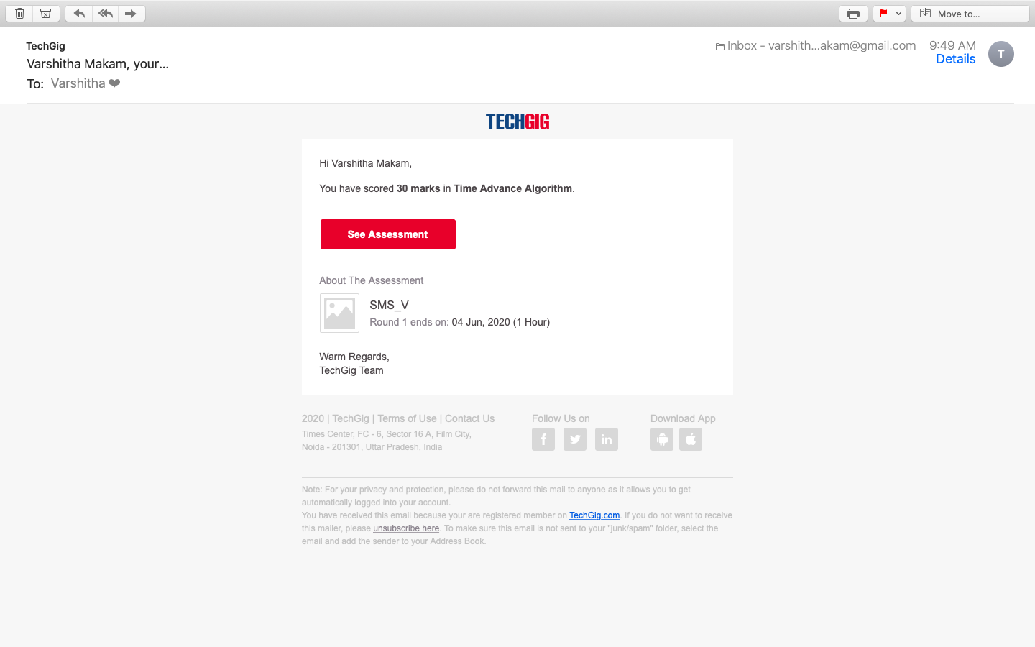

Certification Course Details:

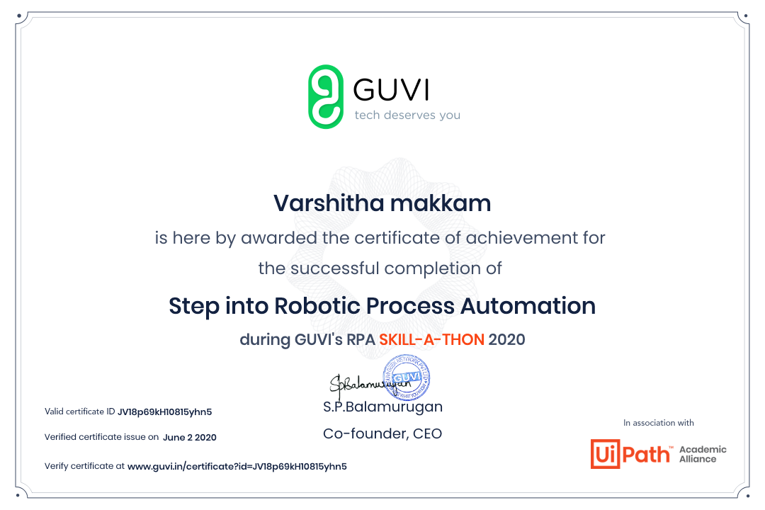

Coding Challenges Details

**Program no:1**

Coding Challenges Details: (Attach the snapshot and briefly write the report

for the same)

Coding was given and it was uploaded for github and slack

Python program to find H.C.F of two numbers

defcompute_hcf(x,y):

ifx>y:

smaller=y else:

smaller=x foriinrange(1,smaller+1):

if((x%i==0)and(y%i==0)):

hcf=i return hcf

num1=54

num2=24

print("TheH.C.F.is",compute_hcf(num1,num2)