**DAILY ONLINE ACTIVITIES SUMMARY**

|  |  |  |  |  |  |  |  |  |
| --- | --- | --- | --- | --- | --- | --- | --- | --- |
| **Date:** | **21/05/2020** | | | | | **Name:** | **Vishal Nayak** | |
| **Sem & Sec** | **8th A** | | | | | **USN:** | **4AL16CS057** | |
| **Online Test Summary** | | | | | | | | |
| **Subject** | | **SMS** | | | | | | |
| **Max. Marks** | | **60** | | **Score** | | | **58** | |
| **Certification Course Summary** | | | | | | | | |
| **Course** | **AWS Cloud Practitioner Essentials** | | | | | | | |
| **Certificate Provider** | | | **AWS** | | **Duration** | | |  |
| **Coding Challenges** | | | | | | | | |
| **Problem Statement:** **Given an array, rotate the array to the right by k steps, where k is non-negative.**  **Example 1:**  **Input1: [1, 2, 3, 4, 5, 6, 7] and k = 3**  **Output1: [5, 6, 7, 1, 2, 3, 4]**  **Explanation:**  **rotate 1 steps to the right: [7, 1, 2, 3, 4, 5, 6]**  **rotate 2 steps to the right: [6, 7, 1, 2, 3, 4, 5]**  **rotate 3 steps to the right: [5, 6, 7, 1, 2, 3, 4]**  **Example 2:**  **Input2: [-1, -100, 3, 99] and k = 2**  **Output2: [3, 99, -1, -100]**  **Explanation:**  **rotate 1 steps to the right: [99, -1, -100 3]**  **rotate 2 steps to the right: [3, 99, -1, -100]** | | | | | | | | |
| **Status:** | | | | | | | | |
| **Uploaded the report in Github** | | | | | **Yes** | | | |
| **If yes Repository name** | | | | | **vishal_nayak** | | | |
| **Uploaded the report in slack** | | | | | **Yes** | | | |

Online Test Details: (Attach the snapshot and briefly write the report for the same)

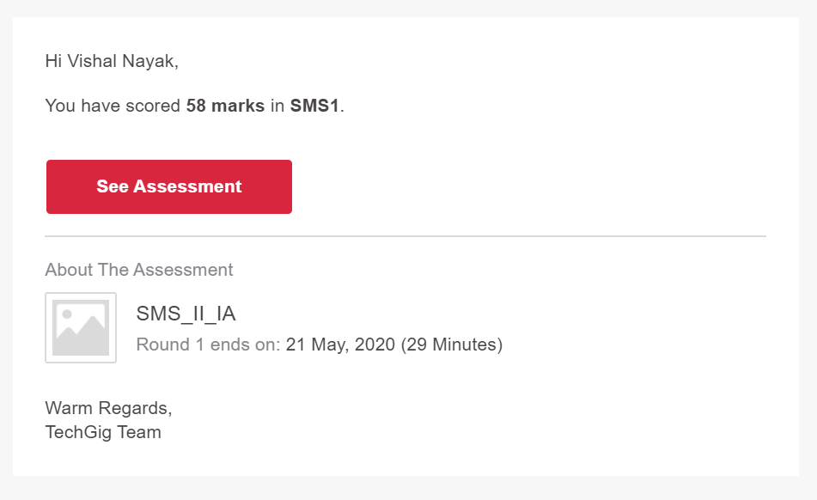

Certification Course Details: (Attach the snapshot and briefly write the report for the same)

