IBM CLOUD NETWORKING
VPC Flow Logs  Configuration, validation and centralized logging guidance | IBM  Cloud

Purpose
Provide a repeatable procedure to enable IBM Cloud VPC Flow Logs, verify that flow data is being written to Cloud Object Storage, and quickly determine whether network traffic was accepted or rejected by VPC security controls.
Scope
- Flow Log Collector creation at VPC scope (recommended baseline).
- Cloud Object Storage prerequisites and IAM authorization.
- CLI and console validation.
- JSON interpretation for accepted / rejected traffic.
- Enterprise centralization considerations.
Key design fact
VPC Flow Logs are written to IBM Cloud Object Storage. The destination bucket must be single-region and in the same region as the monitored VPC resource.

1. What VPC Flow Logs provide
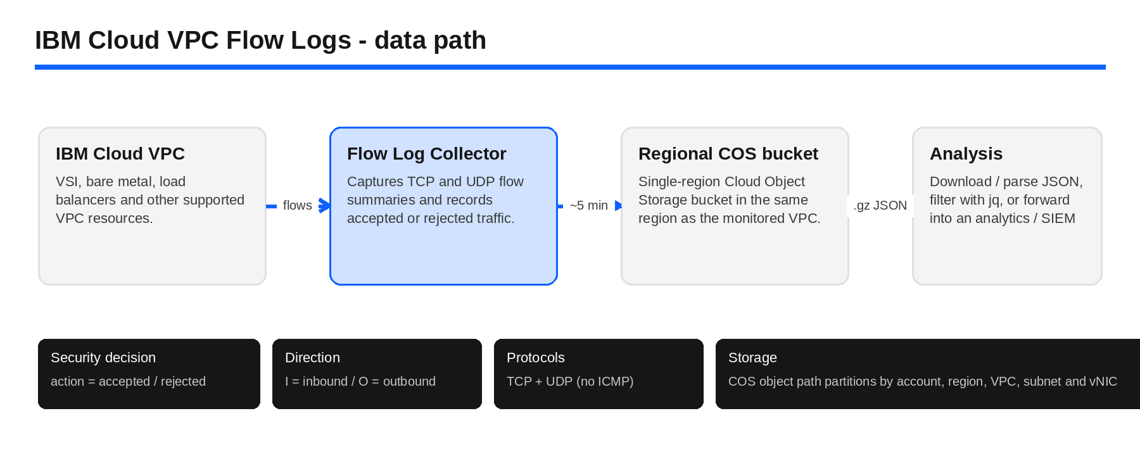
Figure 1. VPC Flow Logs collection and analysis path
VPC Flow Logs summarize network connections observed by VPC virtual network interfaces. They are intended for connectivity troubleshooting, security analysis, traffic pattern review and forensics—not full packet capture.
Capability | Behavior
Accepted vs. rejected | The action field is accepted or rejected. Rejected flows indicate packets blocked by a security group or network ACL.
Direction | I means inbound; O means outbound, based on the first packet processed by the vNIC.
Protocols | TCP and UDP traffic are collected. ICMP is not collected by VPC Flow Logs.
Delivery cadence | Objects are typically written to COS about every five minutes; they can be published earlier if the collector reaches its flow-size threshold.
Storage format | Each object is a gzip-compressed JSON document containing a flow_logs array and collector metadata.

Recommended baseline
Create the collector at VPC scope unless you have a specific reason to isolate logging to a subnet, instance, NIC, VNI or network attachment. A VPC-level collector gives the simplest enterprise baseline.

2. Prerequisites
- An IBM Cloud VPC and permissions to create / manage Flow Log Collectors.
- An IBM Cloud Object Storage instance.
- A single-region COS bucket in the same region as the VPC being monitored.
- IAM authorization that allows VPC Flow Logs to write objects to the COS destination.
- IBM Cloud CLI with the VPC Infrastructure Services plug-in for CLI validation (optional but recommended).
- jq and gzip for convenient local inspection of flow log objects.
Regional constraint
A VPC in br-sao requires a single-region COS bucket in br-sao. Repeat this pattern for every region where you operate VPC resources.

3. Configuration procedure
1 | Create the regional COS bucket  Create or select a Cloud Object Storage instance, then create a single-region bucket in the same IBM Cloud region as the VPC.
Example naming
VPC region : br-sao
Bucket : enterprise-vpc-flowlogs-br-sao
Resiliency : Single Region

2 | Create the service authorization  Authorize VPC Infrastructure Services / Flow Logs to write to the Cloud Object Storage destination with the Writer role.
ibmcloud iam authorization-policy-create \
is \
cloud-object-storage \
Writer \
--source-resource-type flow-log-collector \
--target-service-instance-id <COS_INSTANCE_GUID>

3 | Create the Flow Log Collector in the console  In IBM Cloud Console open Infrastructure > VPC > Network > Flow logs > Create. Select the VPC as the target, turn Active on, and select the regional COS bucket.
Name |  | flowlog-prod-vpc
Target type |  | VPC
Target |  | prod-vpc
Active |  | On
COS bucket |  | enterprise-vpc-flowlogs-br-sao

4 | Create the collector with the CLI (alternative)  Target the correct region, then create the Flow Log Collector. The target type can be vpc, subnet, instance, nic, vni or nac.
ibmcloud target -r br-sao
ibmcloud is flow-log-create \
--bucket enterprise-vpc-flowlogs-br-sao \
--target prod-vpc \
--target-type vpc \
--name flowlog-prod-vpc \
--active true

4. Validate that Flow Logs are working
1 | Verify collector health  The collector should show Status = Stable and Active = On. A stable collector that is not active will not write log objects.
# List all collectors in the current account / resource group context
ibmcloud is flow-logs
# Inspect one collector
ibmcloud is flow-log flowlog-prod-vpc

2 | Generate known test traffic  Generate both an allowed connection and, when safe, a deliberately blocked connection. This makes it easy to validate accepted and rejected records.
# Allowed test example
curl -I https://example.com
# Connectivity tests to known targets
nc -vz <target-ip> 443
nc -vz <target-ip> 22
nc -vz <target-ip> 12345

Safety note
Only test ports and hosts you are authorized to access. A rejected record is most useful when the expected security group / ACL behavior is already known.

3 | Check the COS bucket  Open the configured bucket and confirm that new .gz objects appear. Objects are partitioned by account, region, VPC, subnet, endpoint and time.
ibm_vpc_flowlogs_v1/
account=<account>/
region=br-sao/
vpc-id=<vpc-id>/
subnet-id=<subnet-id>/
endpoint-type=vnics/
instance-id=<instance-id>/
vnic-id=<vnic-id>/
record-type=all|ingress|egress/
year=YYYY/month=MM/day=DD/hour=HH/
stream-id=<timestamp>/<sequence>.gz

4 | Download and inspect an object  Use the COS console or CLI to download one .gz object, then inspect the JSON with gzip and jq.
gzip -dc flowlog.gz | jq .

5. Interpret accepted and rejected traffic
{
"state": "ok",
"number_of_flow_logs": 1,
"flow_logs": [
{
"direction": "I",
"action": "rejected",
"initiator_ip": "192.168.10.50",
"initiator_port": 54321,
"target_ip": "10.20.30.40",
"target_port": 22,
"transport_protocol": 6
}
]
}

Field | How to use it
state | ok = collection / shipping worked for the capture interval. skip data means some flow data was lost.
action | accepted or rejected.
direction | I = inbound, O = outbound.
initiator_ip / port | Connection initiator (source) address and port.
target_ip / port | Connection target (destination) address and port.
transport_protocol | IANA protocol number: 6 = TCP, 17 = UDP.
number_of_flow_logs | Count of flow records contained in the COS object.

Important interpretation
A rejected flow means packets were blocked by a security group or network ACL. Flow Logs do not directly tell you which exact SG / ACL rule caused the decision; correlate the IPs, ports, direction and VPC configuration.

6. Fast troubleshooting filters

Rejected traffic only
gzip -dc flowlog.gz | jq '.flow_logs[] | select(.action == "rejected")'

Accepted traffic only
gzip -dc flowlog.gz | jq '.flow_logs[] | select(.action == "accepted")'

Compact rejected-traffic table
gzip -dc flowlog.gz | jq -r '
.flow_logs[]
| select(.action == "rejected")
| [
.start_time,
.direction,
.initiator_ip,
.initiator_port,
.target_ip,
.target_port,
.transport_protocol,
.action
]
| @tsv
'

7. Troubleshooting checklist
Symptom | What to check
No objects in COS | Confirm the collector is Active, not merely Stable. Verify the COS bucket is same-region and single-region, and check the VPC-to-COS Writer authorization.
Collector is Failed | Inspect the collector details, target resource and bucket configuration. Re-check IAM authorization and region alignment.
Objects exist but flow_logs is empty | The capture interval can legitimately contain no traffic. Generate controlled TCP / UDP traffic and re-check a later object.
Expected ping traffic is missing | ICMP is not collected. Use TCP or UDP tests instead.
Rejected traffic is unexpected | Correlate the initiator / target tuple and direction against security groups and network ACLs. Remember that rejected packets can occur during connection initiation or on an existing connection.
state = skip data | The collector lost some data during that capture interval. Treat the interval as incomplete and investigate unusually high traffic / rejected packet rates.

8. Enterprise centralized logging pattern
For the broader enterprise objective of concentrating logs into one logging account, treat VPC Flow Logs as a regional data source. Keep the operational ownership centralized, but preserve the same-region COS requirement for every VPC region.
Workload accounts | Regional flow collectors | Central logging account
VPCs  br-sao / us-south / eu-de | Same-region COS buckets  per region | Analysis / SIEM / retention  IBM Cloud Logs or other tooling
Log producers only | Flow log landing zone | Enterprise operations and governance

Cross-account note
IBM documentation is explicit about the same-region COS requirement. Before standardizing direct cross-account Flow Log writes to a COS bucket owned by the central logging account, validate that exact authorization path in your enterprise. If needed, use a regional landing bucket and then forward / replicate into the central analytics layer.

References
IBM Cloud Docs — Viewing flow log objects
IBM Cloud Docs — Listing flow log collectors
IBM Cloud Docs — VPC CLI reference
IBM Cloud Docs — Flow Logs for VPC cluster components
Carbon Design System — Color tokens
Carbon Design System — Typography
Document note
This guide uses an IBM Carbon-inspired visual treatment for internal technical communication. Product behavior and CLI syntax should be revalidated against IBM Cloud documentation when used in production automation.

