Game Design Document

Fill up the following document

1. Write the title of your project.

Fly High Kite

1. What is the goal of the game?

The kite should not touch the obstacles that are buildings .

1. Write a brief story of your game.

When u press the up arrow key the kite moves upwards and if you

leave the key the kite might touch the buildings.

1. Which are the playing characters of this game?

* Playing characters are the ones who respond to the user based on the input from the user.
* Cars, monkeys, dinos, wizards, etc., are the playing characters in the game.

|  |  |  |
| --- | --- | --- |
| Number | Character Name | What can this character do? |
| 1 | Kite | It is the main character and it can fly high |
| 2 | Buildings | There are 6 buildings coming in row to stop the Kite |
| 3 |  |  |
| 4 |  |  |
| 5 |  |  |
| 6 |  |  |
| 7 |  |  |
| 8 |  |  |

1. Which are the Non-Playing Characters of this game?

* Non-Playing characters are the ones that don't have an action or behavior when the user interacts with the game.
* Hurdles, stones, bananas, coins, etc., are non-playing characters in the game.

|  |  |  |
| --- | --- | --- |
| Number | Character Name | What can this character do? |
| 1 | Buildings | Buildings have to touch the kite and not let it pass |
| 2 |  |  |
| 3 |  |  |
| 4 |  |  |
| 5 |  |  |
| 6 |  |  |
| 7 |  |  |
| 8 |  |  |

Draw your imagination of this game. What does this game look like?

* Draw the game either on your computer or on paper.
* Add images of the game scenes to show each of the playing and non-playing characters at least once.

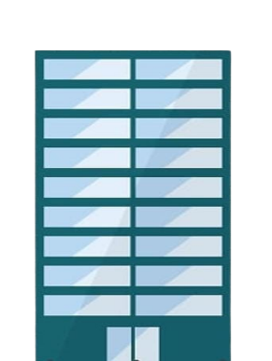

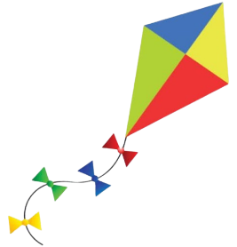

How do you plan to make your game engaging?

The game is an infinite game. The person who will play the game will find it engaging as it is an infinite game, if they lose at their first try they can click on the retry and play again.