To find the marginal add the two joint probabilities and not the conditional probabilities.
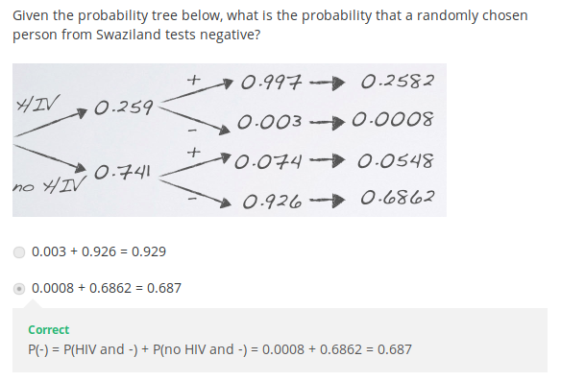
BAYESIAN INFERENCE:
