1. We have to create 2 pages, one for admin validation and another for adding and deleting from list. Each pages have 2 classes, one for creating UI and another for controlling the UI. We also need 1 class for database operation such as connection, query execution.
2. For the first page we created a class named “Login” which extends JFrame to create a window and added UI elements to the window. The Component tree looks like this:

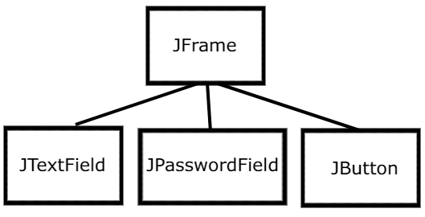

And The resulting UI looks like this:

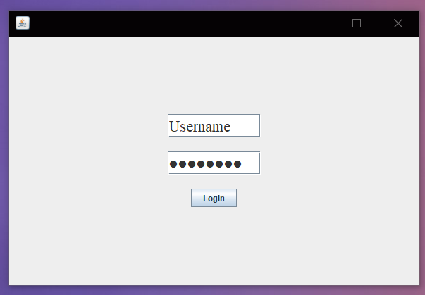

1. Then we created a controller class named “LoginController” which extends ActionListener and FocusListener to catch event changes. With the controller class we can use database class to see if login is valid or not.
2. For the employee info page, we create a class named “Information” that also extends JFrame to create window and creates the UI components for the page. We can switch to Information window when login authentication is valid. The UI component tree looks like this:

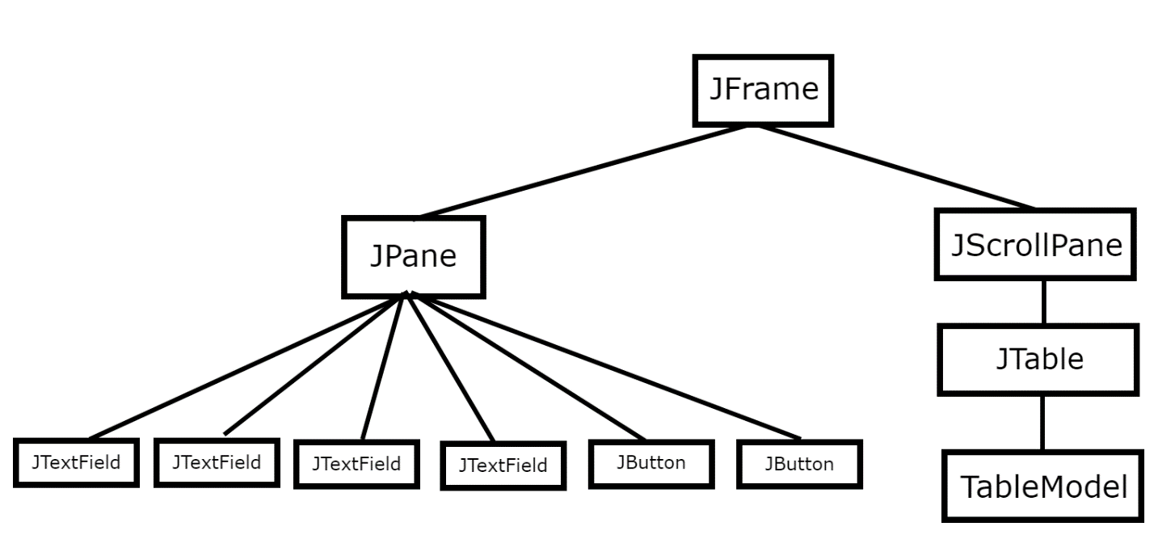

The resulting UI Looks like this:

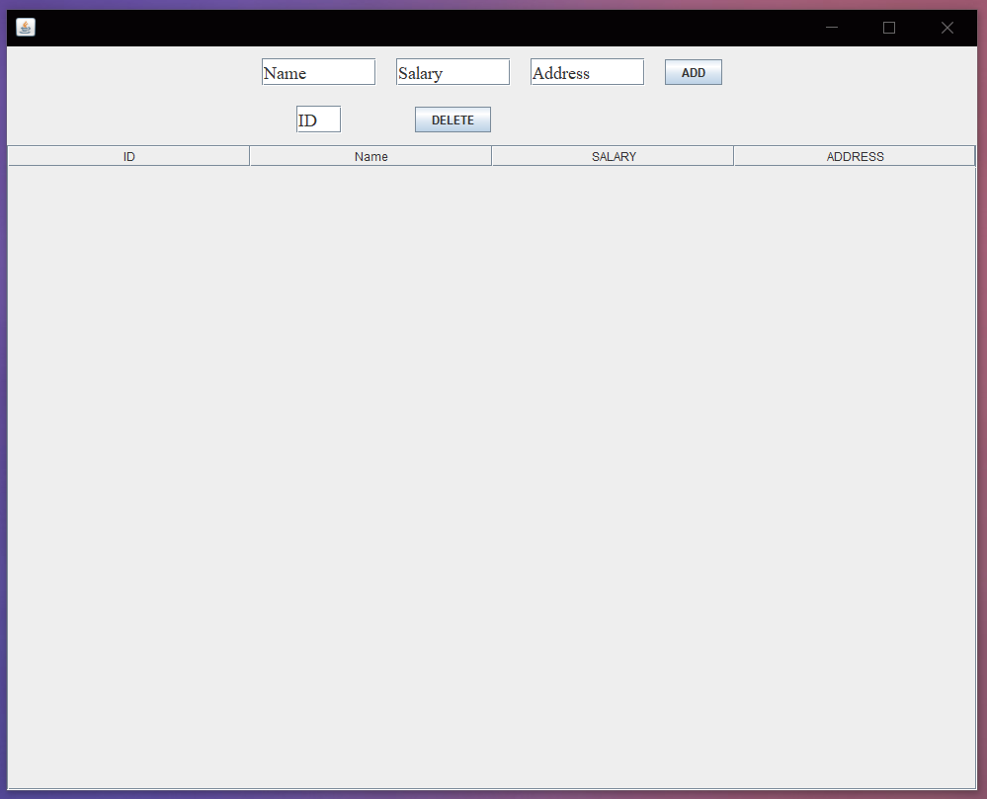

1. Then we created a controller class named “InformationController” which extends ActionListener and FocusListener to catch event changes. With the controller class we can use database class to insert and delete query. We can delete the rows by using id.
2. We created a class named “Database” which controls all the lower-level database creation to database insertion. For the database we created 2 tables. The queries are given below:

* CREATE TABLE admin (username TEXT, password TEXT, PRIMARY KEY(username))
* CREATE TABLE info(id INTEGER, name TEXT, salary INTEGER,address TEXT, PRIMARY KEY(id AUTOINCREMENT))

1. All the additional queries are given below:

* SELECT password FROM admin WHERE username = username
* INSERT INTO info(name,salary,address) VALUES(name,salary,address)
* DELETE FROM info WHERE id = id

1. The database class handles all the SQL exceptions and if any error occurs the UI uses showMessageDialog() to alert the user.

