1. **How to enumerate function works?**

Basically, enumerate function returned the index value with the items of a list or a tuple. A enumerate function has 2 parameters. Like

1. Iterable: it is the collection of data of list or tuple which is returned as enumerate objects
2. Start: it is the indexing value of enumerate object. 0 is the default value of start

If we see a example then we see, we have a list then we insert that list in a enumerate function and for output we print i = for indexing and j = for the data of the list

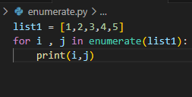**Input:**

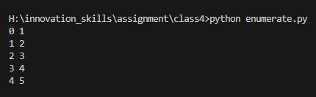 **Output:**

**2. How zip function works internally?**

Zip function works like a zipper. This function basically joins the multiple lists like,

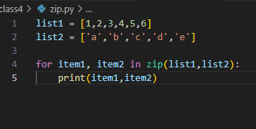**Input:**

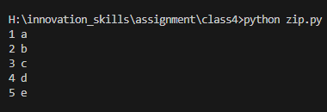 **Output:**

Here we see both functions are attached now.

1. **what happens if size of any list is not equal to each other in zip?**

The extra item of a list will not show in the output. That means if we have 2 lists like

List1 = [1,2,3,4,5,6]

List2 = [‘a’,’b’,’c’,’d’,’e’]

From both list we see that in list1 we have 6 items and in list2 we have 5 items. When we use the zip function and we want to see the output at that moment the extra item of list1 will not show.

****Input:

 Output:

1. **Execution time of list comprehension and traditional approach**

Though it depends for different program but if we do this for a same program then we will find the difference.

**With for loop:**

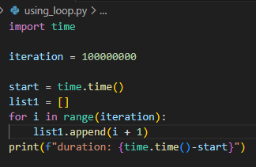**Input:**

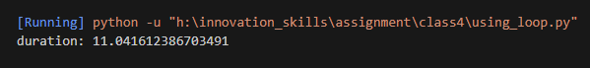 **Output:**

**Using list comprehension:**

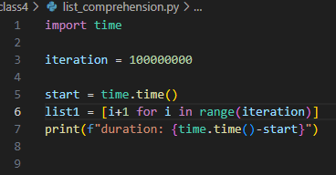**Input:**

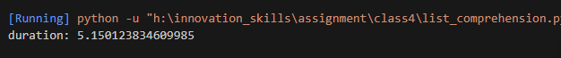**Output:**

Here we see that list comprehension is faster than using normal loops because it makes the program small compare to using loop and list comprehension make less complex. So, it takes less time.

**5. Memory size of each index in a list according to different types of data**

**input**

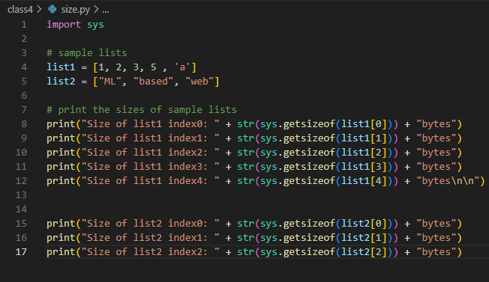

**Output:**

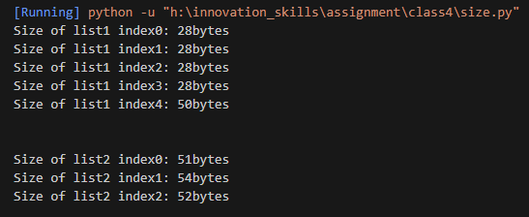

**NB: I am very much less known about sys module and also it uses. I will try to figure out it’s uses**