­­­ **Workshop 8**



|  |  |  |
| --- | --- | --- |
| Nama | : | Defri Indra Mahardika |
| NRP | : | 3120510402 |
| PRODI | : | D3 PJJ TI B |

1. Percobaan 1

<!DOCTYPE html>

<html lang="en">

<head>

    <meta charset="UTF-8">

    <meta name="viewport" content="width=device-width, initial-scale=1.0">

    <title>Percobaan 1</title>

    <link rel="stylesheet" href="https://stackpath.bootstrapcdn.com/bootstrap/4.5.2/css/bootstrap.min.css" integrity="sha384-JcKb8q3iqJ61gNV9KGb8thSsNjpSL0n8PARn9HuZOnIxN0hoP+VmmDGMN5t9UJ0Z" crossorigin="anonymous">

</head>

<body>

    <div class="container p-4 text-black">

        <ul class="list-group">

            <li class="list-group-item list-group-item-success">Success</li>

            <li class="list-group-item list-group-item-secondary">Secondary</li>

            <li class="list-group-item list-group-item-info">Info</li>

            <li class="list-group-item list-group-item-warning">Warning</li>

            <li class="list-group-item list-group-item-danger">Danger</li>

            <li class="list-group-item list-group-item-primary">primary</li>

            <li class="list-group-item list-group-item-dark">dark</li>

            <li class="list-group-item list-group-item-light">light</li>

          </ul>

    </div>

    <script src="https://code.jquery.com/jquery-3.5.1.slim.min.js" integrity="sha256-4+XzXVhsDmqanXGHaHvgh1gMQKX40OUvDEBTu8JcmNs=" crossorigin="anonymous"></script>

    <script src="https://stackpath.bootstrapcdn.com/bootstrap/4.5.2/js/bootstrap.min.js" integrity="sha384-B4gt1jrGC7Jh4AgTPSdUtOBvfO8shuf57BaghqFfPlYxofvL8/KUEfYiJOMMV+rV" crossorigin="anonymous"></script>

    <script src="https://stackpath.bootstrapcdn.com/bootstrap/4.5.2/js/bootstrap.bundle.min.js" integrity="sha384-LtrjvnR4Twt/qOuYxE721u19sVFLVSA4hf/rRt6PrZTmiPltdZcI7q7PXQBYTKyf" crossorigin="anonymous"></script>

</body>

</html>

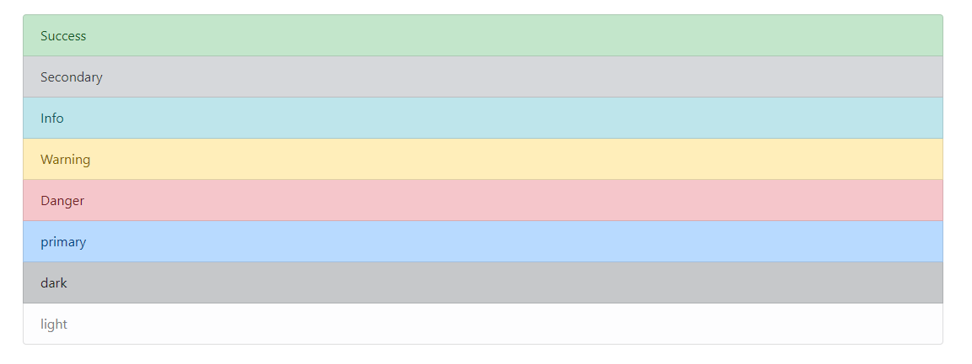

**Penjelasan :**

List grup adalah salah 1 component dari bootstrap, sama halnya dengan component lainnya list grup juga mempunyai varian seperti diatas.

1. Percobaan 2

<!DOCTYPE html>

<html lang="en">

<head>

    <meta charset="UTF-8">

    <meta name="viewport" content="width=device-width, initial-scale=1.0">

    <title>Percobaan 2</title>

    <link rel="stylesheet" href="https://stackpath.bootstrapcdn.com/bootstrap/4.5.2/css/bootstrap.min.css"

        integrity="sha384-JcKb8q3iqJ61gNV9KGb8thSsNjpSL0n8PARn9HuZOnIxN0hoP+VmmDGMN5t9UJ0Z" crossorigin="anonymous">

</head>

<body>

    <div class="container p-4 text-black">

        <h2>Ini Dropdown</h2>

        <div class="dropdown">

            <button class="btn btn-primary dropdown-toggle" type="button" data-toggle="dropdown">Dropdown Example

                <span class="caret"></span></button>

            <div class="dropdown-menu">

                <a class="dropdown-item" href="#">Link 1</a>

                <a class="dropdown-item" href="#">Link 2</a>

                <a class="dropdown-item" href="#">Link 3</a>

                <h5 class="dropdown-header">Header Bro</h5>

                <a class="dropdown-item" href="#">Lainnya</a>

            </div>

        </div>

    </div>

    <script src="https://code.jquery.com/jquery-3.2.1.slim.min.js" integrity="sha384-KJ3o2DKtIkvYIK3UENzmM7KCkRr/rE9/Qpg6aAZGJwFDMVNA/GpGFF93hXpG5KkN" crossorigin="anonymous"></script>

    <script src="https://cdnjs.cloudflare.com/ajax/libs/popper.js/1.12.9/umd/popper.min.js" integrity="sha384-ApNbgh9B+Y1QKtv3Rn7W3mgPxhU9K/ScQsAP7hUibX39j7fakFPskvXusvfa0b4Q" crossorigin="anonymous"></script>

    <script src="https://maxcdn.bootstrapcdn.com/bootstrap/4.0.0/js/bootstrap.min.js" integrity="sha384-JZR6Spejh4U02d8jOt6vLEHfe/JQGiRRSQQxSfFWpi1MquVdAyjUar5+76PVCmYl" crossorigin="anonymous"></script>

</body>

</html>

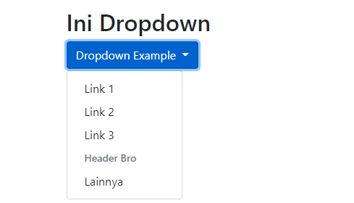

**Penjelasan :**

Dropdown adalah component yang sering digunakan dalam sebuah website, dropdown ini sangat cocok untuk menghemat ruang dalam penataan tata letak dari sebuah website.

1. Percobaan 3

<!DOCTYPE html>

<html lang="en">

<head>

    <meta charset="UTF-8">

    <meta name="viewport" content="width=device-width, initial-scale=1.0">

    <title>Percobaan 3</title>

    <link rel="stylesheet" href="https://stackpath.bootstrapcdn.com/bootstrap/4.5.2/css/bootstrap.min.css"

        integrity="sha384-JcKb8q3iqJ61gNV9KGb8thSsNjpSL0n8PARn9HuZOnIxN0hoP+VmmDGMN5t9UJ0Z" crossorigin="anonymous">

</head>

<body>

    <nav class="navbar navbar-expand-sm bg-dark navbar-dark">

        <a class="navbar-brand" href="#">WebSiteName</a>

        <ul class="navbar-nav">

            <li class="nav-item">

                <a class="nav-link" href="#">Link 1</a>

            </li>

            <li class="nav-item">

                <a class="nav-link" href="#">Link 2</a>

            </li>

            <li class="nav-item dropdown">

                <a class="btn btn-primary dropdown-toggle" href="#" id="napbarku" data-toggle="dropdown">Dropdown

                    Example

                    <span class="caret"></span></a>

                <div class="dropdown-menu">

                    <a class="dropdown-item" href="#">Link 1</a>

                    <a class="dropdown-item" href="#">Link 2</a>

                    <a class="dropdown-item" href="#">Link 3</a>

                </div>

            </li>

        </ul>

    </nav>

    <script src="https://code.jquery.com/jquery-3.2.1.slim.min.js"

        integrity="sha384-KJ3o2DKtIkvYIK3UENzmM7KCkRr/rE9/Qpg6aAZGJwFDMVNA/GpGFF93hXpG5KkN" crossorigin="anonymous">

    </script>

    <script src="https://cdnjs.cloudflare.com/ajax/libs/popper.js/1.12.9/umd/popper.min.js"

        integrity="sha384-ApNbgh9B+Y1QKtv3Rn7W3mgPxhU9K/ScQsAP7hUibX39j7fakFPskvXusvfa0b4Q" crossorigin="anonymous">

    </script>

    <script src="https://maxcdn.bootstrapcdn.com/bootstrap/4.0.0/js/bootstrap.min.js"

        integrity="sha384-JZR6Spejh4U02d8jOt6vLEHfe/JQGiRRSQQxSfFWpi1MquVdAyjUar5+76PVCmYl" crossorigin="anonymous">

    </script>

</body>

</html>

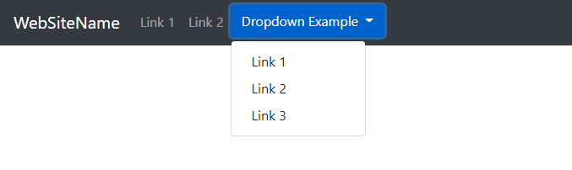

**Penjelasan :**

Navbar adalah sebuah common component dari sebuah website yang berguna untuk memudahkan kita melihat menu menu yang tersedia, dalam bootstrap sendiri banyak sekali style navigasi yang disediakan salah satu seperti dalam source code diatas.

1. Percobaan 4

<!DOCTYPE html>

<html lang="en">

<head>

    <meta charset="UTF-8">

    <meta name="viewport" content="width=device-width, initial-scale=1.0">

    <title>Percobaan 4</title>

    <link rel="stylesheet" href="https://stackpath.bootstrapcdn.com/bootstrap/4.5.2/css/bootstrap.min.css"

        integrity="sha384-JcKb8q3iqJ61gNV9KGb8thSsNjpSL0n8PARn9HuZOnIxN0hoP+VmmDGMN5t9UJ0Z" crossorigin="anonymous">

</head>

<body>

    <div class="container">

        <h2>Ini Porm</h2>

        <form class="was-validated" action="#">

            <div class="form-group">

                <label class="control-label col-sm-2" for="username">Username</label>

                <input type="username" class="form-control" id="username" placeholder="Enter Username" required>

                <div class="valid-feedback">Valid.</div>

                <div class="invalid-feedback">Please fill out this field</div>

            </div>

            <div class="form-group">

                <label class="control-label col-sm-2" for="pwd">Password</label>

                <input type="password" class="form-control" id="pwd" placeholder="Enter password" required>

                <div class="valid-feedback">Valid.</div>

                <div class="invalid-feedback">Please fill out this field</div>

            </div>

            <div class="form-group form-check">

                    <div class="checkbox">

                        <label class="form-check-label">

                            <input class="form-check-input" name="remember" type="checkbox" required> I setuju with term kamu

                            <div class="valid-feedback">Valid.</div>

                            <div class="invalid-feedback">Please fill out this field</div>

                        </label>

                    </div>

            </div>

            <div class="form-group">

                <div class="col-sm-offset-2 col-sm-10">

                    <button type="submit" class="btn btn-primary">Submit</button>

                </div>

            </div>

        </form>

    </div>

    <script src="https://code.jquery.com/jquery-3.2.1.slim.min.js"

        integrity="sha384-KJ3o2DKtIkvYIK3UENzmM7KCkRr/rE9/Qpg6aAZGJwFDMVNA/GpGFF93hXpG5KkN" crossorigin="anonymous">

    </script>

    <script src="https://cdnjs.cloudflare.com/ajax/libs/popper.js/1.12.9/umd/popper.min.js"

        integrity="sha384-ApNbgh9B+Y1QKtv3Rn7W3mgPxhU9K/ScQsAP7hUibX39j7fakFPskvXusvfa0b4Q" crossorigin="anonymous">

    </script>

    <script src="https://maxcdn.bootstrapcdn.com/bootstrap/4.0.0/js/bootstrap.min.js"

        integrity="sha384-JZR6Spejh4U02d8jOt6vLEHfe/JQGiRRSQQxSfFWpi1MquVdAyjUar5+76PVCmYl" crossorigin="anonymous">

    </script>

</body>

</html>

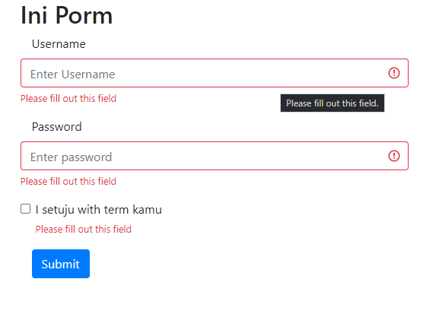

**Penjelasan :**

Dalam bootstrap juga telah disediakan style untuk validasi yang sangat sangat mudah digunakan dari pada membuat sendiri.

1. Percobaan 5

<!DOCTYPE html>

<html lang="en">

<head>

    <meta charset="UTF-8">

    <meta name="viewport" content="width=device-width, initial-scale=1.0">

    <title>Percobaan 4</title>

    <link rel="stylesheet" href="https://stackpath.bootstrapcdn.com/bootstrap/4.5.2/css/bootstrap.min.css"

        integrity="sha384-JcKb8q3iqJ61gNV9KGb8thSsNjpSL0n8PARn9HuZOnIxN0hoP+VmmDGMN5t9UJ0Z" crossorigin="anonymous">

</head>

<body>

    <div class="container">

        <h2>Form Input</h2>

        <form class="form" action="#">

            <div class="form-group">

                <label class="control-label" for="username">Username</label>

                <input type="username" class="form-control" id="username" placeholder="Enter Username" required>

            </div>

            <div class="form-group">

                <label class="control-label" for="pwd">Password</label>

                <input type="password" class="form-control" id="pwd" placeholder="Enter password" required>

            </div>

            <div class="form-group">

                <button type="submit" class="btn btn-primary">Submit</button>

            </div>

        </form>

    </div>

    <script src="https://code.jquery.com/jquery-3.2.1.slim.min.js"

        integrity="sha384-KJ3o2DKtIkvYIK3UENzmM7KCkRr/rE9/Qpg6aAZGJwFDMVNA/GpGFF93hXpG5KkN" crossorigin="anonymous">

    </script>

    <script src="https://cdnjs.cloudflare.com/ajax/libs/popper.js/1.12.9/umd/popper.min.js"

        integrity="sha384-ApNbgh9B+Y1QKtv3Rn7W3mgPxhU9K/ScQsAP7hUibX39j7fakFPskvXusvfa0b4Q" crossorigin="anonymous">

    </script>

    <script src="https://maxcdn.bootstrapcdn.com/bootstrap/4.0.0/js/bootstrap.min.js"

        integrity="sha384-JZR6Spejh4U02d8jOt6vLEHfe/JQGiRRSQQxSfFWpi1MquVdAyjUar5+76PVCmYl" crossorigin="anonymous">

    </script>

</body>

</html>

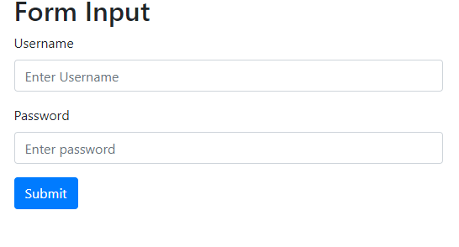

**Penjelasan :**

Pembuatan form akan terasa sangat mudah jika menggunakan boostrap, form input akan langsung terlihat enak dipandang, juga sangat mudah dalam pengostumisasiannya.