**1. Introduction**

Social cues are essential in human interaction, influencing how we communicate and how our messages are interpreted [1]. While verbal communication plays a role, nonverbal cues—such as gestures, facial expressions, and body language—carry greater significance. However, these nonverbal social cues do more than complement our verbal communication—they also serve as an extension of our emotions [2, 3]. Our emotions act as a social signal to convey information about our current state, often influencing our social dynamics in daily life [4]. As a result, the ability to express and interpret emotions is fundamental to human connection and interaction.

Given the importance of emotion in social interaction, researchers have explored digital tools to represent emotions in various ways, mostly through changes in color based on the user’s arousal levels. Previous studies have developed interactive tools for emotion expression, such as MoodLight and BioCrystal, which translate bio-signals into color changes, and HeartBees, which visualizes emotions through flocking behavior. However, these approaches primarily focus on self-regulation rather than facilitating social interaction and often suffer from computational complexity and obtrusive designs [5, 6, 7]. Given the need for a more subtle and non-intrusive approach, we turn to calm technology: a design philosophy that emphasizes unobtrusive and seamless integration of technology into an individual’s lives with a minimal need for attention and cognitive overload [8]. Some examples of calm technology in the past, like CalmResponses and SpeakEasy, showcased designs that minimized cognitive load while still conveying essential information to users [9, 10].

Applying this philosophy, we propose a digital tool that enables subtle and intuitive emotional expression without disrupting daily communication. Our goal in this paper is to build upon insights from the *Emotion Bridge Design Workshop with My Daily Badge* to develop a novel digital visual tool that enables subtle, real-time emotion expression to enhance human interaction [11]. We aim to verify the validity of the insights, and to determine the design, implementation, and evaluation of this tool, demonstrating its potential for enhancing social communication in an unobtrusive manner. With these goals in mind, we aim to derive parameters from the workshop’s findings and minimize them to reduce the computational cost and complexity of our tool.

**2. Method**

2.1 Overview of Workshop Findings

Our findings from the *Emotion Bridge Design Workshop* indicated that smoother shapes correspond to positive emotions, while irregular shapes correspond to negative emotions. The complexity of the shape then determines the emotion's intensity [11]. The workshop also revealed that waveform graphs and personification of emotions were also preferred methods of expressing emotions, but these were either too simple (waveforms) or too complex (personification) for daily use as they lack immediate aesthetic appeal and/or computationally too expensive to be packaged in a small form factor. Therefore, we have decided to keep the shape-based representation, as they strike a balance between the two extremes.

Based on these insights, we conducted a pilot study where we developed a prototype of our visual tool to assess the design structure we discovered in the workshop: irregularity and complexity; and to examine the tool's parameterization and analyze the effectiveness of those parameters in expressing emotions based on the participant’s input.

2.2 Pilot Study: Eliciting Parameters of Emotion Expression

To align with our previous findings from the emotion bridge workshop, we chose parameters that can potentially represent the irregularity and complexity of shapes in the tool [11]. The parameters are as follows: shape, the tool's geometry; noise, the irregularity of the shape's edges; pace, the animated speed of the shape's irregularity; width, the stroke weight of the shape's edges; and space, the spacing between each layered shape. The two parameters, noise and pace, were designed to convey irregularity and complexity, which we hope will represent emotional valence (symmetry) and arousal, respectively [12][13]. We also chose radial visuals for our tool because of their simplistic round shape and their ability to show dissonance in their shape quickly, which we believe will help make our tool replicable and accessible for daily use in representing our emotions [14].

Through our visual tool, we aim to create a form of symmetry and asymmetry within the shape's structure combined with its animation intensity—each corresponding to the irregularity and complexity dimensions we extracted from our workshop—which we believe can evoke positive or negative connotations from the study's participants [15]. We also designed our tool to be monochromatic as we wanted to focus more on our workshop findings that emphasized shape.

For this study, we recruited 53 participants, most of whom were between 20 and 29 years old. Seventy-three percent of the participants originated from Indonesia (73.4%), with the remainder originating from nine other countries. The participants interacted with our tool to express the five basic discrete emotions: joy, sadness, anger, fear, and disgust [16]. The parameters that participants defined will then be analyzed to see potential patterns.

Results and Analysis

Following the participants' parameterization, we analyzed the frequency distribution and density plots of their chosen parameters for specific emotions (Fig. 1). The distributions revealed that noise (Fig. 1b) and pace (Fig. 1c) were significant parameters in specifying discrete emotions due to their notably pronounced peaks. Width (Fig. 2d) and space (Fig. 2e) also influenced the recognizability of the represented emotion; however, their density plots indicated that their peaks exhibited lower slopes and broader areas, suggesting a weaker and less defined impact compared to noise and pace. For shape, there were no clear peaks and regions, which indicates that the geometry of our tool was not a significant indicator for emotion expression and was mainly a preference-based parameter.

We then conducted an ANOVA (analysis of variance) test to assess the parameters' significance. The results indicated that noise (F = 27.51, p < 0.0001) and pace (F = 17.77, p < 0.0001) were once again the most significant parameters influencing emotional representation. In comparison, the effect size of the other parameters was substantially smaller. Specifically, shape (F = 8.99, p < 0.0001) had approximately 67% of the magnitude of noise, while width (F = 8.77, p < 0.0001) and space (F = 9.82, p < 0.0001) exhibited roughly 32% and 36% of noise's effect size, respectively (Table 1).

Based on the findings from the ANOVA test, we decided to analyze the noise and pace parameters even further. We extracted each emotion's noise and pace values to create a corresponding scatter plot (x-axis: pace, y-axis: noise), standardizing the values to eliminate the scalability effects (Fig. 3). Through the scatter plots, we observed potential clusters appearing in all emotions but fear and disgust, which were more dispersed. However, as most of the emotions appeared in clusters, we calculated the centroids of each emotion's data points.

To minimize the impact of outliers, we used the median of each emotion's points as the centroid.  We then constructed a Voronoi region diagram using these points, which we populated once more with all the data points (Fig. 4). We categorized the data points into two groups: those that fell within the regions (circles) and those that did not (triangles).

Our analysis of the scatter plot regions revealed that anger (50.94%) was the emotion most similarly parameterized by participants. In contrast, fear (20.75%) was the lowest, followed by joy (28.30%), sadness (37.74%) and disgust (39.62%). The higher percentage of points correctly categorized to the regions suggests a more universal recognition of the emotion, while a lower percentage indicates potential ambiguity. However, these regions do not represent disgust and fear well, as their data points exhibit high variability, leading to more ambiguous classifications. Given that each region occupies 20% of the total area, this increases the likelihood of misclassifications within broader areas, especially for emotions with more dispersed data points. Joy also appears to be inadequately represented, as its noise values overlap significantly with those of sadness. These data points correspond directly to the participants who reported selecting shapes resembling flowers or stars to represent joy, a parameter not captured by the scatter plot's parameters.

Our findings, however, still support the notion that valence ambiguity influences the recognition and interpretation of emotions [17, 18]. Emotions with clearly defined valence, such as happiness, sadness, and anger, exhibit more distinct clustering. In contrast, emotions like disgust, which involve more significant valence ambiguity, contribute to the more dispersed distribution of data points. On the other hand, we attribute fear's dispersion of data to its multidimensionality, which can vary in intensity and manifestation depending on individuals and situations [19].

Finally, we applied a multinomial logistic regression model to examine the relationship between expressed emotions and the pace and noise parameters (Table 2). Before applying the regression analysis, we removed potential outliers to minimize bias in parameter estimation and enhance the model's generalizability. We identified the outliers and pruned them using a distance threshold of 10% of Voronoi region boundaries.

The model achieved an overall accuracy of 82%, with an average precision of 0.85 across all emotion categories. The recall value of 0.79 showed that the model correctly identified 79% of the actual occurrences of each emotion, while the F1-score of 0.81 shows an overall good model performance. However, we decided to focus more on the coefficients derived from the model. Higher positive coefficient values strongly link the parameter to the emotion, while higher negative values indicate a strong disassociation between the two.

The emotion with the highest positive coefficient for pace was fear (Pace: 2.05, noise: -0.47), while the highest positive coefficient for noise was anger (Pace: 1.67, Noise: 2.49). On the other hand, sadness (Pace: -2.52, noise: -1.67) has the highest negative coefficient for pace, while joy (Pace: 0.40, noise: -2.04) has the highest value for noise. Disgust (Pace: -1.61, Noise: 1.70) had values between the two extremes, with a negative pace and positive noise coefficient. Furthermore, as our goal was to align pace and noise to arousal and valence, we also observed the modality of the coefficients. Based on these coefficient values, we can represent emotions as remodel pace and noise into arousal and valence (Table 3). Pace is directly related to arousal, while noise is inversely related to valence, as higher noise represents a more irregular shape.

With this encoding framework, we reclassified the emotions based on their pace and noise values to their corresponding arousal and valence classifications (Table 4). Through this transformation, we observed that the coefficients from the linear regression mainly successfully modeled the valence and arousal dimensions of emotions, especially for emotions like anger, disgust, and fear. However, the transformation does not represent joy and sadness well, as joy is a high-arousal emotion, and sadness is often associated with a negative valence.

Discussions

This paper’s primary goals were to verify the validity of the insights obtained from the Emotion Bridge workshop regarding a subtle emotion representation through simple shapes and to determine the parameterization of those insights for real-world applications. All our findings from the pilot study strongly support the design parameters established in our earlier emotion bridge design workshop, reinforcing the significance of noise and pace in shaping emotional perception. The results indicate that these parameters correspond to the irregularity and complexity of the perceived shape, influencing how emotions are represented and recognized. Moreover, the relationship between noise and pace also suggests a broader connection to emotional valence and arousal through the coefficients obtained from the multinomial logistic regression analysis.

This relationship aligns with the Gestalt principle of isomorphism and existing research on the impact of visual elements and movement on perceived emotional states [1][7][9].

Therefore, we have successfully achieved our first goal: to verify the insights from our Emotion Bridge workshop.

For our second goal, we managed to reduce the number of significant parameters to model emotion expression to pace and noise from an initial of five. Both the frequency and density distributions revealed the significance of noise and pace as parameters that affected the perceived emotion, which was reinforced further by the ANOVA test. The clustering observed in the scatter plots also supported noise and pace as key parameters. However, the lack of parameters like shape and width, which some participants used to visualize emotion, resulted in a less distinct classification and encoding of the emotions' pace and noise into arousal and valence.

When we interviewed the participants about why they chose their specific parameters, many responses for non-negative valence emotions were related to the shape and width of the visuals. For example, one participant (F, 23) mentioned that "[joy] is like a shape that can go in any general direction … a star-based shape." Other participants also expressed the same thought process, claiming that it looks like a "flower" and is "radiating."

The participants also expressed another common thread regarding joy: a "pulsating" and "vibrating" feeling like the tool was in an excited state. We believe that this pulsing motion or vibrating motion can be used as a parameter to model the level of positivity of the motion in terms of its valence. It is due to the lack of this ‘positivity’ parameter that we believe our tool was weak at differentiating between sadness and joy distinctly, and why they used noise to increase the expressed negativity of the tool and eventually used it to also represent the vibrant and active nature of joy. [insert quotes here if possible].

In our earlier workshop, we focused on modeling valence and arousal into a shape, which we could then divide into the shape's irregularity and complexity. From that notion, we also created our tool to emulate valence and arousal using two parameters. However, our designed parameters operate on a unidirectional scale, demonstrating absence or presence, which allowed for a singular change that became more prominent as the parameter's value increased.

This binary nature of the parameters resulted in an effective model for arousal and a less effective model for valence. Arousal is a state that goes from low to high, while valence can range from negative to positive values. In our tool, this meant that pace could portray the low and high states of arousal, but noise only portrayed an increasing negative valence. In the future, adding a third parameter to work with noise will be crucial to effectively model the broad spectrum of emotions by providing a way for users to portray increasing positive valence.

Another limitation that this study faces is the demographics distribution, with 73.4% of participants being from Indonesia. While this limits a generalization of our findings, we believe that they remain meaningful as our results and analysis aligned with the insights from our previous emotion bridge design workshop which were done with a different demographic.

Conclusions

Through this study, we identified and tested the minimal set of parameters needed to represent the five basic emotions (joy, sadness, anger, fear, disgust), establishing a framework for parametrizing and expressing emotions using a minimum of two parameters: pace and noise. Although we have managed to minimize the number of parameters to two in this study based on our previous workshop findings, introducing one more parameter to indicate positive valence is needed.

In the future, we aim to use this parameterization framework with the biometric data obtained using My Daily Badge. By creating a simple representation of emotional expression that is easily replicable, we hope to provide a subtle way to express emotions in our daily lives as a new and novel way to communicate with each other.

References

1. Straube, B., Green, A., Jansen, A., Chatterjee, A., & Kircher, T. (2010). Social cues, mentalizing and the neural processing of speech accompanied by gestures. Neuropsychologia, 48, 382-393. https://doi.org/10.1016/j.neuropsychologia.2009.09.025.
2. Fichten, C., Tagalakis, V., Judd, D., Wright, J., & Amsel, R. (1992). Verbal and nonverbal communication cues in daily conversations and dating.. Journal of Social Psychology, 132, 751-769. https://doi.org/10.1080/00224545.1992.9712105.
3. Furnham, A., Trevethan, R., & Gaskell, G. (1981). The relative contribution of verbal, vocal, and visual channels to person perception: Experiment and critique. , 37, 39 - 58. https://doi.org/10.1515/semi.1981.37.1-2.39.
4. Hareli, S., & Hess, U. (2012). The social signal value of emotions. Cognition and Emotion, 26, 385 - 389. https://doi.org/10.1080/02699931.2012.665029.
5. Snyder, J., Matthews, M., Chien, J., Chang, P., Sun, E., Abdullah, S., & Gay, G. (2015). MoodLight: Exploring Personal and Social Implications of Ambient Display of Biosensor Data. Proceedings of the 18th ACM Conference on Computer Supported Cooperative Work & Social Computing. https://doi.org/10.1145/2675133.2675191.
6. Roseway, A., Lutchyn, Y., Johns, P., Mynatt, E., & Czerwinski, M. (2015). BioCrystal: An Ambient Tool for Emotion and Communication. Int. J. Mob. Hum. Comput. Interact., 7, 20-41. https://doi.org/10.4018/ijmhci.2015070102.
7. Qin, C., Constantinides, M., Aiello, L., & Quercia, D. (2020). HeartBees: Visualizing Crowd Affects. 2020 IEEE VIS Arts Program (VISAP), 1-8. https://doi.org/10.1109/VISAP51628.2020.00007.
8. Weiser, M.D., & Brown, J.S. (1996). THE COMING AGE OF CALM TECHNOLOGY[1].
9. Maeda, K., Arakawa, R., & Rekimoto, J. (2022). CalmResponses: Displaying Collective Audience Reactions in Remote Communication. Proceedings of the 2022 ACM International Conference on Interactive Media Experiences. https://doi.org/10.1145/3505284.3529959.
10. Jeon, H., Ramachandran, R., Ploerer, V., Diekmann, Y., & Bagga, M. (2023). SpeakEasy: A Conversational Intelligence Chatbot for Enhancing College Students' Communication Skills. ArXiv, abs/2310.14891. https://doi.org/10.48550/arXiv.2310.14891.
11. Shimizu, K., Hanssen, M., Shepherd, J., & Lee, S.H. (2025). Emotion Bridge Design Workshop with My Daily Badge - A Case Study for Exploring Subtle Emotional Representation System in Everyday [ISASE FIX]
12. Salgado-Montejo, A., Alvarado, J., Velasco, C., Salgado, C., Hasse, K., & Spence, C. (2015). The sweetest thing: the influence of angularity, symmetry, and the number of elements on shape-valence and shape-taste matches. Frontiers in Psychology, 6. <https://doi.org/10.3389/fpsyg.2015.01382>.
13. Sundar, S., & Kalyanaraman, S. (2004). AROUSAL, MEMORY, AND IMPRESSION-FORMATION EFFECTS OF ANIMATION SPEED IN WEB ADVERTISING. Journal of Advertising, 33, 17 - 7. <https://doi.org/10.1080/00913367.2004.10639152>.
14. Chuquichambi, E., Corradi, G., Munar, E., & Rosselló, J. (2021). When symmetric and curved visual contour meet intentional instructions: Hedonic value and preference. Quarterly Journal of Experimental Psychology, 74, 1525 - 1541. <https://doi.org/10.1177/17470218211021593>.
15. Hiraga, R. (2011). Emotion recognition in polygons and curved shapes. 2011 IEEE International Conference on Systems, Man, and Cybernetics, 3286-3291. <https://doi.org/10.1109/ICSMC.2011.6084176>.
16. Harmon-Jones, C., Bastian, B., & Harmon-Jones, E. (2016). The Discrete Emotions Questionnaire: A New Tool for Measuring State Self-Reported Emotions. PLoS ONE, 11. <https://doi.org/10.1371/journal.pone.0159915>.
17. Riddell, C., Nikolić, M., Dusseldorp, E., & Kret, M. (2024). Age-related changes in emotion recognition across childhood: A meta-analytic review.. Psychological bulletin, 150 9, 1094-1117 . <https://doi.org/10.1037/bul0000442>.
18. Brainerd, C. (2018). The Emotional-Ambiguity Hypothesis: A Large-Scale Test. Psychological Science, 29, 1706 - 1715. <https://doi.org/10.1177/0956797618780353>.
19. Lang, P., McTeague, L., & Bradley, M. (2016). RDoC, DSM, and the reflex physiology of fear: A biodimensional analysis of the anxiety disorders spectrum.. Psychophysiology, 53 3, 336-47 . <https://doi.org/10.1111/psyp.12462>.

Appendix A

|  |  |  |
| --- | --- | --- |
| Table A1. Age Distribution | | |
| Age Group | Count | Percentage |
| 20-29 | 42 | 79,2% |
| 30-39 | 8 | 15.1% |
| 40-49 | 2 | 3.8% |
| 50-59 | 1 | 1.9% |

|  |  |  |
| --- | --- | --- |
| Table A2. Country Origin Distribution | | |
| Country | Count | Percentage |
| America | 1 | 1.9% |
| Indonesia | 39 | 73.4% |
| China | 5 | 9.5% |
| Colombia | 1 | 1.9% |
| Dutch | 1 | 1.9% |
| Japan | 1 | 1.9% |
| Korea | 2 | 3.8% |
| Malaysia | 1 | 1.9% |
| Mexico | 1 | 1.9% |
| Vietnam | 1 | 1.9% |

|  |  |  |
| --- | --- | --- |
| Table A3. Ethnicity Distribution | | |
| Ethnicity | Count | Percentage |
| American | 1 | 1.9% |
| Asian | 49 | 92.4% |
| Dutch | 1 | 1.9% |
| Latin American | 1 | 1.9% |
| Mexico | 1 | 1.9% |

Figure A1. Sample Emotions

Figures

Figure 1. Frequency Plots

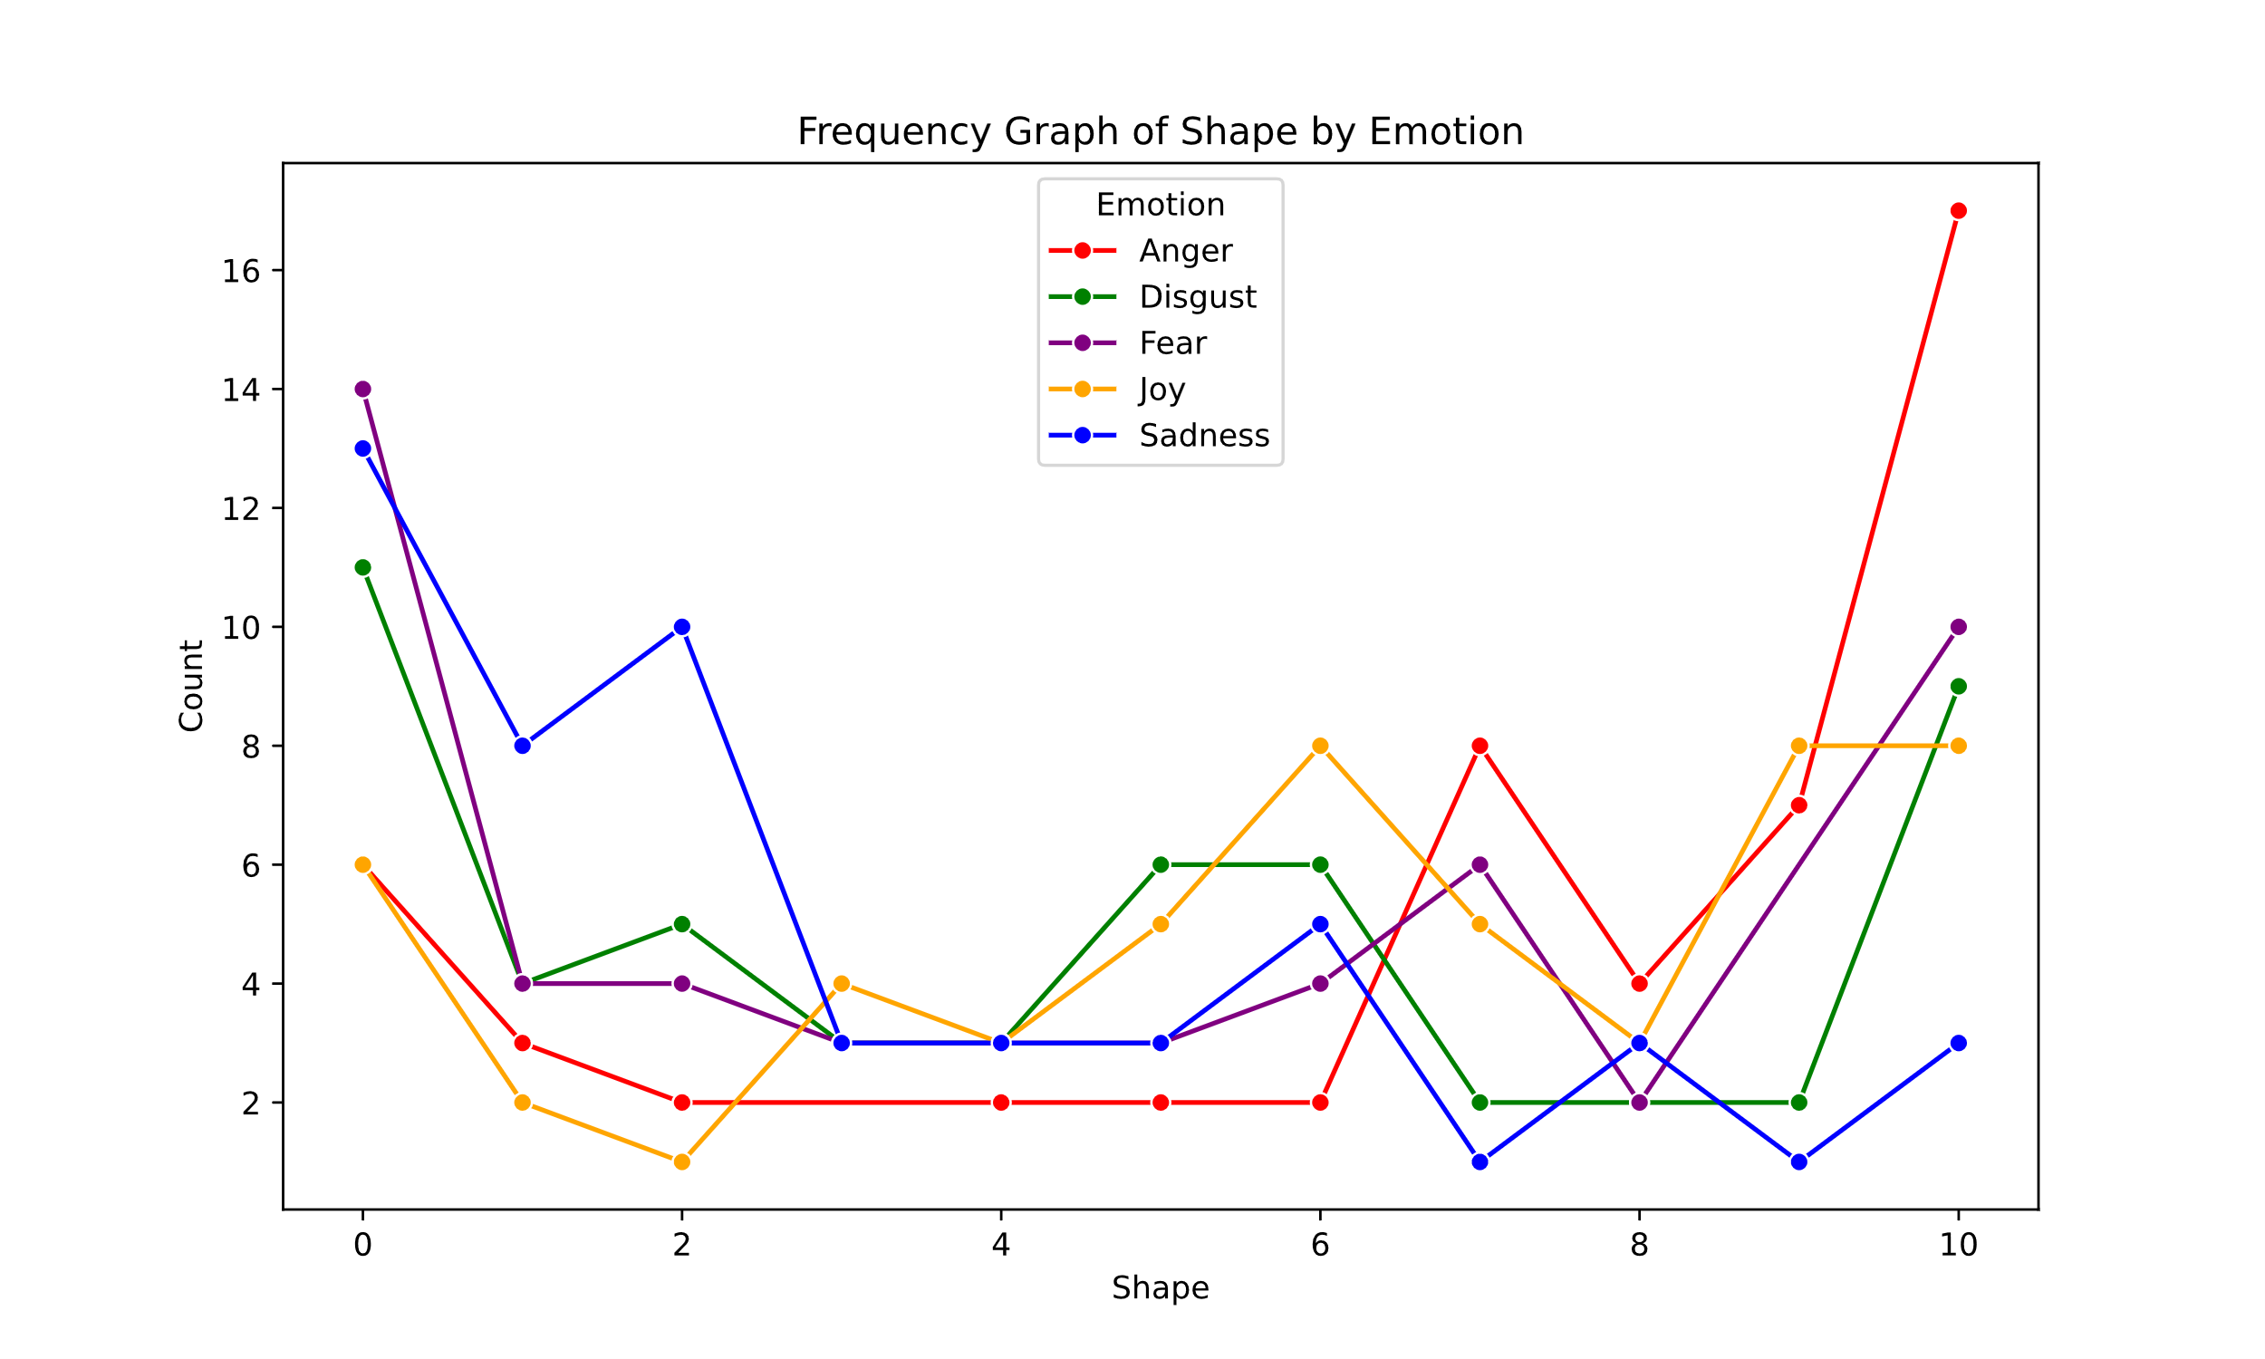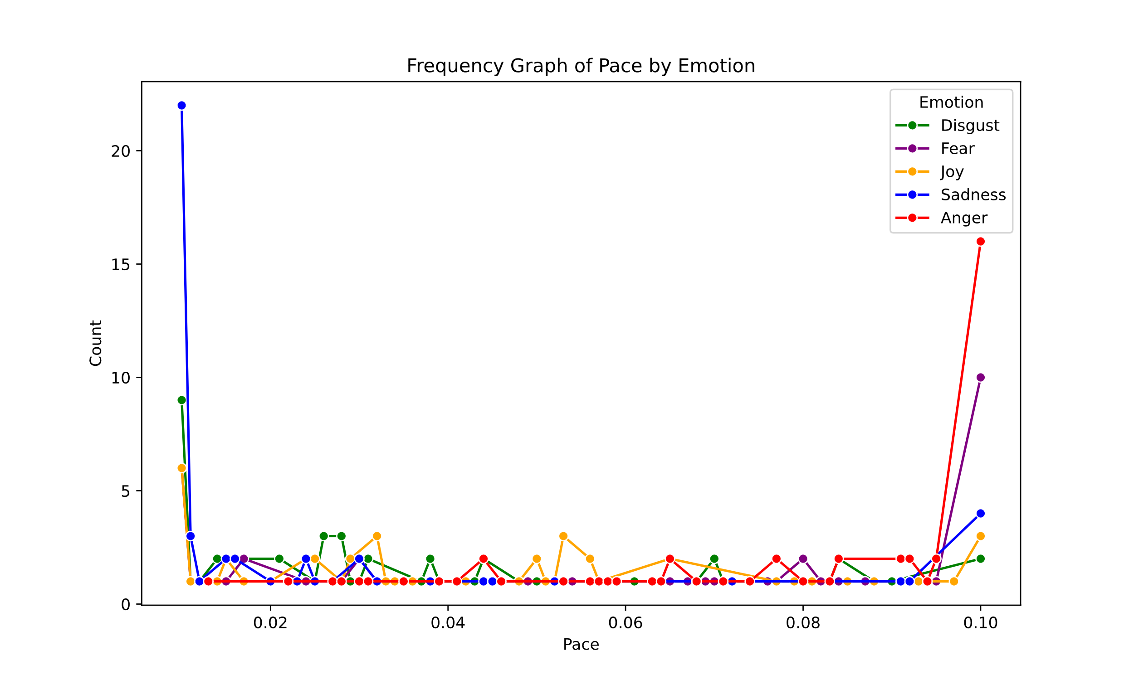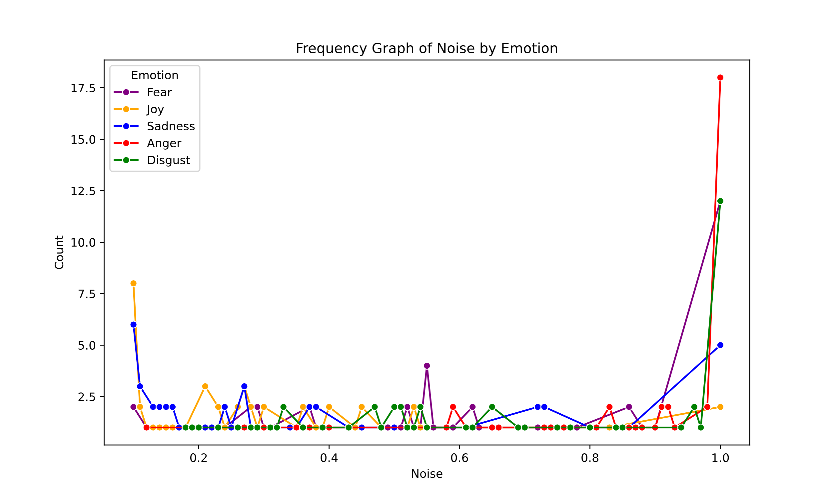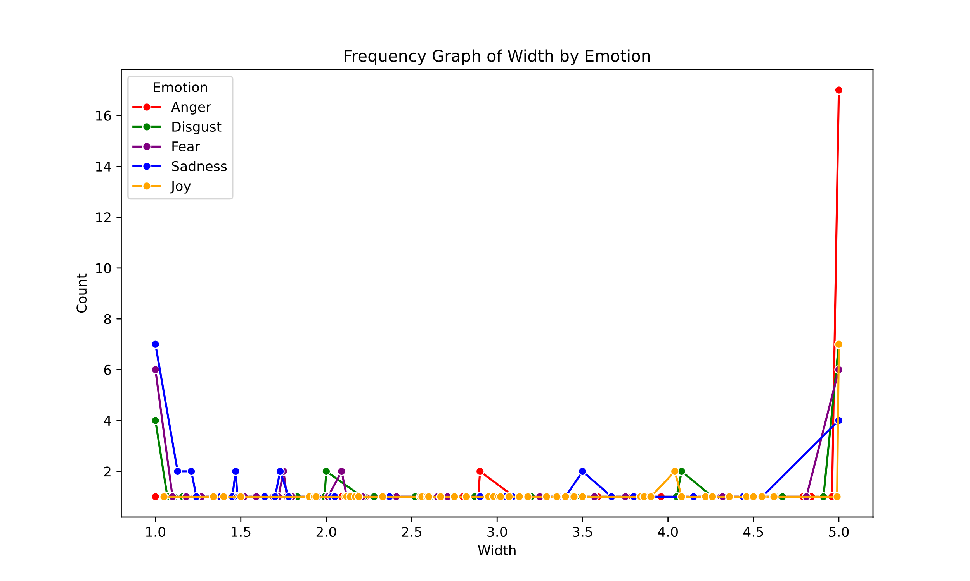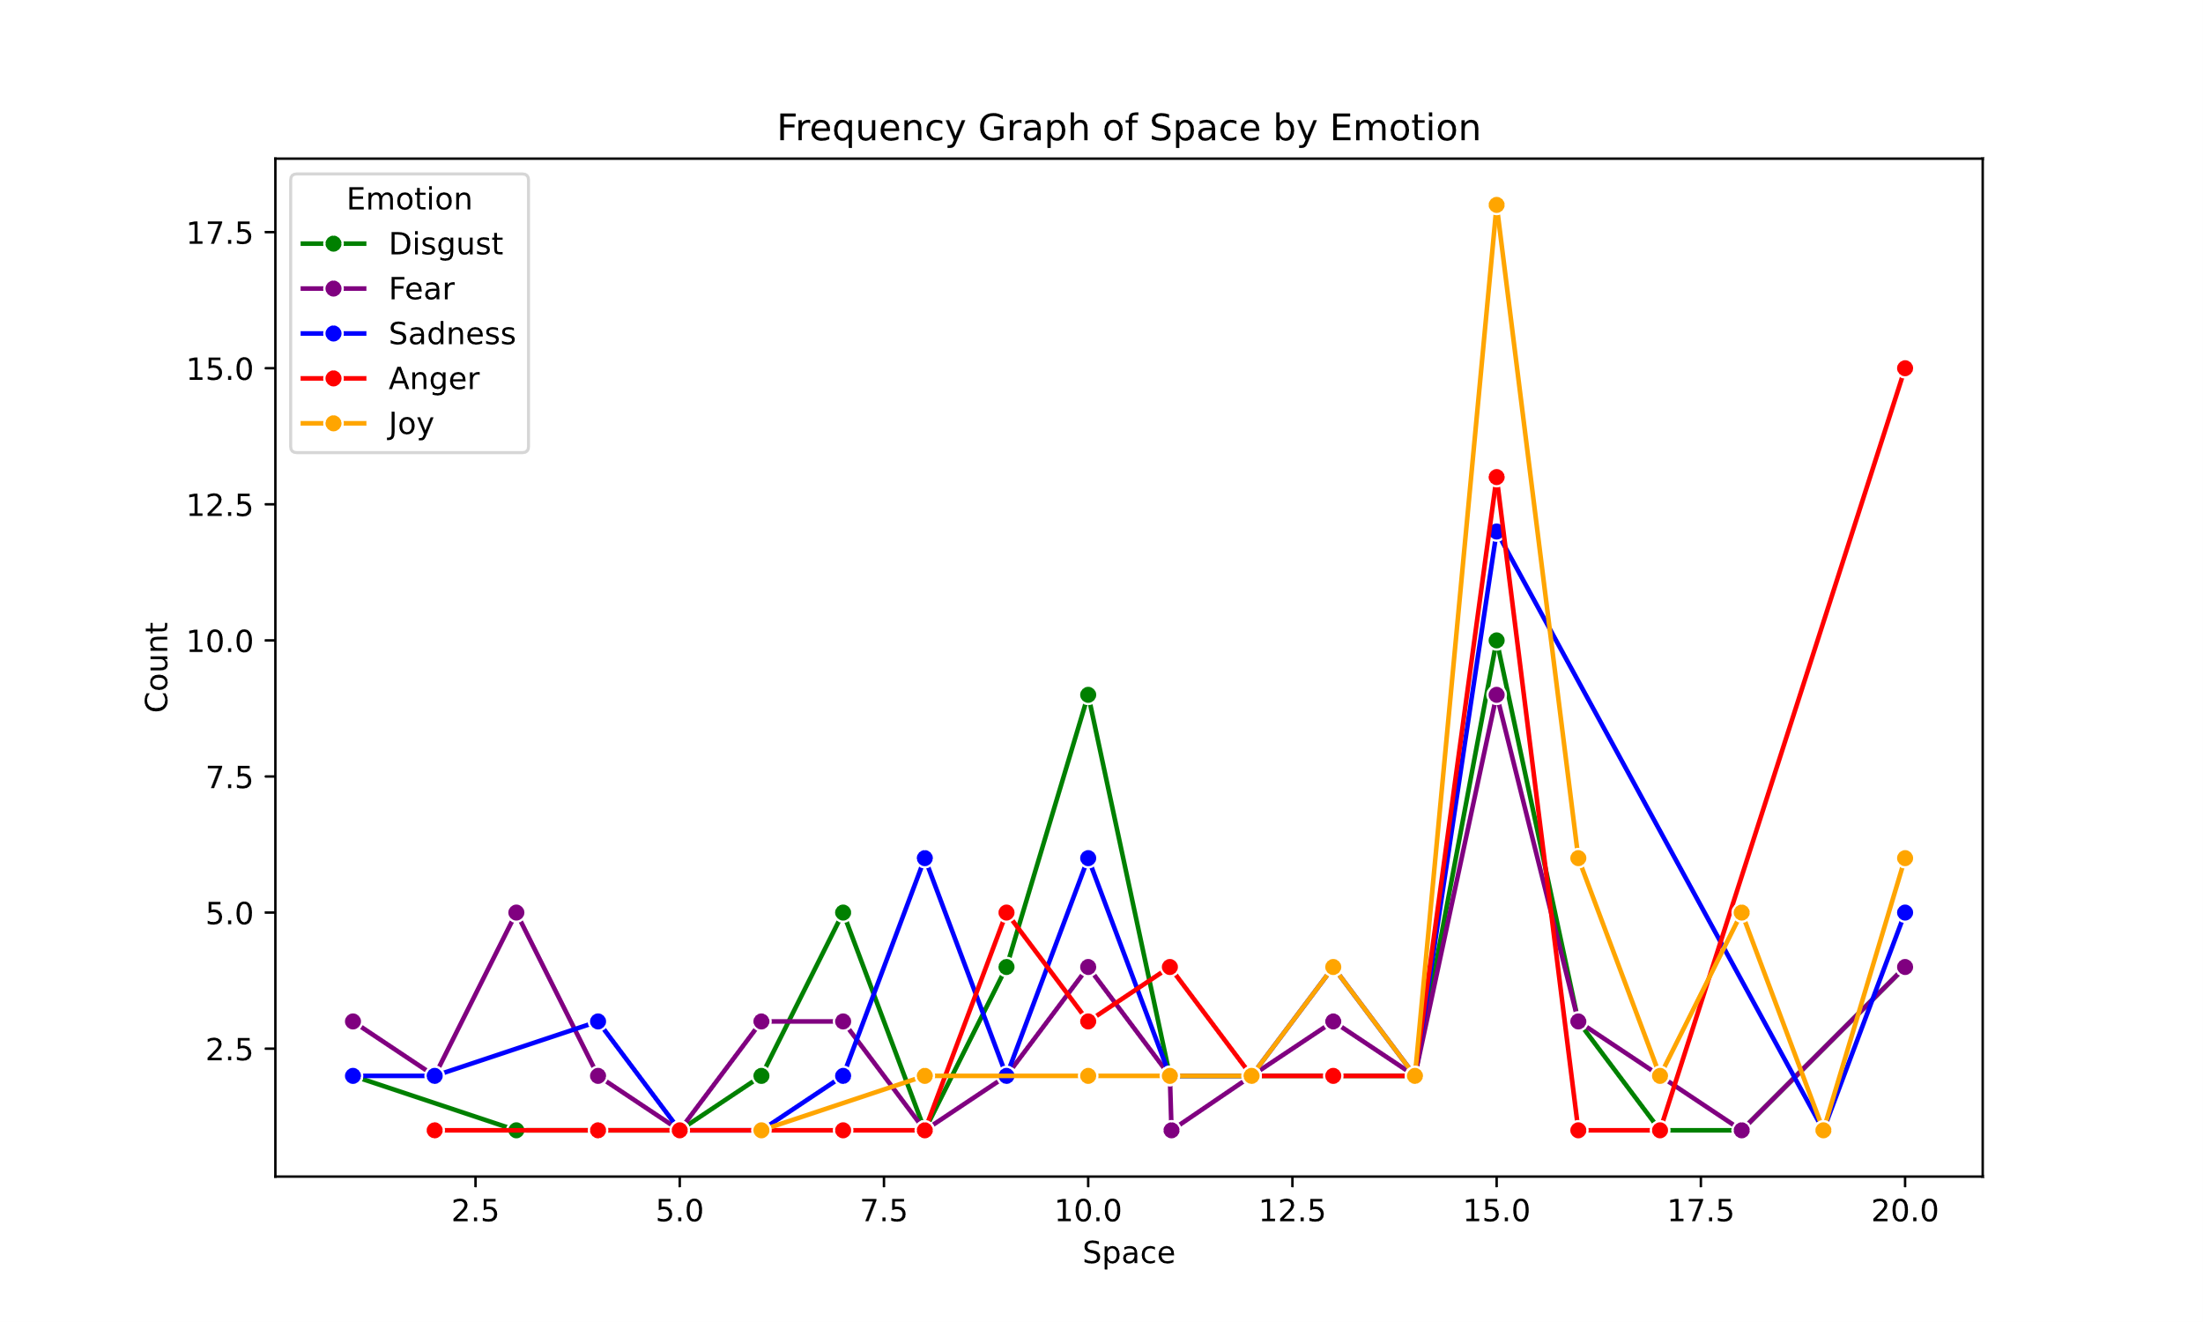

Figure 2. Density Plots

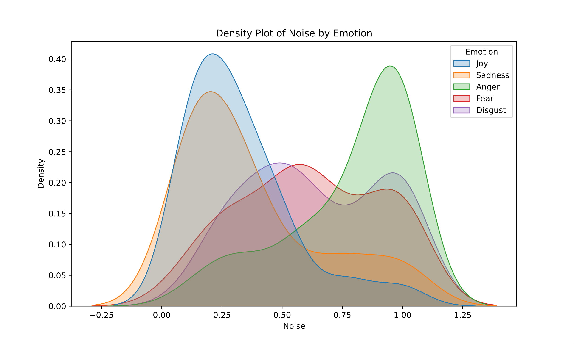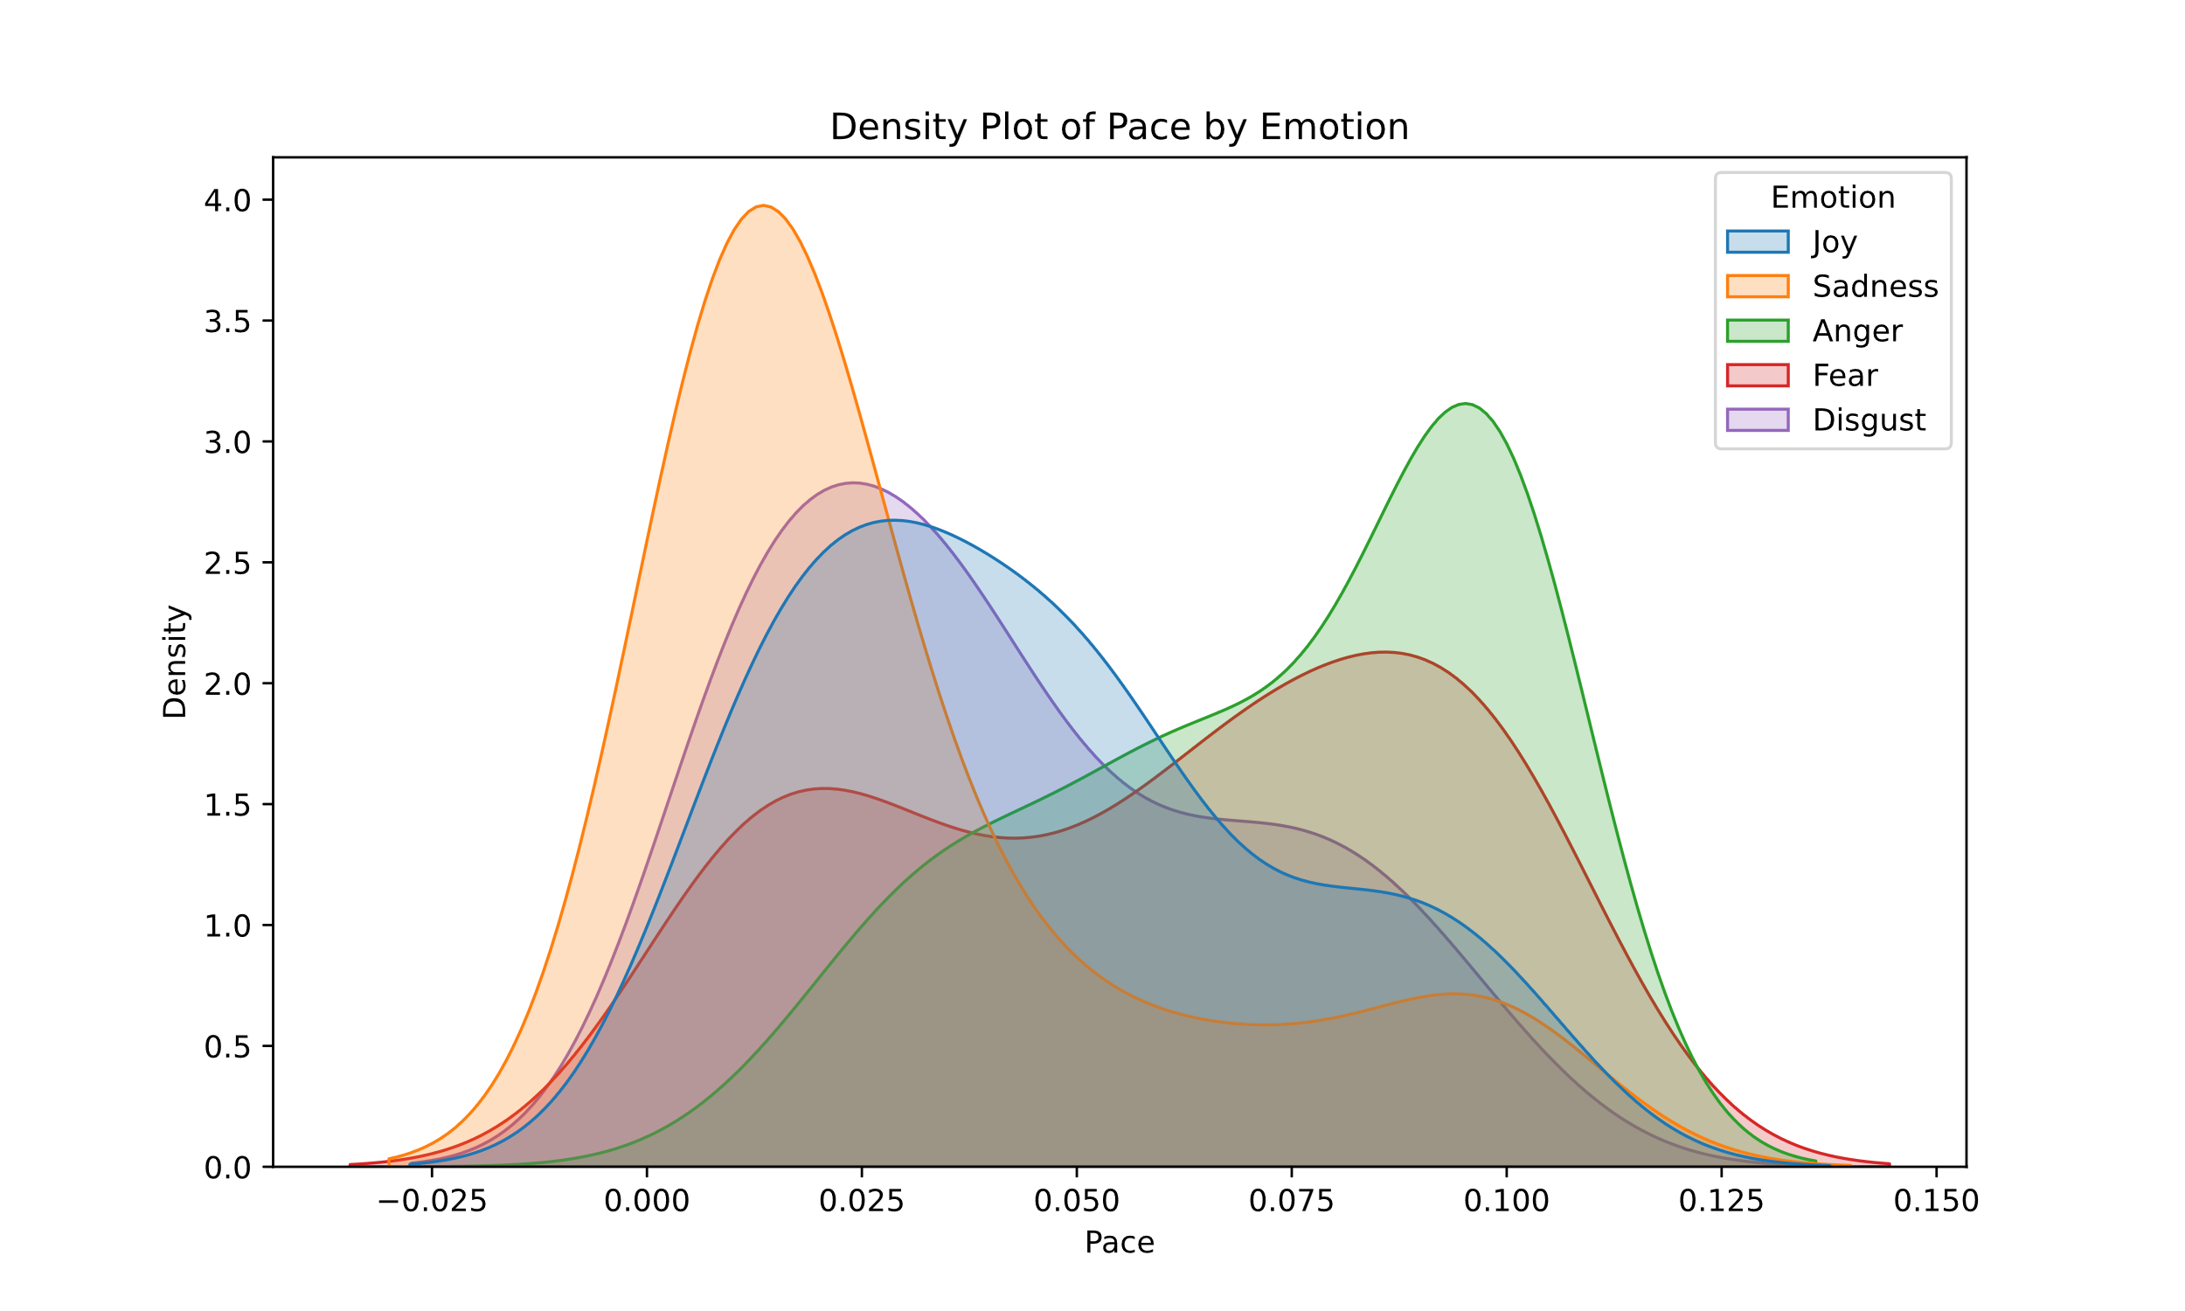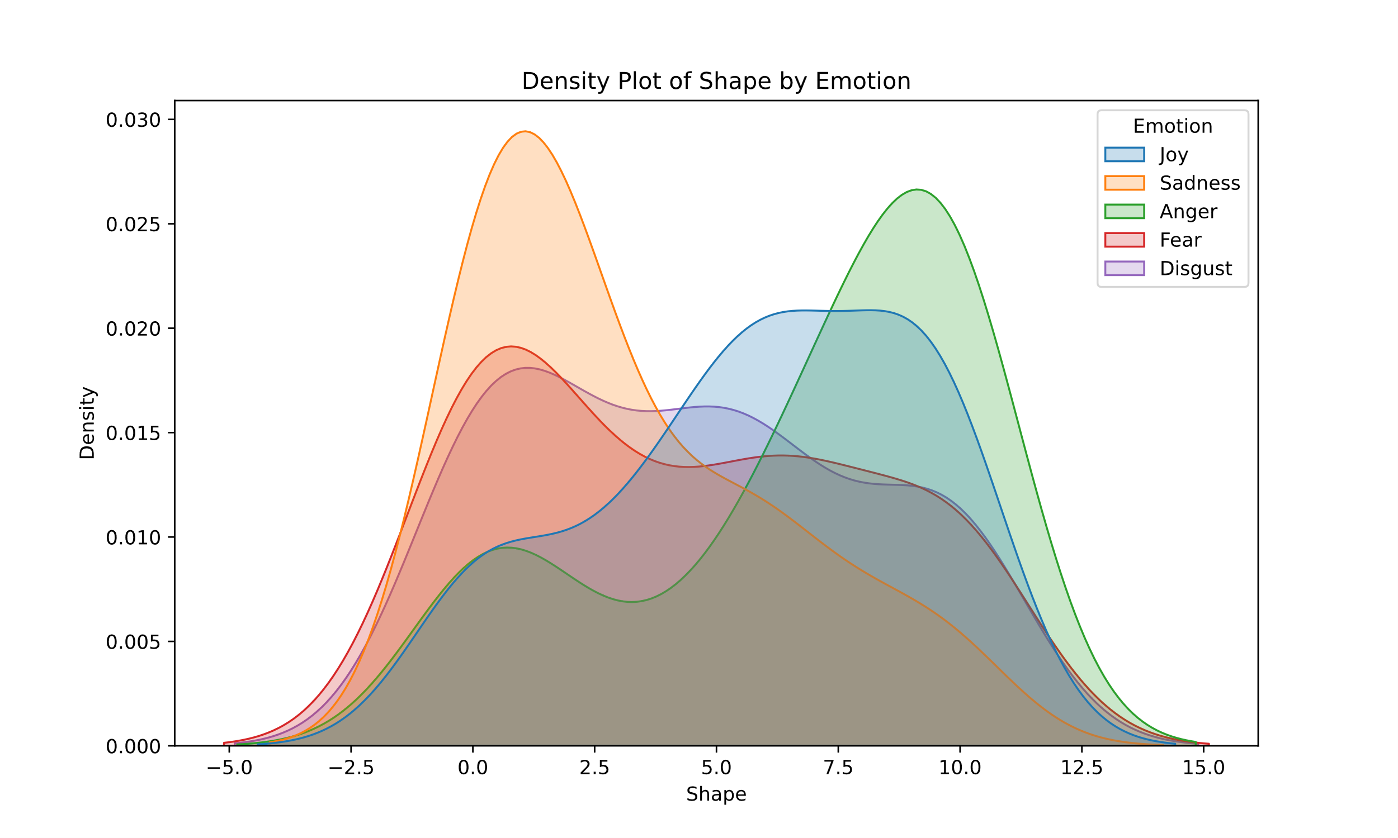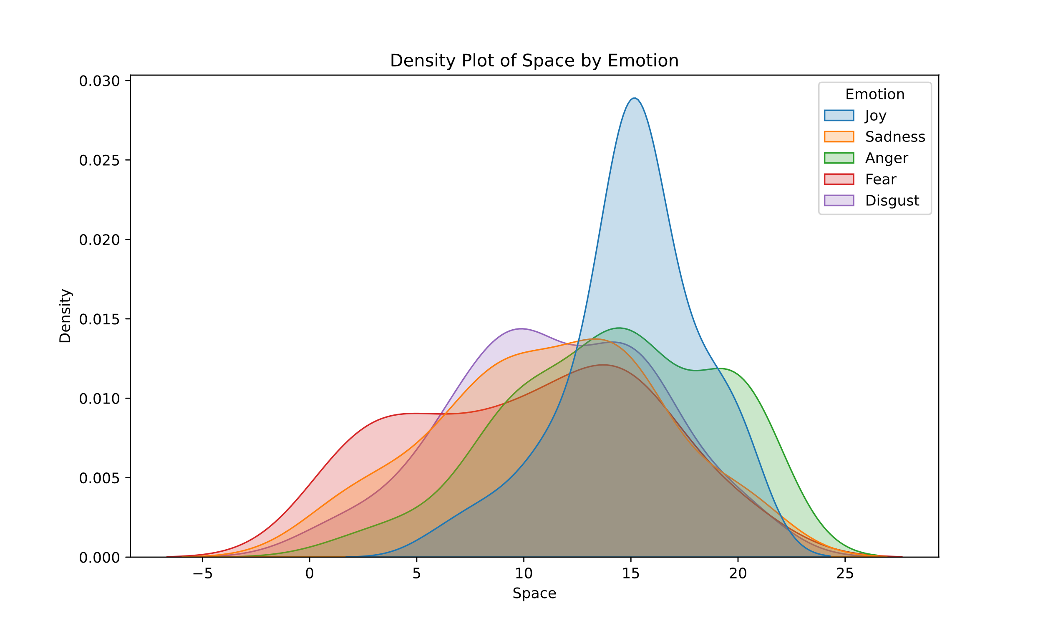 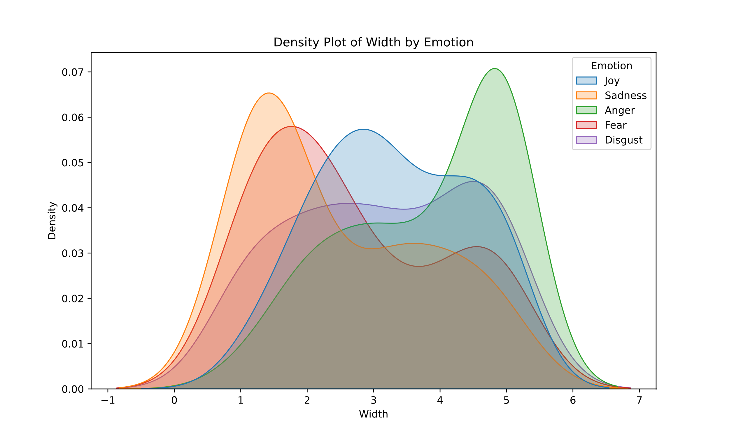

Figure 3. Scatter Plots

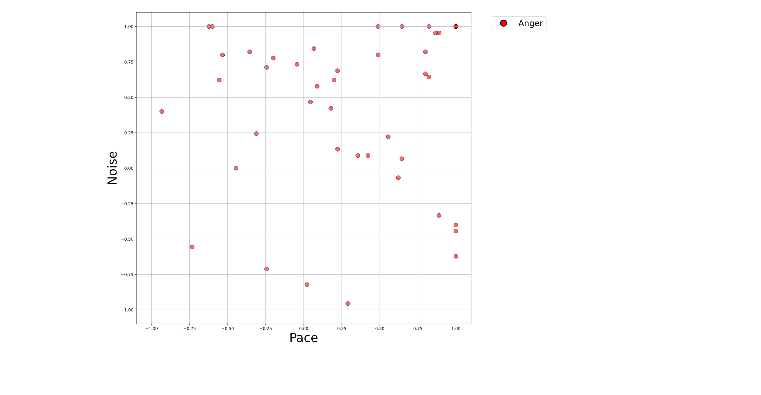 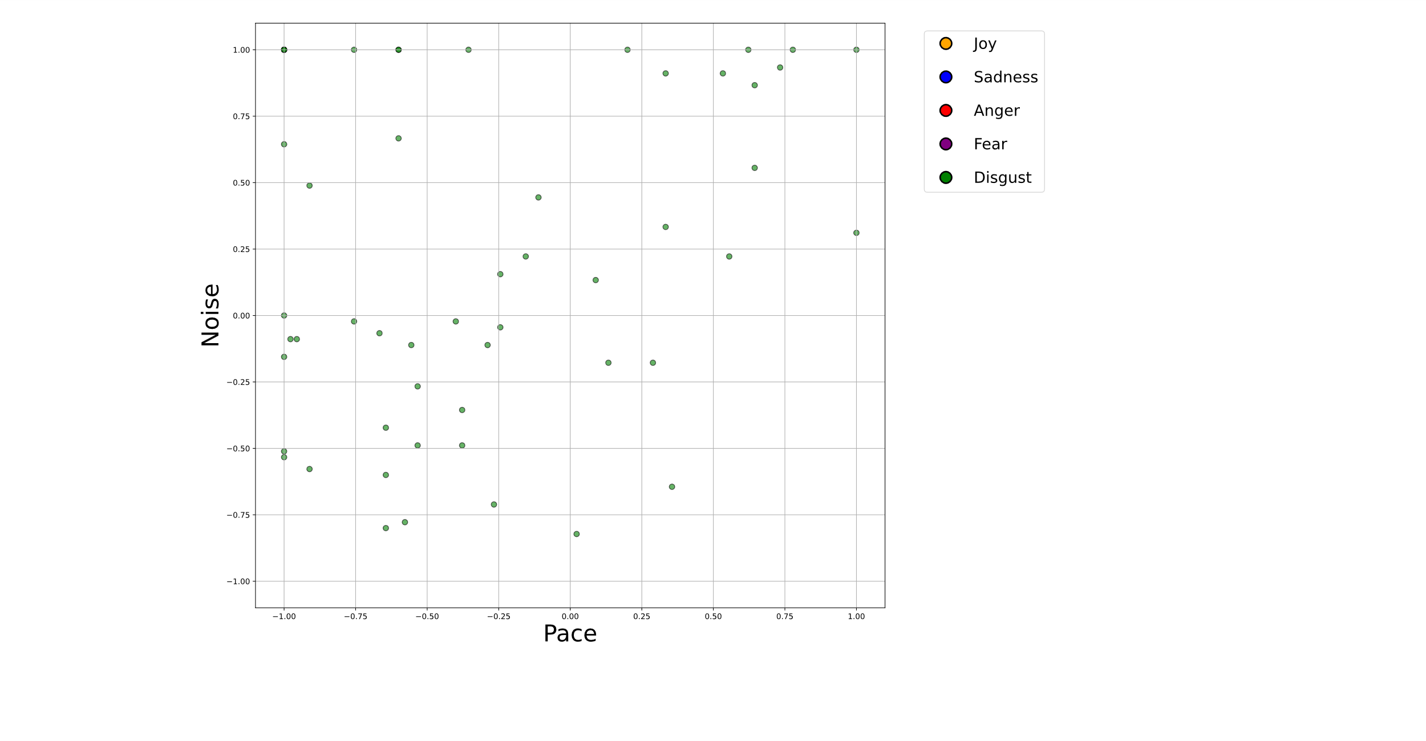 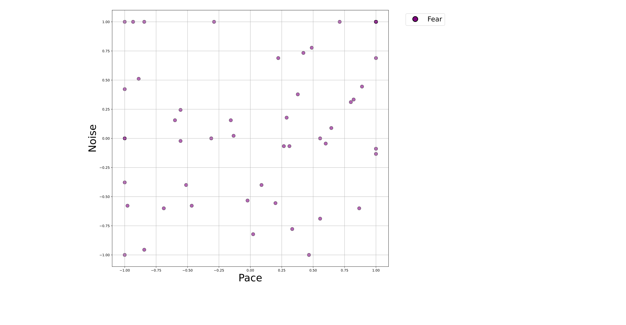 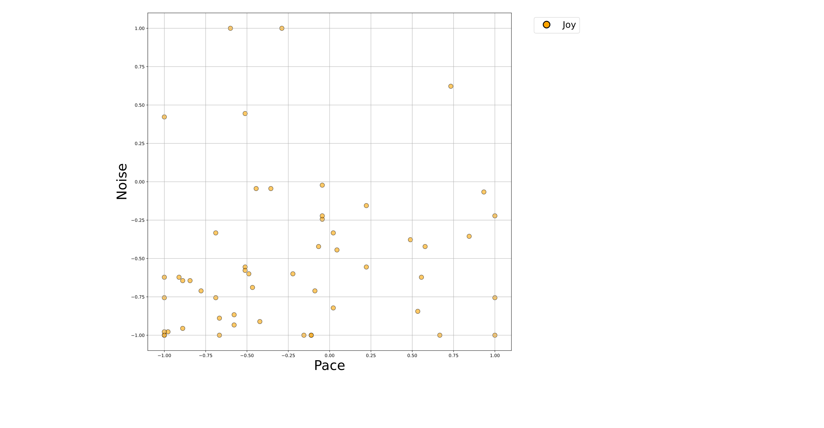 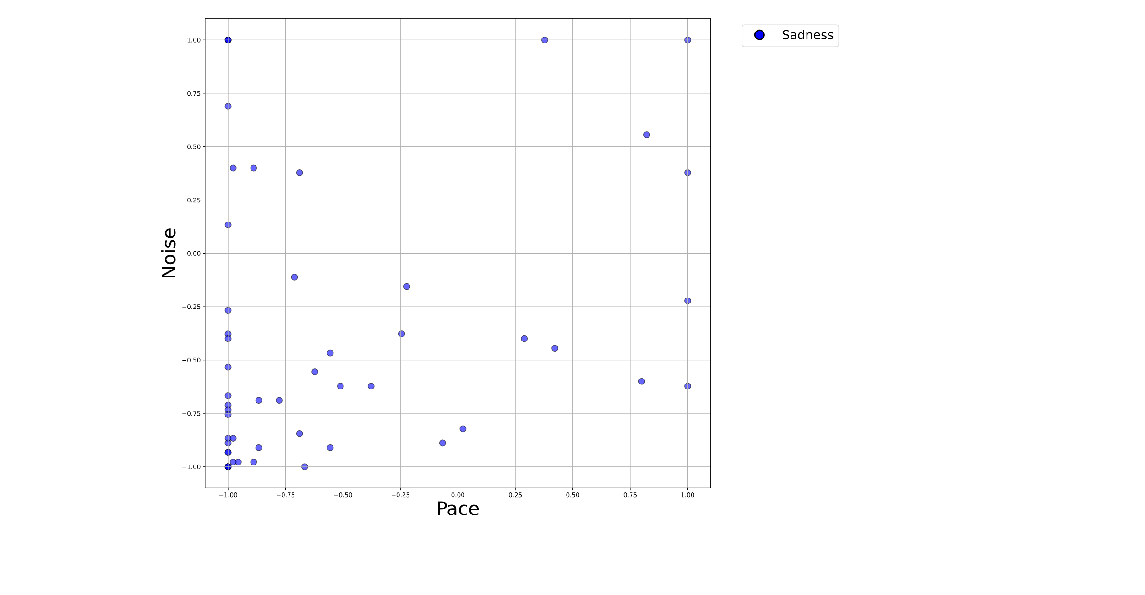 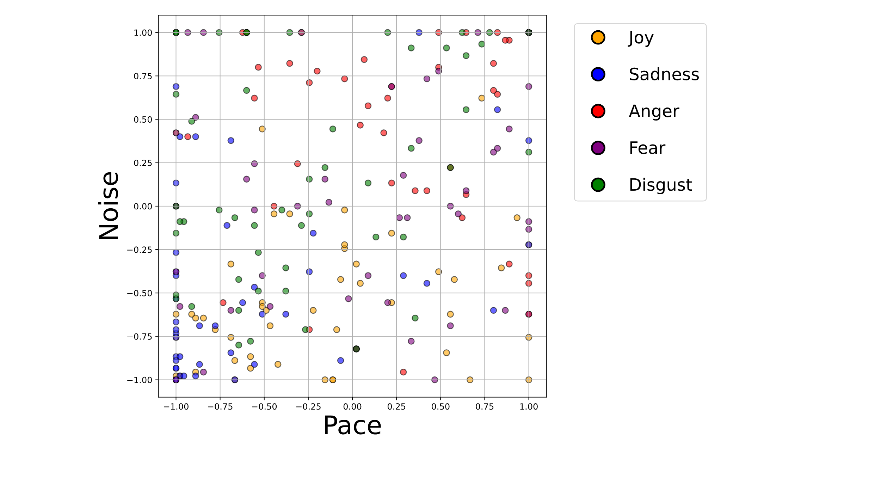

Figure 4. Voronoi Region

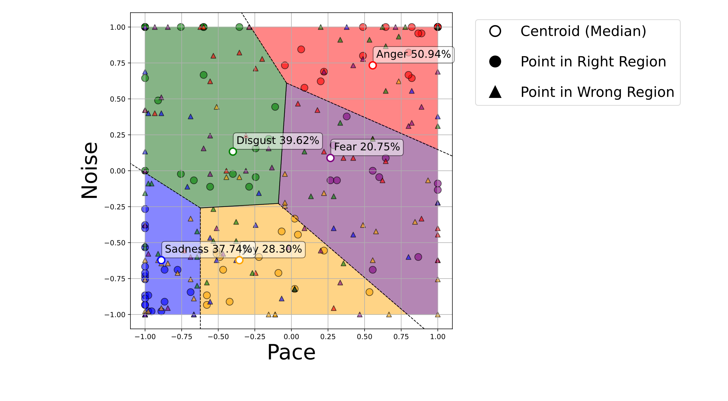

|  |  |  |  |
| --- | --- | --- | --- |
| Table 1: ANOVA Test Results | | | |
| PID | Parameter | F-Value | p-value |
| 0 | Shape | 8.991 | 8.147e-07 |
| 1 | Noise | 17.774 | 6.512e-13 |
| 2 | Pace | 26.512 | 4.690e-19 |
| 3 | Width | 8.766 | 1.184e-06 |
| 4 | Space | 9.821 | 2.055e-07 |

|  |  |  |  |  |  |  |
| --- | --- | --- | --- | --- | --- | --- |
| Table 2: Multinomial Logistic Regression Results | | | | | | |
| ID | Emotion | Pace | Noise | Precision | Recall | F-1 |
| 0 | Anger | 1.67 | 2.49 | 1.00 | 1.00 | 1.00 |
| 1 | Disgust | -1.61 | 1.70 | 0.71 | 0.71 | 0.71 |
| 2 | Fear | 2.05 | -0.47 | 1.00 | 0.60 | 0.75 |
| 3 | Joy | 0.40 | -2.04 | 0.86 | 0.75 | 0.80 |
| 4 | Sadness | -2.52 | -1.67 | 0.67 | 0.89 | 0.76 |
| Overall Accuracy | | | | | | 0.82 |

|  |  |  |  |
| --- | --- | --- | --- |
| Table 3: Parameter Encoding | | | |
| Pace | P- | P0 | P+ |
| Arousal | A- | A0 | A+ |
|  |  |  |  |
| Noise | N- | N0 | N+ |
| Valence | V+ | V0 | V- |

|  |  |  |  |  |  |  |  |
| --- | --- | --- | --- | --- | --- | --- | --- |
| Table 4: Emotion Encoding | | | | | | | |
| ID | Emotion | Pace | | Noise | | Arousal | Valence |
| 0 | Anger | 1.67 | + | 2.49 | + | + |  |
| 1 | Disgust | -1.61 |  | 1.70 | + |  |  |
| 2 | Fear | 2.05 | + | -0.47 | 0 | + | 0 |
| 3 | Joy | 0.40 | 0 | -2.04 |  | 0 | + |
| 4 | Sadness | -2.52 |  | -1.67 |  |  | + |