## Pull Request Process

Contents

Pull Request Process 1

1. Foodrunner Repository 1

2. Create Personal Branch 1

3. Pull Request 1

4. References 3

# Foodrunner Repository

All source codes are here: <https://git.foodrunner.io/dashboard/>

# Create Personal Branch

Create a personal branch for changes to foodrunner project.

origin/personal/[user_name]/[original_branch]_[task_id]

# Pull Request

Example for this project

<https://git.foodrunner.io/foodrunner/accounts>

<https://git.foodrunner.io/foodrunner/accounts/merge_requests>

Click “Merge Requests” link then click “New Merge Request” button

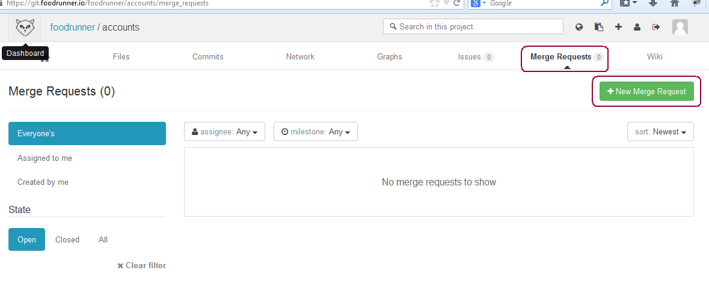

Select the parent branch you want to merge. In this case, this is “master”.  
Select your branch which you want to merge to parent branch. In this case this is “personal/nick/master_01”

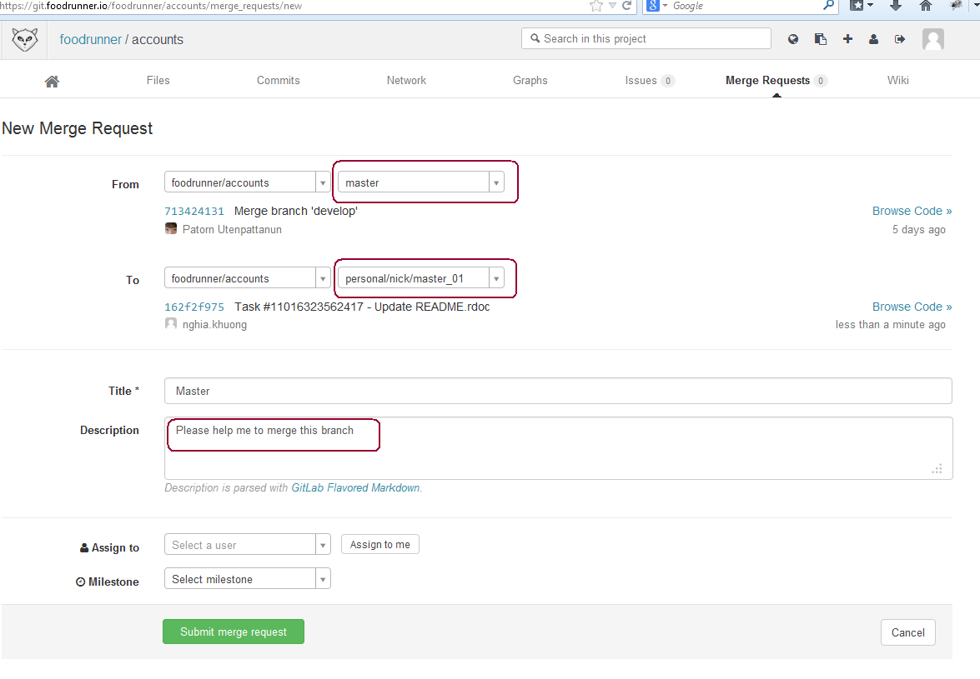

# References

<https://help.github.com/articles/using-pull-requests>