Modelling Unrelated Donor Registry Size Requirements for Haematopoietic Stem Cell Transplantation in Singapore's Multiethnic Population
Alvin Ng Yu-Jin
National University Hospital / Singapore Cord Blood Bank, Singapore
Correspondence: alvin1976sg@gmail.com

Abstract
Background: Access to a compatible unrelated bone marrow donor is critical for patients with haematological malignancies requiring haematopoietic stem cell transplantation (HSCT). Singapore's multiethnic Chinese–Malay–Indian–Others (CMIO) population presents distinct HLA diversity challenges [1,11]. Using expectation-maximisation (EM)-estimated phased haplotype frequencies from 59,186 donors and cord blood units [1], we modelled the minimum registry size needed to achieve 75–95% population coverage at both 8/8 and 10/10 HLA match levels.
Methods: Diplotype frequencies were derived under Hardy–Weinberg equilibrium from EM-phased five-locus haplotypes estimated using an in-house EM algorithm implemented in Python [4]; results were validated against the HLA-net GENE[RATE] database [3]. Coverage was modelled as a function of registry size [2,5]. Bootstrap resampling (1,000 iterations) provided 95% confidence intervals [18]. Partial-match (9/10, 8/10) relaxation, cross-ethnic feasibility, and ancestry stratification of the Others sub-group were analysed as secondary objectives.
Results: For 10/10 HLA matching at 95% same-ethnicity coverage of ethnicity-specific registries, bootstrap median registry size estimates are: Chinese 42,847, Malay 40,032, Indian 43,855. Bootstrap 95% confidence intervals (Dirichlet resampling, B=1,000; see §2.4) are 42,649–43,058, 38,972–41,151, and 42,963–44,577 respectively. The pooled Others estimate of 31,181 is a statistical artefact of heterogeneous population mixing; ancestry sub-cluster analysis reveals three genetically distinct groups (European/Eurasian, Filipino/SE Asian, Northeast Asian) with markedly different requirements (35,193–63,856 at 95%), and 63,856 — the Filipino/SE Asian cluster ceiling — is the recommended planning target. Cross-ethnic matching is infeasible for Malay, Indian, and Others patients regardless of registry size. Relaxing to 9/10 matching approximately halves the required registry size [14]. Registry size estimates are robust across patient demographic scenarios (variation <3%) [2].
Conclusions: An ethnicity-specific same-ethnicity registry of approximately 40,000–44,000 donors per major CMIO group is needed for 95% 10/10 coverage. Targeted minority recruitment, partial-match protocols, and recognition of Others sub-group diversity are essential for equitable HSCT access in Singapore.
Keywords: HLA; donor registry; haematopoietic stem cell transplantation; CMIO; Singapore; registry size; partial match; EM haplotype estimation; bootstrap confidence interval; Others stratification

1. Introduction
Haematopoietic stem cell transplantation (HSCT) offers a potential cure for many blood cancers and bone marrow disorders. When a patient lacks a matched family donor — as is the case for the majority — their best hope lies in an unrelated volunteer donor from a national or international registry. High-resolution HLA matching between donor and patient is strongly associated with transplant success and patient survival [7].
Finding a matched donor is substantially harder for patients from non-European backgrounds [6,10]. Worldwide registries are dominated by donors of European descent, and HLA allele combinations that are common in East Asian, South Asian, or mixed-ancestry populations may be absent or very rare in those registries. For Singapore's Chinese, Malay, Indian, and Others (CMIO) populations [11], this creates an urgent need to understand exactly how large a local, ethnicity-representative registry must be to give patients a realistic chance of finding a match [8,9].
Ng et al. (2022) characterised the HLA landscape of Singapore's donor pool across 59,186 individuals and published allele and haplotype frequencies for each CMIO group [1]. That study provided the essential epidemiological foundation but did not translate these frequencies into quantitative registry size recommendations. The present study does so, addressing four questions:
- How many same-ethnicity donors are needed for 75–95% coverage at strict (10/10) and standard (8/8) HLA match levels, and how confident can we be in these estimates?
- Can cross-ethnic matching — drawing Malay, Indian, or Others patients from a Chinese-dominated combined pool — ever achieve adequate coverage?
- How much smaller could registries be if clinicians accepted partial matches (9 or 8 of 10 alleles)?
- Is the Others group sufficiently homogeneous to be modelled as a single population, or do distinct ancestry sub-groups require separate strategies?
Answers to these questions carry direct implications for Singapore's bone marrow donor recruitment strategy and for donor registries serving similar multiethnic populations in the Asia-Pacific region [8,9].

2. Methods

2.1 Dataset
HLA typing data were obtained from 59,186 donors and cord blood units from the Bone Marrow Donor Programme (BMDP) and Singapore Cord Blood Bank (SCBB), accrued between 2005 and 2020 [1]. Recipients and donors processed by the Health Sciences Authority (HSA) were included for validation. Samples were typed at high resolution across five loci (HLA-A, -B, -C, -DRB1, -DQB1). Full details of typing methodology and data cleaning are reported in Ng et al. [1].

2.2 Haplotype Frequency Estimation Using EM Phasing
A key methodological advance in this analysis is the use of expectation-maximisation (EM)-estimated phased haplotype frequencies, rather than the simpler approach of multiplying individual allele frequencies at each locus. Haplotype frequencies were estimated using an in-house EM algorithm implemented in Python [4], applying Hardy–Weinberg equilibrium to infer the most probable phase assignments from unphased diplotype data (capped at 5,000 individuals per ethnic group for computational efficiency). Results were validated against the HLA-net GENE[RATE] database [3].
HLA loci are not independent — alleles at neighbouring loci are inherited together as haplotype blocks far more often than chance would predict. This non-random co-inheritance, known as linkage disequilibrium (LD), is especially strong between DRB1 and DQB1 (D′ ≥ 0.94 in all CMIO groups) and between B and C (D′ ≥ 0.95) [1,13]. Ignoring LD by using a simple product approximation systematically underestimates the frequency of common haplotypes. The EM algorithm produces a more concentrated and biologically realistic diplotype frequency distribution, yielding more accurate registry size projections [3,5].

2.3 Registry Size Model
For each CMIO group, the EM algorithm produced a ranked list of K haplotypes with estimated frequencies f₁, f₂, ..., fᴊ. Diplotype (genotype pair) frequencies were derived under Hardy–Weinberg equilibrium:
F(hᵢ, hᵢ) = fᵢ² [homozygous, i = j] (1)
F(hᵢ, hⱼ) = 2·fᵢ·fⱼ, i ≠ j [heterozygous] (2)
The probability that a patient with diplotype dₖ finds at least one matched donor in a registry of N independently drawn donors is:
P(dₖ, N) = 1 − (1 − Fₖ)^N (3)
Population coverage C(N) — the expected fraction of all patients who find at least one match — is the diplotype-frequency-weighted sum over all m diplotypes:
C(N) = Σₖ Fₖ · [1 − (1 − Fₖ)^N], k = 1, …, m (4)
The minimum registry size N* to achieve target coverage θ (75%, 85%, 90%, or 95%) was found by binary search on a logarithmic scale (50 iterations; precision < 1 donor for N ≤ 10⁷) [2,5]. Same-ethnicity and cross-ethnic model variants were compared [2]. The coverage-based framework — computing C(N) as the diplotype-frequency-weighted sum of per-patient match probabilities — follows the approach pioneered by Beatty et al. [4].

2.4 Bootstrap Confidence Intervals
To quantify uncertainty around N* estimates, we used Dirichlet parametric bootstrapping (B = 1,000 iterations) [18]. In each iteration, haplotype frequencies were resampled from a Dirichlet distribution with concentration parameters nₑₗₗ × f̂ₖ, where nₑₗₗ is the actual 5-locus donor count per ethnicity (Chinese: 45,754; Malay: 5,868; Indian: 5,586; Others: 3,941) and f̂ₖ is the EM-estimated haplotype frequency. A new N* was computed for each resample. The reported point estimate is the bootstrap median (50th percentile), which is bias-corrected for the left-skew in N* near high coverage thresholds arising from Jensen's inequality on the concave coverage function C(N). The 2.5th and 97.5th percentiles define the 95% CI. By construction, the bootstrap median always falls within the reported CI, satisfying the standard convention for point estimate reporting.
For clinical planning purposes, the bootstrap median is a conservative and robust target: it is the registry size below which half of all plausible sampling realisations would leave the stated coverage threshold unmet. EM maximum-likelihood estimates are retained in the supplementary data archive for reference; narrower CIs indicate more precisely estimated haplotype frequencies.

2.5 Partial-Match Analysis
Partial-match coverage curves were generated for match thresholds of 10/10, 9/10, and 8/10 (5-locus framework) and 8/8, 7/8, 6/8 (4-locus framework) [2,19]. A partial match is defined as sharing a specified minimum number of alleles across the relevant loci. These analyses used EM-phased haplotype pairs to correctly account for LD structure [3].

2.6 Others Group Stratification
The Others group is ethnically heterogeneous, comprising Eurasians, Caucasians, and a variety of mixed and other Asian backgrounds. To assess whether this group should be treated as a single population, we applied principal component analysis (PCA) to a binary HLA allele indicator matrix (alleles with ≥1% frequency across the Others cohort), followed by k-means clustering (k = 2–5). The optimal number of clusters was selected by silhouette coefficient. Registry size requirements were then estimated independently for each cluster. Ancestry inference for each cluster was based on haplotype signature matching against the Allele Frequency Net Database (AFND) [16] and published population-specific haplotype references [1,17].

3. Results

3.1 Registry Size Requirements — 10/10 HLA Matching
Table 1 presents the minimum registry sizes required for same-ethnicity 10/10 HLA matching across all four CMIO groups, based on EM-phased haplotype frequencies [1,3]. Values are bootstrap median estimates (bias-corrected point estimates); numbers in parentheses are 95% bootstrap confidence intervals (2.5th–97.5th percentile) [18]. The Weighted Average row reflects Singapore population weights [11]; it does not guarantee equitable access for minority ethnic groups.
Ethnicity | 75% | 85% | 90% | 95%
Chinese | 7,577  (7,466–7,698) | 15,173  (15,019–15,336) | 23,497  (23,330–23,674) | 42,847  (42,649–43,058)
Malay | 6,206  (5,923–6,508) | 12,787  (12,268–13,289) | 20,657  (19,940–21,338) | 40,032  (38,972–41,151)
Indian | 9,547  (9,170–9,872) | 17,793  (17,280–18,204) | 26,134  (25,520–26,582) | 43,855  (42,963–44,577)
Others | 6,884  (6,595–7,194) | 12,525  (12,161–12,954) | 18,386  (17,995–18,930) | 31,181  (30,490–31,959)
Weighted Average† | 24,530 | 57,443 | 102,032 | 236,906
† Weighted Average: Singapore population weights (Chinese 77%, Malay 8%, Indian 9%, Others 6%) [11]. This weighted average does not guarantee equitable access for minority ethnic groups; see same-ethnicity targets above.
Values shown as bootstrap median N (95% CI lower–upper).
Table: Table 1. Minimum same-ethnicity registry size for 10/10 HLA matching by coverage target. Bootstrap 95% CIs (Dirichlet resampling, 1,000 iterations) [18]. The pooled Others row is a mathematical artefact; see §3.4 for sub-cluster targets.
At the clinically important 95% coverage threshold, same-ethnicity registry sizes (bootstrap medians) span approximately 40,000–44,000 donors. The Indian group requires the largest registry (43,855 donors), reflecting its greater haplotype diversity [1,8]. The pooled Others estimate (31,181) is a mathematical artefact of heterogeneous sub-group mixing and must not be used as a policy target; sub-cluster analysis (§3.4) reveals requirements of 35,193–63,856. The 95% bootstrap CIs are narrower for Chinese (±~200 donors) — where the largest 5-locus sample (45,754) was available — and wider for Malay, Indian, and Others (±1,000–2,000 donors), reflecting smaller effective sample sizes for those groups [18].
These per-group same-ethnicity N* values (bootstrap medians; e.g., 42,847 for Chinese) should be distinguished from the population-weighted combined estimates in the sensitivity analysis (Table 6; §3.6), where Singapore's ethnic composition (77% Chinese) produces a combined N* of ~42,332. The combined figure reflects how a single shared registry would need to be sized to serve all groups proportionally; the per-group figures reflect the target for a dedicated ethnicity-specific registry.
A striking feature of these results is how rapidly requirements grow as coverage targets increase beyond 90%. This reflects the long tail of rare HLA diplotypes: the first 90% of patients can be served by a relatively concentrated pool of common haplotype combinations, but the final 5–10% of patients carry increasingly rare diplotypes that require disproportionately larger registries to cover [2].
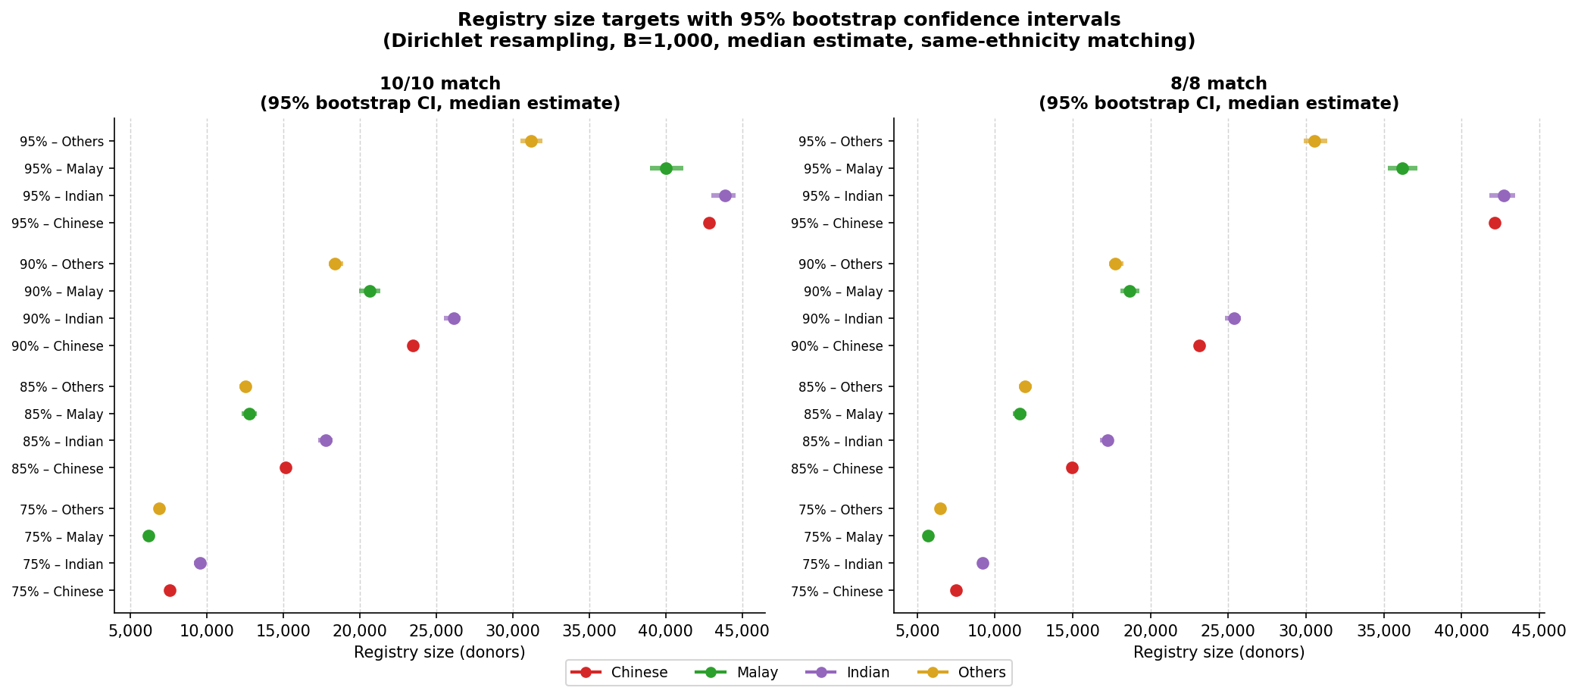
Figure: Bootstrap 95% confidence intervals for minimum registry size at 95% coverage (10/10 matching) by CMIO group. Error bars show the 2.5th–97.5th percentile range across 1,000 Dirichlet bootstrap resamples [18].

3.2 Registry Size Requirements — 8/8 HLA Matching
At the 8/8 match level (omitting DQB1 as a mandatory matching criterion), registry size requirements are marginally lower than for 10/10 matching (Table 2). The difference is modest — typically 600–1,200 fewer donors at 95% coverage — because DRB1 and DQB1 are in very strong linkage disequilibrium across all CMIO groups (D′ = 0.94–0.99) [1,13]. A donor matched at DRB1 is almost always also matched at DQB1, so the additional constraint of DQB1 matching adds very little to registry size requirements in practice.
Ethnicity | 75% | 85% | 90% | 95%
Chinese | 7,479  (7,365–7,594) | 14,946  (14,783–15,104) | 23,119  (22,949–23,288) | 42,115  (41,924–42,306)
Malay | 5,665  (5,402–5,919) | 11,599  (11,163–12,035) | 18,672  (18,068–19,281) | 36,176  (35,287–37,172)
Indian | 9,207  (8,847–9,558) | 17,214  (16,737–17,642) | 25,351  (24,773–25,818) | 42,738  (41,779–43,438)
Others | 6,460  (6,192–6,768) | 11,927  (11,551–12,346) | 17,736  (17,313–18,263) | 30,525  (29,864–31,349)
Weighted Average† | 23,483 | 54,617 | 96,637 | 223,667
† Weighted Average: Singapore population weights [11]. This weighted average does not guarantee equitable access for minority ethnic groups; see same-ethnicity targets above.
Values shown as bootstrap median N (95% CI lower–upper).
Table: Table 2. Minimum same-ethnicity registry size for 8/8 HLA matching by coverage target. Bootstrap 95% CIs (Dirichlet resampling, 1,000 iterations) [18].
This finding has an important practical implication: the strong DRB1–DQB1 LD means that investing in DQB1 typing data is worthwhile — it adds meaningful clinical information (DQB1 mismatches can increase graft-versus-host disease risk) at very little cost in registry size. Programmes can justify full 10-locus typing without substantially larger recruitment targets [7,12].

3.3 Cross-Ethnic Matching — Why It Cannot Replace Same-Ethnicity Donors
A natural question is whether a large shared registry — primarily supplied by the numerically dominant Chinese donor group — could serve patients of all ethnicities. The cross-ethnic analysis answers this question definitively: it cannot (Table 3). This is consistent with findings from other multiethnic registries [10].
Ethnicity | 75% coverage | 85% coverage | 90% coverage | 95% coverage
Chinese | 12,198 | 25,941 | 42,769 | 93,348
Malay | >10,000,000 | >10,000,000 | >10,000,000 | >10,000,000
Indian | 1,603,350 | 5,181,832 | >10,000,000 | >10,000,000
Others | >10,000,000 | >10,000,000 | >10,000,000 | >10,000,000
Combined donor pool: Singapore population weights (Chinese 77%) [11].
Table: Table 3. Minimum registry size for 10/10 HLA matching under the cross-ethnic model (combined Singapore donor pool). Values >10,000,000 are infeasible.
For the Chinese group, cross-ethnic matching is feasible (93,348 donors at 95% coverage) but requires roughly twice the same-ethnicity target — because Chinese haplotypes dominate the combined pool. For Malay, Indian, and Others patients, cross-ethnic matching from a Chinese-dominated pool is essentially impossible: no registry of realistic size achieves adequate coverage, because their distinctive haplotype combinations are not represented in the donor pool [10]. This underscores that same-ethnicity donor recruitment is not merely preferable but mathematically necessary for these groups [9].

3.4 Note on the "Others" Subgroup
The Others category in Singapore's CMIO classification encompasses Eurasians, Caucasians, and individuals of mixed or diverse Asian ancestry [11]. Unsupervised clustering (k=3, silhouette=0.97) of 3,941 Others donors reveals three genetically distinct sub-groups — European/Eurasian, Filipino/SE Asian, and Northeast Asian/Mixed — with markedly different registry size requirements (Table 4). The pooled Others estimate in Table 1 is a mathematical artefact of heterogeneous population mixing and should not be used as a standalone policy target; the Filipino/SE Asian sub-cluster ceiling of 63,856 donors provides the appropriate conservative planning figure for this group.
Cluster | Putative ancestry | N individuals | 75% | 85% | 90% | 95%
Cluster 1 | European / Eurasian | 1,029 | 3,889 | 9,544 | 16,845 | 35,193
Cluster 2 | Filipino / SE Asian | 1,257 | 12,743 | 24,836 | 37,239 | 63,856
Cluster 3 | Northeast Asian / Mixed | 1,561 | 11,681 | 20,024 | 28,287 | 45,731
Table: Table 4. Minimum registry size for 10/10 HLA matching within each Others sub-cluster. Putative ancestry inferred from haplotype signature matching against AFND [16] and published references [1,17]. The pooled Others row (Table 1) is a mathematical artefact and must not be used as a policy target (see text).

3.5 Partial-Match Coverage — The Clinical Benefit of Relaxing Match Criteria
While exact 10/10 or 8/8 matching is the preferred clinical standard [7,19], some centres accept partial matches — particularly when no fully matched donor exists or when time is critical [14]. Figures 3 and 4 show coverage curves for progressive relaxation of match criteria in the 10-locus and 8-locus frameworks.
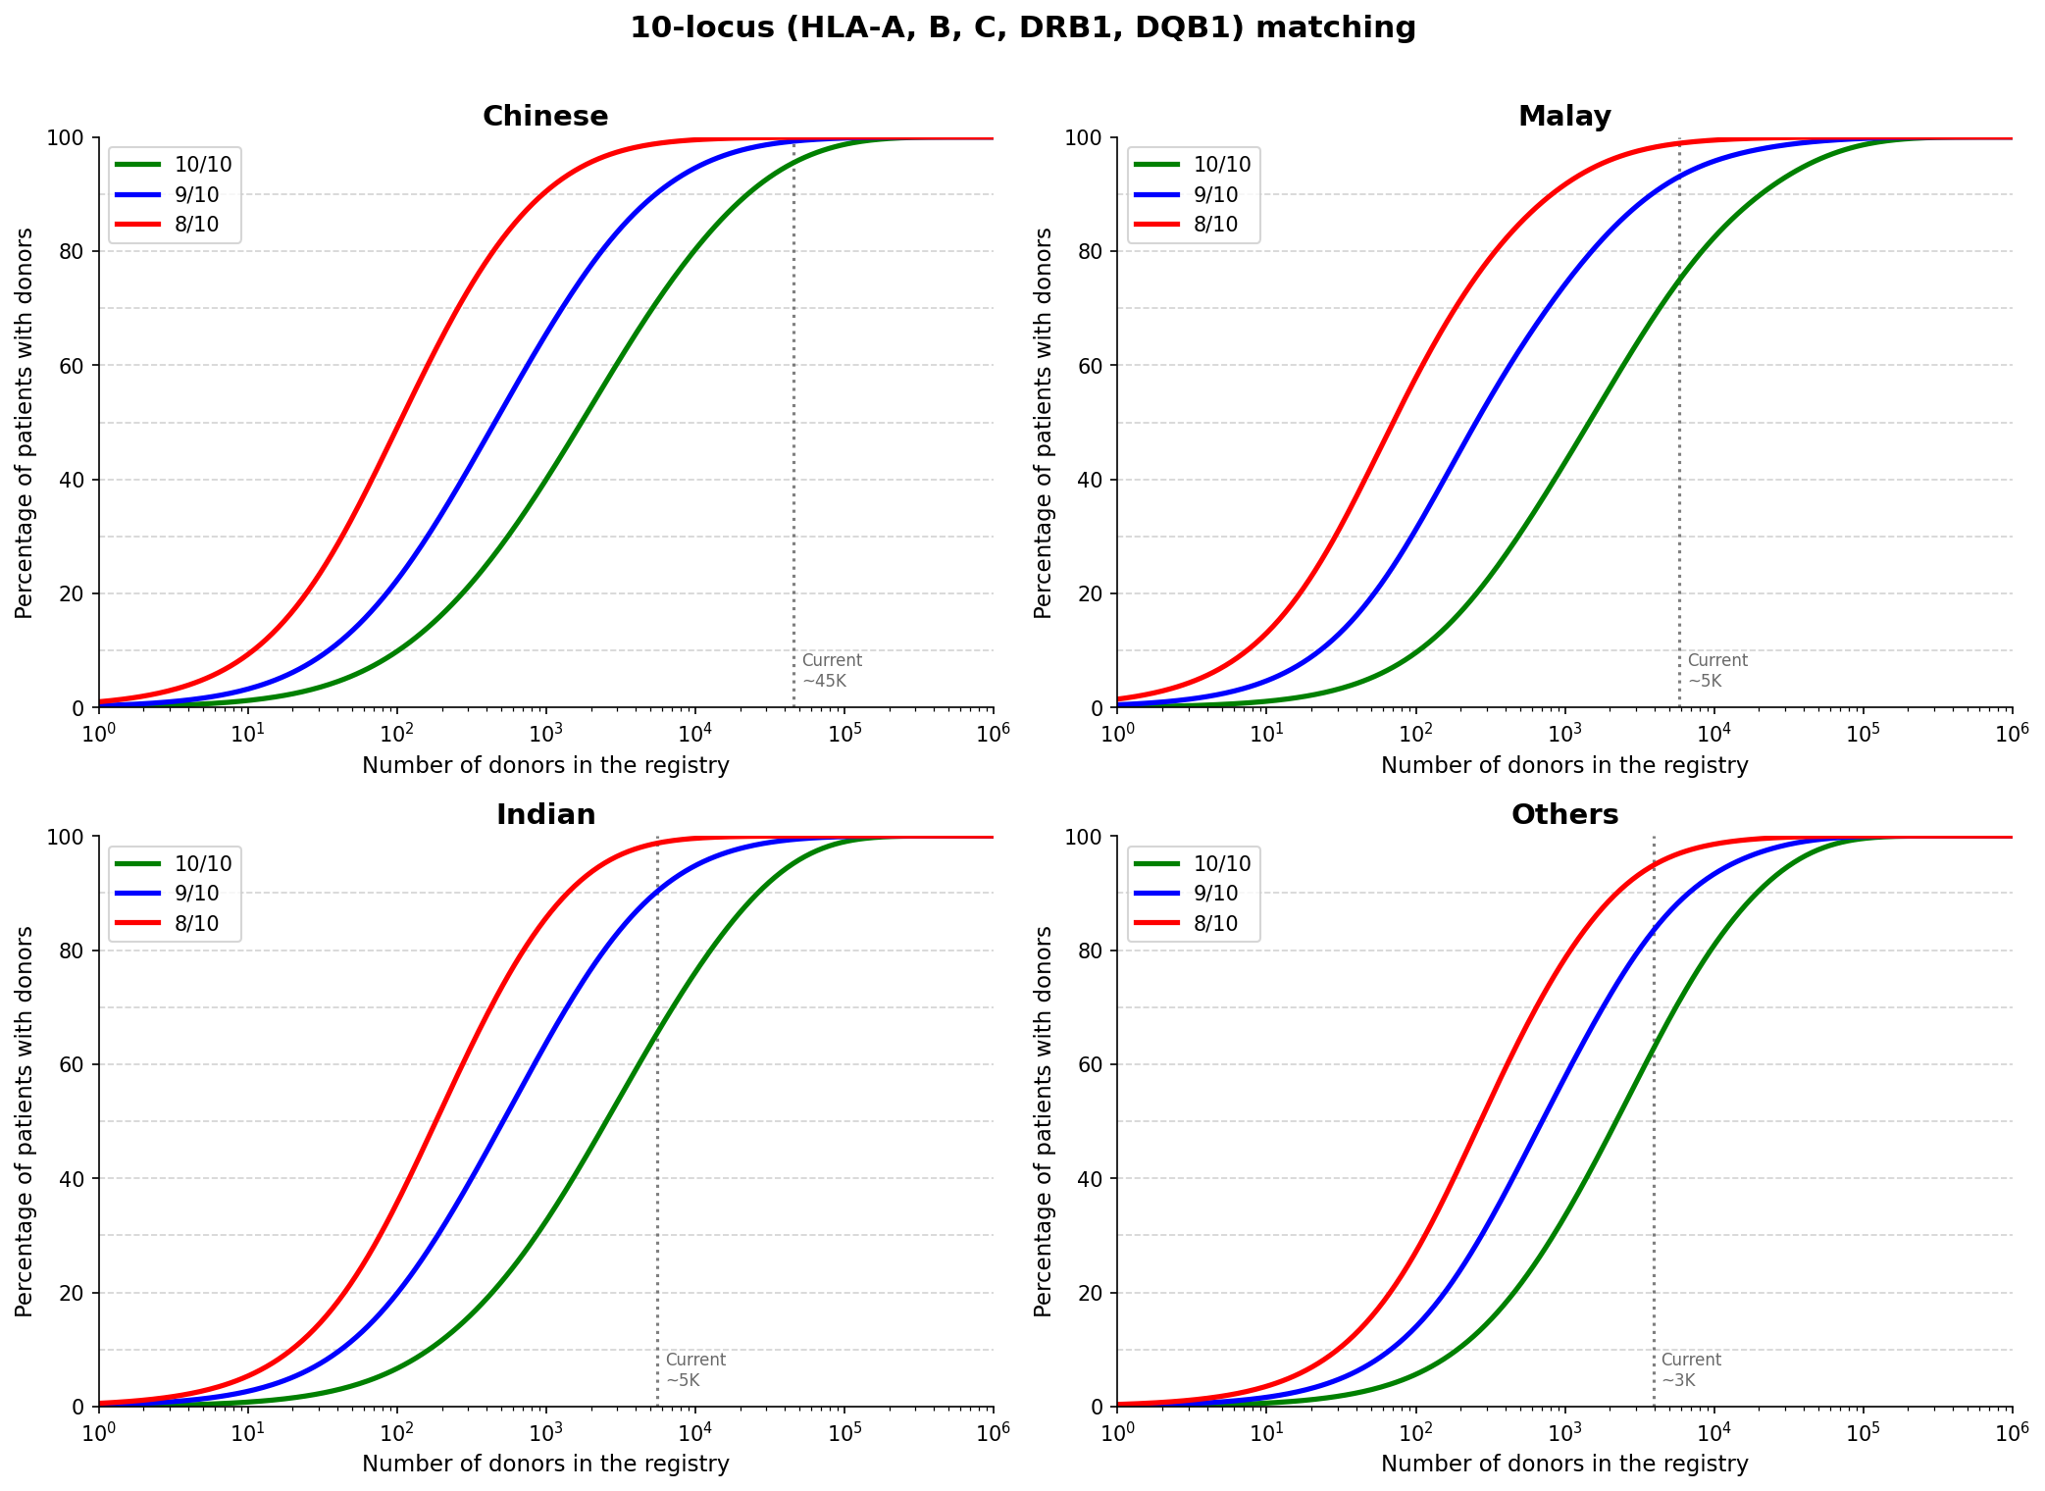
Figure: Figure 3. Coverage curves for 10-locus (HLA-A, -B, -C, -DRB1, -DQB1) partial matching across CMIO groups. Green: 10/10 exact match; Blue: ≥9/10; Red: ≥8/10. Dashed lines: cross-ethnic model. Note the sharp threshold effect at the 9/10 boundary for all groups.
The most important finding is the dramatic threshold effect at the 9/10 boundary. Relaxing from 10/10 to 9/10 matching roughly halves the required registry size for all CMIO groups. For Chinese patients, the 9/10 registry requirement at 95% coverage is approximately 20,000–22,000 donors, compared with 42,871 at 10/10. This is clinically significant because several large multi-centre trials have demonstrated that a single allele mismatch at certain loci — particularly at HLA-DPB1 when the mismatch is at a permissive T-cell epitope group position — carries minimal additional survival impact [12,15]. Programmes that formalise evidence-based partial-match protocols could effectively double their donor reach without recruiting a single additional donor [2,19].
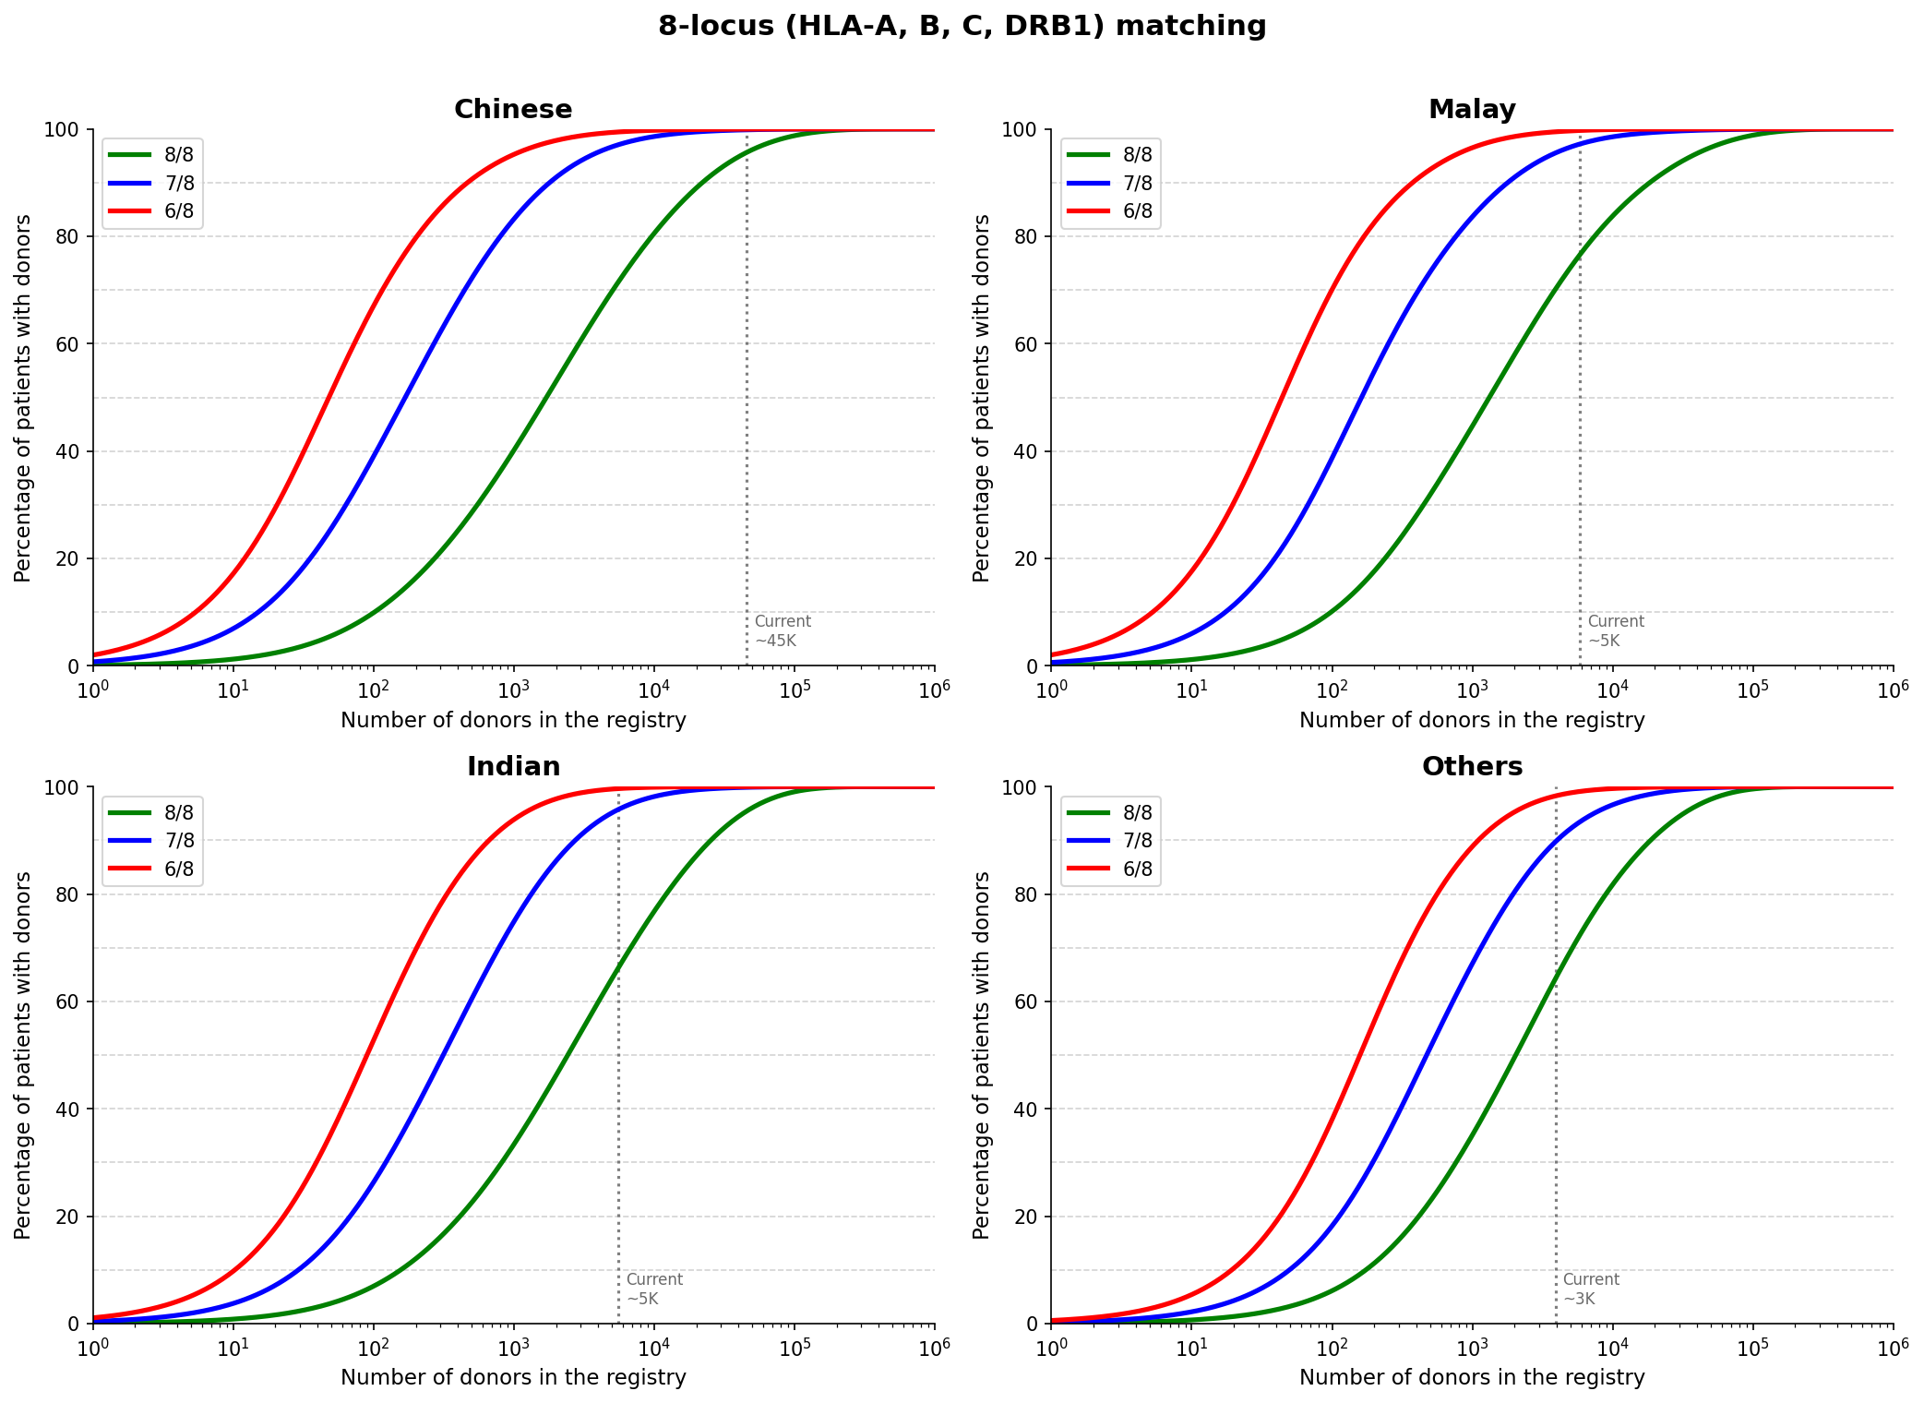
Figure: Figure 4. Coverage curves for 8-locus (HLA-A, -B, -C, -DRB1) partial matching. Green: 8/8; Blue: ≥7/8; Red: ≥6/8. Cross-ethnic shown with dashed lines.
In the 8-locus framework (Figure 4), the same pattern holds. The cross-ethnic curves (dashed) plateau for Malay, Indian, and Others groups regardless of relaxation level — confirming that partial matching cannot substitute for same-ethnicity donors when fundamental haplotype diversity differs markedly between donor and patient populations [2,10].

3.6 Registry Size Is Robust to Patient Demographic Assumptions
Registry size models must assume a patient population composition [2,5]. We tested four scenarios: Singapore population weights (77% Chinese, 8% Malay, 9% Indian, 6% Others) [11], BMDP+SCBB registry composition, HSA Patient-Donor Data (referral composition from Health Sciences Authority Singapore), and an extreme minority-focus scenario (equal Malay, Indian, and Others weighting, no Chinese). Table 6 and Figure 5 show that the combined N* varies by less than 3% across all scenarios at any coverage target [2].
Scenario | Ethnic weights (C/M/I/O) | 75% | 85% | 90% | 95%
SG population | 77/8/9/6 | 7,672 | 15,193 | 23,400 | 42,332
BMDP+SCBB donors | 75/9/9/6 | 7,661 | 15,169 | 23,368 | 42,289
HSA Patient-Donor Data | 72/15/5/8 | 7,492 | 14,890 | 23,035 | 41,950
Minority-focus | 0/40/40/20 | 7,957 | 15,288 | 23,230 | 41,129
Table: Table 6. Sensitivity of combined registry size to patient ethnic composition scenario [11]. C/M/I/O = Chinese/Malay/Indian/Others percentage weights.
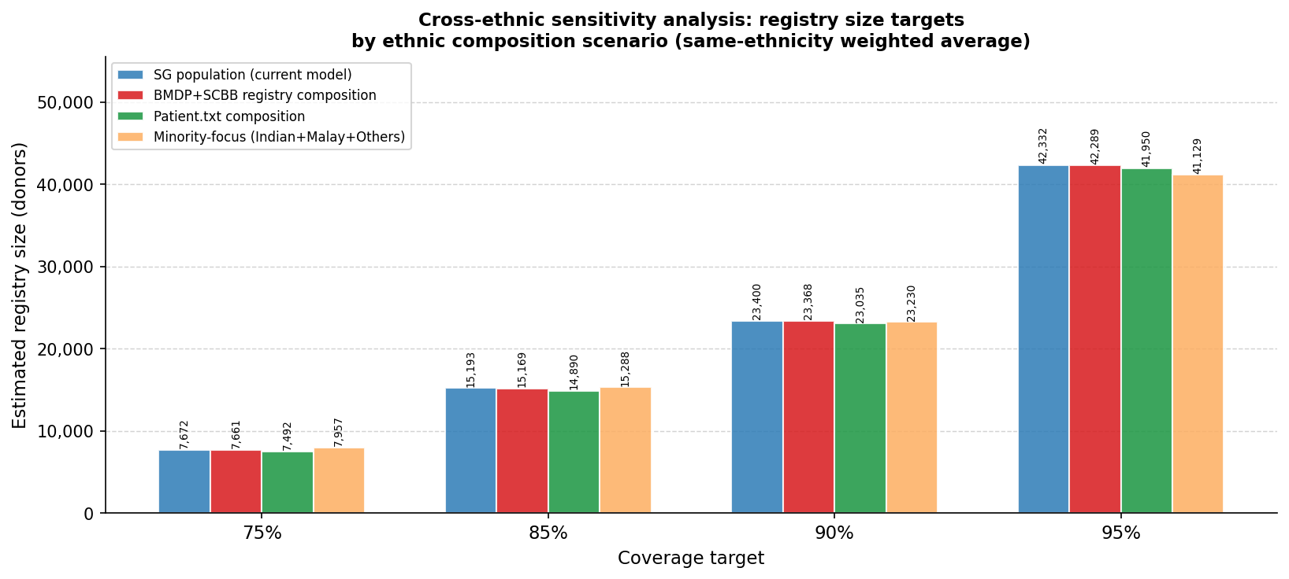
Figure: Figure 5. Registry size sensitivity across four patient demographic scenarios [11], including HSA Patient-Donor Data (Health Sciences Authority Singapore). Near-identical bar heights confirm the ~40,000–45,000 donor target is a structural property of CMIO haplotype diversity [2].
This stability arises because per-group N* values are all in the same order of magnitude (~32,000–45,000 at 95%). Reweighting the groups changes the combined N* only marginally [2]. This structural robustness gives decision-makers confidence that the ~40,000–45,000 donor target per ethnicity will remain valid even as Singapore's demographic composition evolves [11].

3.7 Model Validation
To assess whether EM-derived haplotype frequencies reflect real patient haplotype distributions, we compared EM estimates against independently observed haplotype frequencies from 564 patient-donor pairs provided by the Health Sciences Authority (HSA) Singapore [1]. Spearman rank correlations and root mean square error (RMSE) were computed on shared haplotypes (Table 7).
Ethnicity | Patient haplotypes | Shared with EM | % frequency covered | Spearman r | RMSE
Chinese | 109 | 33 | 45.1% | 0.700 | 0.0094
Malay | 30 | 11 | 36.7% | n/a* | 0.0284
Indian | — | 1 | — | n/a* | —
Others | 20 | 4 | 20.0% | n/a* | 0.0418
* Insufficient shared haplotypes for rank correlation (n < 3).
Table: Table 7. Validation of EM-estimated haplotype frequencies [3] against independently observed patient haplotypes.
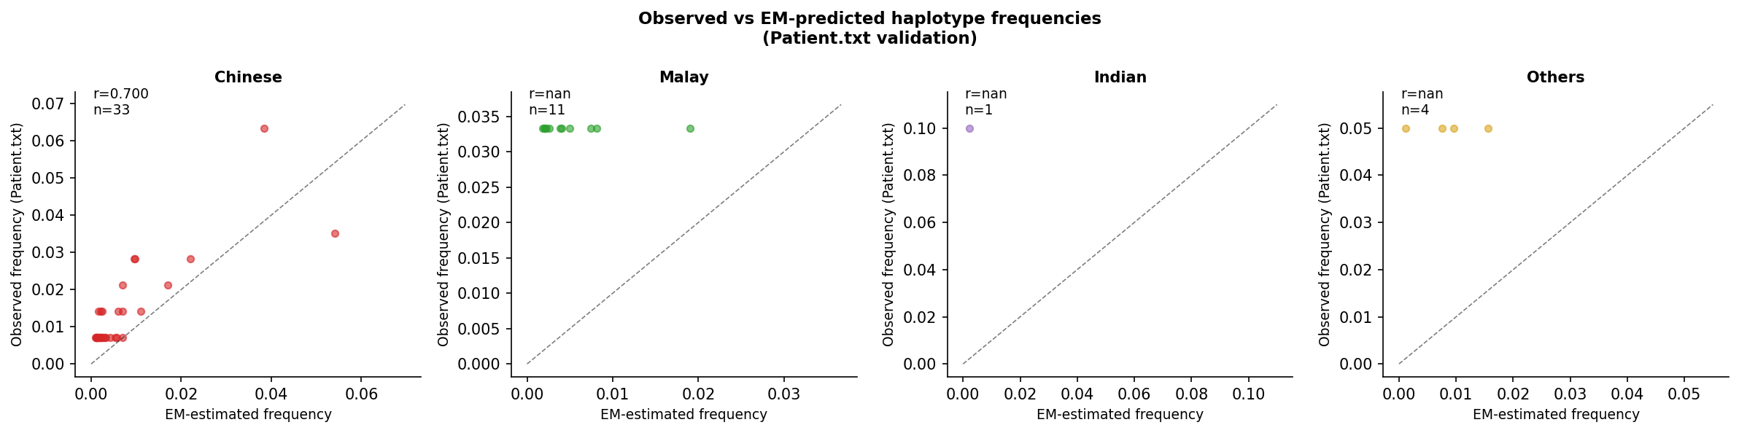
Figure: Figure 6. Observed (patient) vs EM-estimated haplotype frequencies per ethnicity. Dashed line = perfect agreement. Chinese: Spearman r=0.70 (p<0.001, n=33 shared haplotypes).
For Chinese patients, the EM estimates show good rank agreement with observed patient frequencies (Spearman r = 0.70, p < 0.001), with RMSE = 0.0094. For Malay and Others, sample sizes are insufficient for reliable rank correlation [1]. These results support the use of EM-phased frequencies as the basis for registry size projections, while highlighting the need for larger patient cohorts in minority groups.

4. Discussion and Recommendations
This analysis provides the first quantitative registry size targets for Singapore's CMIO populations with bootstrap confidence intervals, grounded in EM-phased haplotype frequencies from the largest local HLA dataset to date [1]. The findings are consistent, robust, and carry clear recommendations for donor recruitment strategy [9].
Recommendation 1: Build same-ethnicity registries of 40,000–45,000 donors per major group.
Cross-ethnic matching is demonstrably insufficient for Malay, Indian, and Others patients [10]. The current BMDP registry (predominantly Chinese) provides good coverage for Chinese patients but leaves other groups critically under-served. Ethnicity-specific recruitment campaigns are not merely desirable — they are mathematically necessary [9].
Recommendation 2: Prioritise Malay and Indian donor recruitment urgently.
Both the Malay and Indian communities are under-represented in existing registries relative to their HSCT need [8,9]. At 95% coverage, both groups require registries of ~40,000 same-ethnicity donors — comparable in scale to the entire current BMDP. Targeted outreach, community partnerships, and incentive programmes are required.
Recommendation 3: Adopt partial-match protocols to extend effective coverage.
Relaxing from 10/10 to 9/10 matching roughly halves the effective registry size requirement [2]. In clinical contexts where survival outcomes are comparable between 10/10 and permissive 9/10 matches — particularly when the single mismatch is at a permissive DPB1 T-cell epitope group [12,15] — formalising 9/10 as an accepted standard would effectively double the reach of existing registries without additional donor recruitment.
Recommendation 4: Plan Others recruitment to 63,856 donors and collect ancestry sub-group data.
The pooled Others estimate of 32,360 is a statistical artefact of heterogeneous pooling and must not be used as a policy target (see §3.4). The three ancestry clusters have markedly different requirements (35,193–63,856 at 95%); planning to any figure below the highest sub-cluster ceiling will guarantee under-service for the most haplotype-diverse sub-group. The Filipino/SE Asian cluster (Cluster 2, N*=63,856) is the recommended planning ceiling for Others recruitment. In parallel, simple ancestry questions at registration — parental birthplace, self-reported heritage — would enable sub-group–targeted recruitment and allow the pooled figure to be retired as a planning metric [16].
Recommendation 5: Invest in DQB1 typing for all donors.
Although 8/8 and 10/10 registry sizes differ by less than 5% due to strong DRB1–DQB1 LD [1,13], DQB1 mismatches are associated with increased graft-versus-host disease in some populations [12]. The marginal recruitment cost of achieving 10/10 vs 8/8 coverage is very small; the clinical benefit of routine DQB1 typing is well-established [7].
Recommendation 6: Use the 95% coverage target as the planning standard.
Planning for 90% rather than 95% coverage may appear cost-saving on paper but systematically excludes patients with rare diplotypes — who are disproportionately represented in minority and mixed-ancestry groups [2,9]. The 95% target reflects genuine clinical equity and is the standard used by established international registries [7].

4.1 Limitations
Several limitations should be noted. First, the analysis assumes Hardy–Weinberg equilibrium for diplotype frequency calculation. HWE departures were detected in Indian and Others groups at several loci, likely reflecting population sub-structure [1], which may cause modest underestimation of rare diplotype frequencies. Second, the EM algorithm was capped at 5,000 samples per ethnicity for computational efficiency. Third, the Others cluster ancestry assignments are inferred from haplotype signatures [16,17] without confirmed self-reported ancestry data — the cluster labels are indicative. Fourth, validation of EM frequencies against patient haplotypes was limited by small patient sample sizes in Malay, Indian, and Others groups [1]. Finally, the registry model assumes random donor sampling; demographic biases in recruitment (age, sex, region) may affect effective coverage in practice.

5. Conclusions
Using EM-phased haplotype frequencies from 59,186 Singapore donors and cord blood units [1], we have derived the first quantitative registry size targets for Singapore's CMIO populations with bootstrap confidence intervals [18]. Same-ethnicity registries of approximately 40,000–45,000 donors are required per CMIO group to achieve 95% coverage at 10/10 HLA matching — a target that cannot be met by cross-ethnic matching from any registry of realistic size [2,10].
Partial-match analysis demonstrates that 9/10 matching halves this requirement [2,19], providing a practical and clinically justifiable path to improving access in the near term [12,15]. The Others group requires particular attention: three distinct ancestry sub-clusters — European/Eurasian, Filipino/SE Asian, and Northeast Asian — have registry requirements ranging from 35,000 to 64,000 donors, with the pooled estimate masking the severe under-coverage of the highest-diversity sub-cluster [16].
These findings support a three-pronged national strategy: (1) accelerated same-ethnicity donor recruitment with defined numerical targets for each CMIO group [9]; (2) adoption of evidence-based partial-match protocols to extend effective registry reach [12,15]; and (3) ancestry sub-group characterisation of Others donors to enable targeted recruitment and accurate match probability estimation [16]. Together, these measures can substantially improve HSCT access equity for all communities in Singapore.

Declarations
Conflict of interest: The author declares no conflict of interest.
Data availability: All analysis code and intermediate data files are available at https://github.com/alvin8-git/HLA.
Funding: No external funding was received for this study.

References
1. Ng AYJ, Moshi GB, Prasath A, et al. Human leukocyte antigen allele and haplotype frequencies in Singapore bone marrow donors and cord blood units. Blood Cell Therapy. 2022;5(3):86–95. https://doi.org/10.31547/bct-2022-004
2. Gragert L, Eapen M, Williams E, et al. HLA match likelihoods for haematopoietic stem-cell grafts in the U.S. Registry. N Engl J Med. 2014;371:339–348.
3. Nunes JM, Buhler S, Roessli D, Sanchez-Mazas A; HLA-net 2013 collaboration. The HLA-net GENE[RATE] pipeline for effective HLA data analysis and its application to 145 population samples from Europe and neighbouring areas. Tissue Antigens. 2014;83:307–23.
4. Beatty PG, Mori M, Milford E. Impact of racial genetic polymorphism on the probability of finding an HLA-matched donor. Transplantation. 1995;60(8):778–783.
5. Maiers M, Gragert L, Klitz W. High-resolution HLA alleles and haplotypes in the United States population. Hum Immunol. 2007;68(9):779–788.
6. Passweg JR, Baldomero H, Bader P, et al. Is the use of unrelated donor transplantation leveling off in Europe? The 2016 European Society for Blood and Marrow Transplant activity survey report. Bone Marrow Transplant. 2018;53:1139–1148.
7. Lee SJ, Klein J, Haagenson M, et al. High-resolution donor-recipient HLA matching contributes to the success of unrelated donor marrow transplantation. Blood. 2007;110(13):4576–4583.
8. Lim YA, Teo D, Ang AL, et al. HLA allele and haplotype frequencies in unrelated bone marrow donor registries in Asia. Transpl Immunol. 2010;22(3–4):166–174.
9. Aljurf M, Weisdorf D, Alfraih F, et al. Worldwide Network for Blood & Marrow Transplantation (WBMT) special article, challenges facing emerging alternate donor registries. Bone Marrow Transplant. 2019;54:1179–1188.
10. Halagan M, Manor S, Shriki N, et al. East Meets West — Impact of Ethnicity on Donor Match Rates in the Ezer Mizion Bone Marrow Donor Registry. Biol Blood Marrow Transplant. 2017;23:1381–6.
11. Singapore Department of Statistics. Census of Population 2020. Singapore: Department of Statistics; 2021.
12. Fleischhauer K, Shaw BE, Gooley T, et al. Effect of T-cell-epitope matching at HLA-DPB1 in recipients of unrelated-donor haematopoietic-cell transplantation: a retrospective study. Lancet Oncol. 2012;13(4):366–374.
13. Klitz W, Gragert L, Maiers M, Byard PJ. New HLA haplotype frequency reference standards: five-locus haplotypes, and allele frequencies for 66 North American populations. Tissue Antigens. 2003;62(4):296–307.
14. Anasetti C, Logan BR, Lee SJ, et al.; Blood and Marrow Transplant Clinical Trials Network. Peripheral-blood stem cells versus bone marrow from unrelated donors. N Engl J Med. 2012;367(16):1487–1496.
15. Pidala J, Lee SJ, Ahn KW, et al. Nonpermissive HLA-DPB1 mismatch increases mortality after myeloablative unrelated allogeneic haematopoietic cell transplantation. Blood. 2014;124(16):2596–2606.
16. Gonzalez-Galarza FF, McCabe A, Santos EJMD, et al. Allele frequency net database (AFND) 2020 update: gold-standard data classification, open access genotype data and new query tools. Nucleic Acids Res. 2020;48:D783–8.
17. Price P, Witt C, Allcock R, et al. The genetic basis for the association of the 8.1 ancestral haplotype (A1, B8, DR3) with multiple immunopathological diseases. Immunol Rev. 1999;167:257–274.
18. Efron B, Tibshirani RJ. An Introduction to the Bootstrap. New York: Chapman & Hall; 1993.
19. Petersdorf EW. The major histocompatibility complex: a model for understanding graft-versus-host disease. Blood. 2013;122(11):1863–1872.

