AI機器人於思覺失調患者之應用服務開發建置案

異狀行為預測軟體原始碼及資料庫說明

使用說明

1. 從 google drive取得原始碼並初始化：

https://drive.google.com/drive/folders/1Uvxwet8Z-JRPP3fllr9H5h4Tp7oIU7qb?usp=sharing

* + 下載資料集：

https://caer-dataset.github.io/

1. 建立 Python 虛擬環境並安裝需要的套件：

|  |
| --- |
| $ conda create -n pywork python=3.6  $ source activate pywork  $ pip install -r requirements.txt |

1. 建立 dataset list與預先偵測人臉：

|  |
| --- |
| $ python3 build_train_list.py  $ python3 det_face.py |

1. 執行training code：

|  |
| --- |
| $ python3 train.py |

1. 執行inference code：

|  |
| --- |
| $ python3 inference.py |

程式碼架構

|  |
| --- |
| project_code  └── project_code  ├── data #資料集，若無需再次訓練可忽略  ├── dataset # 資料集載入  ├── model # 模型定義  ├── model_weight # model 儲存  ├── build_train_list.py # 前處理 (用於訓練的資料載入)  ├── inference.py # 偵測異常行為程式  ├── util.py # common function  └── det_face.py ＃ 前處理 （偵測人臉） |

* 情緒識別: 透過人臉(face)與完整環境(context)來訓練模型
  + train.py: 訓練程式碼
    - main(): 主程式
      * 定義dataloader與model
      * 迴圈執行training與testing

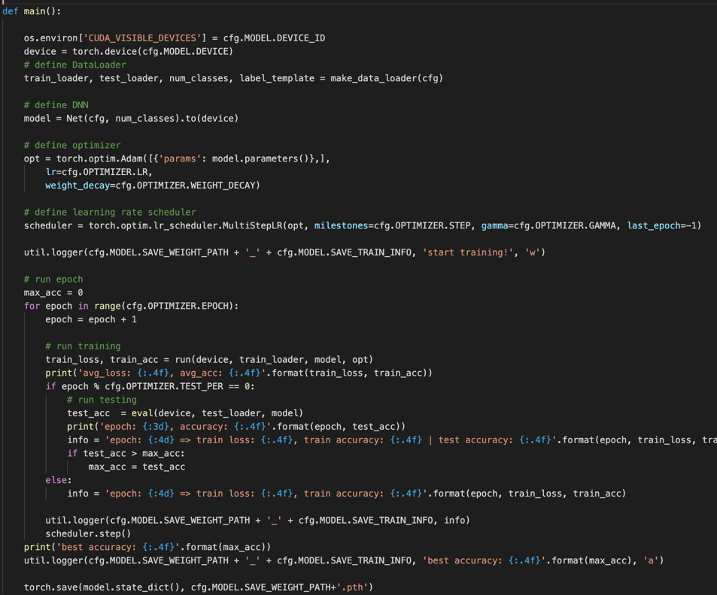

* + - run(): training function

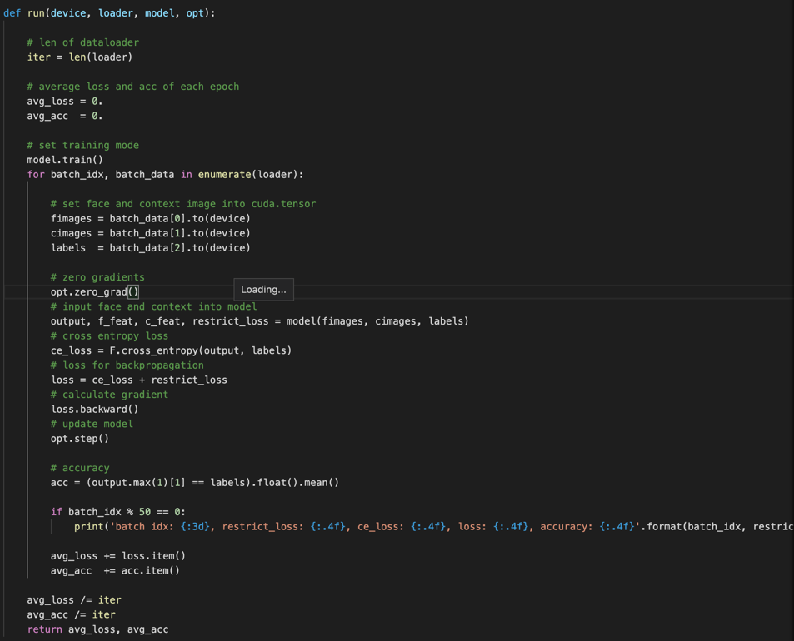

* + - eval(): testing function

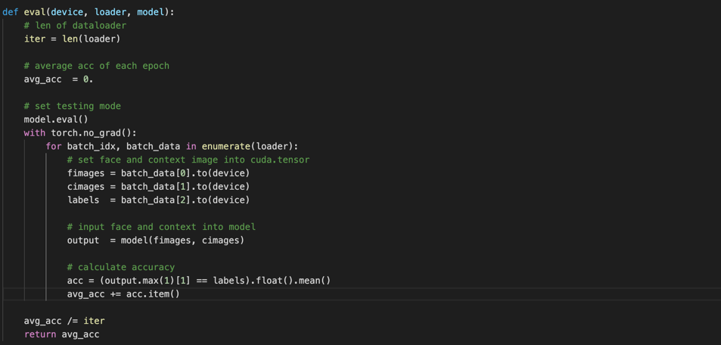

* + ./model/overall_net.py:
    - Net: 定義model架構
      * Baseline: convolutional neural networks encoder
      * Graph_Net: cross-modality graph convolutional networks
      * weight: classifier
      * p_m, n_m and s: 計算metric loss之參數

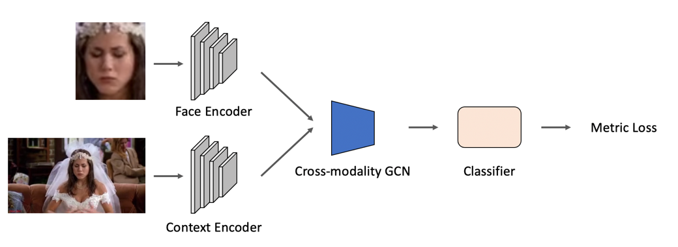

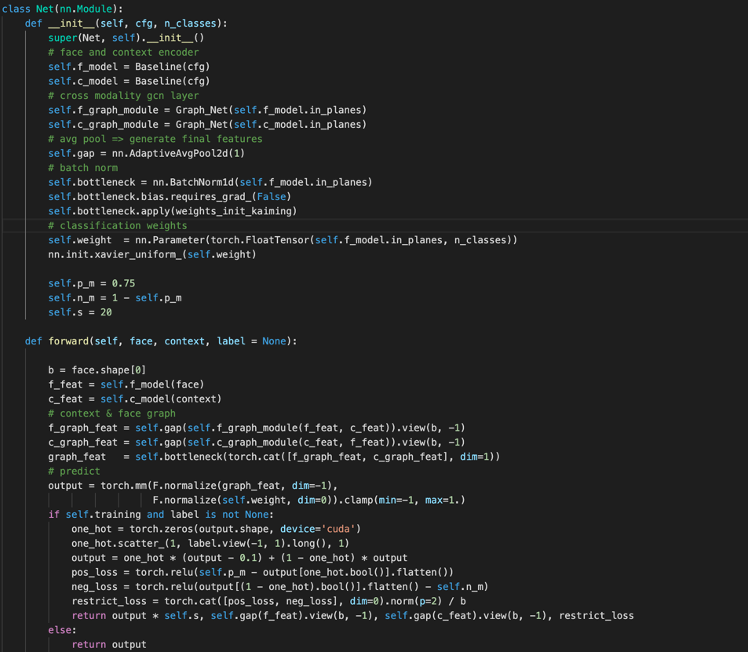

* + - Graph_Net: cross-modality gcn
      * build_graph():
        + 計算face與context的affinity graph
        + 利用bernoulli sampling來達成稀疏的graph

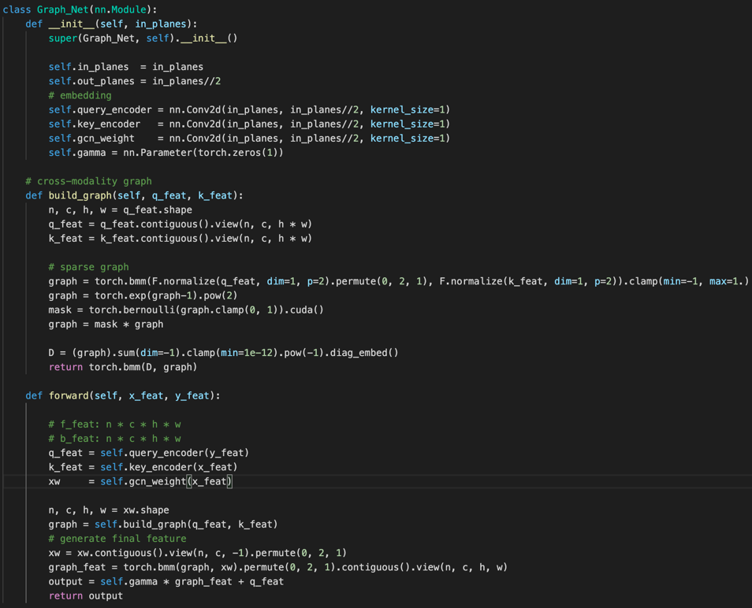

* + - metric loss: 定義boundary
      * 利用boundary（pos: 0.75, neg: 0.25）來更好的規範特徵分佈

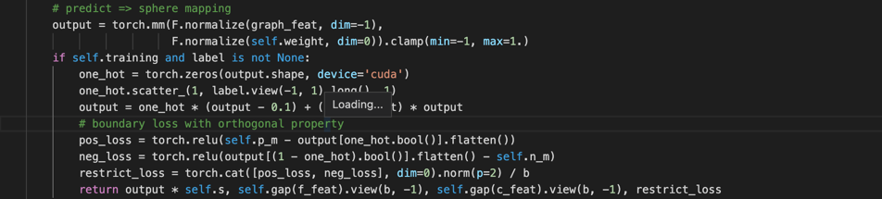

* ./inference.py: 異常偵測

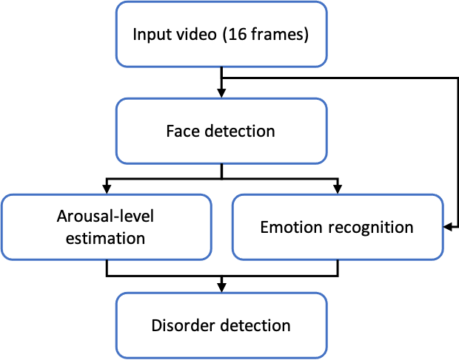

圖二、異常偵測流程圖

* + 每16個frame（0.5 s）組成一個video clips，並對整個clip進行人臉偵測，接下來分別進行movement estimation與emotion recognition。
  + Arousal-level estimation: 根據左右眼睛與眉毛的特徵點（action unit）的位移來估計病患當前的位移程度
    - eye_brow_distance: 計算點集合間的Euclidean distance
    - normalize_values: 透過與temporal set (16 frame)的比較與標準化，可以衡量人的移動程度。

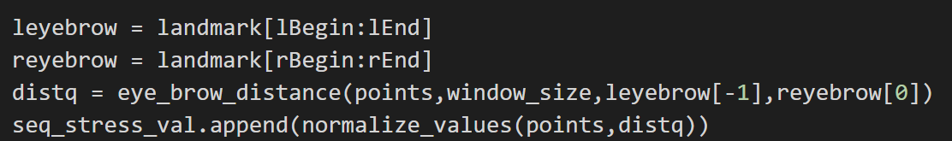

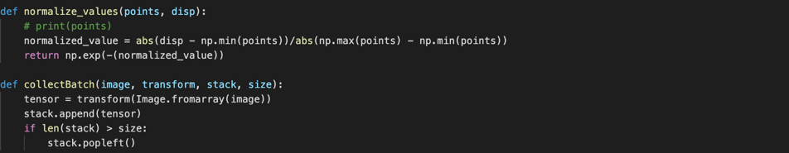

* + emotion recognition: 人顯露的情緒大概會維持1~2秒，因此我們對每個video clip (16 frames)預測一emotion，接著利用sliding window的方式來統計emotion的變化(64 clips)

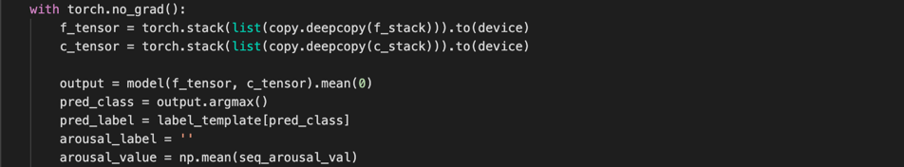

* + disorder detection: 在這裏我們根據arousal-level與emotion的變化(entropy)來進行異常行為偵測。

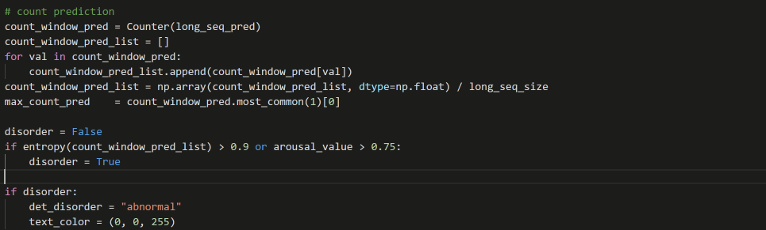

實驗結果:

* 資料集: 我們採用CAER(Context-aware Emotion Recognition)資料集來驗證模型的有效性。CAER資料集包含6種標準的情緒(Happy, Anger, Disgust, Sad, Surprise, Fear)與1中性類別(Neutral)，如下圖一所示。

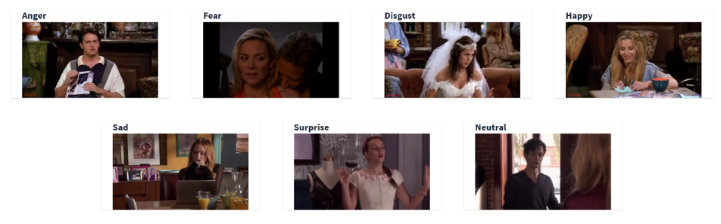

圖一、CAER資料集的類別與範例圖片

CAER 資料集的分布如下:

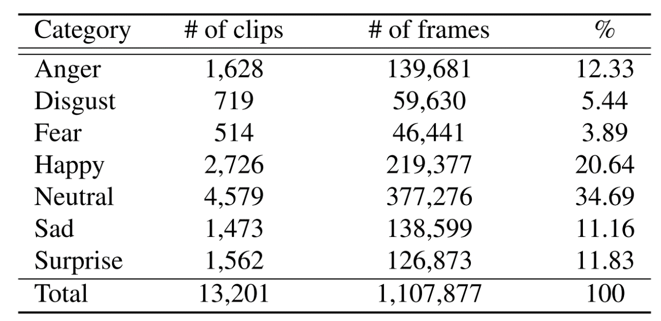

* 結果:

|  |  |  |
| --- | --- | --- |
| method | Input type | Accuracy |
| CAER-2D | Image | 73.51 |
| CAER-3D | Video | 77.04 |
| ours | Image | 87.26 |

Source Code:

config

./configs/image_config.py

from yacs.config import CfgNode as CN

_C = CN()

_C.DATASETS = CN()

_C.DATASETS.NAMES = ('CAER_S')

_C.DATASETS.ROOT_DIR = ('./data/CAER/')

_C.DATALOADER = CN()

# Number of data loading threads

_C.DATALOADER.NUM_WORKERS = 8

# Sampler for data loading

_C.DATALOADER.SAMPLER = 'PK_BATCH'

# Number of instance for one batch

_C.DATALOADER.NUM_INSTANCE = 10

_C.DATALOADER.IMS_PER_BATCH = 70

_C.MODEL = CN()

_C.MODEL.DEVICE = "cuda"

_C.MODEL.DEVICE_ID = '0'

# _C.MODEL.BACKBONE = 'resnet18'

# _C.MODEL.PRETRAIN_CHOICE = 'imagenet'

_C.MODEL.BACKBONE = 'convnet'

_C.MODEL.PRETRAIN_CHOICE = ''

_C.MODEL.PRETRAIN_PATH = './imagenet_weights/' + _C.MODEL.BACKBONE + '.pth'

_C.MODEL.SAVE_WEIGHT_PATH = './model_weights/' + _C.MODEL.BACKBONE + '_' + _C.DATASETS.NAMES

_C.MODEL.SAVE_TRAIN_INFO = 'training_info.txt'

_C.INPUT = CN()

# Size of the image during training

_C.INPUT.SIZE_TRAIN = [112, 112]

# Size of the image during test

_C.INPUT.SIZE_TEST = [112, 112]

# Random probability for image horizontal flip

_C.INPUT.PROB = 0.5

# Random probability for random erasing

_C.INPUT.RE_PROB = 0.5

# Values to be used for image normalization

_C.INPUT.PIXEL_MEAN = [0.485, 0.456, 0.406]

# Values to be used for image normalization

_C.INPUT.PIXEL_STD = [0.229, 0.224, 0.225]

_C.OPTIMIZER = CN()

_C.OPTIMIZER.OPTIMIZER_NAME = 'Adam'

if _C.MODEL.PRETRAIN_CHOICE == 'imagenet':

_C.OPTIMIZER.EPOCH = 70

_C.OPTIMIZER.STEP = [50]

_C.OPTIMIZER.GAMMA = 0.1

_C.OPTIMIZER.LR = 5e-4

else:

_C.OPTIMIZER.EPOCH = 300

_C.OPTIMIZER.STEP = [40, 250]

_C.OPTIMIZER.GAMMA = 0.1

_C.OPTIMIZER.LR = 5e-3

_C.OPTIMIZER.WEIGHT_DECAY = 1e-5

_C.OPTIMIZER.E_MARGIN = 0.5

_C.OPTIMIZER.TEST_PER = 10

Dataloader

./dataset/__init__.py

from .build import make_data_loader

./dataset/build.py

from torch.utils.data import DataLoader

from .collate_batch import collate_fn

from .datasets import init_dataset, ImageDataset

from .samplers import RandomIdentitySampler

from .transforms import build_transforms

def make_data_loader(cfg):

train_transforms_f = build_transforms(cfg, is_train=True)

train_transforms_c = build_transforms(cfg, is_drop=True, is_train=True)

val_transforms = build_transforms(cfg, is_train=False)

num_workers = cfg.DATALOADER.NUM_WORKERS

dataset = init_dataset(cfg.DATASETS.NAMES, root=cfg.DATASETS.ROOT_DIR)

label_template = dataset.label_template

num_classes = dataset.num_train_eids

train_set = ImageDataset(dataset.train, train_transforms_f, train_transforms_c)

train_loader = DataLoader(

train_set, batch_size=cfg.DATALOADER.IMS_PER_BATCH,

sampler=RandomIdentitySampler(dataset.train, cfg.DATALOADER.IMS_PER_BATCH, cfg.DATALOADER.NUM_INSTANCE),

num_workers=num_workers, collate_fn=collate_fn

)

test_set = ImageDataset(dataset.test, val_transforms, val_transforms)

test_loader = DataLoader(

test_set, batch_size=cfg.DATALOADER.IMS_PER_BATCH, shuffle=False, num_workers=num_workers,

collate_fn=collate_fn

)

return train_loader, test_loader, num_classes, label_template

./dataset/collate_batch.py

import torch

def collate_fn(batch):

c_imgs, f_imgs, eids = zip(*batch)

eids = torch.tensor(eids, dtype=torch.int64)

return torch.stack(c_imgs, dim=0), torch.stack(f_imgs, dim=0), eids

./dataset/datasets/__init__.py

from .CAER_S import CAER_S

from .CAER import CAER

from .dataset_loader import ImageDataset

__factory = {

'CAER_S': CAER_S,

'CAER': CAER

}

def get_names():

return __factory.keys()

def init_dataset(name, *args, **kwargs):

if name not in __factory.keys():

raise KeyError("Unknown datasets: {}".format(name))

return __factory[name](*args, **kwargs)

./dataset/datasets/bases.py

import numpy as np

class BaseDataset(object):

"""

Base class of CAER dataset

"""

def get_imagedata_info(self, data):

eids = []

for _, _, eid in data:

eids += [eid]

eids = set(eids)

num_eids = len(eids)

num_imgs = len(data)

return num_eids, num_imgs

def get_videodata_info(self, data):

eids = []

for _, eid in data:

eids += [eid]

eids = set(eids)

num_eids = len(eids)

num_videos = len(data)

return num_eids, num_videos

def print_dataset_statistics(self):

raise NotImplementedError

class BaseImageDataset(BaseDataset):

"""

Base class of image dataset

"""

def print_dataset_statistics(self, train, test):

num_train_eids, num_train_imgs = self.get_imagedata_info(train)

num_test_eids, num_test_imgs = self.get_imagedata_info(test)

print("Dataset statistics:")

print(" ----------------------------------------")

print(" subset | # ids | # images |")

print(" ----------------------------------------")

print(" train | {:5d} | {:8d} |".format(num_train_eids, num_train_imgs))

print(" test | {:5d} | {:8d} |".format(num_test_eids, num_test_imgs))

print(" ----------------------------------------")

class BaseVideoDataset(BaseDataset):

"""

Base class of video dataset

"""

def print_dataset_statistics(self, train, validation, test):

num_train_eids, num_train = self.get_videodata_info(train)

num_validation_eids, num_validation = self.get_videodata_info(validation)

num_test_eids, num_test = self.get_videodata_info(test)

print("Dataset statistics:")

print(" ----------------------------------------")

print(" subset | # ids | # videos |")

print(" ----------------------------------------")

print(" train | {:5d} | {:8d} |".format(num_train_eids, num_train))

print(" validation | {:5d} | {:8d} |".format(num_validation_eids, num_validation))

print(" test | {:5d} | {:8d} |".format(num_test_eids, num_test))

print(" ----------------------------------------")

./dataset/datasets/CAER_S.py

import os

import os.path as osp

from .bases import BaseImageDataset

class CAER_S(BaseImageDataset):

dataset_dir = 'CAER-S/CAER-S'

def __init__(self, root='./data/', **kwargs):

super(CAER_S, self).__init__()

self.dataset_dir = osp.join(root, self.dataset_dir)

self.train_dir = osp.join(self.dataset_dir, 'train')

self.test_dir = osp.join(self.dataset_dir, 'test')

self.label_template = self._make_id_template(self.train_dir)

self.train = self._process_dir(self.train_dir)

self.test = self._process_dir(self.test_dir)

self.num_train_eids, self.num_train_imgs = self.get_imagedata_info(self.train)

self.num_test_eids, self.num_test_imgs = self.get_imagedata_info(self.test)

self.print_dataset_statistics(self.train, self.test)

def _make_id_template(self, train_dir):

label_template = []

for label in os.listdir(train_dir):

label_template.append(label)

return label_template

def _process_dir(self, dir_path):

dataset = []

no_face = 0

for key in os.listdir(dir_path):

eid = self.label_template.index(key)

image_dir = osp.join(dir_path, key)

for image_path in os.listdir(image_dir):

context_path = osp.join(image_dir, image_path)

face_path = context_path.replace('CAER-S/CAER-S', 'CAER-S/CAER-S-FACE')

if os.path.isfile(face_path):

dataset.append((context_path, face_path, eid))

else:

no_face += 1

dataset.append((context_path, context_path, eid))

return dataset

./dataset/datasets/dataset_loader.py

import os.path as osp

from PIL import Image

from torch.utils.data import Dataset

def read_image(img_path):

"""Keep reading image until succeed.

This can avoid IOError incurred by heavy IO process."""

got_img = False

if not osp.exists(img_path):

raise IOError("{} does not exist".format(img_path))

while not got_img:

try:

img = Image.open(img_path).convert('RGB')

got_img = True

except IOError:

print("IOError incurred when reading '{}'. Will redo. Don't worry. Just chill.".format(img_path))

pass

return img

class ImageDataset(Dataset):

def __init__(self, dataset, f_transform = None, c_transform=None):

self.dataset = dataset

self.c_transform = c_transform

self.f_transform = f_transform

def __len__(self):

return len(self.dataset)

def __getitem__(self, index):

context_path, face_path, id = self.dataset[index]

context = read_image(context_path)

face = read_image(face_path)

if (self.c_transform is not None) and (self.f_transform is not None):

context = self.c_transform(context)

face = self.f_transform(face)

return context, face, id

./dataset/samplers/__init__.py

from .triplet_sampler import RandomIdentitySampler

./dataset/samplers/triplet_sampler.py

import copy

import random

import torch

from collections import defaultdict

import numpy as np

from torch.utils.data.sampler import Sampler

class RandomIdentitySampler(Sampler):

"""

Randomly sample N identities, then for each identity,

randomly sample K instances, therefore batch size is N*K.

Args:

- data_source (list): list of (img_path, pid, camid).

- num_instances (int): number of instances per identity in a batch.

- batch_size (int): number of examples in a batch.

"""

def __init__(self, data_source, batch_size, num_instances):

self.data_source = data_source

self.batch_size = batch_size

self.num_instances = num_instances

self.num_pids_per_batch = self.batch_size // self.num_instances

self.index_dic = defaultdict(list)

for index, (_, _, pid) in enumerate(self.data_source):

self.index_dic[pid].append(index)

self.pids = list(self.index_dic.keys())

# estimate number of examples in an epoch

self.length = 0

for pid in self.pids:

idxs = self.index_dic[pid]

num = len(idxs)

if num < self.num_instances:

num = self.num_instances

self.length += num - num % self.num_instances

def __iter__(self):

batch_idxs_dict = defaultdict(list)

for pid in self.pids:

idxs = copy.deepcopy(self.index_dic[pid])

if len(idxs) < self.num_instances:

idxs = np.random.choice(idxs, size=self.num_instances, replace=True)

random.shuffle(idxs)

batch_idxs = []

for idx in idxs:

batch_idxs.append(idx)

if len(batch_idxs) == self.num_instances:

batch_idxs_dict[pid].append(batch_idxs)

batch_idxs = []

avai_pids = copy.deepcopy(self.pids)

final_idxs = []

while len(avai_pids) >= self.num_pids_per_batch:

selected_pids = random.sample(avai_pids, self.num_pids_per_batch)

for pid in selected_pids:

batch_idxs = batch_idxs_dict[pid].pop(0)

final_idxs.extend(batch_idxs)

if len(batch_idxs_dict[pid]) == 0:

avai_pids.remove(pid)

self.length = len(final_idxs)

return iter(final_idxs)

def __len__(self):

return self.length

./dataset/datasets/transforms/__init__.py

from .build import build_transforms

./dataset/datasets/transforms/build.py

import torchvision.transforms as T

from .transforms import RandomErasing

from .transforms import RandomPatch

from .transforms import Cutout

def build_transforms(cfg, is_drop=False, is_train=True, is_face=False):

normalize_transform = T.Normalize(mean=cfg.INPUT.PIXEL_MEAN, std=cfg.INPUT.PIXEL_STD)

if is_train:

transform = [

T.Resize(cfg.INPUT.SIZE_TRAIN),

T.Pad(10),

T.RandomCrop(cfg.INPUT.SIZE_TRAIN),

T.RandomHorizontalFlip(p=cfg.INPUT.PROB),

T.ToTensor(),

normalize_transform

]

if is_drop:

transform.append(RandomErasing(probability=cfg.INPUT.RE_PROB, mean=cfg.INPUT.PIXEL_MEAN))

transform = T.Compose(transform)

else:

if is_face:

transform = T.Compose([

T.Resize(cfg.INPUT.SIZE_TEST),

T.ToTensor(),

normalize_transform])

else:

transform = T.Compose([

T.Resize((128, 171)),

T.CenterCrop(cfg.INPUT.SIZE_TEST),

T.ToTensor(),

normalize_transform])

return transform

./dataset/datasets/transforms/transforms.py

from PIL import Image

import numpy as np

import torch

import math

import random

from collections import deque

class RandomPatch(object):

"""Random patch data augmentation.

There is a patch pool that stores randomly extracted pathces from person images.

For each input image, RandomPatch

1) extracts a random patch and stores the patch in the patch pool;

2) randomly selects a patch from the patch pool and pastes it on the

input (at random position) to simulate occlusion.

Reference:

- Zhou et al. Omni-Scale Feature Learning for Person Re-Identification. ICCV, 2019.

- Zhou et al. Learning Generalisable Omni-Scale Representations

for Person Re-Identification. arXiv preprint, 2019.

"""

def __init__(

self,

prob_happen=0.5,

pool_capacity=50000,

min_sample_size=100,

patch_min_area=0.01,

patch_max_area=0.5,

patch_min_ratio=0.1,

prob_rotate=0.5,

prob_flip_leftright=0.5,

):

self.prob_happen = prob_happen

self.patch_min_area = patch_min_area

self.patch_max_area = patch_max_area

self.patch_min_ratio = patch_min_ratio

self.prob_rotate = prob_rotate

self.prob_flip_leftright = prob_flip_leftright

self.patchpool = deque(maxlen=pool_capacity)

self.min_sample_size = min_sample_size

def generate_wh(self, W, H):

area = W * H

for attempt in range(100):

target_area = random.uniform(

self.patch_min_area, self.patch_max_area

) * area

aspect_ratio = random.uniform(

self.patch_min_ratio, 1. / self.patch_min_ratio

)

h = int(round(math.sqrt(target_area * aspect_ratio)))

w = int(round(math.sqrt(target_area / aspect_ratio)))

if w < W and h < H:

return w, h

return None, None

def transform_patch(self, patch):

if random.uniform(0, 1) > self.prob_flip_leftright:

patch = patch.transpose(Image.FLIP_LEFT_RIGHT)

if random.uniform(0, 1) > self.prob_rotate:

patch = patch.rotate(random.randint(-10, 10))

return patch

def __call__(self, img):

W, H = img.size # original image size

# collect new patch

w, h = self.generate_wh(W, H)

if w is not None and h is not None:

x1 = random.randint(0, W - w)

y1 = random.randint(0, H - h)

new_patch = img.crop((x1, y1, x1 + w, y1 + h))

self.patchpool.append(new_patch)

if len(self.patchpool) < self.min_sample_size:

return img

if random.uniform(0, 1) > self.prob_happen:

return img

# paste a randomly selected patch on a random position

patch = random.sample(self.patchpool, 1)[0]

patchW, patchH = patch.size

x1 = random.randint(0, W - patchW)

y1 = random.randint(0, H - patchH)

patch = self.transform_patch(patch)

img.paste(patch, (x1, y1))

return img

class RandomErasing(object):

""" Randomly selects a rectangle region in an image and erases its pixels.

'Random Erasing Data Augmentation' by Zhong et al.

See https://arxiv.org/pdf/1708.04896.pdf

Args:

probability: The probability that the Random Erasing operation will be performed.

sl: Minimum proportion of erased area against input image.

sh: Maximum proportion of erased area against input image.

r1: Minimum aspect ratio of erased area.

mean: Erasing value.

"""

def __init__(self, probability=0.5, sl=0.02, sh=0.4, r1=0.3, mean=(0.4914, 0.4822, 0.4465)):

self.probability = probability

self.mean = mean

self.sl = sl

self.sh = sh

self.r1 = r1

def __call__(self, img):

if random.uniform(0, 1) >= self.probability:

return img

for attempt in range(100):

area = img.size()[1] * img.size()[2]

target_area = random.uniform(self.sl, self.sh) * area

aspect_ratio = random.uniform(self.r1, 1 / self.r1)

h = int(round(math.sqrt(target_area * aspect_ratio)))

w = int(round(math.sqrt(target_area / aspect_ratio)))

if w < img.size()[2] and h < img.size()[1]:

x1 = random.randint(0, img.size()[1] - h)

y1 = random.randint(0, img.size()[2] - w)

if img.size()[0] == 3:

img[0, x1:x1 + h, y1:y1 + w] = self.mean[0]

img[1, x1:x1 + h, y1:y1 + w] = self.mean[1]

img[2, x1:x1 + h, y1:y1 + w] = self.mean[2]

else:

img[0, x1:x1 + h, y1:y1 + w] = self.mean[0]

return img

return img

class Cutout(object):

"""Randomly mask out one or more patches from an image.

Args:

n_holes (int): Number of patches to cut out of each image.

length (int): The length (in pixels) of each square patch.

"""

def __init__(self, n_holes, length):

self.n_holes = n_holes

self.length = length

def __call__(self, img):

"""

Args:

img (Tensor): Tensor image of size (C, H, W).

Returns:

Tensor: Image with n_holes of dimension length x length cut out of it.

"""

h = img.size(1)

w = img.size(2)

mask = np.ones((h, w), np.float32)

for n in range(self.n_holes):

y = np.random.randint(h)

x = np.random.randint(w)

y1 = np.clip(y - self.length // 2, 0, h)

y2 = np.clip(y + self.length // 2, 0, h)

x1 = np.clip(x - self.length // 2, 0, w)

x2 = np.clip(x + self.length // 2, 0, w)

mask[y1: y2, x1: x2] = 0.

mask = torch.from_numpy(mask)

mask = mask.expand_as(img)

img = img * mask

return img

./model/__init__.py

from .baseline import Baseline

def build_model(cfg):

model = Baseline(cfg.MODEL.PRETRAIN_PATH, cfg.MODEL.BACKBONE, cfg.MODEL.PRETRAIN_CHOICE)

return model

./model/baseline.py

import torch

from torch import nn

import torch.nn.functional as F

from torch.jit.annotations import Dict

from .backbones.resnet import ResNet, BasicBlock, Bottleneck

from .backbones.senet import SENet, SEResNetBottleneck, SEBottleneck, SEResNeXtBottleneck

from .backbones.resnet_ibn_a import resnet50_ibn_a

from .backbones.convnet import ConvNet

# show

from collections import OrderedDict

from PIL import Image

from torchvision import datasets, models, transforms

import matplotlib.pyplot as plt

def weights_init_kaiming(m):

classname = m.__class__.__name__

if classname.find('Linear') != -1:

nn.init.kaiming_normal_(m.weight, a=0, mode='fan_out')

nn.init.constant_(m.bias, 0.0)

elif classname.find('Conv') != -1:

nn.init.kaiming_normal_(m.weight, a=0, mode='fan_in')

if m.bias is not None:

nn.init.constant_(m.bias, 0.0)

elif classname.find('BatchNorm') != -1:

if m.affine:

nn.init.constant_(m.weight, 1.0)

nn.init.constant_(m.bias, 0.0)

class Baseline(nn.Module):

in_planes = 2048

def __init__(self, cfg):

super(Baseline, self).__init__()

model_path = cfg.MODEL.PRETRAIN_PATH

model_name = cfg.MODEL.BACKBONE

pretrain_choice = cfg.MODEL.PRETRAIN_CHOICE

last_stride = 1

if model_name == 'resnet18':

self.in_planes = 512

self.base = ResNet(last_stride=last_stride,

block=BasicBlock,

layers=[2, 2, 2, 2])

self.expansion = BasicBlock.expansion

elif model_name == 'resnet34':

self.in_planes = 512

self.base = ResNet(last_stride=last_stride,

block=BasicBlock,

layers=[3, 4, 6, 3])

self.expansion = BasicBlock.expansion

elif model_name == 'resnet50':

self.base = ResNet(last_stride=last_stride,

block=Bottleneck,

layers=[3, 4, 6, 3])

self.expansion = BasicBlock.expansion

elif model_name == 'resnet101':

self.base = ResNet(last_stride=last_stride,

block=Bottleneck,

layers=[3, 4, 23, 3])

self.expansion = BasicBlock.expansion

elif model_name == 'resnet152':

self.base = ResNet(last_stride=last_stride,

block=Bottleneck,

layers=[3, 8, 36, 3])

self.expansion = BasicBlock.expansion

elif model_name == 'se_resnet50':

self.base = SENet(block=SEResNetBottleneck,

layers=[3, 4, 6, 3],

groups=1,

reduction=16,

dropout_p=None,

inplanes=64,

input_3x3=False,

downsample_kernel_size=1,

downsample_padding=0,

last_stride=last_stride)

self.expansion = SEResNetBottleneck.expansion

elif model_name == 'se_resnet101':

self.base = SENet(block=SEResNetBottleneck,

layers=[3, 4, 23, 3],

groups=1,

reduction=16,

dropout_p=None,

inplanes=64,

input_3x3=False,

downsample_kernel_size=1,

downsample_padding=0,

last_stride=last_stride)

self.expansion = SEResNetBottleneck.expansion

elif model_name == 'se_resnet152':

self.base = SENet(block=SEResNetBottleneck,

layers=[3, 8, 36, 3],

groups=1,

reduction=16,

dropout_p=None,

inplanes=64,

input_3x3=False,

downsample_kernel_size=1,

downsample_padding=0,

last_stride=last_stride)

self.expansion = SEResNetBottleneck.expansion

elif model_name == 'se_resnext50':

self.base = SENet(block=SEResNeXtBottleneck,

layers=[3, 4, 6, 3],

groups=32,

reduction=16,

dropout_p=None,

inplanes=64,

input_3x3=False,

downsample_kernel_size=1,

downsample_padding=0,

last_stride=last_stride)

self.expansion = SEResNeXtBottleneck.expansion

elif model_name == 'se_resnext101':

self.base = SENet(block=SEResNeXtBottleneck,

layers=[3, 4, 23, 3],

groups=32,

reduction=16,

dropout_p=None,

inplanes=64,

input_3x3=False,

downsample_kernel_size=1,

downsample_padding=0,

last_stride=last_stride)

self.expansion = SEResNeXtBottleneck.expansion

elif model_name == 'senet154':

self.base = SENet(block=SEBottleneck,

layers=[3, 8, 36, 3],

groups=64,

reduction=16,

dropout_p=0.2,

last_stride=last_stride)

self.expansion = SEResNeXtBottleneck.expansion

elif model_name == 'convnet':

self.base = ConvNet()

self.in_planes = 256

if pretrain_choice == 'imagenet':

self.load_param(model_path)

print('Loading pretrained ImageNet model......')

def forward(self, x):

feat = self.base(x)

return feat

def load_param(self, trained_path):

param_dict = torch.load(trained_path)

for i in param_dict:

if ('fc' in i) or ('classifier' in i):

continue

self.base.state_dict()[i].copy_(param_dict[i])

./model/graph_net.py

import torch

import torch.nn as nn

import torch.nn.functional as F

class Graph_Net(nn.Module):

def __init__(self, in_planes):

super(Graph_Net, self).__init__()

self.in_planes = in_planes

self.out_planes = in_planes//2

# embedding

self.query_encoder = nn.Conv2d(in_planes, in_planes//2, kernel_size=1)

self.key_encoder = nn.Conv2d(in_planes, in_planes//2, kernel_size=1)

self.gcn_weight = nn.Conv2d(in_planes, in_planes//2, kernel_size=1)

self.gamma = nn.Parameter(torch.zeros(1))

# cross-modality graph

def build_graph(self, q_feat, k_feat):

n, c, h, w = q_feat.shape

q_feat = q_feat.contiguous().view(n, c, h * w)

k_feat = k_feat.contiguous().view(n, c, h * w)

# sparse graph

graph = torch.bmm(F.normalize(q_feat, dim=1, p=2).permute(0, 2, 1), F.normalize(k_feat, dim=1, p=2)).clamp(min=-1, max=1.)

graph = torch.exp(graph-1).pow(2)

mask = torch.bernoulli(graph.clamp(0, 1)).cuda()

graph = mask * graph

D = (graph).sum(dim=-1).clamp(min=1e-12).pow(-1).diag_embed()

return torch.bmm(D, graph)

def forward(self, x_feat, y_feat):

# f_feat: n * c * h * w

# b_feat: n * c * h * w

q_feat = self.query_encoder(y_feat)

k_feat = self.key_encoder(x_feat)

xw = self.gcn_weight(x_feat)

n, c, h, w = xw.shape

graph = self.build_graph(q_feat, k_feat)

# generate final feature

xw = xw.contiguous().view(n, c, -1).permute(0, 2, 1)

graph_feat = torch.bmm(graph, xw).permute(0, 2, 1).contiguous().view(n, c, h, w)

output = self.gamma * graph_feat + q_feat

return output

./model/overall_net.py

import torch

from torch import nn

import torch.nn.functional as F

from .baseline import Baseline

from .graph_net import Graph_Net

def weights_init_kaiming(m):

classname = m.__class__.__name__

if classname.find('Linear') != -1:

nn.init.kaiming_normal_(m.weight, a=0, mode='fan_out')

nn.init.constant_(m.bias, 0.0)

elif classname.find('Conv') != -1:

nn.init.kaiming_normal_(m.weight, a=0, mode='fan_in')

if m.bias is not None:

nn.init.constant_(m.bias, 0.0)

elif classname.find('BatchNorm') != -1:

if m.affine:

nn.init.constant_(m.weight, 1.0)

nn.init.constant_(m.bias, 0.0)

class Net(nn.Module):

def __init__(self, cfg, n_classes):

super(Net, self).__init__()

# face and context encoder

self.f_model = Baseline(cfg)

self.c_model = Baseline(cfg)

# cross modality gcn layer

self.f_graph_module = Graph_Net(self.f_model.in_planes)

self.c_graph_module = Graph_Net(self.c_model.in_planes)

# avg pool => generate final features

self.gap = nn.AdaptiveAvgPool2d(1)

# batch norm

self.bottleneck = nn.BatchNorm1d(self.f_model.in_planes)

self.bottleneck.bias.requires_grad_(False)

self.bottleneck.apply(weights_init_kaiming)

# classification weights

self.weight = nn.Parameter(torch.FloatTensor(self.f_model.in_planes, n_classes))

nn.init.xavier_uniform_(self.weight)

self.p_m = 0.75

self.n_m = 1 - self.p_m

self.s = 20

def forward(self, face, context, label = None):

b = face.shape[0]

f_feat = self.f_model(face)

c_feat = self.c_model(context)

# context & face graph

f_graph_feat = self.gap(self.f_graph_module(f_feat, c_feat)).view(b, -1)

c_graph_feat = self.gap(self.c_graph_module(c_feat, f_feat)).view(b, -1)

graph_feat = self.bottleneck(torch.cat([f_graph_feat, c_graph_feat], dim=1))

# predict => sphere mapping

output = torch.mm(F.normalize(graph_feat, dim=-1),

F.normalize(self.weight, dim=0)).clamp(min=-1, max=1.)

if self.training and label is not None:

one_hot = torch.zeros(output.shape, device='cuda')

one_hot.scatter_(1, label.view(-1, 1).long(), 1)

output = one_hot * (output - 0.1) + (1 - one_hot) * output

# boundary loss with orthogonal property

pos_loss = torch.relu(self.p_m - output[one_hot.bool()].flatten())

neg_loss = torch.relu(output[(1 - one_hot).bool()].flatten() - self.n_m)

restrict_loss = torch.cat([pos_loss, neg_loss], dim=0).norm(p=2) / b

return output * self.s, self.gap(f_feat).view(b, -1), self.gap(c_feat).view(b, -1), restrict_loss

else:

return output

./model/backbones/__init__.py (empty file)

./model/backbones/convnet.py

import torch

import torch.nn as nn

import torch.nn.functional as F

import math

class Block(nn.Module):

def __init__(self, in_planes, out_planes, stride=1, padding = 1):

super(Block, self).__init__()

self.conv = nn.Conv2d(in_planes, out_planes, kernel_size=3, stride=stride, padding=padding, bias=False)

self.bn = nn.BatchNorm2d(out_planes)

self.relu = nn.ReLU(inplace=True)

def forward(self, x):

x = self.conv(x)

x = self.bn(x)

x = self.relu(x)

return x

class ConvNet(nn.Module):

def __init__(self):

super(ConvNet, self).__init__()

self.pool = nn.MaxPool2d(2, 2)

self.block_1 = Block(3, 32, 1, 1)

self.block_2 = Block(32, 64, 1, 1)

self.block_3 = Block(64, 128, 1, 1)

self.block_4 = Block(128, 256, 1, 1)

self.block_5 = Block(256, 256, 1, 1)

self.random_init()

def forward(self, x):

x = self.block_1(x)

x = self.pool(x)

x = self.block_2(x)

x = self.pool(x)

x = self.block_3(x)

x = self.pool(x)

x = self.block_4(x)

x = self.pool(x)

x = self.block_5(x)

return x

def random_init(self):

for m in self.modules():

if isinstance(m, nn.Conv2d):

n = m.kernel_size[0] * m.kernel_size[1] * m.out_channels

m.weight.data.normal_(0, math.sqrt(2. / n))

elif isinstance(m, nn.BatchNorm2d):

m.weight.data.fill_(1)

m.bias.data.zero_()

./build_train_list.py

import os

def main():

path = './data/CAER/CAER/CAER/'

for type_dir in os.listdir(path):

# train, validation, test

txt_file = path + type_dir + '.txt'

type_dir = os.path.join(path, type_dir)

for label_dir in os.listdir(type_dir):

# Anger, Disgust, Fear, Happy, Neutral, Sad, Suprise

label = label_dir

label_dir = os.path.join(type_dir, label_dir)

for avi_file in os.listdir(label_dir):

avi_file = os.path.join(label_dir, avi_file)

f = open(txt_file, 'a')

f.write(avi_file + ' ' + label + '\n')

f.close()

if __name__ == "__main__":

main()

./det_face.py

import os

import os.path as osp

import shutil

import face_alignment

from PIL import Image

import numpy as np

import copy

if __name__ == "__main__":

# cuda for CUDA

fa = face_alignment.FaceAlignment(face_alignment.LandmarksType._2D, device='cuda')

org_path = './data/CAER/CAER-S/CAER-S'

tgt_path = './data/CAER/CAER-S/CAER-S-FACE'

log_file = './log.txt'

if os.path.isdir(tgt_path):

shutil.rmtree(tgt_path)

os.mkdir(tgt_path)

for data_type in os.listdir(org_path):

org_data_dir = osp.join(org_path, data_type)

tgt_data_dir = osp.join(tgt_path, data_type)

os.mkdir(tgt_data_dir)

for label_dir in os.listdir(org_data_dir):

org_label_dir = osp.join(org_data_dir, label_dir)

tgt_label_dir = osp.join(tgt_data_dir, label_dir)

os.mkdir(tgt_label_dir)

for image_file in os.listdir(org_label_dir):

image = Image.open(osp.join(org_label_dir, image_file))

np_image = np.array(image)

# det face

preds = fa.get_landmarks(np_image)

max_area = 0

max_pred = []

if preds is not None:

for i, pred in enumerate(preds):

xmin = int(min(pred[:, 0]))

xmax = int(max(pred[:, 0]))

ymin = int(min(pred[:, 1]))

ymax = int(max(pred[:, 1]))

w = xmax - xmin

h = ymax - ymin

b_size = max(w, h)

mid_x = (xmax + xmin) /2

mid_y = (ymax + ymin) /2

area = w*h

if area > max_area:

max_area = area

max_pred = [mid_x - b_size*0.5, mid_y - b_size*0.5, mid_x + b_size*0.5, mid_y + b_size*0.5]

image.crop(max_pred).save(osp.join(tgt_label_dir, image_file))

else:

f = open(log_file, "a")

f.write(osp.join(org_label_dir, image_file) + '\n')

f.close()

./inference.py

import copy

import os

import time

from collections import Counter, deque

import cv2

import face_alignment

import numpy as np

import torch

import torch.nn.functional as F

import torchvision

from imutils import face_utils

from PIL import Image

from scipy.spatial import distance as dist

from scipy.stats import entropy

from torchvision import transforms, utils

import util

from configs.image_cfg import _C as cfg

from dataset import make_data_loader

from dataset.transforms import build_transforms

from model.graph_net import Graph_Net

from model.overall_net import Net

def main():

os.environ['CUDA_VISIBLE_DEVICES'] = cfg.MODEL.DEVICE_ID

device = torch.device("cuda:0" if torch.cuda.is_available() else "cpu")

torch.backends.cudnn.benchmark = True

# train_loader, test_loader, num_classes, label_template = make_data_loader(cfg)

label_template = ['Angry', 'Disgust', 'Fear', 'Happy', 'Neutral', 'Sad', 'Surprise']

pos_template = ['Happy', 'Surprise']

neg_template = ['Angry', 'Disgust', 'Fear', 'Sad']

neutral_class = 'Neutral'

num_classes = len(label_template)

# define and load model

model_path = cfg.MODEL.SAVE_WEIGHT_PATH+'.pth'

model = Net(cfg, num_classes).to(device)

model.load_state_dict(torch.load(model_path))

model.eval()

# face detector

fa = face_alignment.FaceAlignment(face_alignment.LandmarksType._2D, flip_input=False, device='cuda')

(lBegin, lEnd) = face_utils.FACIAL_LANDMARKS_IDXS["right_eyebrow"]

(rBegin, rEnd) = face_utils.FACIAL_LANDMARKS_IDXS["left_eyebrow"]

f_transform = build_transforms(cfg, is_train=False, is_face=True)

c_transform = build_transforms(cfg, is_train=False, is_face=False)

# video path

video_path = './test.mp4'

cap = cv2.VideoCapture(video_path)

f_stack = deque([])

c_stack = deque([])

seq_pred = deque([])

points = deque([])

seq_arousal_val = deque([])

long_seq_pred = deque([])

long_seq_prob = deque([])

long_seq_size = 64

window_size = 16

if (cap.isOpened()== False):

print("Error opening video stream or file")

while(cap.isOpened()):

ret, frame = cap.read()

if ret == True:

if cv2.waitKey(25) & 0xFF == ord('q'):

break

frame = cv2.resize(frame,None,fx=0.5,fy=0.5,interpolation=cv2.INTER_CUBIC)

# cv2.imwrite('./test.png', frame)

# print(Image.open('./test.png').size, torchvision.io.read_image('./test.png').shape, frame.shape)

# assert i == -1

# cv2.imshow('Frame', frame)

# cv2.putText(frame, label_table[np.argmax(emotion_count)], (max_face_info[0], int(max_face_info[2] - 5)), cv2.FONT_HERSHEY_SIMPLEX, 1, (0, 255, 0), 4)

face, context, landmark = detFace(fa, frame)

collectBatch(face, f_transform, f_stack, window_size)

collectBatch(context, c_transform, c_stack, window_size)

leyebrow = landmark[lBegin:lEnd]

reyebrow = landmark[rBegin:rEnd]

distq = eye_brow_distance(points,window_size,leyebrow[-1],reyebrow[0])

seq_arousal_val.append(normalize_values(points,distq))

if len(seq_arousal_val) > window_size:

seq_arousal_val.popleft()

if len(f_stack) == window_size:

with torch.no_grad():

f_tensor = torch.stack(list(copy.deepcopy(f_stack))).to(device)

c_tensor = torch.stack(list(copy.deepcopy(c_stack))).to(device)

output = model(f_tensor, c_tensor).mean(0)

pred_class = output.argmax()

pred_label = label_template[pred_class]

arousal_label = ''

arousal_value = np.mean(seq_arousal_val)

# if arousal_value > 0.75:

# arousal_label = 'high arousal'

# else:

# arousal_label = 'low arousal'

# print(label_template[pred_class], np.mean(seq_arousal_val))

det_disorder = "normal"

long_seq_pred.append(pred_label)

long_seq_prob.append(output.cpu().numpy())

text_color = (0, 255, 0)

if len(long_seq_pred) > long_seq_size:

long_seq_pred.popleft()

long_seq_prob.popleft()

mean_pred = np.mean(long_seq_prob, 0)

mean_prob = prob(mean_pred)

# count prediction

count_window_pred = Counter(long_seq_pred)

count_window_pred_list = []

for val in count_window_pred:

count_window_pred_list.append(count_window_pred[val])

count_window_pred_list = np.array(count_window_pred_list, dtype=np.float) / long_seq_size

max_count_pred = count_window_pred.most_common(1)[0]

disorder = False

if entropy(count_window_pred_list) > 0.9 or arousal_value > 0.75:

disorder = True

if disorder:

det_disorder = "abnormal"

text_color = (0, 0, 255)

# assert i == -1

# if max_count_pred[1] > (long_seq_size // 2) and max_count_pred[0] != pred_label:

# det_disorder = "abnormal"

# text_color = (0, 0, 255)

# print(count_window_pred, max_count_pred)

# assert i == -1

cv2.putText(frame, pred_label,

(20, 30),

cv2.FONT_HERSHEY_SIMPLEX, 1, (0, 255, 0), 4)

cv2.putText(frame, 'arousal => {:.4f}'.format(arousal_value),

(20, 70),

cv2.FONT_HERSHEY_SIMPLEX, 1, (0, 255, 0), 4)

cv2.putText(frame, det_disorder,

(20, 110),

cv2.FONT_HERSHEY_SIMPLEX, 1, text_color, 4)

# show_face = cv2.cvtColor(face, cv2.COLOR_RGB2BGR)

cv2.imshow('frame', frame)

else:

break

cap.release()

cv2.destroyAllWindows()

def prob(log_output):

return np.exp(log_output)/sum(np.exp(log_output))

def eye_brow_distance(points, size, leye, reye):

distq = dist.euclidean(leye,reye)

points.append(int(distq))

if len(points) > size:

points.popleft()

return distq

def normalize_values(points, disp):

# print(points)

normalized_value = abs(disp - np.min(points))/abs(np.max(points) - np.min(points))

arousal_value = np.exp(-(normalized_value))

return arousal_value

def collectBatch(image, transform, stack, size):

tensor = transform(Image.fromarray(image))

stack.append(tensor)

if len(stack) > size:

stack.popleft()

def detFace(model, image):

process_image = cv2.cvtColor(image, cv2.COLOR_BGR2RGB)

w, h, c = process_image.shape

preds = model.get_landmarks(process_image)

if preds != None and len(preds) > 0:

max_face_area = 0

max_face_info = [0, 0, 0, 0]

max_landmark = None

try:

for i, landmark in enumerate(preds):

x1 = np.min(landmark[:, 0])

y1 = np.min(landmark[:, 1])

x2 = np.max(landmark[:, 0])

y2 = np.max(landmark[:, 1])

box_len = int((float(max(x2 - x1, y2 - y1)) / 2.) * 1.3)

center_x = int(float(x1 + x2) / 2.)

center_y = int(float(y1 + y2) / 2.)

if box_len > max_face_area:

max_face_area = box_len

max_face_info = [center_x, center_y]

max_landmark = landmark

sx = max_face_info[0] - max_face_area

ex = max_face_info[0] + max_face_area

sy = max_face_info[1] - max_face_area

ey = max_face_info[1] + max_face_area

face = process_image[sx:ex, sy:ey, :]

wf, hf, cf = face.shape

result = np.full((max_face_area * 2,max_face_area * 2, c), (0,0,0), dtype=np.uint8)

xx = (max_face_area * 2 - wf) // 2

yy = (max_face_area * 2 - hf) // 2

result[xx:xx+wf, yy:yy+hf] = process_image[sx:ex, sy:ey, :]

return result, process_image, landmark

except Exception as e:

print(e)

mid_w = w // 2

mid_h = h // 2

box_len = min(mid_h, mid_w) // 2

return process_image[(mid_w - box_len):(mid_w + box_len), (mid_h - box_len):(mid_h + box_len), :], process_image, None

if __name__ == "__main__":

main()

./train.py

import os

import torch

import torch.nn.functional as F

import util

from configs.image_cfg import _C as cfg

from dataset import make_data_loader

from model.graph_net import Graph_Net

from model.overall_net import Net

def main():

os.environ['CUDA_VISIBLE_DEVICES'] = cfg.MODEL.DEVICE_ID

device = torch.device(cfg.MODEL.DEVICE)

# define DataLoader

train_loader, test_loader, num_classes, label_template = make_data_loader(cfg)

# define DNN

model = Net(cfg, num_classes).to(device)

# define optimizer

opt = torch.optim.Adam([{'params': model.parameters()},],

lr=cfg.OPTIMIZER.LR,

weight_decay=cfg.OPTIMIZER.WEIGHT_DECAY)

# define learning rate scheduler

scheduler = torch.optim.lr_scheduler.MultiStepLR(opt, milestones=cfg.OPTIMIZER.STEP, gamma=cfg.OPTIMIZER.GAMMA, last_epoch=-1)

util.logger(cfg.MODEL.SAVE_WEIGHT_PATH + '_' + cfg.MODEL.SAVE_TRAIN_INFO, 'start training!', 'w')

# run epoch

max_acc = 0

for epoch in range(cfg.OPTIMIZER.EPOCH):

epoch = epoch + 1

# run training

train_loss, train_acc = run(device, train_loader, model, opt)

print('avg_loss: {:.4f}, avg_acc: {:.4f}'.format(train_loss, train_acc))

if epoch % cfg.OPTIMIZER.TEST_PER == 0:

# run testing

test_acc = eval(device, test_loader, model)

print('epoch: {:3d}, accuracy: {:.4f}'.format(epoch, test_acc))

info = 'epoch: {:4d} => train loss: {:.4f}, train accuracy: {:.4f} | test accuracy: {:.4f}'.format(epoch, train_loss, train_acc, test_acc)

if test_acc > max_acc:

max_acc = test_acc

else:

info = 'epoch: {:4d} => train loss: {:.4f}, train accuracy: {:.4f}'.format(epoch, train_loss, train_acc)

util.logger(cfg.MODEL.SAVE_WEIGHT_PATH + '_' + cfg.MODEL.SAVE_TRAIN_INFO, info)

scheduler.step()

print('best accuracy: {:.4f}'.format(max_acc))

util.logger(cfg.MODEL.SAVE_WEIGHT_PATH + '_' + cfg.MODEL.SAVE_TRAIN_INFO, 'best accuracy: {:.4f}'.format(max_acc), 'a')

torch.save(model.state_dict(), cfg.MODEL.SAVE_WEIGHT_PATH+'.pth')

def run(device, loader, model, opt):

# len of dataloader

iter = len(loader)

# average loss and acc of each epoch

avg_loss = 0.

avg_acc = 0.

# set training mode

model.train()

for batch_idx, batch_data in enumerate(loader):

# set face and context image into cuda.tensor

fimages = batch_data[0].to(device)

cimages = batch_data[1].to(device)

labels = batch_data[2].to(device)

# zero gradients

opt.zero_grad()

# input face and context into model

output, f_feat, c_feat, restrict_loss = model(fimages, cimages, labels)

# cross entropy loss

ce_loss = F.cross_entropy(output, labels)

# loss for backpropagation

loss = ce_loss + restrict_loss

# calculate gradient

loss.backward()

# update model

opt.step()

# accuracy

acc = (output.max(1)[1] == labels).float().mean()

if batch_idx % 50 == 0:

print('batch idx: {:3d}, restrict_loss: {:.4f}, ce_loss: {:.4f}, loss: {:.4f}, accuracy: {:.4f}'.format(batch_idx, restrict_loss.item(), ce_loss.item(), loss.item(), acc.item()))

avg_loss += loss.item()

avg_acc += acc.item()

avg_loss /= iter

avg_acc /= iter

return avg_loss, avg_acc

def eval(device, loader, model):

# len of dataloader

iter = len(loader)

# average acc of each epoch

avg_acc = 0.

# set testing mode

model.eval()

with torch.no_grad():

for batch_idx, batch_data in enumerate(loader):

# set face and context image into cuda.tensor

fimages = batch_data[0].to(device)

cimages = batch_data[1].to(device)

labels = batch_data[2].to(device)

# input face and context into model

output = model(fimages, cimages)

# calculate accuracy

acc = (output.max(1)[1] == labels).float().mean()

avg_acc += acc.item()

avg_acc /= iter

return avg_acc

if __name__ == "__main__":

main()

./util.py

import os

import shutil

def logger(txt, log_info, mode = 'a'):

# print(log_info)

f = open(txt, mode)

f.write(log_info + '\n')

f.close()

def make_dir(_path, _is_del = True):

if _path[-1] != '/':

_path = _path + '/'

if os.path.isdir(_path):

if _is_del == True:

shutil.rmtree(_path)

os.mkdir(_path)

else:

if not os.path.exists(os.path.dirname(_path)):

os.makedirs(os.path.dirname(_path))

return _path