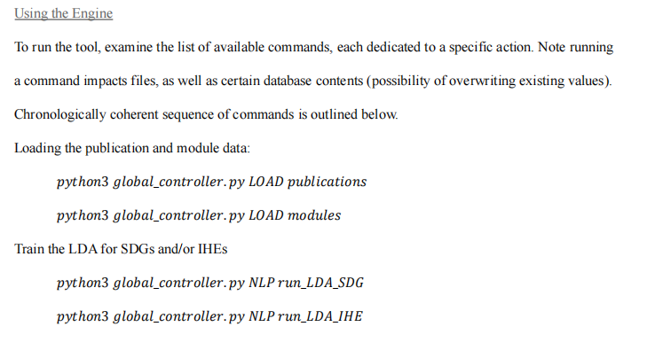

**Train the LDA for SDG PUBS, IHE MODULES, HA, HA MODULES**

python global_controller.py NLP run_LDA_SDG_PUB

python global_controller.py NLP run_LDA_IHE_MODULES

python global_controller.py NLP run_LDA_HA

python global_controller.py NLP run_LDA_HA_MODULES

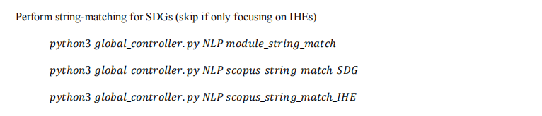

**Perform string-matching for HA, IHE MODULES, HA MODULES, SDG PUB**

python global_controller.py NLP ha_module_string_match

python global_controller.py NLP ihe_module_string_match

python global_controller.py NLP scopus_string_match_HA

python global_controller.py NLP scopus_string_match_HA_MODULE

python global_controller.py NLP scopus_string_match_IHE_MODULE

python global_controller.py NLP scopus_string_match_SDG_PUB

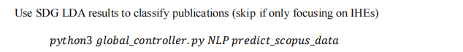

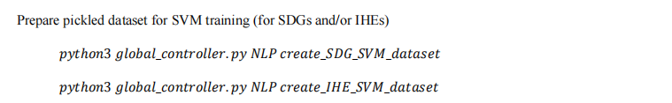

python global_controller.py NLP create_IHE_SVM_MODULE_dataset

python global_controller.py NLP create_HA_SVM_dataset

python global_controller.py NLP create_HA_SVM_MODULE_dataset

python global_controller.py NLP create_SDG_SVM_PUB_dataset

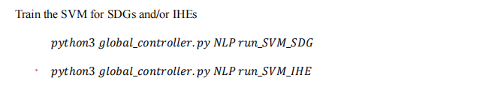

python global_controller.py NLP run_SVM_SDG_PUB

python global_controller.py NLP run_SVM_IHE_MODULE

python global_controller.py NLP run_SVM_HA

python global_controller.py NLP run_SVM_HA_MODULE

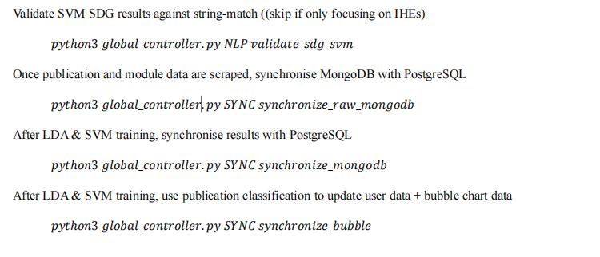

**Generate parser csv file**

python global_controller.py NLP run_SDG_TO_CSV

python global_controller.py NLP run_SDG_TO_CSV2