# EY Resume Score Report

## Candidate Information

Name: John Doe

Email: john.doe@example.com

Job Title: Data Analyst

## Resume Score

Score: 76.5%

## Section Analysis

✔️ Contact

✔️ Skills

❌ Work History

✔️ Education

## Score Donut Chart



## Section Strength

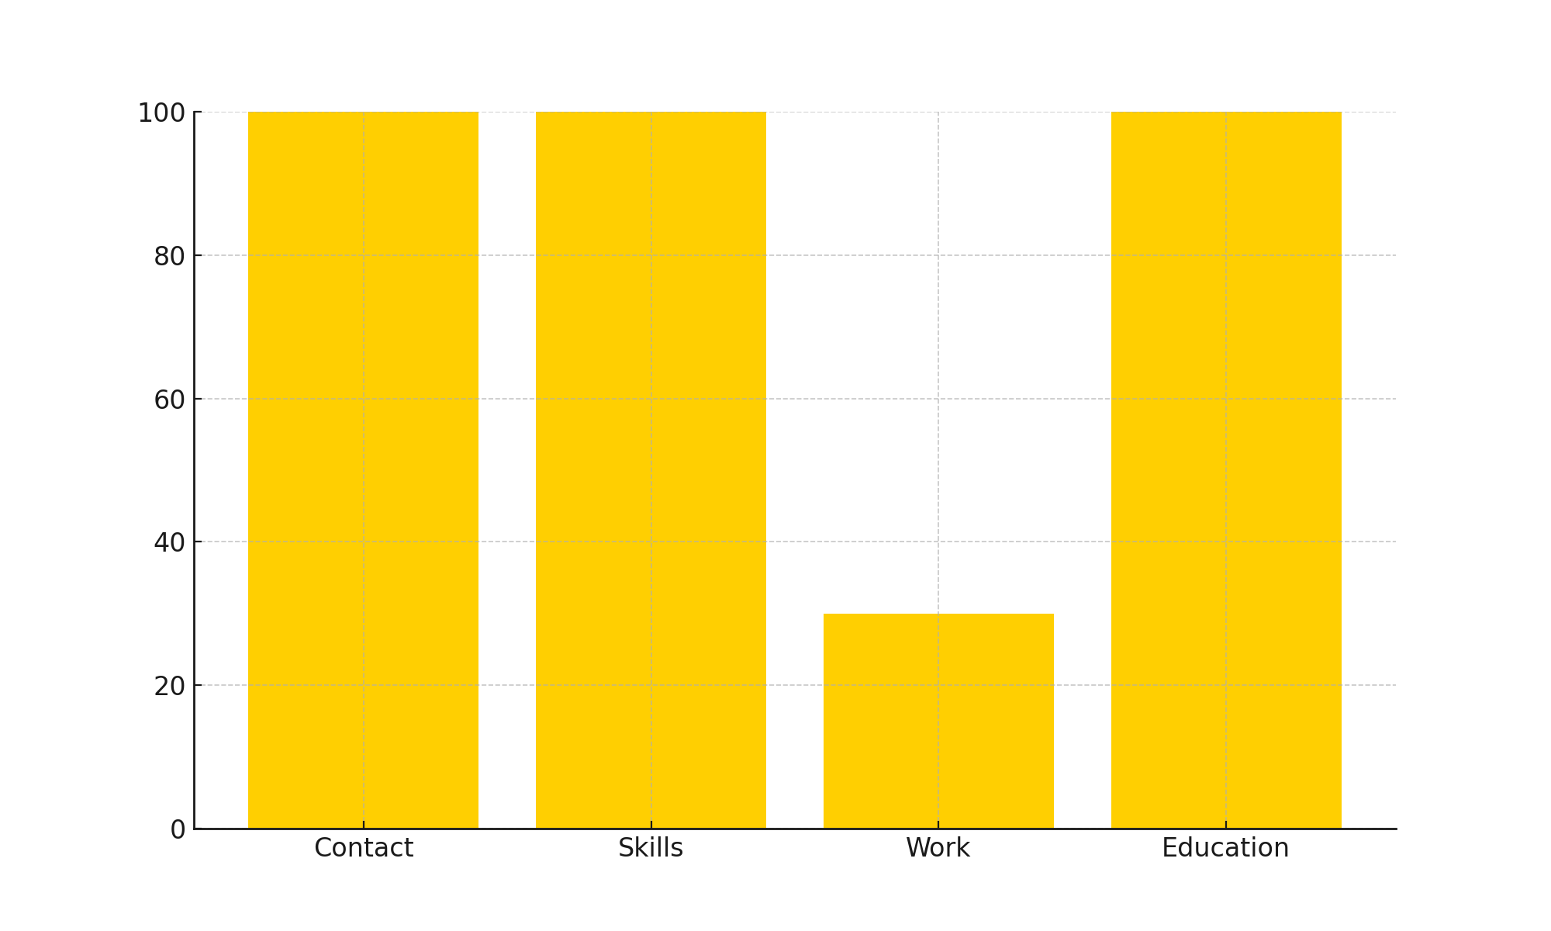

## Word Cloud



## Resume Snapshot



## JD Snapshot



This report was auto-generated by EY People Consulting Resume Analyzer.