SOAL 1-3 > soal1-3/logic.go

4.

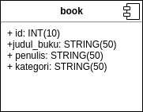

5. SELECT * FROM BOOK WHERE penulis = ? ;

6. SELECT judul_buku,penulis FROM BOOK WHERE kategori = ?;

7. localhost:1234/books/judul

METHOD : GET

BODY : FORM DATA (judul_buku)

RESPONSE : status, message, data

8. localhost:1234/books/penulis

METHOD : GET

BODY : FORM DATA (penulis)

RESPONSE : status, message,data

9. localhost:1234/books/kategori

METHOD : GET

BODY : FORM DATA (kategori)

RESPONSE : status, message,data