**LAB REPORT**

**LAB #2**

**SECTION #2**

**FULL NAME**

**Alvin John Thomas**

**SUBMISSION DATE:**

**9/12/2023**

**DATE**

**9/5/2023**

# Problem

1: Creating your own program.

# Analysis

lab02-skeleton.c was the source file to be modified

# Design

I typed my full name, course title and the date on new lines in the source code

# Testing

I ran the code to display my full name, course title and that day’s date each on new lines

# Comments

N/A

# Source Code

/*----------------------------------------------------------------------------

- SE 185: Lab 02 - Solving Simple Problems in C -

- Name: Alvin Thomas -

- Section: 2 -

- NetID: alvin -

- Date: 9/5/2023 -

-----------------------------------------------------------------------------*/

/*----------------------------------------------------------------------------

- Includes -

-----------------------------------------------------------------------------*/

#include <stdio.h>

#include <math.h>

/*----------------------------------------------------------------------------

- Implementation -

-----------------------------------------------------------------------------*/

int main(int argc, char *argv[])

{

/* Put your code after this line */

printf("Alvin John Thomas \nSE 185 \n9/5/2023");

return 0;

}

# Screen Shots

1.1

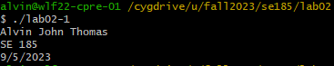

# Problem

2: A simple program with input. To input values of width and height of a rectangle and then calculate its area. Also another program which inputs values of width, height and length of a rectangle and calculates its volume.

# Analysis

The area of a rectangle is the product of its height and width.

The area of a rectangle is the product of its height, width and length.

# Design

I used scanf to input width and height and then ‘*’ operator to calculate the area and volume.

# Testing

I tried inputting different values for the height and width and breadth of the rectangle to see if it calculates the area and volume correctly. Including the values 2, 64 and 8 of a cube to find its volume.

# Comments

I did not encounter any problems.

# Source Code

/*----------------------------------------------------------------------------

- SE 185: Lab 02 - Solving Simple Problems in C -

- Name: Alvin Thomas -

- Section: 2 -

- NetID: alvin -

- Date: 9/5/2023 -

-----------------------------------------------------------------------------*/

/*----------------------------------------------------------------------------

- Includes -

-----------------------------------------------------------------------------*/

#include <stdio.h>

#include <math.h>

/*----------------------------------------------------------------------------

- Implementation -

-----------------------------------------------------------------------------*/

int main(int argc, char *argv[])

{

/* Put your code after this line */

int x,y;

printf("Enter a width: ");

scanf("%d", &x);

printf("Enter a height: ");

scanf("%d", &y);

printf("A %d by %d rectangle's area is %d\n", x, y, x*y);

return 0;

}

/*----------------------------------------------------------------------------

- SE 185: Lab 02 - Solving Simple Problems in C -

- Name: Alvin Thomas -

- Section: 2 -

- NetID: alvin -

- Date: 9/12/2023 -

-----------------------------------------------------------------------------*/

/*----------------------------------------------------------------------------

- Includes -

-----------------------------------------------------------------------------*/

#include <stdio.h>

#include <math.h>

/*----------------------------------------------------------------------------

- Implementation -

-----------------------------------------------------------------------------*/

int main(int argc, char *argv[])

{

/* Put your code after this line */

int x,y,z;

printf("Enter a width: ");

scanf("%d", &x);

printf("Enter a height: ");

scanf("%d", &y);

printf("Enter a length");

scanf("%d", &z);

printf("A %d by %d by %d rectangular cube's area is %d\n", x, y, z, x*y*z);

return 0;

# Screen Shots

2.1

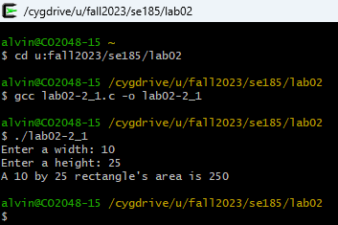

2.2

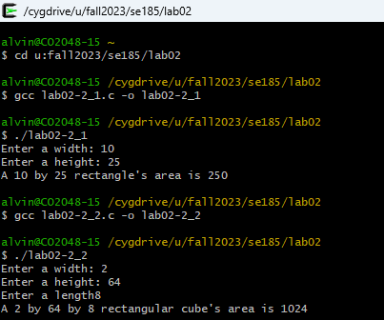

# Problem

3: Mysterious Output. Correct errors in example source code

# Analysis

I had to find out errors and correct them

# Design

I replaced %lf with %d in line 23, typed integer_result in line 26 and replaced %d with %lf in line 29

# Testing

I tested the output to check whether the errors had been corrected.

# Comments

I did not encounter any problems

# Source Code

/*----------------------------------------------------------------------------

- SE 185: Lab 02 - Solving Simple Problems in C -

- Name: Alvin Thomas -

- Section: 2 -

- NetID: alvin -

- Date: 9/12/2023 -

-----------------------------------------------------------------------------*/

/*----------------------------------------------------------------------------

- Includes -

-----------------------------------------------------------------------------*/

#include <stdio.h>

/*----------------------------------------------------------------------------

- Implementation -

-----------------------------------------------------------------------------*/

int main(int argc, char *argv[])

{

int integer_result;

double decimal_result;

integer_result = 77 / 5;

printf("The value of 77/5 is %d, using integer math.\n", integer_result); //Replaced %lf with %d which is used for integers

integer_result = 2 + 3;

printf("The value of 2+3 is %d.\n",integer_result); //Typed integer_result to be printted

decimal_result = 1.0 / 22.0;

printf("The value 1.0/22.0 is %lf.\n", decimal_result); //Replaced %d which is used for integers with %lf which is used for double

return 0;

}

# Screen Shots

3.1

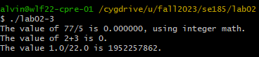

3.2

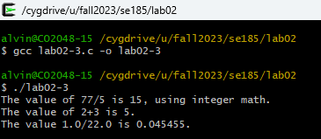

# Problem

Creating a program to do certain arithmetic operations and develop equations for some problems.

# Analysis

I had to type the equations without changing the syntax

# Design

I included math.h to use M_PI to get the exact value of pi to calculate the area of a circle.

I converted 14 feet to metres and 76 degrees Farenheit to Celsius using the conversion factor provided in the question.

# Testing

I tested the program to see if the conversions were correct.

# Comments

The third equation is incorrect because 12/5 has no decimal point so it evaluates to 2.

The fifth equation is incorrect because 22/3 evaluates to 7 instead of 7.333

The sixth and seventh equations are incorrect because 22/(3*3) evaluates to 22/9 and neither has a decimal point.

# Source Code

#include <stdio.h>

#include <math.h>

int main()

{

int a=6427+1725;

int b=(6971*3925) - 95;

double c=79+12/5;

double d=3640.0/107.9;

int e=(22/3)*3;

int f=22/(3*3);

double g=22/(3*3);

double h=22/3*3;

double i=(22.0/3)*3.0;

int j=22.0/(3*3.0);

double k=22.0/3.0*3.0;

printf("6427+1725 = %d \n(6971 * 3925) - 95 = %d \n79+12/5 = %.2lf \n3640.0/107.9 = %.2lf \n(22/3)*3 = %d \n22/(3*3) = %d \n22/(3*3) = %.2lf \n22/3*3 = %.2lf \n(22.0/3)*3.0 = %.2lf \n22.0/3.0*3.0 = %.2lf\n", a, b, c, d, e, f, g, h, i, j, k);

double l=(23.567*23.567)/(4*M_PI);

double m=14*0.3048;

double n=(76-32)/1.8;

printf("Area of a circle with circumference 23.567 = %lf\n", l);

printf("14 ft. = %lf m\n", m);

printf("76 Farenheit = %lf Celsius\n", n);

return 0;

}

# Screen Shots

4.1

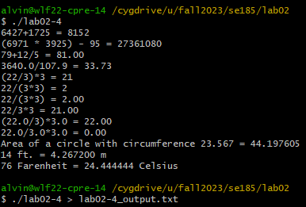

4.2

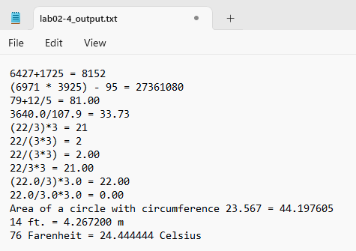

# Problem

Creating a program that finds the length of one side of a triangle using Pythagorean Theorem.

# Analysis

The length of one side of a triangle, c, is c2 = b2 + a2

# Design

I included math.h to use sqrt() function to find the square root of a2 + b2

# Testing

I tested the program by inputting values a = 5 and b = 9

# Comments

I did not encounter any problem

# Source Code

/*----------------------------------------------------------------------------

- SE 185: Lab 02 - Solving Simple Problems in C -

- Name: Alvin Thomas -

- Section: 2 -

- NetID: alvin -

- Date: 9/5/2023 -

-----------------------------------------------------------------------------*/

/*----------------------------------------------------------------------------

- Includes -

-----------------------------------------------------------------------------*/

#include <stdio.h>

#include <math.h> // Google this header file to learn more! :)

/*----------------------------------------------------------------------------

- Implementation -

-----------------------------------------------------------------------------*/

int main(int argc, char *argv[])

{

double a, b, c;

double filler;

/* Put your code after this line */

printf("Enter the value of a: ");

scanf("%lf", &a);

printf("Enter the value of b: ");

scanf("%lf", &b);

/* This next line will calculate the square root of whatever value is

* inside the parenthesis and assigns it to the variable filler. */

filler = sqrt((a*a)+(b*b));

c=filler;

printf("c = %lf",c);

return 0;

}

# Screen Shots

5.1

