**LAB REPORT**

**LAB #3**

**SECTION #2**

**FULL NAME**

**Alvin John Thomas**

**SUBMISSION DATE:**

**9/16/2023**

**DATE**

**9/12/2023**

# Problem

1: DualShock 4 Data Collection

# Analysis

ds4rd.exe was downloaded and saved to lab03 folder.

# Design

When I moved the controller, the outputted values changed.

# Testing

I took 3 data samples saved to a .csv file. I then opened them in a spreadsheet and created a scatter plot based on the values.

# Comments

The scatter point changed as the values changed.

# Screen Shots

1.1

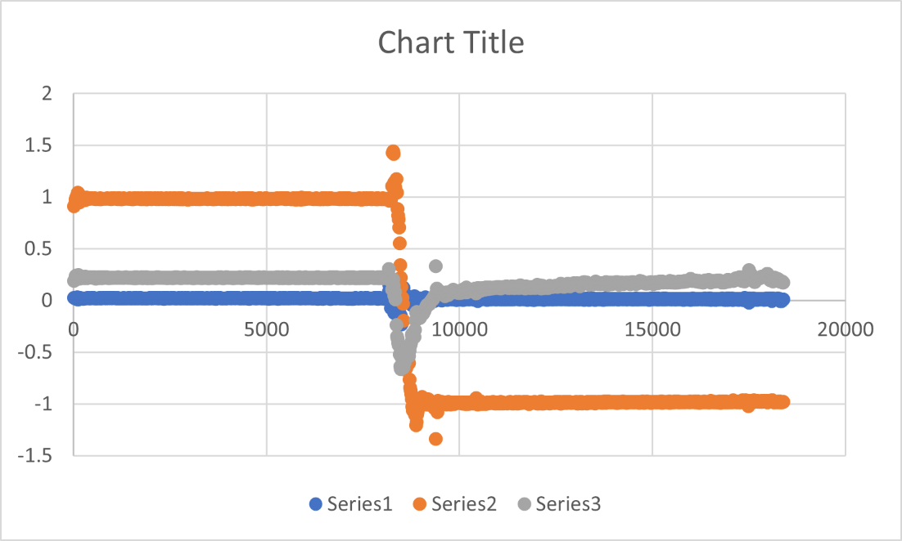

1.2

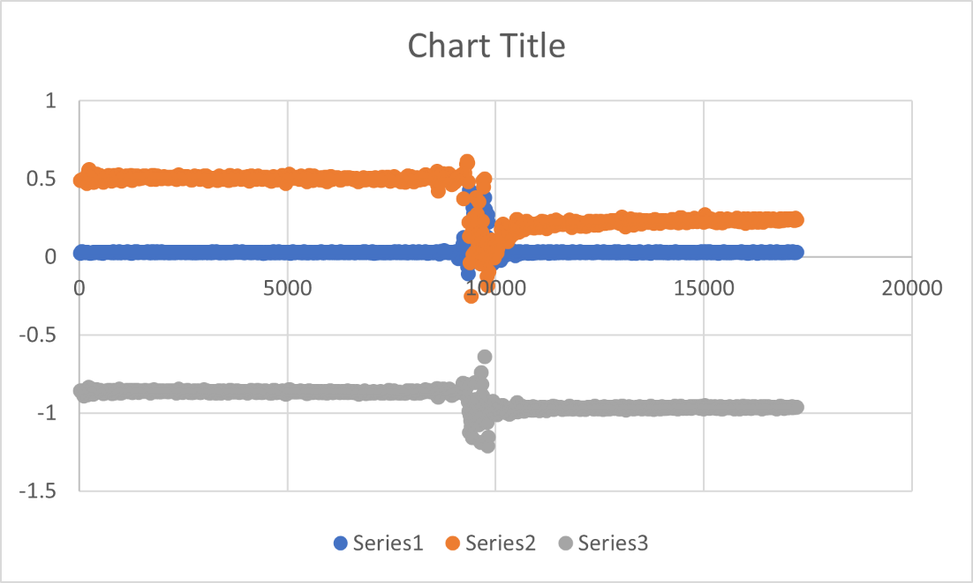

1.3

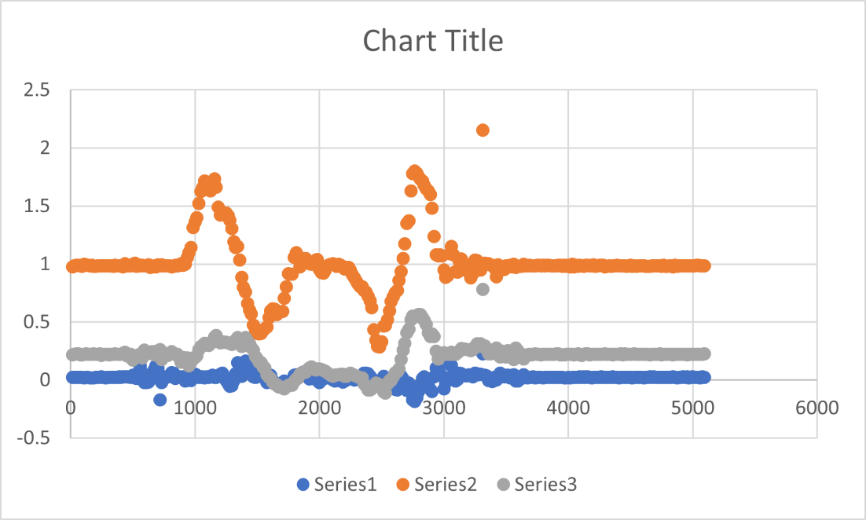

# Problem

2: Write a function to calculate magnitude of acceleration. Also write three functions to convert milliseconds to minutes, seconds and milliseconds.

# Analysis

Magnitude of acceleration is √x2+y+z2

# Design

I wrote three functions which accept milliseconds and return values of minutes, seconds and milliseconds as integers.

# Testing

I moved the controller around to see if the magnitude of acceleration changed.

# Comments

I did not encounter any problems.

# Source Code

/*----------------------------------------------------------------------------

- SE 185: Lab 03 - Introduction to the DS4 and Functions -

- Name: Alvin Thomas -

- Section: 2 -

- NetID: alvin -

- Date: 9/12/2023 -

-----------------------------------------------------------------------------*/

/*----------------------------------------------------------------------------

- Includes -

-----------------------------------------------------------------------------*/

#include <stdio.h>

#include <math.h>

/*----------------------------------------------------------------------------

- Prototypes -

-----------------------------------------------------------------------------*/

double magnitude(double x, double y, double z);

/*----------------------------------------------------------------------------

- Notes -

-----------------------------------------------------------------------------*/

// Compile with gcc lab03-1.c

/*----------------------------------------------------------------------------

- Implementation -

-----------------------------------------------------------------------------*/

int main(int argc, char *argv[])

{

/* DO NOT MODIFY THESE VARIABLE DECLARATIONS */

int t;

double ax, ay, az;

while (1)

{

scanf("%d, %lf, %lf, %lf", &t, &ax, &ay, &az);

/* CODE SECTION 0 */

printf("Echoing output: %08.3lf, %07.4lf, %07.4lf, %07.4lf\n", t/1000.0, ax, ay, az);

/* CODE SECTION 1 */

printf("At %d ms, the acceleration's magnitude was: %lf\n", t, magnitude(ax, ay, az));

/* CODE SECTION 2 */

printf("At %d minutes, %d seconds, and %d milliseconds it was: %lf\n",

minutes(t), seconds(t), milliseconds(t), magnitude(ax, ay, az));

}

return 0;

}

/* Put your functions here */

int minutes(int t)

{

int m = t/60000;

return m;

}

int seconds(int t)

{

int s = (t%60000)/1000;

return s;

}

int milliseconds (int t)

{

int ms = t%1000;

return ms;

}

/*

* Calculates and returns the magnitude of three given values.

*

* @param x - The x-axis scanned values from the DS4 controller.

* @param y - The y-axis scanned values from the DS4 controller.

* @param z - The z-axis scanned values from the DS4 controller.

* @return - The magnitude of the given values.

*/

double magnitude(double x, double y, double z)

{

// Step 8, uncomment and modify the next line

return sqrt(x*x+y*y+z*z);

}

# Screen Shots

2.1 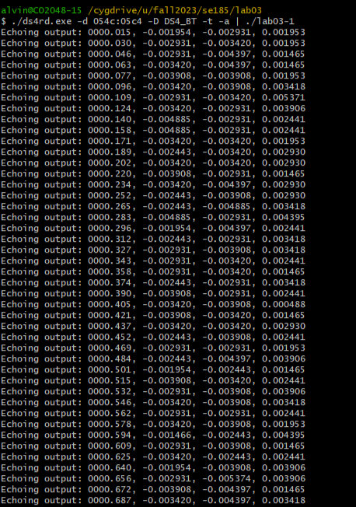

2.2 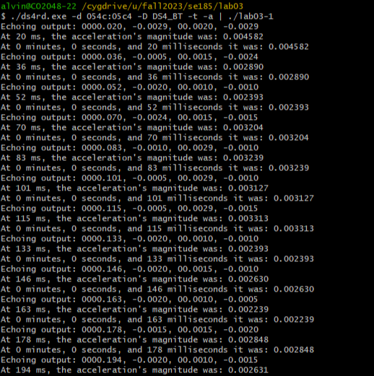

# Problem

3: Write a program to count the number of buttons being pressed on the controller

# Analysis

When a button is pressed the value changes from 0 to 1.

# Design

I wrote a function which added up the values to know how many buttons are being pressed.

# Testing

I tried pressing different combinations of buttons on the controller to see if it outputted the correct number of buttons being pressed

# Comments

I did not encounter any problems.

# Source Code

/*----------------------------------------------------------------------------

- SE 185: Lab 03 - Introduction to the DS4 and Functions -

- Name: Alvin Thomas -

- Section: 2 -

- NetID: alvin -

- Date: 9/16/2023 -

-----------------------------------------------------------------------------*/

/*----------------------------------------------------------------------------

- Includes -

-----------------------------------------------------------------------------*/

#include <stdio.h>

#include <math.h>

/*----------------------------------------------------------------------------

- Prototypes -

-----------------------------------------------------------------------------*/

/*----------------------------------------------------------------------------

- Notes -

-----------------------------------------------------------------------------*/

// Compile with gcc lab03-2.c -o lab03-2

// Run with ./ds4rd.exe -d 054c:05c4 -D DS4_BT -b | ./lab03-2

/*----------------------------------------------------------------------------

- Implementation -

-----------------------------------------------------------------------------*/

int main(int argc, char *argv[])

{

int triangle;

int circle;

int x;

int square;

while (1)

{

scanf("%d, %d, %d, %d", &triangle, &circle, &x, &square);

printf("Number of buttons being pressed: %d\n", buttons(triangle, circle, x, square));

fflush(stdout);

}

return 0;

}

/* Put your functions here, and be sure to put prototypes above. */

int buttons(int triangle, int circle, int x, int square)

{ int numButtons = triangle + circle + x + square;

return numButtons;

}

# Screen Shots

3.1 