**LAB REPORT**

**LAB #6**

**SECTION #2**

**FULL NAME**

**Alvin John Thomas**

**SUBMISSION DATE:**

**10/10/2023**

**DATE**

**10/3/2023**

# Problem

Write a program that acts a Bop-It game. It should have a start menu asking the user button to start and wait for the user to push a button. The game will involve printing a line telling the user which button to press (chosen randomly by the program) and will wait a certain time for a response. After each successful action by the player the time the program will wait for a response will reduce. The game ends when the player does the wrong action or time runs out.

# Analysis

I had to figure out how to make a timer so that the game ends when time runs out. I had to figure out a way to prevent a player from just pressing every button. I need to generate a random button for the user to press each time.

# Design

I used variables t, timeCheck and timeCount to create a timer. To prevent the player from pressing multiple buttons at a time, I used an if statement to make sure only one button was being pressed at a time.

# Testing

I tested the program by letting the time run out to see if the game ended, as seen in screenshot 1.1. I also checked by pressing a wrong button to see if the program would terminate, as seen in screenshot 1.2. I checked to see if the number of successful buttons pressed at the end was correct.

# Comments

1. How did you randomize the buttons that needed to be pressed?

A. I used rand() function. The statement rand()%4+1; returns an integer value between 1 and 4. I stored it in a variable n. Then using if, else if statements I printed the button to be pressed corresponding to each n value.

2. What game states, if any, did you keep track of?

A. I kept track of the time using a timer I made with 3 variables. I also kept track of the number of correct button presses using a variable, count.

3. What mechanism did you use to make sure extraneous button presses were not registered?

A. I used if statements to make sure only one button was pressed, if more than one button is pressed the if statement will not be entered and the game will terminate.

# Screen Shots

1.1

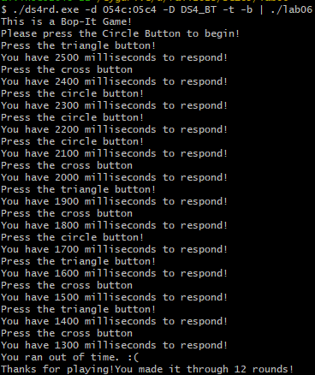

1.2

