,The Raspberry Pi Beboputer: A Hands-On Tour of PY-DIYCALCULATOR

Install it, meet the interface, write your first program, and build a working calculator — all on a Raspberry Pi

By Alvin Brown & Clive “Max” Maxfield

This article is a single, self-contained walkthrough of PY-DIYCALCULATOR on the platform it is built for: the Raspberry Pi. It covers everything you need to go from a blank SD card to a working four-function calculator written entirely in 8-bit assembly language — what the software is, how to get it from GitHub onto your Pi, a guided tour of the interface, how to write and run your first program, how to watch that program execute instruction by instruction in the Memory Walker, and finally how to build a real calculator program from scratch. Along the way it points to the full tutorial series for anyone who wants to go deeper.

What Is PY-DIYCALCULATOR?
PY-DIYCALCULATOR is a fully functional emulator of the fictional 8-bit Beboputer CPU, implemented in Python 3 and tkinter. It faithfully recreates the instruction set, memory architecture, and peripherals of the original “DIY Calculator” project from the book How Computers Do Math by Clive “Max” Maxfield and Alvin Brown, updated for modern desktops — and, in particular, for Raspberry Pi OS.
The DIY Calculator is based on a very simple microcomputer system comprising a central processing unit (CPU), some memory, and a set of memory-mapped input and output (I/O) ports that let the system “talk” to the outside world. This virtual system comes equipped with an assembler and a variety of diagnostic tools — a CPU register display, a live memory viewer, a disassembler, and more. It also features a virtual calculator front panel with buttons, lights, and a pseudo-LCD display, all wired to the CPU through the same kind of I/O ports a real 1970s-era microcomputer would have used.
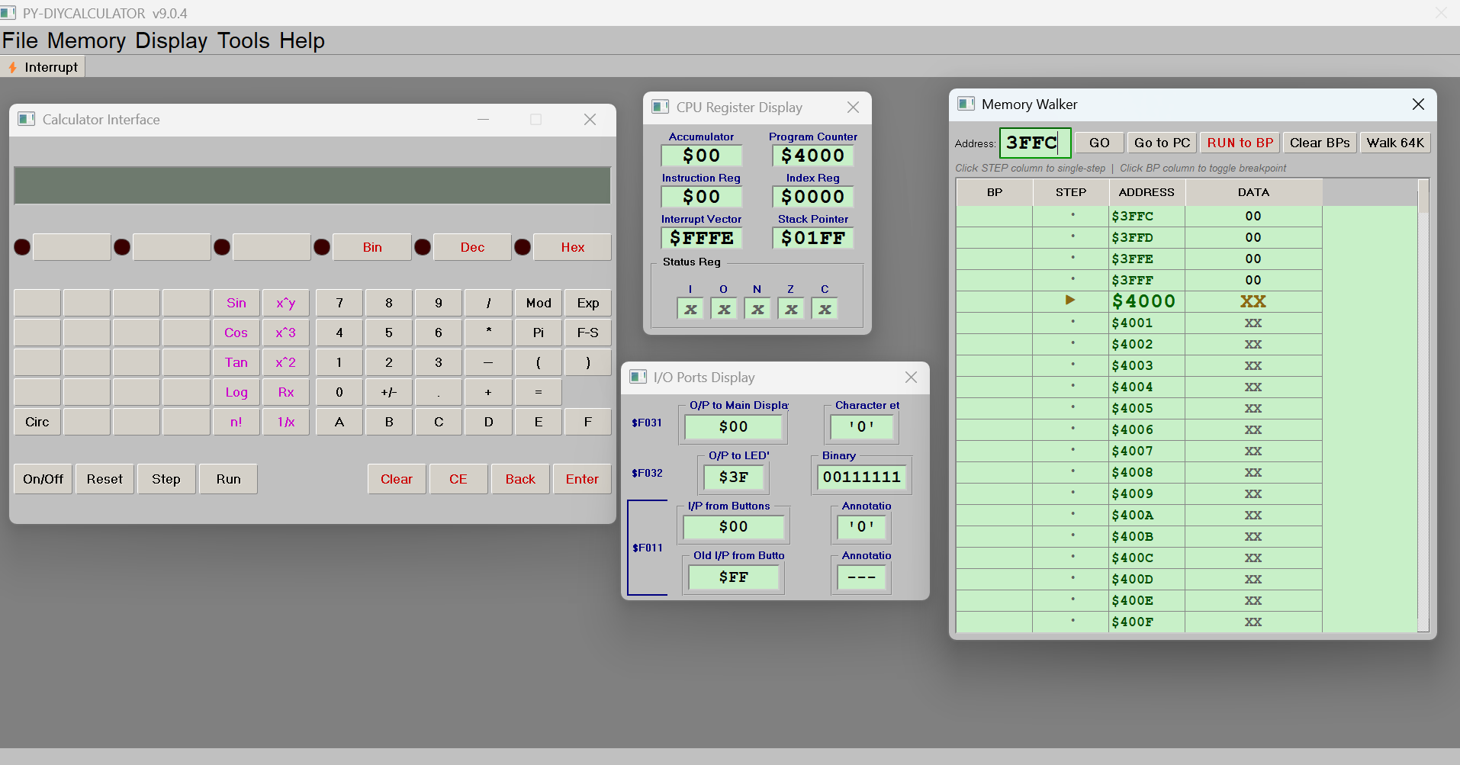
Figure 1: PY-DIYCALCULATOR's floating panels — Calculator, CPU Register Display, I/O Ports Display, and Memory Walker — all open at once.
The application presents a rich graphical user interface with multiple floating panels, a built-in assembler and text editor, a virtual workbench with switches and LEDs, a calculator widget, a hexadecimal keyboard, and a CRT-style terminal. Every one of these panels is a live window onto the same 64KB of emulated RAM, which is what makes the whole thing such a good teaching tool: you can change a register in one panel and watch the effect ripple through the others in real time.
What makes the Raspberry Pi such a good host for this software is a combination of factors: the Pi runs a Debian-based Linux distribution, Python 3 is a first-class citizen of the platform, and tkinter ships with the standard Python installer — there is nothing extra to compile, no GPU drivers to fight, and no licensing to worry about. A modestly priced computer running a free, open-source emulator of a free, open-source 8-bit machine is exactly the kind of full-circle nerdery this project was made for.

Before You Begin: What You Will Need
To follow this guide you will need:
- A Raspberry Pi 3B+, Pi 4 (any RAM variant), or Pi 5
- Raspberry Pi OS (Bookworm or Bullseye, Trixy, 32-bit or 64-bit)
- A keyboard, mouse, and monitor (or Pi-Connect)
- An internet connection to fetch the software from GitHub
Older Pi models such as the Pi 2 or Pi Zero are not recommended — they lack the processing power to keep the GUI responsive, and the tkinter interface can be slow to redraw on lower-specification hardware. On a Pi 4 or Pi 5, the application launches in under five seconds and runs perfectly throughout a long session.

Installing PY-DIYCALCULATOR from GitHub
PY-DIYCALCULATOR lives at github.com/alvinmb/DIYCalculator. There are two ways to get it onto a Pi: install the prebuilt .deb package straight from the project's GitHub releases (one dpkg command and you're done), or clone the source and run it directly with Python. Either method gets you the same application; pick Method 1 if you just want to use it, or Method 2 if you want the full source tree to read or tweak.

Method 1: Install the Prebuilt .deb Package (Recommended)
The project publishes a Debian package, beboputer_<version>_all.deb, built with the build_deb.sh script that ships in the repo. Because PY-DIYCALCULATOR is pure Python, the package is architecture-independent and installs identically on any Pi model, 32-bit or 64-bit.
Open a terminal and fetch the latest release's .deb asset directly from GitHub:
DEB_URL=$(curl -s https://api.github.com/repos/alvinmb/DIYCalculator/releases/latest \
| grep "browser_download_url.*\.deb" \
| cut -d '"' -f 4)
wget "$DEB_URL"
Then install it with dpkg, and let apt-get install -f pull in the one dependency the package declares (python3-tk) if it isn't already on your system:
sudo dpkg -i beboputer_*.deb
sudo apt-get install -f
That's the whole installation. dpkg unpacks the application to /usr/share/beboputer, installs a beboputer launcher to /usr/bin, and registers a .desktop entry so PY-DIYCALCULATOR appears in the Education category of the Raspberry Pi OS application menu.

Method 2: Run Directly from Source
If you want the full project tree on your Pi — to read or tweak the Python source, add your own tutorial exercises, or track development between releases — clone the repository instead and run it straight from Python:
cd ~
git clone https://github.com/alvinmb/DIYCalculator.git Bebop_python
No git installed? sudo apt install git, or download the zip archive from the green Code button on the GitHub repository page and unzip it instead:
cd ~
unzip DIYCalculator-main.zip
mv DIYCalculator-main Bebop_python
Check that tkinter is available — it ships with Python on Raspberry Pi OS, but if python3 -c "import tkinter" reports an error, install it with sudo apt install python3-tk. Then launch the application directly:
cd ~/Bebop_python/bin
python3 -m beboputer_tk
That's it — no installer script, no files copied elsewhere, no desktop entry. Running this way is ideal for development, since you can edit the source in place and re-run to see changes immediately.

Launching the Application
If you installed via Method 1, click the newly created menu entry, or launch it from a terminal:
beboputer
If you ran it from source (Method 2), use the python3 -m beboputer_tk command shown above instead. Either way, the application opens maximised, filling your screen with the main window — a normal, resizable window with the usual title bar, but the intent is a dedicated, full-screen learning environment, so the cleanest way to exit is File → Exit, which shuts down the CPU timer and closes every floating panel before quitting.

A Tour of the Interface
When PY-DIYCALCULATOR first opens, you are greeted by a menu bar — File, Setup, Display, Memory, Tools, Help — and three panels open by default: the Calculator, the Memory Walker, and the Message Display. Every other panel lives in the Display, Memory, or Tools menu and opens as its own floating window that you can drag, resize, and close independently. Nothing about the layout is fixed, so feel free to arrange the panels however suits your screen.

The CPU Registers Panel
Opened from Display → CPU Registers, this panel is the heartbeat of the emulator. It shows the current value of every register in the machine: the Accumulator (ACC), the 16-bit Program Counter (PC), the Instruction Register, the Index Register (IX), the Stack Pointer (SP), the Interrupt Vector, and the individual flag bits — Carry, Overflow, Negative, Zero. Watching these registers change one instruction at a time, using the Memory Walker's single-step feature described later, is one of the most educational aspects of the whole tool.
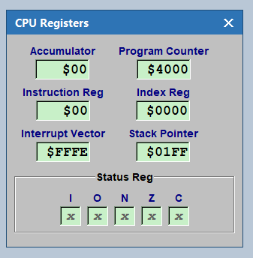
The CPU Register Display panel.

The Disassembler
Opened from Display → Disassembler, this panel reads instructions starting at the Program Counter and shows the human-readable assembly mnemonics they correspond to, alongside the raw machine-code bytes. It is a handy way to confirm that the bytes your assembler produced really do mean what you think they mean.
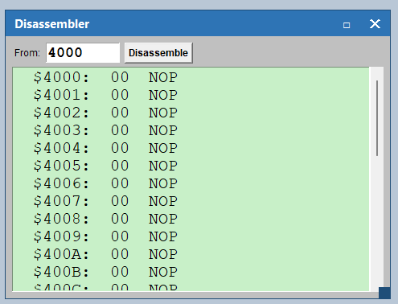
The Disassembler panel.

The Port Map Status
Opened from Display → Port Map Status, this panel shows the live value of every memory-mapped I/O port in the system side by side — the calculator display and keypad ports, the Workbench switches and LEDs, and the Terminal port. It is the fastest way to see, at a glance, what a running program is currently doing to the outside world.
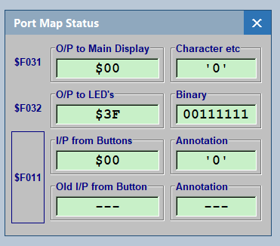
The Port Map Status panel.

Message Display and Terminal
The Message Display (open by default) is the application's diagnostic log — a scrolling text panel that records system events such as successful assemblies, load results, and errors. The Terminal, opened from Display → Terminal, is a CRT-style output device driven by the Beboputer itself through a dedicated memory-mapped port; any program can print characters to it the same way a real serial terminal would receive them.

The Memory Walker
Opened from Memory → Memory Walker (and already open by default), this is the single most useful debugging tool in the application: a live, scrollable view of all 64KB of RAM, with a Program Counter marker that tracks execution and per-row breakpoint and single-step controls. It gets a full walkthrough of its own later in this article.

The Tools Menu
Beyond the display panels, the Tools menu opens a set of interactive tool windows.
- EPROM Burner — simulates programming read-only memory: load a pre-assembled binary image into any region of the 64KB address space.
- Calculator... — the virtual calculator front panel: buttons, LEDs, and an LCD-style display, wired to the CPU through I/O ports exactly like the real DIY Calculator hardware.
- Keyboard... — a virtual hexadecimal keypad that simulates the physical keyboard described in How Computers Do Math, using a status-then-data two-port polling design.
- Workbench 1... — the most visually engaging tool in the application: a panel of physical-style switches, LEDs, and 7-segment displays wired to their own dedicated I/O ports.
- Assembler / Editor... — the integrated development environment where you write, assemble, and load Beboputer programs. Covered in detail in the next section.
- Code Coverage... and Code Profiler... — analysis tools added in v10.1.4 that show which lines of a program actually ran, and where it spent most of its execution time. See Tutorial 18 in the tutorial series for a hands-on walkthrough of both.
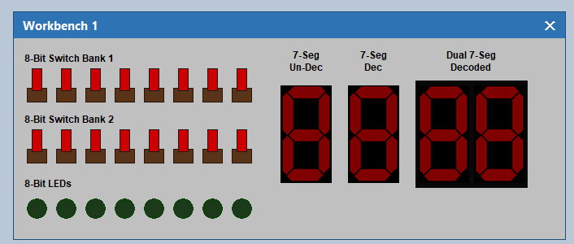
Workbench 1 — switches, LEDs, and 7-segment displays.
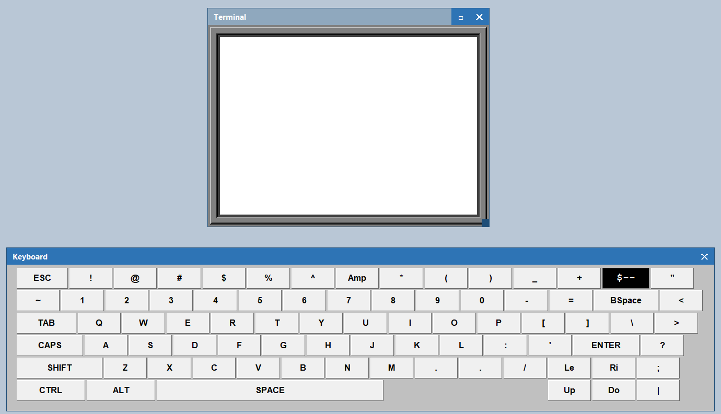
The virtual hexadecimal Keyboard.
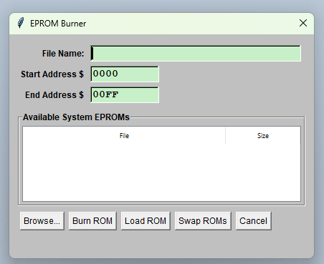
The EPROM Burner.

The Setup Menu
The Setup menu controls how the emulator behaves rather than what it displays: System Clock... sets how fast the emulated CPU runs, Interrupt fires a one-off hardware interrupt, and Load/Save Button File... and Restore Defaults manage custom key mappings for the Calculator and Keyboard panels. The System Clock dialog is the one you will reach for most — slowing the clock down to a few Hz while you step through a loop makes it much easier to watch the Memory Walker and Port Map update on every pass.
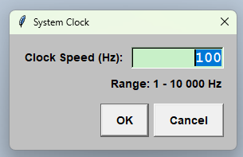
The System Clock dialog (Setup → System Clock...) sets the emulated CPU speed, from 1 Hz up to 10,000 Hz.

Writing Your First Assembly Language Program
The Assembler / Editor, opened from Tools → Assembler / Editor..., is the integrated development environment where you write, assemble, and load Beboputer programs. The source editor occupies the main part of the window; the toolbar across the top provides Assemble and Load → CPU, and the Messages panel at the bottom reports the result of every assembly attempt — success, with the address range and byte count, or a line-numbered error if something is wrong.
The Beboputer assembly language is clean and readable. Instructions use familiar mnemonics — LDA to load the accumulator, STA to store it, JMP to jump — and comments begin with #. Memory addresses are written in square brackets, either as a raw hex address like [$F000] or, more commonly, as a symbolic label defined earlier in the program with .EQU.
Here is a complete, working program — the simplest one in the tutorial series — that reads Switch Bank 1 on the Workbench and mirrors its value continuously to the LED bar:
SW1: .EQU $F000
LED8: .EQU $F022
.ORG $4000
LOOP: LDA [SW1]
STA [LED8]
JMP [LOOP]
.END $4000
The two .EQU lines just give friendly names to two I/O port addresses. .ORG $4000 tells the assembler where in RAM the program should live — $4000 is the conventional start address for user programs, leaving the region below it free for the stack and system use. The loop itself is three instructions: load the switches, store that value to the LEDs, jump back to the top — forever.
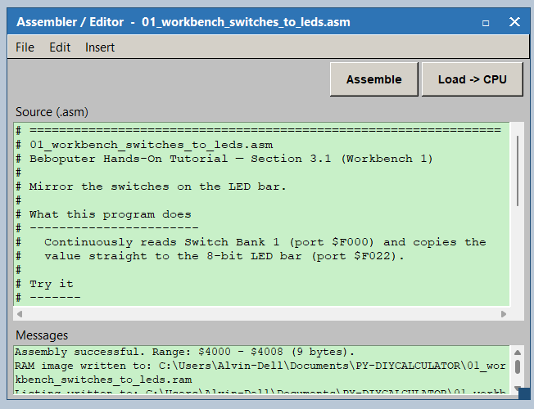
The Assembler / Editor with the switches-to-LEDs program assembled successfully.

Assembling, Loading, and Running It
Type the program into the Source (.asm) box (or use File → Open... if you saved it to disk first), then click Assemble. A successful assembly reports the address range and byte count in the Messages panel:
Assembly successful. Range: $4000 - $4008 (9 bytes).
Click Load -> CPU to copy those bytes into the emulator's RAM at the address the program specified. At this point the Memory Walker (see the next section) will show your program's bytes sitting at $4000 if you scroll or type that address into it. Nothing is executing yet — loading and running are two separate, deliberate steps, which is exactly what makes it possible to inspect a freshly loaded program before a single instruction of it has run.
To actually run it, press Run on the Calculator panel (or Step to execute one instruction at a time — see below). With the switches-to-LEDs program above, open Tools → Workbench 1..., flip a few switches in Switch Bank 1, and watch the LED bar respond immediately, updated 100 times a second by the default system clock.

Watching It Run in the Memory Walker
The Memory Walker (Memory → Memory Walker, and open by default) is a live, scrollable table of all 64KB of RAM: one row per address, with the current byte value shown in hex. Type an address into the Address field and click GO to jump the view there directly — for example, type 4000 to see the switches-to-LEDs program you just loaded, byte for byte, exactly as the assembler emitted it.
- BP column — click this cell next to any address to toggle a breakpoint on it (marked with a red dot). RUN to BP then runs the CPU at full speed and stops the instant it fetches an instruction from that address.
- STEP column — click this cell to single-step: execute exactly one instruction and stop, so you can watch the Program Counter, the byte values, and the CPU Registers panel change one instruction at a time.
- Go to PC — scrolls the view to wherever the Program Counter currently is, which is useful after you have scrolled away to inspect a data table elsewhere in RAM.
- Clear BPs — removes every breakpoint you have set.
While a program is running or single-stepping, an amber marker (▶) appears next to the row at the current Program Counter, and the view automatically scrolls to keep that row in sight.
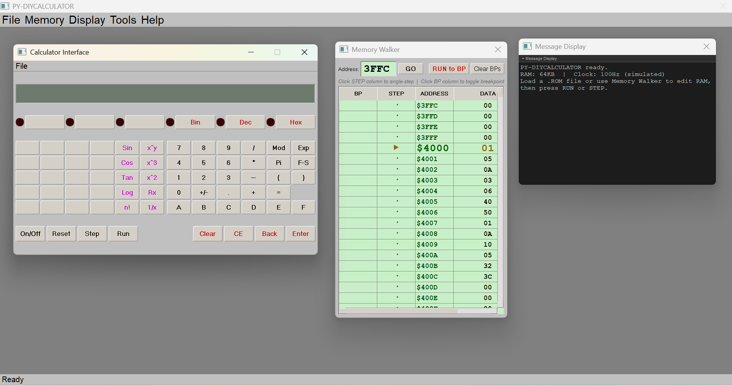
The Memory Walker mid-run: the amber PC marker sits at $4000, the first byte of the loaded program, with the Message Display and Calculator open alongside it.
Try it: Load the switches-to-LEDs program from the previous section, click the BP cell next to the LOOP: label's address ($4000) before pressing Run. Execution stops the instant it reaches that instruction — click RUN to BP repeatedly and watch the CPU race around the three-instruction loop, one full lap per click. Slow the System Clock down to a few Hz first (Setup → System Clock...) if you would rather watch it happen at full speed instead of one lap at a time.

Building a 4-Function Calculator
Once you are comfortable loading, running, and stepping through a small program, the natural next project is the one at the heart of How Computers Do Math: a real, working calculator. The full exercise lives in tutorial/10_calculator_four_function.asm and its companion document, Building a 4-Function Calculator — this section gives you the shape of it.
Once assembled, loaded, and run, the finished program behaves like this on the Calculator panel:
5 + 3 = -> shows 5+3=8
7 * 8 = -> shows 7*8=56
2 - 9 = -> shows 2-9=-7
9 / 0 = -> shows 9/0=Err
Two memory-mapped ports do all the work. $F011 is the keypad port: it is a read-clear latch, meaning the instant your program reads a non-$FF value from it, the port resets to $FF so the same keypress can never be read twice by accident. $F031 is the display port: writing a character to it simply appends that character to the Calculator's display, so the display behaves like a tiny one-line terminal rather than a fixed set of digit slots — which is exactly what lets the program build up strings like 5+3=8 one character at a time.
The whole program is one loop built around a single state variable, STAGE, that tracks what the calculator is waiting for next — a first operand, an operator, a second operand, or the Enter key. Every keypress runs through the same short dispatcher: read the key exactly once from $F011, check globally for Clear/CE, then jump to the routine for the current stage. Each stage routine updates STAGE and moves on.
The Beboputer CPU has no hardware multiply or divide instruction, so multiplication is done by repeated addition and division by repeated subtraction — both counting how many times the operation happens to build the result. Subtraction is the trickiest of the four, because it depends on getting the Carry flag's meaning exactly right: CMPA sets Carry only when the accumulator is strictly greater than the operand, so a correct "is A at least as big as B" test needs both a Carry check and a Zero check. Missing the Zero case was, in fact, a real bug caught during testing — exactly the kind of subtle, easy-to-miss branch the Code Coverage tool mentioned earlier (Tools → Code Coverage..., see Tutorial 18) is built to catch.
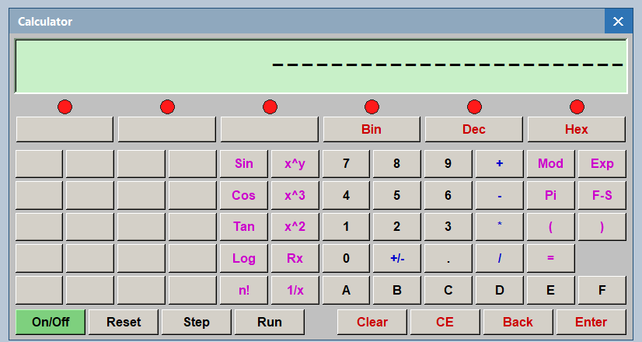
The Calculator panel mid-calculation.
The full tutorial document walks through every stage of the state machine, the complete multiply and divide routines, negative-number display, divide-by-zero handling, and two real bugs (and their fixes) found while building it — well worth reading end to end once you have this article's shorter version working.

Where to Go Next: The Full Tutorial Series
Everything above is enough to get you writing and running your own Beboputer programs on a Raspberry Pi. From here, the hands-on tutorial series takes you through the rest of the application's peripherals — the Workbench, Keyboard, and Terminal, trigonometry and BCD math, hex/binary conversion, and the Code Coverage and Code Profiler tools introduced earlier. Each exercise is a separate document; click a title below to open it (the files live in the tutorial folder alongside this article):
- Beboputer Hands-On Tutorial — Exercises 01–09 — the foundational walkthrough of the Workbench, Calculator, Keyboard, and Terminal.
- Building a 4-Function Calculator — Exercise 10 — the full version of the calculator built above, with every routine explained.
- Adding a Circumference Button — Exercise 11 — add a dedicated circumference button to the calculator.
- Sin, Cos, and Tan: Trig Functions on the Beboputer — Exercise 12 — implement trigonometric functions.
- Basic BCD Math Routines: +, -, *, / — Exercise 13 — write core BCD arithmetic routines.
- Hex ↔ Binary Conversion with the Top-Row Bin/Hex Buttons and LEDs — Exercise 14 — convert between hex and binary using the top-row buttons and LEDs.
- Lab 2: Beboputer Fundamentals — Exercises 15a–15f — a guided lab covering the fundamentals.
- Lab 3: Loops, Nybbles, the Stack, and Recursion — Exercises 16a–16q — loops, nybbles, the stack, and recursion.
- Scientific Functions in BCD: Sin, Cos, Tan, x², and n! — Exercise 17 — scientific functions implemented in BCD.
- Code Coverage & Code Profiler — Exercise 18 — analyse which lines run and where time is spent.
- A Tiny BASIC Interpreter — Exercise 19 — write and run small BASIC-style programs on the emulated CPU using the Keyboard and Terminal.

Why the Raspberry Pi Is the Perfect Host
There is something philosophically appropriate about running an 8-bit computer emulator on a modern ARM single-board computer that itself started life as an education project. For educators, the combination is compelling: a classroom of Raspberry Pis, each running PY-DIYCALCULATOR, gives every student their own virtual 8-bit lab bench for the price of the Pi alone — no proprietary tools, no per-seat licensing, and a codebase small enough to read in an afternoon.
Install it. Flip the switches. Watch the LEDs. Write a few dozen lines of assembly. Step through them instruction by instruction and watch the registers change. Build the calculator. That kind of ground-up understanding — of how a handful of transistors and a simple instruction set add up to a working machine — is rarer than it should be. PY-DIYCALCULATOR, on a Raspberry Pi, puts it within reach of everyone who bothers to try.
Festooned with nuggets of information and tidbits of trivia, our book How Computers Do Math (ISBN: 0471732788) provides the full story behind every exercise in this series, for anyone who wants to keep going once the Pi is up and running.

