A Virtual 8-Bit Computer on a Raspberry Pi

How PY-DIYCALCULATOR brings a classic computing education project to life on the world’s favourite single-board computer

By Alvin Brown & Clive “Max” Maxfield

There is something deeply satisfying about understanding how a computer works from the ground up — not in the abstract sense of software layers and operating system calls, but right down to the transistors, logic gates, registers, and raw binary arithmetic that make every digital device tick. For decades, the book How Computers Do Math by Clive “Max” Maxfield and Alvin Brown has guided curious minds through the architecture of an imaginary 8-bit computer called the Beboputer, teaching assembly language, memory-mapped input and output, binary arithmetic, and the fundamentals of CPU design. Now, with PY-DIYCALCULATOR — a faithful Python and tkinter reimagining of the original companion software — the Beboputer has arrived on the Raspberry Pi, and the combination is nothing short of wonderful.
This article walks you through everything you need to know: what PY-DIYCALCULATOR is, what it can do, how to get it running on your Pi, and how to start writing your first assembly language programs.

What Is PY-DIYCALCULATOR?
PY-DIYCALCULATOR is a fully functional emulator of the fictional 8-bit Beboputer CPU, implemented in Python 3 and tkinter. It faithfully recreates the instruction set, memory architecture, and peripheral devices described in How Computers Do Math, giving readers — and anyone curious about computing history and CPU design — a hands-on environment in which to experiment without needing any physical hardware beyond the computer in front of them.

Don’t Panic if any of the terms on this page are unfamiliar to you, because everything is explained in our book How Computers Do Math, and by the time you’ve read this little scamp you’ll be an expert.
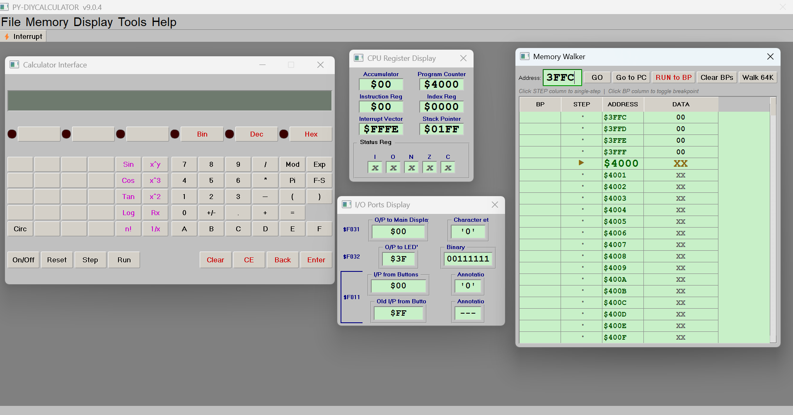
Figure 1 shows the PY-DIYCALCULATOR main window.

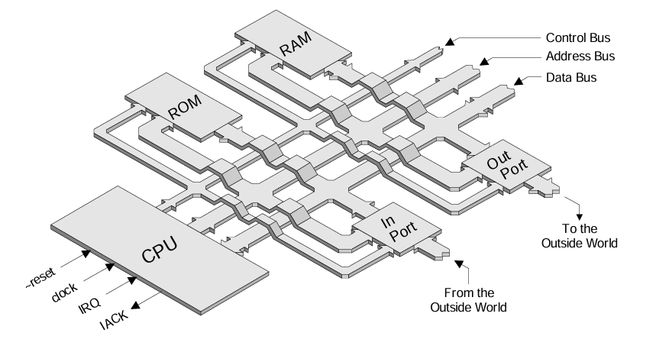

The DIY Calculator is based on a very simple microcomputer system comprising a central processing unit (CPU), some memory, and some input and output (I/O) ports (these ports allow the system to “talk” with the outside world). The CPU itself is very straightforward and easy to understand: it has an 8-bit data bus and a 16-bit address bus; it contains a small number of simple registers like an accumulator, index register, and stack pointer; and it supports a very simple instruction set along the lines of ADD, SUBTRACT, SHIFT, ROTATE, AND, and OR.
This virtual system comes equipped with an assembler and a variety of diagnostic tools, such as a CPU Register Display, a Memory Display, and more — the list goes on.
The DIY Calculator also features a virtual calculator front panel with buttons, lights, and a pseudo-liquid crystal display (LCD). This front panel is “connected” to the virtual computer via its input and output ports.
The application presents a rich graphical user interface with multiple floating panels, a built-in assembler and text editor, a virtual workbench with switches and display devices, a calculator widget, a terminal, a memory walker, a disassembler, and a simulated clock. Every instruction the virtual CPU executes is visible in real time. Every memory location can be inspected. Every port can be watched. It is, in effect, a complete learning laboratory for 8-bit computing.
During the course of How Computers Do Math, we learn how to create software routines that detect when the various buttons are pressed, input decimal numbers and convert them into the binary representations used by the computer, perform math operations on these numbers, and then convert them back into decimal values to be presented on the main display.
First we learn about the binary and hexadecimal number systems, and then we learn a little about computers and calculators and perform some simple experiments with the DIY Calculator. Next we are introduced to some fundamental computing concepts such as the use of the index register, the stack, and subroutines. Along the way we gain familiarity with the assembly language used to create programs for the DIY Calculator.
As we proceed through the book, we create a simple four-function (add, subtract, multiply, and divide) calculator program that treats all values as 16-bit integers. Although it is fun to see this calculator perform its magic, we also discover the limitations associated with our 16-bit number representations. Thus, in the More Cool Stuff area on the website, we introduce more sophisticated representations such as fixed-point and floating-point.
And in addition to all of the above, we’ll discover lots of interesting snippets of information, such as the origin of the math symbols we use like +, −, ×, ÷, and =.
What makes the Raspberry Pi such an ideal host for this software is a combination of factors: the Pi runs a Debian-based Linux distribution, Python 3 is a first-class citizen of the platform, tkinter ships with the standard Python installer, so there is no separate GUI toolkit to install, and the Pi is inexpensive enough that a student or hobbyist can dedicate one entirely to this kind of project. Running PY-DIYCALCULATOR on a Raspberry Pi 4 or Pi 5 with a connected display feels completely natural — the GUI is responsive, the assembler is fast, and the whole experience has the right flavour of sitting in front of a dedicated learning machine.

Before You Begin: What You Will Need
To follow this guide you will need:
- A Raspberry Pi 3B+, Pi 4 (any RAM variant), or Pi 5
- Raspberry Pi OS (Bookworm or Bullseye, 32-bit or 64-bit)
- A keyboard, mouse, and monitor (or VNC access)
- An internet connection for the initial package installation
- The PY-DIYCALCULATOR project archive (a zip file of the Bebop_python folder)
Older Pi models such as the Pi 2 or Pi Zero are not recommended — they lack the processing power to keep the GUI responsive, and the tkinter interface can be slow to redraw on lower-specification hardware. On a Pi 4 or Pi 5, however, the application launches in under five seconds and runs perfectly throughout a long session.

Installing PY-DIYCALCULATOR on Raspberry Pi OS
There are two ways to get PY-DIYCALCULATOR onto a Pi: install the prebuilt .deb package straight from the project’s GitHub releases (one dpkg command and you’re done), or clone the source and run it directly with python -m beboputer_tk — no separate installer script is needed, since tkinter ships with Python itself. Both take well under two minutes on a Pi 4 with a decent internet connection, and both leave you with the same beboputer launcher command and application-menu entry.

Method 1: Install the Prebuilt .deb Package (Recommended)
The project publishes a Debian package, beboputer_<version>_all.deb, built with the build_deb.sh script that ships in the repo. Because PY-DIYCALCULATOR is pure Python, the package is architecture-independent (all) — the same file installs on a Pi 3, 4, or 5, 32-bit or 64-bit.
Open a terminal and fetch the latest release’s .deb asset directly from GitHub with curl and wget:
DEB_URL=$(curl -s https://api.github.com/repos/alvinmb/DIYCalculator/releases/latest \
| grep “browser_download_url.*\.deb” \
| cut -d ’”’ -f 4)
wget “$DEB_URL”
Then install it with dpkg, and let apt-get install -f pull in the one dependency the package declares (python3-tk) if it isn’t already on your system:
sudo dpkg -i beboputer_*.deb
sudo apt-get install -f
That’s the whole installation. dpkg unpacks the application to /usr/share/beboputer, installs a beboputer launcher to /usr/bin, and registers a .desktop entry so PY-DIYCALCULATOR appears in the Education category of your Raspberry Pi OS application menu, icon included.

Method 2: Run Directly from Source
If you want the full project tree on your Pi — to read or tweak the Python source, add your own tutorial exercises, or track development between releases — clone the repository instead and run it straight from the source tree. Because tkinter ships with the standard Python installer, there is no separate installer script or GUI toolkit to install.
cd ~
git clone https://github.com/alvinmb/DIYCalculator.git Bebop_python
No git installed? sudo apt install git, or download the zip archive from the green Code button on the GitHub repository page and unzip it:
cd ~
unzip DIYCalculator-main.zip
mv DIYCalculator-main Bebop_python
Check that tkinter is available — it ships with Python on Raspberry Pi OS, but if python3 -c "import tkinter" reports an error, install it with sudo apt install python3-tk. Then launch the application directly:
cd ~/Bebop_python/bin
python3 -m beboputer_tk
That’s it — no installer script, no files copied elsewhere, no desktop entry. Running this way is ideal for development (edit the source in place and re-run to see changes immediately), but it does not give you a beboputer launcher command or an application-menu icon — use Method 1 if you want the fully integrated desktop experience.

Launching the Application
If you installed via Method 1, click the newly created menu entry, or launch it from a terminal:
beboputer
If you ran it from source (Method 2), use the same python3 -m beboputer_tk command shown above instead. Either way, the application opens maximised, filling your screen with the main window — a normal, resizable window with the usual title bar, but the intent is still a dedicated, full-screen learning environment, so the cleanest way to exit is File → Exit, which shuts down the CPU timer and closes every floating panel before quitting.

Tools You Will Use While Debugging
These three tools are not tied to any one exercise - you will reach for all of them constantly while working through this tutorial. Get comfortable with them now.

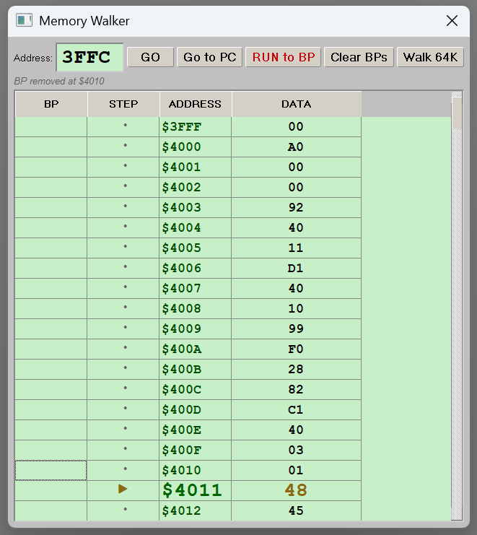
The Memory Walker

The Memory Walker is already open when the application starts (it is one of the three panels shown by default, alongside the Message Display and the Calculator), and it can also be reopened from Memory -> Memory Walker. It shows a scrollable, live 256-row window of RAM with four columns: BP, STEP, ADDRESS, and DATA.

Table 7: Memory Walker Controls
Control | What it does
Address field + GO | Type a 4-digit hex address (e.g. 4000) and click GO to jump the view there. This locks the view in place - it will not auto-follow the Program Counter until you step from inside the Memory Walker again.
Click a BP cell | Toggles a breakpoint (shown as a red dot) at that row's address.
Click a STEP cell | Executes exactly one CPU instruction, independently of the Calculator's Step button, and updates the status line with the mnemonic that ran and the resulting Accumulator value.
RUN to BP | Runs the CPU until it hits any breakpoint, executes HALT, or reaches the safety limit of 500,000 steps.
Clear BPs | Removes every breakpoint.
Double-click a DATA cell | Lets you type a new hex byte directly into that RAM address - a live memory editor.
While your program is running or single-stepping, an amber triangle marks the row at the current Program Counter, and the view automatically scrolls to keep it in sight (unless you have manually navigated there with GO).
Try this: Load the switches-to-LEDs program from the Workbench exercise below, then click the BP cell next to the LOOP label's address before pressing Run. Execution will stop the instant it reaches that address, and you can then use the STEP column to advance one instruction at a time and watch the DATA column change as STA writes to $F022.
Also useful: After assembling a program that includes a .BYTE table (see the message-printing exercise later in this tutorial), type the table's address into the Memory Walker and click GO to confirm the assembler laid out exactly the bytes you expect.

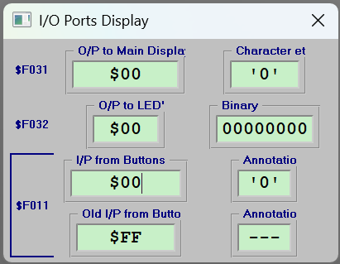
The I/O Ports Display
Open with Display -> Port Map Status. Unlike the Memory Walker, this panel does not show general RAM - it is a dedicated live monitor for exactly three fixed addresses: the ones the Calculator itself uses.
Table 8 shows what the I/O Ports Display shows at each address.

Address | What is shown
$F031 | The last byte written to the Calculator's display, in hex and as a printable character/annotation.
$F032 | The last byte written to the Calculator's LEDs, in hex and as an 8-bit binary pattern.
$F011 | The current key code (hex + annotation) and the previous key code (hex + annotation), so you can see a keypress transition even though the port auto-clears back to $FF.

Important: The I/O Ports Display does NOT show the Workbench's ports ($F000, $F001, $F021-$F024) or the Terminal's port ($F028) - only the three addresses above. For the Workbench exercises, watch the Workbench panel itself; the I/O Ports Display is most useful for the Calculator and Keyboard exercises.
The "I/P from Buttons" field is editable: type a hex value (e.g. 07) into it and press Enter, and it writes that value directly into RAM at $F011 - simulating a keypress without touching the Calculator or the on-screen Keyboard at all. This is a convenient way to feed a specific test value into a WAIT/poll loop while you are debugging it.

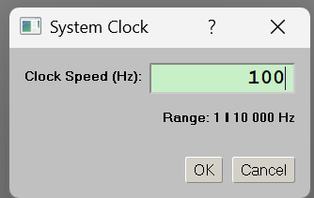
The System Clock
Open with Tools -> System Clock... This dialog sets how fast the emulated CPU runs, from 1 Hz up to 10,000 Hz (the default is 100 Hz). Type a new value and click OK; if Run is currently active, the change takes effect immediately.

Try this: Slow the clock down to around 2-5 Hz before running one of the WAIT-and-poll loops in this tutorial, so you can watch the Memory Walker's PC marker and the I/O Ports Display update on every single pass of the loop. Speed it back up to the default 100 Hz (or higher) once you just want the program to run.

Additional Learning Material
The remainder of this document is the Beboputer Hands-On Tutorial: a set of worked, tested assembly-language exercises for PY-DIYCALCULATOR’s four interactive peripherals (Workbench 1, the Calculator, the on-screen Keyboard, the Terminal), plus reference appendices covering every memory-mapped port, the full instruction set, and the ASCII character set. Where the article above introduces PY-DIYCALCULATOR and its interface, this tutorial is the hands-on companion — start here once you have the application installed and want to write your own Beboputer programs.

Beboputer Hands-On Tutorial
Exercising the Workbench, Calculator, Keyboard, and Terminal with real assembly programs
The tutorial is delivered as a set of separate documents, one per exercise. Click a title below to open it (the files live in the tutorial folder alongside this article):
- Beboputer Hands-On Tutorial — Exercises 01–09 — the foundational walkthrough of the Workbench, Calculator, Keyboard, and Terminal.
- Building a 4-Function Calculator — Exercise 10 — build a working +, −, ×, ÷ calculator.
- Adding a Circumference Button — Exercise 11 — add a dedicated circumference button to the calculator.
- Sin, Cos, and Tan: Trig Functions on the Beboputer — Exercise 12 — implement trigonometric functions.
- Basic BCD Math Routines: +, -, *, / — Exercise 13 — write core BCD arithmetic routines.
- Hex ↔ Binary Conversion with the Top-Row Bin/Hex Buttons and LEDs — Exercise 14 — convert between hex and binary using the top-row buttons and LEDs.
- Lab 2: Beboputer Fundamentals — Exercises 15a–15f — a guided lab covering the fundamentals.
- Lab 3: Loops, Nybbles, the Stack, and Recursion — Exercises 16a–16q — loops, nybbles, the stack, and recursion.
- Scientific Functions in BCD: Sin, Cos, Tan, x², and n! — Exercise 17 — scientific functions implemented in BCD.
- Code Coverage & Code Profiler — Exercise 18 — analyse which lines run and where time is spent.

