THICK-FILM HYBRID LAYOUT CAD
HLayout
A layout editor built specifically for thick-film hybrid microelectronics — resistor inks, conductor traces, dielectric layers, and glaze overprints on a ceramic substrate, alongside standard surface-mount footprints. Reads and writes native GDSII. Every operation works three ways — click it on the canvas, type it in an AutoCAD-style command bar, or drive it with full Python scripting — the same design, three ways in.
THE CANVAS
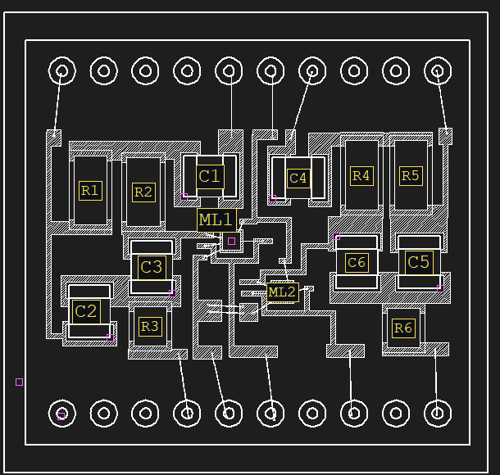
A notch-filter hybrid: resistors, capacitors, bare dies, and routed conductor — opened straight from GDSII.
KEY CAPABILITIES
• Native GDSII — 64 layers, up to 500×500 mm, 1 µm database units.
• Two front ends — an AutoCAD-style command bar and a full Python scripting API onto the same design.
• Mask operations & DRC — size/AND/OR/NOT/XOR layer booleans, saved design-rule checks.
• Thick-Film Resistor Designer — sizes printed resistors and simulates the laser trim before you cut.
• Assembly tools — wire bonding, netlist extraction, and orthogonal auto-routing.
• Printable assembly drawings — hidden-line pictorial view, BOM and pinout tables, titled A3/A4 sheets.
• Manufacturing export — Gerber, DXF, and a FreeCAD 3D macro with a component STEP library.
github.com/alvinmb/Hlayout · free prebuilt installers for Windows, macOS, and Linux

TWO WAYS IN
COMMAND BAR | PYTHON
  RECT 0 0,0 100,50
  SREF VIA_Layer1_to_Layer3 200,0
  s = Session.new("MYLIB")
  s.rect(layer=0, x1=0, y1=0,
  x2=100, y2=50)
  s.save("out.gds")
THE FULL INTERFACE
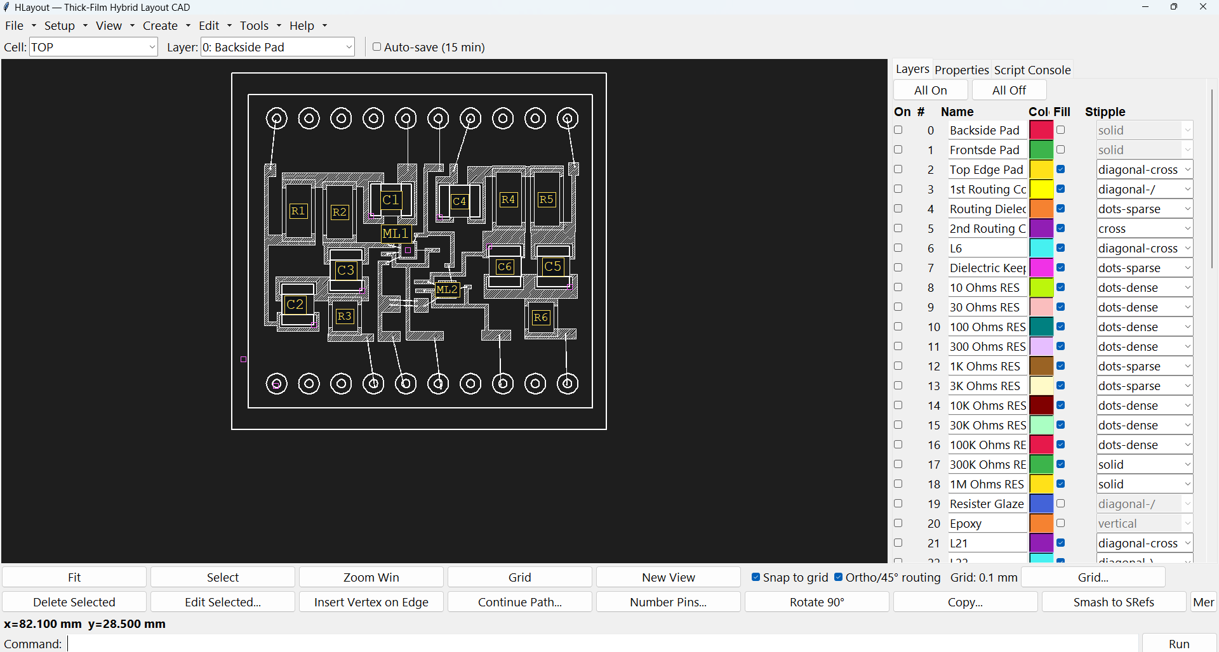
Menus, layer table, canvas, and command bar — one window, every tool.
GET STARTED
pip install -r requirements.txt
python hlayout_app.py
Requires Python with Tkinter (bundled on Windows/macOS; `sudo apt install python3-tk` on Debian/Ubuntu). Prebuilt installers are attached to every GitHub Release.
Alvin Brown · alvinmb@gmail.com · github.com/alvinmb/Hlayout

