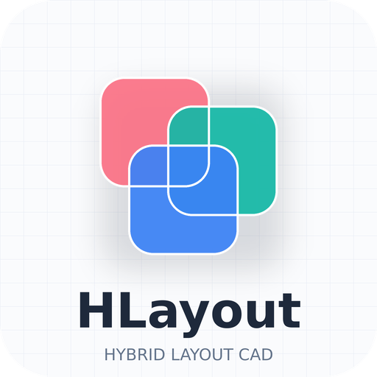
HLayout in Practice
Designing a chip-and-wire hybrid, from netlist to 3D
Student handout
Three-day course · HLayout 0.8 · built around the ALU8 example
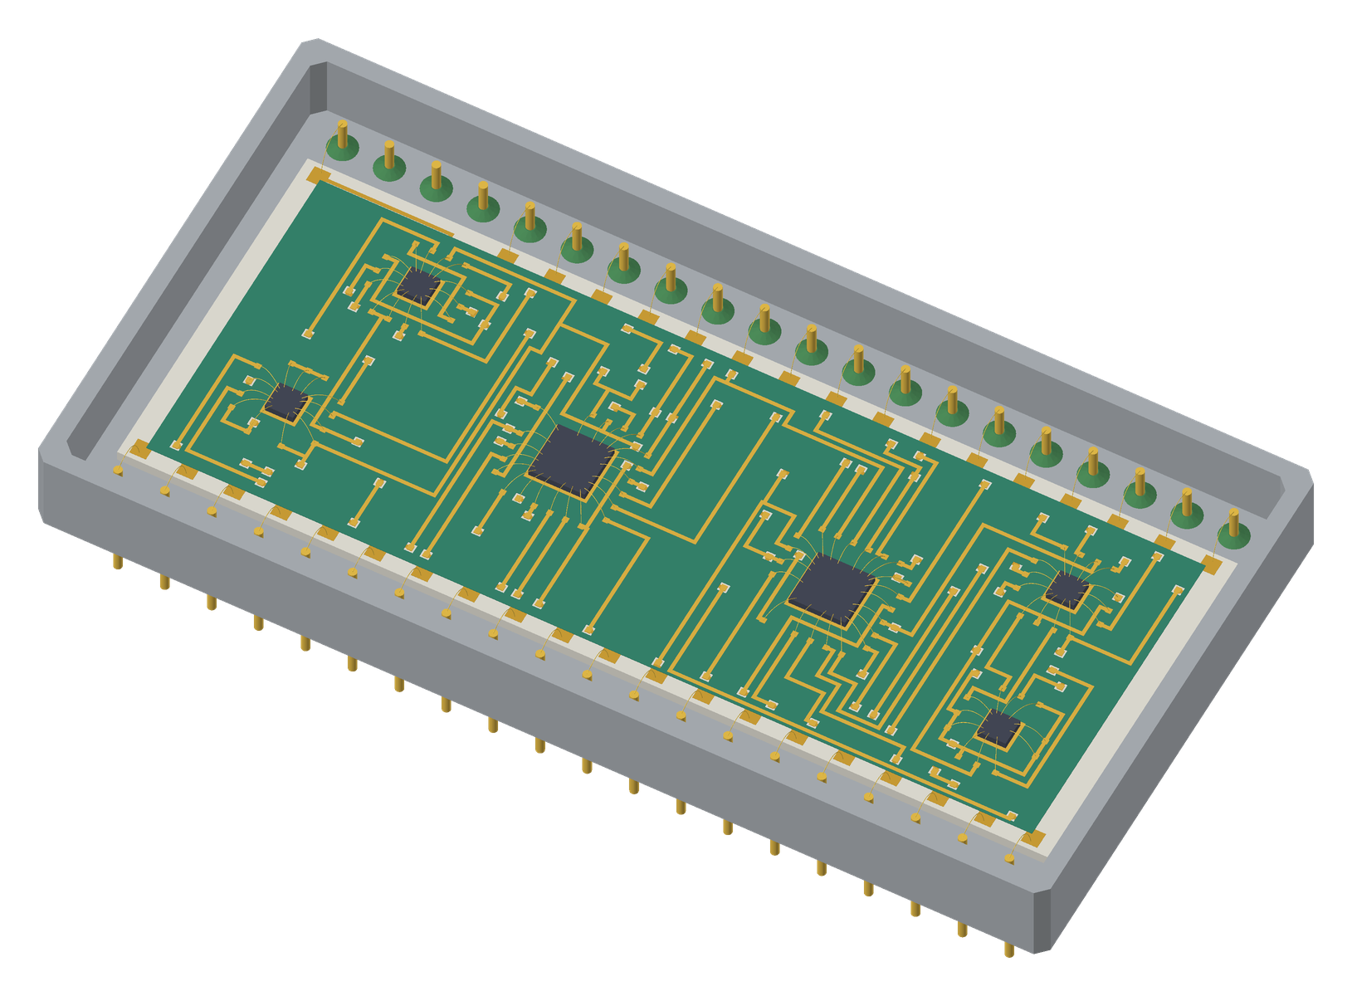

Name
Organisation
Course dates
Trainer

Contents

If the page numbers are missing, right-click the contents in Word and choose Update Field.

1 Course map
Over three days you learn the drawing basics, mask operations and printed resistors, then take one real design, the ALU8, from its KiCad netlist to print artwork, a bond list, an assembly drawing and a 3D model, and link its 2D cells to 3D STEP models. Each module ends with a lab. Each lab has a checkpoint file, so if you fall behind or break your design you can load the checkpoint and carry on.

What you will be able to do
- Draw shapes, paths and cells, and place them as SRefs and ARefs.
- Set up a thick-film process: layers, rules, wire bonds and dielectric, saved as a technology file.
- Derive layers with mask operations, and create and delete the dielectric.
- Size printed resistors from value and power, place them and simulate the trim.
- Build vias, land patterns and bare-die parts with the wizards, and place them automatically from a KiCad netlist.
- Bond every die and package pin, and clear unused bonds before routing.
- Route two conductors with Freerouting and clean the result up.
- Verify with DRC, bond-angle checks, connectivity and thermal analysis.
- Deliver Gerbers, DXF, pick and place, a bond list, an assembly drawing and a 3D model linked to STEP files.

Timetable
Time | Day 1: foundations | Day 2: netlist to routed design | Day 3: checks, outputs, 3D
09:00 | 1 Welcome · 2 Hybrids | 8 Circuit and netlist · Lab 6 | 14 Verification · Lab 12
10:30 | 3 Tour of HLayout · Lab 1 | 9 Wizards, dies, package · Lab 7 (09:45) | 15 Outputs · Lab 13 (10:15)
11:15 | 4 Shapes, paths, SRef, ARef · Lab 2 | 10 Auto Place · Lab 8 (11:15) | 16 2D to 3D STEP · Lab 14
13:15 | 5 Technology setup · Lab 3 | 11 Nets and wire bonds · Lab 9 | 17 Documentation, 3D · Lab 15
14:05 | 6 Mask ops, dielectric, bond edits · Lab 4 | 12 Routing · Lab 10 (14:45) | 18 Automation · Lab 16 (14:00)
15:15 | 7 Thick-film resistors · Lab 5 | 13 Editing the route · Lab 11 (16:00) | Capstone (14:30)
16:35 | Day 1 review (16:40) | Day 2 review (16:45) | Quiz and wrap-up (16:15)
Lunch 12:30–13:15. Breaks: day 1 10:15 and 15:00; day 2 11:00 and 14:30; day 3 11:00 and during the capstone.

The workflow
Every hybrid passes through the same seven stages. Only stage 1 and the machines at the end sit outside HLayout.
Stage | What happens | Tool | Course
1 Schematic | Reference designators, die-pad numbers, power nets; export the netlist | KiCad | Module 8
2 Technology and parts | Shapes and cells, layers, rules, dielectric, resistors, dies, package | HLayout | Modules 4–7, 9
3 Placement | Auto Place from the netlist on a 50 µm grid | HLayout | Module 10
4 Nets and bonds | Net names, wire bonds, I/O pads | HLayout | Modules 6, 11
5 Routing | Two conductors, vias, bond fingers | Freerouting | Modules 12, 13
6 Verification | DRC, connectivity, thermal | HLayout | Module 14
7 Outputs | Gerber, DXF, pick and place, drawings, 3D linked to STEP | HLayout, FreeCAD | Modules 15–17

Course files
Everything is in C:\dev\HLayout\training\checkpoints, copied from examples\8bit_ALU__chip_wire. Always copy a .gds together with its .gds.hlaux sidecar.
File | Contains | Used in
CP0_shapes_reference.gds | Reference drawing for the shapes lab | Lab 2
my_parts.gds | Your own parts library: a copy of chip_wire.gds the wizards write into | Lab 7
alu8_die.net | KiCad netlist, pins numbered by die pad | Labs 6, 8
alu8.net | The same netlist numbered by LCC terminal | Lab 6
alu8_netlist.csv | Every pin with both numbers | Lab 6
io_pinout.csv | Package pin to net | Labs 9, 15
alu8_tech.json | The ALU8 technology file | Labs 3, 5, capstone
CP1_dies_on_substrate.gds | Six dies and I/O pads on a 30 × 30 mm substrate | Labs 7, 8, capstone
CP2_bonded_ready_to_route.gds | Placed in the DIP40, bonded, fingers fanned out | Labs 7, 9, 10, 16
CP3_routed.gds | All 46 nets routed, two DRC errors left in | Labs 4, 11–15
8bit_alu.gds | The finished reference design | Lab 1

2 The ALU8 design
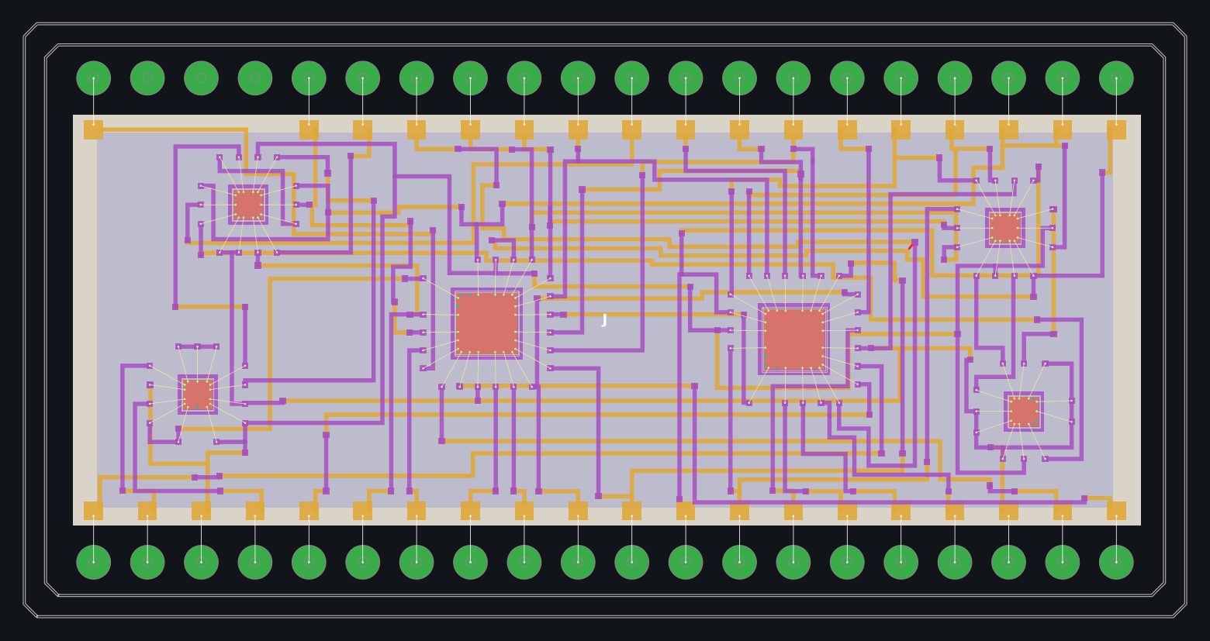
The finished ALU8: six bare dies on a two-conductor substrate inside a 40-pin Kovar DIP
The ALU8 is an 8-bit arithmetic logic unit built as a chip-and-wire hybrid. Two 54AS181 4-bit ALU slices do the arithmetic and logic: U1 takes bits 0–3 and U2 bits 4–7. The carry ripples from U1 Cn+4 to U2 Cn on net C4. Four 54LS gate dies make the status flags.
Ref | Part | Function in the ALU8 | Die
U1 | 54AS181 | ALU slice, bits 0–3 | 3.0 mm, 24 pads
U2 | 54AS181 | ALU slice, bits 4–7 | 3.0 mm, 24 pads
U3 | 54LS27 | Triple 3-input NOR: zero detect on F0–F7 | 1.5 mm, 14 pads
U4 | 54LS30 | 8-input NAND: combines the NOR outputs into Z | 1.5 mm, 14 pads
U5 | 54LS86 | Quad XOR: overflow and subtract logic | 1.5 mm, 14 pads
U6 | 54LS00 | Quad NAND: carry and overflow flags | 1.5 mm, 14 pads

Operations
Operation | S3 S2 S1 S0 | M | CN | SUB
ADD | 1 0 0 1 | 0 | 1 | 0
SUB | 0 1 1 0 | 0 | 0 | 1
AND | 1 0 1 1 | 1 | – | –
OR | 1 1 1 0 | 1 | – | –
XOR | 0 1 1 0 | 1 | – | –
NOT A | 0 0 0 0 | 1 | – | –
Active-high data. Flags: Z = all of F7–F0 low · N = F7 · C = NOT Cn+4 (1 = carry, or no borrow) · V = (A7 ⊕ F7) · (B7 ⊕ SUB ⊕ F7).

Physical build
Item | Value
Substrate | Alumina 0.635 mm, 21.7 × 14.9 mm, two printed conductors with dielectric
Package | KOVAR_DIP40: 40 pins on 2.54 mm pitch, rows 22.86 mm apart; 37 pins used
Dies | On epoxy, on die-attach pads on the 2nd conductor
Wire bonds | 94 die bonds, 30 µm gold, 1.65–1.89 mm long; plus one header bond per used pin
Nets | 46, with VCC and GND as power nets
Representative die sizes
TI does not publish die drawings for these parts, so the ALU8 die sizes and pad positions are representative. On a real job, use the supplier's die drawing.

Lab 1: Find your way round the ALU8
Module | Time | Start from
3 · Tour of HLayout | Day 1, 10:45 · 30 min | checkpoints\8bit_alu.gds

Goal. Open the finished design and learn to navigate, inspect and measure it.

Steps
- File → Open GDS… and open 8bit_alu.gds. Press F to fit the design in the window.
- In the Layers tab, untick layer 3 (1st conductor) and layer 4 (dielectric), then tick them again. Watch what disappears.
- Zoom to U1 (the right-hand large die) with the mouse wheel. Click one of its die pads and read the pin number in the Properties tab.
- Edit → Highlight Net, then click any pad of net C4. Follow the carry from U1 to U2. Edit → Clear Net Highlight when done.
- Press M for the Measure tool and measure one wire bond from end to end.
- On the command bar type HILITE GND and press Enter. Then type HILITE OFF.
- Open the Console tab and run print(s.sli()["complete"]).

Check it worked
☐ C4 joins U1 pad 16 to U2 pad 7
☐ Your bond measured between 1.0 and 2.5 mm
☐ The console printed 46

Your notes and answers
Which layer would you hide to see the 2nd conductor on its own?

What does the status bar show while you measure?

Lab 2: Draw and edit the basics
Module | Time | Start from
4 · Shapes, paths and cell instances | Day 1, 11:50 · 40 min | File → New; compare with checkpoints\CP0_shapes_reference.gds

Goal. Draw every primitive, make a cell, place it as SRefs and an ARef, and edit them.

Table 2.1 Drawing primitives
Primitive | How to draw it | Command
Rectangle | Click two opposite corners | RECT layer x1,y1 x2,y2
Polygon | Click points; Enter or double-click closes (3–200 points) | POLY layer x1,y1 x2,y2 …
Path | Click the centre line; width and end cap from Path Style | PATH layer width cap x1,y1 …
Circle | Click the centre, then a point on the radius | CIRCLE layer cx,cy r [segments]
Text | Click the insertion point, type the string | TEXT layer x,y "text" [height]
SRef (cell instance) | Pick a cell, click where it goes | SREF cell x,y [rot] [mag] [mirror]
ARef (array instance) | Pick a cell, columns, rows, spacing | AREF cell x,y cols rows dx dy

Table 2.2 Path end caps
End cap | Where the path ends | Use it for
Flush | Exactly at the end point | Ends that must stop on a pad edge
Square (extended) | Half the width past the end point | Corners and joins that must overlap cleanly
Round | A half circle, half the width past the end point | Smooth ends; matches a printed track end

Table 2.3 Editing
Edit | How | Command
Move | Drag, or arrow keys (one grid step) | MOVE dx,dy
Reshape | Drag a vertex or an edge | –
Exact values | Double-click → Edit Selected… | PROPS
Rotate | R (90° counter-clockwise) | ROTATE deg
Mirror, magnify | Edit Selected… on an instance | –
Copy | Edit → Copy… with dx, dy | COPY dx,dy
Extend a path | Edit → Continue Path… | –
Break an array | Edit → Smash Selected to SRefs | SMASH
Join shapes | Window-select, Edit → Merge Selected… | UNION

Steps
- Draw a rectangle, a polygon and a 32-segment circle on layer 3.
- Setup → Path Style…: width 0.4 mm. Draw three L-shaped paths on layer 5, one with each end cap.
- Drag one corner of the rectangle: it becomes a polygon. Ctrl+Z.
- Draw a 0.6 mm square pad with a small triangle in one corner. Select both and Create → Create Cell from Selection…, named PAD.
- Place three PAD SRefs: one plain, one rotated 90° (R), one mirrored (Edit Selected…).
- Place a 5 × 2 ARef of PAD at 1.1 mm pitch. Select it, Edit → Smash Selected to SRefs, and delete one pad.
- Edit the PAD cell: make the pad larger. Watch every instance change.
- Open CP0_shapes_reference.gds and compare with your drawing.
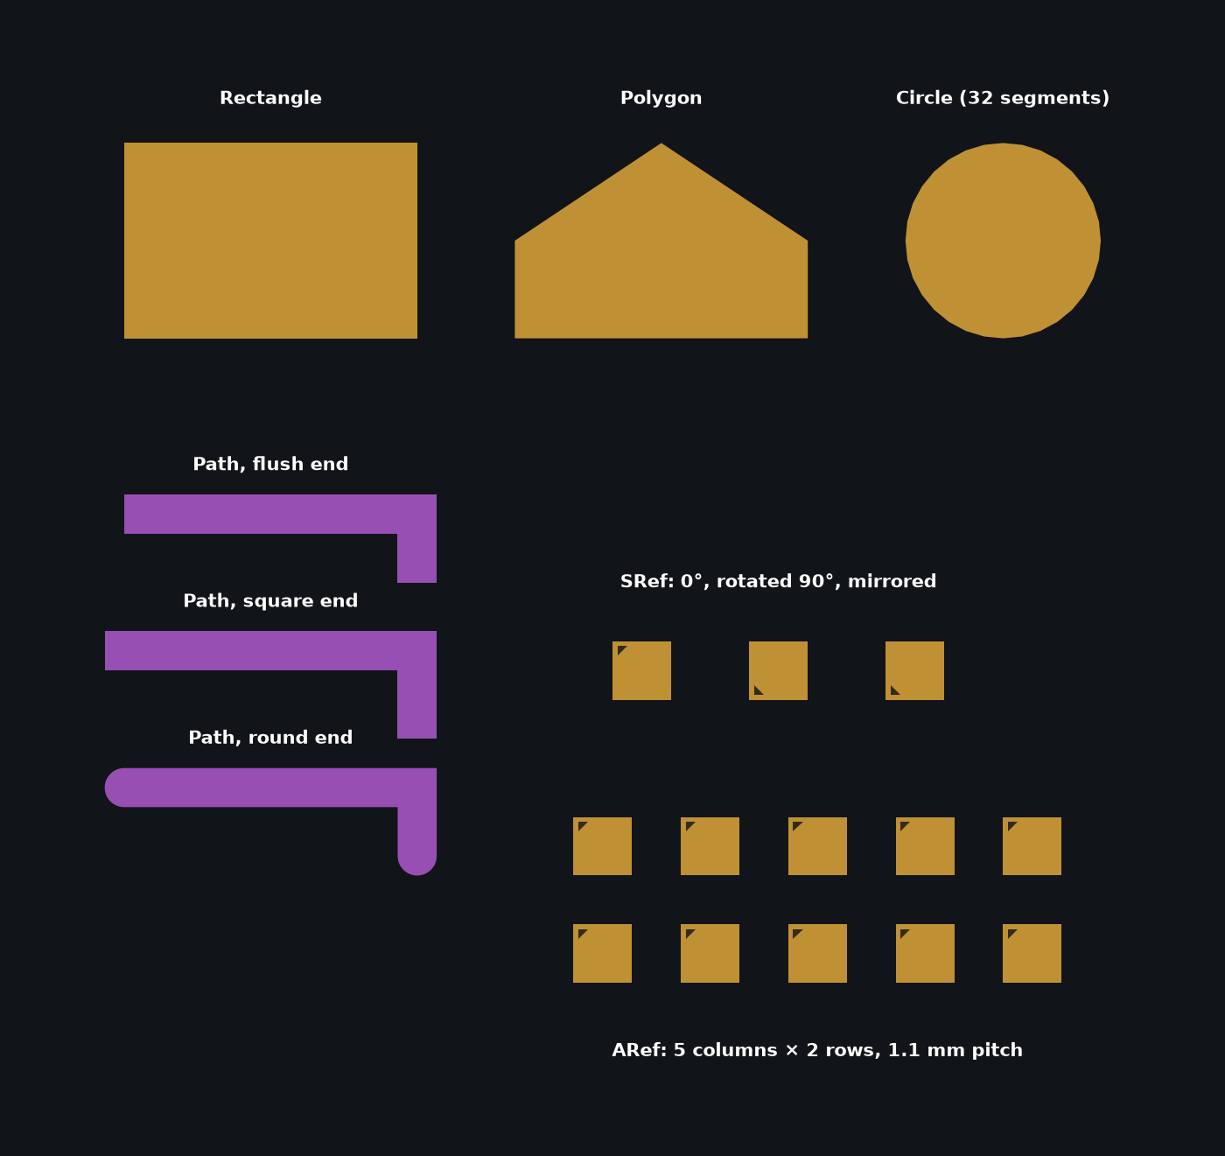
CP0: every primitive, the three path caps, PAD as SRefs and as a 5 × 2 ARef
Why the triangle?
A square pad looks the same rotated or mirrored. The triangle shows which way each instance is turned.

Check it worked
☐ All shapes and three path caps drawn
☐ PAD placed as SRefs and an ARef
☐ Editing PAD changed every copy

Your notes and answers
How far past the end point does a square end cap reach on a 0.4 mm path?

After Smash, does editing the PAD cell still change the nine pads? Why?

Lab 3: Set up the ALU8 process
Module | Time | Start from
5 · Technology setup | Day 1, 13:35 · 30 min | File → New

Goal. Build the ALU8 technology from a blank design and save it as a technology file.

Table 3.1 ALU8 layers
Layer | Name | Role | Thickness
3 | 1st Routing Conductor | 1st conductor | 12 µm
4 | Routing Dielectric | Dielectric (generated) | 30 µm
5 | 2nd Routing Conductor | 2nd conductor, die-attach pads, bond fingers | 12 µm
6 | DRC ERROR | DRC markers | –
20 | Epoxy | Die attach epoxy | –
49 | L49 | Package pin pads (isolated) | 10 µm
57 | substrate utie | Substrate outline | 0.635 mm substrate
58 | Chip_Pads | Die pads (isolated) | 10 µm
59 | Chip_wire_Bond | Die wire bonds | 12 µm
60 | Header_wire_Bond | Header wire bonds | 10 µm
61 | Document 1 | Outlines | –
62 | RefDes | Reference designators | –
63 | Dimention 2 | Dimensions | –

Table 3.2 Technology Properties
Tab | Field | ALU8 value
Route | Layer A / Layer B | 3 / 5
Route | Via cell | VIA_Layer3_to_Layer5
Wire Bonds | Bond layer | 59
Wire Bonds | Wire width / end ball | 0.03 mm / 0.1 mm
Wire Bonds | Isolated pad layers | 58, 49
I/O Pads | Pad width × length / bond inset | 0.9 × 0.9 mm / 0.2 mm
Dielectric | Fill layer / margin / clearance / via window margin | 4 / 0.2 mm / 0.1 mm / 0.1 mm
Thicknesses | Layers 3, 4, 5 | 12, 30, 12 µm
Ref-Des | Reference designator layer | 62

Table 3.3 ALU8 design rules
Name | Kind | Layers | Value
1st con min_width | MIN_WIDTH | 3 | 200 µm
1st con metal_2_metal | MIN_SPACE_BETWEEN | 3, 3 | 200 µm
BOND.L.MIN | BOND_MIN_LENGTH | 59 | 1000 µm
BOND.L.MAX | BOND_MAX_LENGTH | 59 | 2500 µm
BOND.ANGLE | BOND_MAX_ANGLE | 59, 58 | 45°

Steps
- Setup → Layers…: name the layers as in Table 3.1. Pick colours you can tell apart.
- Setup → Technology Properties…, Route tab: Layer A 3, Layer B 5.
- Wire Bonds tab: layer 59, wire width 0.03 mm, isolated pad layers 58, 49.
- Dielectric tab: layer 4, margin 0.2 mm, clearance 0.1 mm, via window margin 0.1 mm. Thicknesses tab: 3 = 12 µm, 4 = 30 µm, 5 = 12 µm. Press OK.
- Tools → DRC…: add the two layer-3 rules from Table 3.3, then press Add Bond Rules and set the limits to 1.0 mm, 2.5 mm and 45°.
- File → Save Technology File… as my_alu8_tech.json.
- Compare with alu8_tech.json: open it in a text editor and look at the drc_rules and bond_rules entries.
Watch the units
Dialogs take millimetres; the command bar and the technology file use microns (DBU). A 30 µm wire is 0.03 in the Wire Bonds tab and 30 in the file.

Check it worked
☐ my_alu8_tech.json is saved
☐ Five rules listed in Tools → DRC
☐ Isolated pad layers read 58, 49

Lab 4: Mask ops, dielectric and a bond move
Module | Time | Start from
6 · Mask operations, dielectric and bond edits | Day 1, 14:30 · 30 min | checkpoints\CP3_routed.gds, saved as my_playground.gds

Goal. Make derived layers, delete and rebuild the dielectric, and move a wire bond safely.

Table 4.1 Mask operations
Operation | Result | Typical hybrid use
OVERSIZE | Every shape grown by a fixed amount | Glaze over a resistor; a clearance ring round a conductor
UNDERSIZE | Every shape shrunk by a fixed amount | Check a minimum width survives
AND | Where both layers are | Overlap of conductor and dielectric
OR | Either layer | Combine two layers into one
NOT | First layer minus the second | Bare substrate (57 NOT 3)
XOR | One layer or the other, not both | What changed between two versions

Table 4.2 The dielectric
Task | Menu | Command
Create or replace the fill | Tools → Generate Dielectric Fill… | DIELECTRIC
Delete the fill | Tools → Remove Dielectric Fill | DIELECTRIC CLEAR
Add an opening | Draw on layer 4 (datatype 0), then Generate | –
Remove an opening | Delete its input shape, then Generate | –
Change margins | Technology Properties → Dielectric tab | –
Redraw vias and windows | Tools → Fix Vias… | VIA FIX

The dielectric has two parts on layer 4. Inputs (datatype 0) are the boundary, via windows and keep-outs. The fill (datatype 1) is generated from them. Remove Dielectric Fill deletes only the fill, so you can always generate it again.

Steps
- File → Save As… my_playground.gds, so the checkpoint is never changed.
- Tools → Mask Operations…: OVERSIZE layer 3 by 100 µm into layer 55. Hide layer 3 and look at 55.
- NOT: layer 57 minus layer 3 into layer 54. What does 54 show?
- Tools → Remove Dielectric Fill. Hide every layer but 4: what is left?
- Tools → Generate Dielectric Fill… with the default settings. How many fill pieces does the log report?
- Edit → Move Wire Bond on a U3 bond: drag an end until the preview turns red, then back to a legal length and click.
- Run Tools → DRC…. Then Ctrl+Z the bond move.
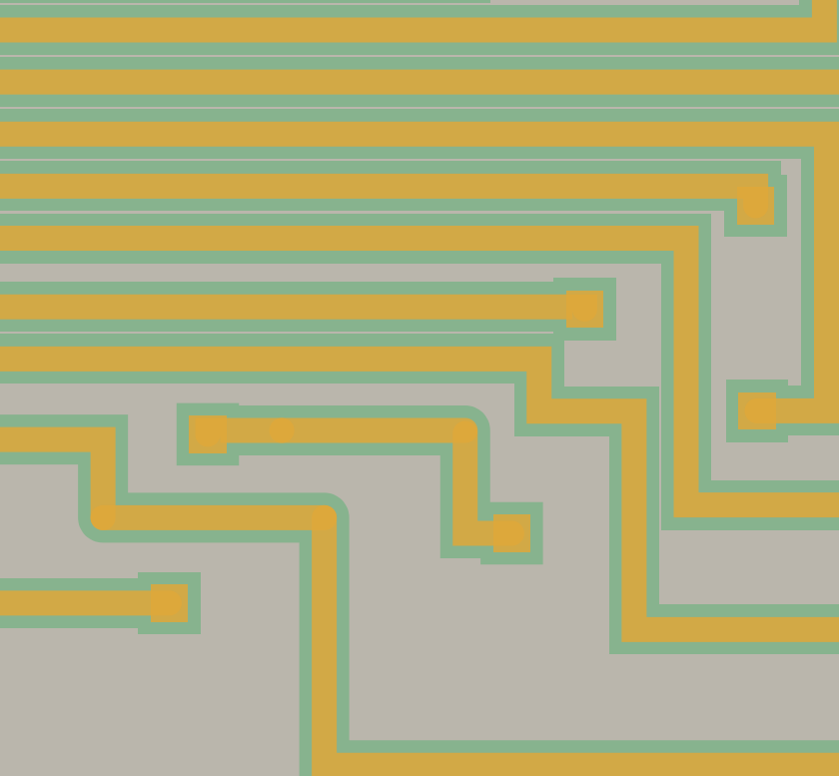
Layer 3 oversized by 100 µm onto layer 55
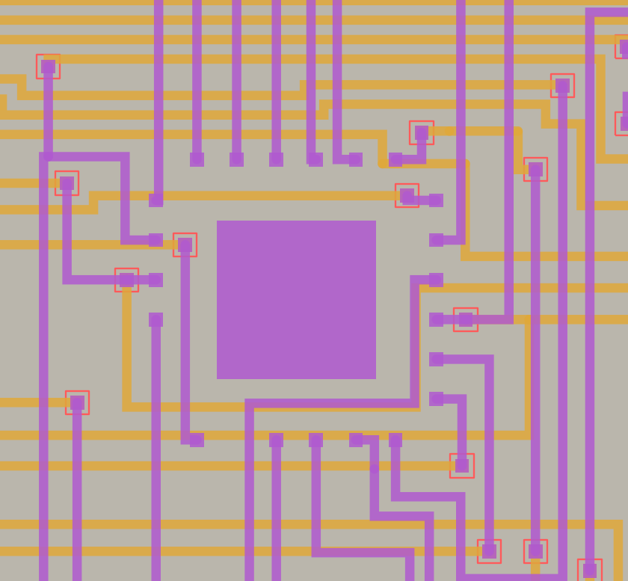
After Remove Dielectric Fill: only the inputs remain
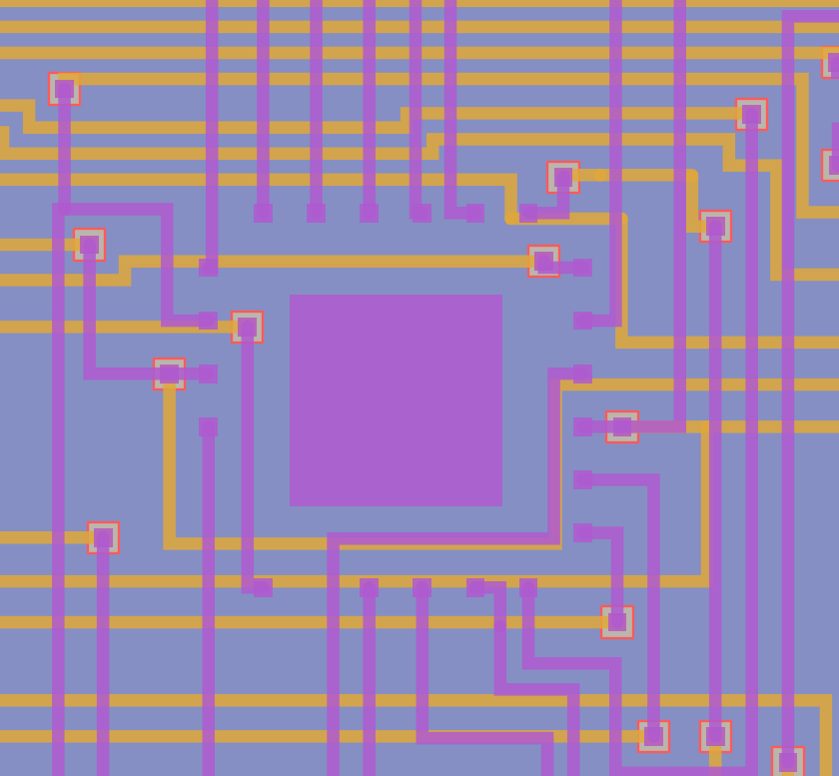
After Generate Dielectric Fill

Check it worked
☐ Layer 55 is layer 3 grown by 0.1 mm
☐ Fill removed and regenerated
☐ Bond move checked with DRC

Your notes and answers
What does layer 54 show?

What was left on layer 4 after Remove Dielectric Fill, and how many fill pieces came back?

Which DRC rule flags a bond moved too far?

Lab 5: Size, place and trim resistors
Module | Time | Start from
7 · Thick-film resistor design | Day 1, 16:00 · 40 min | File → New, then Setup → Load Technology File… alu8_tech.json

Goal. Size four resistors with the Resistor Designer, check them by hand, place them and trim one.

How the Resistor Designer sizes a resistor
R = Rsh × L / W. Rsh is the ink sheet resistance in Ω/□; L / W is the number of squares. Laser trimming only cuts ink away, so it can only raise the resistance: print low, then trim up to value.
- Width from power. Pick the smallest width in Table 5.1 whose after-trim rating covers the power.
- Aim value = value × (aim % + tolerance %). Default aim 75 %.
- Squares = aim value / Rsh, for each ink.
- Aspect window. Keep inks giving 0.25 to 4 squares.
- Recommend the ink closest to one square (smallest |ln squares|).
- Length L = squares × W.

Table 5.1 Width and power (ALU8 rules)
Width (mm) | 1.0 | 1.4 | 1.8 | 2.0 | 2.4 | 2.8 | 3.0 | 3.4 | 3.8
Full power (mW) | 62.5 | 125 | 200 | 250 | 375 | 500 | 625 | 750 | 1000
After trim (mW) | 31.3 | 62.5 | 100 | 125 | 187.5 | 250 | 312.5 | 375 | 500

Inks: 10, 30, 100, 300 Ω/□, 1, 3, 10, 30, 100, 300 kΩ/□ and 1 MΩ/□. Layout rules: ink overlaps each pad by A 0.3 mm; pad runs B 0.5 mm beyond; pad C 0.3 mm wider than the ink each side; glaze D 0.3 mm all round; dielectric keep-out E 1.0 mm.
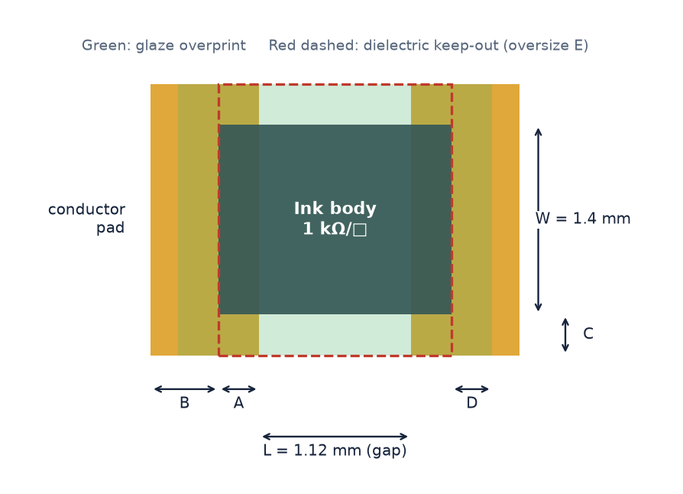
A 1 kΩ resistor: ink 1.72 × 1.40 mm, pads 0.80 × 2.00 mm, glaze, keep-out

Steps
- Tools → Thick-Film Resistor Designer…. Check Design Rules…: aim 75 %, aspect 0.25–4.
- Add R1 1 kΩ 5 % 50 mW, R2 10 kΩ 1 % 100 mW, R3 47 Ω 5 % 200 mW, R4 220 kΩ 10 % 10 mW, with width Auto from power.
- Fill in Table 5.2 by hand first, then compare with the Solutions tab.
- Auto-Select All, then Place All in Layout…. Look at each resistor's layers: ink, pads, glaze, keep-out.
- Select R1 and open Trim Simulator…: plunge cut to 25 % of the width, 40 µm kerf; then Add L-Cut 400 µm.
- Fill in Table 5.3.
- Open Setup → Technology Properties… → Resistor Shapes and check Top-hat with roof is ticked: only ticked shapes are offered. Then Edit… R1 and set Shape: Top-hat with roof. Note the ink, squares and L the Designer picks and look at the preview.
- Open Trim Simulator… for R1 again (the shape window), keep the 40 µm kerf and the default depth, Run, and fill in Table 5.5.

Table 5.2 Your hand sizing
Ref | Value | Power | Width (mm) | Aim (Ω) | Ink (Ω/□) | Squares | L (mm)
R1 | 1 kΩ 5 % | 50 mW
R2 | 10 kΩ 1 % | 100 mW
R3 | 47 Ω 5 % | 200 mW
R4 | 220 kΩ 10 % | 10 mW

Table 5.3 Trimming R1
Stage | Resistance (Ω) | Sensitivity (Ω/µm)
As printed |  | –
After plunge, 25 % of width
After L-cut, 400 µm

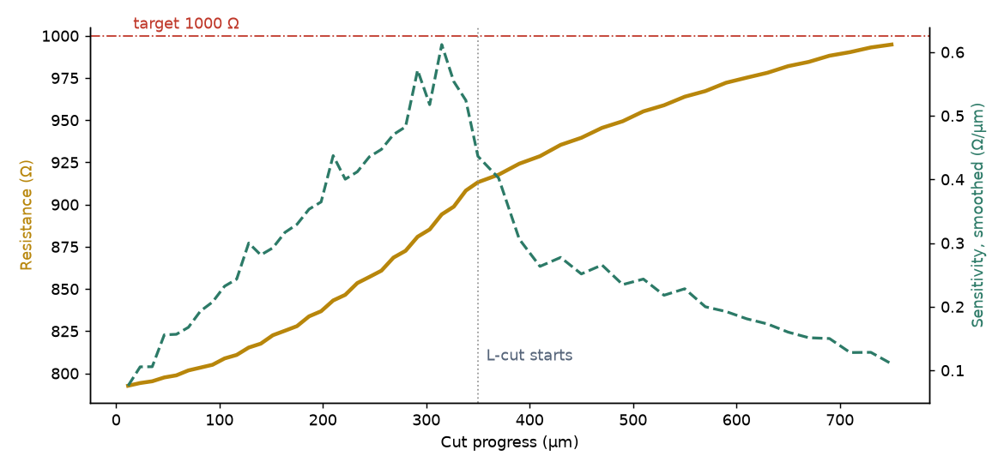
R1 trim: a fast plunge, then a slow, controllable L-cut

Table 5.4 Resistor shapes
Shape | Code | Why use it
Rectangle | R | Simplest; plunge or L-cut trim
Top-hat | TH | A crown on the bar gives the plunge more range
Top-hat with roof | THR | A conductor roof on the crown: the cut never opens the resistor
U-shape | U | Pads side by side; long resistor in a short space
U-shape with roof | UR | Roofed skirt under the U: safe, wide trim
Angle / double angle | A / AA | Pads on adjacent sides, or opposite and offset
Angle three-sided | A3 | Leads joined by a raised loop: long path, compact

A shape is sized by solving its ink as a resistive sheet, so each right-angle corner counts as about 0.56 square and a crown or roof is counted exactly; the Designer then sets the shape's length L for each ink inside the aspect rules. Which shapes are offered is part of the technology: Setup → Technology Properties → Resistor Shapes has a picture and a check box for each, and only ticked shapes appear in the Shape list.
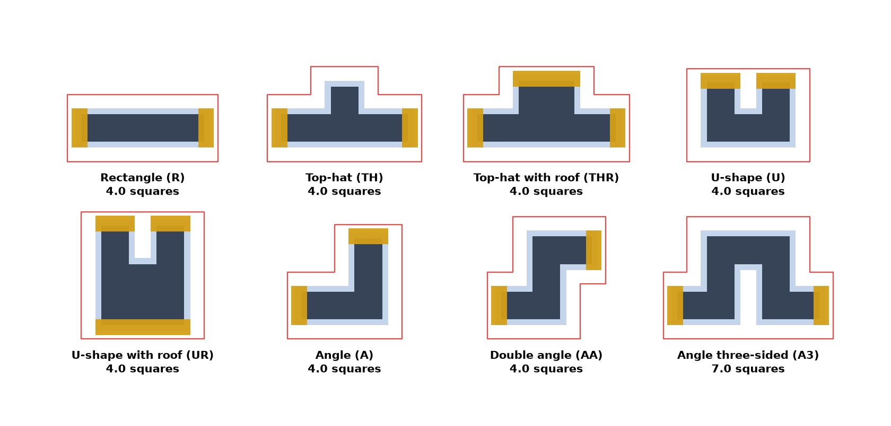
The eight shapes, each sized to the squares shown

Table 5.5 R1 as a top-hat with roof
Ink (Ω/□) | Squares | L (mm) | Printed (Ω) | Reaches 1 kΩ at (µm) | R at full depth (Ω) | Opens?

Check it worked
☐ Your hand sizes match the Designer
☐ Four resistors placed with glaze and keep-out
☐ R1 trims to about 995 Ω
☐ As a roofed top-hat, R1 reaches 1 kΩ without opening

Your notes and answers
Why does R3 need a 2.8 mm body and not 2.4 mm?

Why finish with an L-cut instead of a deeper plunge?

Why can the cut in a roofed top-hat go so much deeper than in a rectangle?

Lab 6: Read the ALU8 netlist
Module | Time | Start from
8 · Circuit and netlist | Day 2, 09:20 · 25 min | checkpoints\alu8_die.net, alu8_netlist.csv

Goal. Find the facts you will need for placement and routing in the netlist files.
Use the full net list in Appendix A of this handout, or open the files themselves.

Steps
- Open alu8_netlist.csv in a spreadsheet or text editor. Columns: net, ref, part, lcc_pin, dip_die_pad, pin_name, pin_type.
- How many pins does GND have? Which dies are on it?
- Which die pads carry the carry net C4?
- Which nets join U1 and U2 directly?
- Open alu8_die.net in a text editor and find net F7. How many pins does it have, and why are two header pins on it?
- Which pins of U4 are tied to VCC, and why?

Check it worked
☐ GND: 11 pins, all six dies plus J1 and J2
☐ C4: U1 pad 16 and U2 pad 7
☐ Shared by U1 and U2: S0–S3, M and C4
☐ F7: 6 pins

Your notes and answers
GND pins:

C4 die pads:

Nets shared by U1 and U2:

F7 pins, and why two header pins:

U4 pins on VCC, and why:

Lab 7: Build a parts library with the wizards
Module | Time | Start from
9 · Wizards, bare dies and the package | Day 2, 10:15 · 45 min | File → New, Setup → Load Technology File… alu8_tech.json, then attach checkpoints\my_parts.gds

Goal. Make a via, a capacitor land and a 54LS00 die with the three wizards, save them in your own parts library, and place them.
The three wizards on the Tools menu add new parts to a library. Each one writes the finished cell straight into an attached library file, so attach the library first (Setup → Attach Library…). Without one, the wizard tells you to attach one and stops. my_parts.gds is your own copy of the example parts library chip_wire.gds; it already holds the die-pad cells chip_pin_1 (200 µm, marks pin 1) and chip_pin (100 µm).

Table 7.1 The wizards
Wizard | Makes | Command / Python
Via Wizard… | Square or round pad on two conductors, with an optional window in the dielectric between them. Defaults come from the Autoroute via and the Dielectric tab, so it matches the routed vias. | VIA · create_via_cell()
Pad Wizard… | A conductor pad with a paste (or epoxy) pad undersized by a margin on every side; one pad or a rows × cols grid. Two-pad footprints are numbered 1 and 2 for you. | PAD · create_pad_cell()
Chip Wizard… | A bare-die footprint: body outline, epoxy, optional die-attach pad, then one click per pin. Pins are numbered 1..N, or named (E,B). A die whose back is a contact can make the die-attach pad a pin (C) with a tab for the track. Saved to the first attached library when the last pin is placed. | create_chip_cell() + export_cell_to_library()

Table 7.2 Settings for this lab
Part | Wizard settings
VIA_R300 | Shape round, size 0.3 mm, Layer 1 = 3, Layer 2 = 5, Add dielectric via window on 4, window 0.5 mm, Cell name VIA_R300
LAND_0805 | Cell name LAND_0805, length 1.0, width 1.4, paste undersize 0.1 mm, conductor layer 5, paste layer 20 (epoxy), rows × cols 1 × 2, pitch X 1.9 mm
MY_54LS00 | Chip 1.5 × 1.5 mm, graphics layer 61, epoxy 1.4 × 1.4 mm on 20, die-attach pad on 5, 0.2 mm larger; pin 1 cell chip_pin_1, pins 2..N chip_pin, 14 pins; Save to attached library

Table 7.3 Pin positions for MY_54LS00 (mm from the die centre, grid 0.1 mm)
Pin | 1 | 2 | 3 | 4 | 5 | 6 | 7
x, y | −0.2, 0.6 | −0.4, 0.6 | −0.6, 0.4 | −0.6, 0 | −0.6, −0.4 | −0.4, −0.6 | −0.2, −0.6
Pin | 8 | 9 | 10 | 11 | 12 | 13 | 14
x, y | 0.2, −0.6 | 0.4, −0.6 | 0.6, −0.4 | 0.6, 0 | 0.6, 0.4 | 0.4, 0.6 | 0.2, 0.6

Steps
- Setup → Attach Library… and choose checkpoints\my_parts.gds.
- Tools → Via Wizard… with the Table 7.2 settings. Press Create.
- Tools → Pad Wizard… with the Table 7.2 settings. Press Create.
- Tools → Chip Wizard… with the Table 7.2 settings. Press Start Placing Pins.
- Click pins 1 to 14 at the Table 7.3 positions, counter-clockwise from pin 1. The status bar asks for each pin; each is labelled with its number.
- Create → Find & Place Cell…: place VIA_R300, LAND_0805 and MY_54LS00. Select the land and read its pin numbers in Properties.
- Setup → Library Cells…: find your three cells and their created and modified dates.
- Open checkpoints\CP1_dies_on_substrate.gds. Compare MY_54LS00 with DIE_54LS00 (U6). Then open CP2: where does the substrate sit?
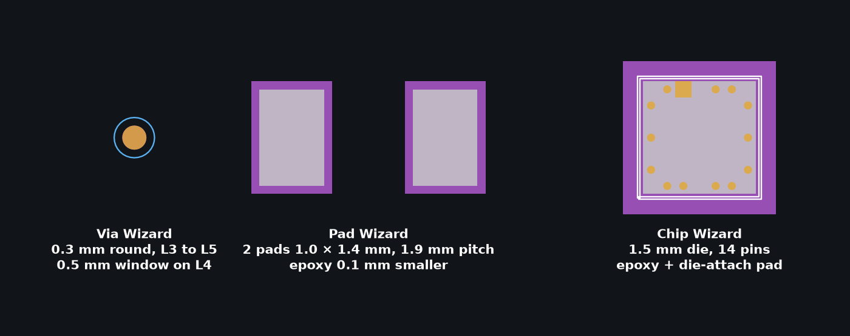
The three parts: VIA_R300, LAND_0805 and MY_54LS00
Die cell | Used as | Size | Pads
DIE_54AS181 | U1, U2 | 3.0 × 3.0 mm | 24
DIE_54LS27 | U3 | 1.5 × 1.5 mm | 14
DIE_54LS30 | U4 | 1.5 × 1.5 mm | 14
DIE_54LS86 | U5 | 1.5 × 1.5 mm | 14
DIE_54LS00 | U6 | 1.5 × 1.5 mm | 14

Die sizes
TI does not publish die drawings for these parts. The ALU8 die sizes are representative; on a real job use the supplier's die drawing.

Transistor dies
Pins can be names as well as numbers. For a bipolar transistor die with emitter and base on top: Pin names E,B, and tick Back of die is a contact with pin C and a 0.6 mm tab, because the collector is the back of the die, joined to the die-attach pad by conductive epoxy. The tab lets a track reach the pad past the die keep-out. The names must match the pin numbers in your KiCad netlist exactly: edit the symbol pins to E, B, C, or number the die pins to match the symbol.

Check it worked
☐ VIA_R300, LAND_0805 and MY_54LS00 are in my_parts.gds
☐ LAND_0805 pads are pins 1 and 2
☐ MY_54LS00 has 14 numbered pins and a 1.9 mm die-attach pad

Your notes and answers
How big is the dielectric window on VIA_R300, and where does that size come from?

Why does the lab not use the default via name?

Lab 8: Place the ALU8
Module | Time | Start from
10 · Auto Place | Day 2, 11:45 · 45 min | checkpoints\CP1_dies_on_substrate.gds

Goal. Place the six dies from the netlist with the shortest total net length you can get.
Setting | Value
Netlist | alu8_die.net (pins numbered by die pad)
Grid | 50 µm
Clearance | 0.3 mm
Bond reach | 1.5 mm
Thermal | 1
Effort / seed | 1 / 0

Steps
- Tools → Auto Place… and choose alu8_die.net.
- On the Parts tab check every U1–U6 maps to a DIE_ cell with family die.
- Enter the settings above and press Run.
- Tick View → Straight-Line Interconnects. Write the total length from the status bar in the table below.
- Improve the placement by dragging and rotating (R) parts, or with Improve. Record your best total.
- On the command bar run AUTOPLACE WEIGHT C4 3, then Improve. What moved?
- File → Save As… my_alu8_placed.gds.
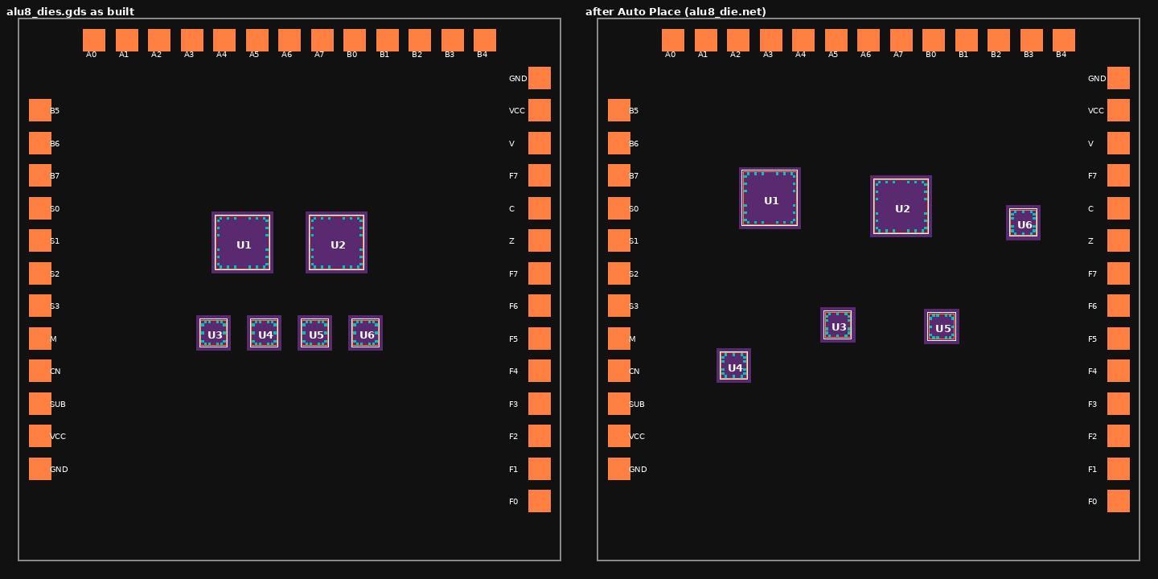
CP1 before (left) and after Auto Place (right)
Run | Total SLI length (mm) | What you changed
First Auto Place
After hand moves
After C4 weight 3 + Improve

Check it worked
☐ No overlaps; every die inside the I/O pad ring
☐ Totals recorded in the table
☐ U1 and U2 side by side

Lab 9: Bond the ALU8
Module | Time | Start from
11 · Nets and wire bonds | Day 2, 13:50 · 40 min | checkpoints\CP2_bonded_ready_to_route.gds

Goal. Check net names, practise bonding, remove unused bonds and follow the header bonds.

Steps
- Edit → Highlight Net: click the I/O pad for header pin 18 and check it is VCC; click U1 die pad 16 and check it is C4.
- Zoom to U3. Edit → Delete Wire Bond on one of its bonds, then redraw it with Create → Wire Bond: click the die pad, then the landing point.
- Edit → Move Wire Bond: drag an end until the preview turns red (too long or too short). Press Esc, or Ctrl+Z if you committed it.
- On the command bar run UNUSEDBONDS. Note which pads are listed.
- Run Tools → Remove Unused Bonds…. Note the new die cell names in the cell list.
- In the Layers tab hide everything except 49, 59 and 60. Follow a header bond from a package pin to its I/O pad.
- Save as my_alu8_bonded.gds.
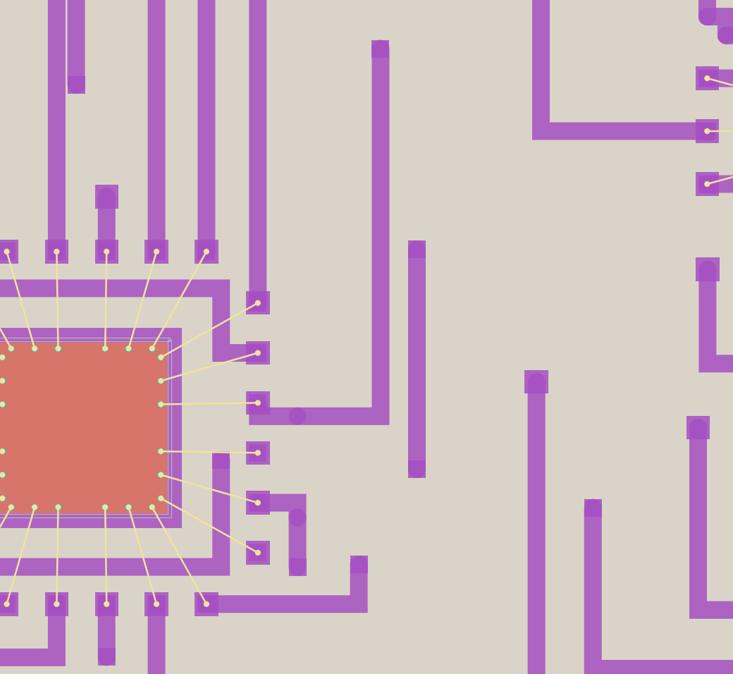
U1 bonded in CP2: die pads to bond fingers on the 2nd conductor

Check it worked
☐ Your redrawn bond is between 1.0 and 2.5 mm
☐ You can name the unused pads, or explain why none are listed
☐ You traced a header bond pin to pad

Your notes and answers
Unused pads listed by UNUSEDBONDS:

Why remove unused bonds before routing?

Lab 10: Route the ALU8
Module | Time | Start from
12 · Routing with Freerouting | Day 2, 15:15 · 45 min | my_alu8_bonded.gds, or checkpoints\CP2_bonded_ready_to_route.gds

Goal. Route every net with Freerouting and get 46 of 46 complete.

Table 10.1 ALU8 Autoroute settings
Field | Value
Launcher / .jar | freerouting.exe (Java build); a .jar needs Java 25 or later
Signal width / power width | 200 µm / 200 µm
Clearance | 200 µm
Signal via pad / power via pad | 300 µm / 300 µm (dielectric window 500 µm)
Route passes / optimize passes | 25 / 25, stop optimizing below 1 %
Bond finger / die keep-out | 200 µm / 200 µm
Via cost / against-direction cost | 35 / 3
Power nets | VCC, GND
90-degree routing only | On
Remove ALL existing tracks and vias | On
Layers | Both conductors
Bond fingers on | 2nd conductor
Track directions | 1st horizontal, 2nd vertical
Via optimisation at the end | On
Shorten tracks at the end | On

Steps
- Tools → Autoroute (Freerouting)…. Check the status line says Freerouting is ready; if not, set the Launcher / .jar path.
- Enter the settings in Table 10.1.
- Press Route. Watch the percentage; the window comes back when the route finishes.
- Read the log: tracks and vias imported, bond fingers laid, and Nets complete: N of 46.
- If any nets are left: View → Unrouted Nets…, then route again with Keep existing tracks and vias ticked.
- Note how many vias the log reports before and after via optimisation.
- On the command bar run SHORTS. Save as my_alu8_routed.gds.
The routed ALU8: 1st conductor orange, 2nd conductor purple, dielectric blue
Via windows
Each via window in the dielectric is the via pad plus the via window margin on every side: 300 µm + 2 × 0.1 mm = 500 µm.

Check it worked
☐ Nets complete: 46 of 46
☐ SHORTS reports none
☐ my_alu8_routed.gds saved

Your notes and answers
Vias before and after optimisation:

Route time:

Lab 11: Break it and fix it
Module | Time | Start from
13 · Editing the route | Day 2, 16:15 · 30 min | my_alu8_routed.gds, or checkpoints\CP3_routed.gds

Goal. Rip up a net, find it again with the tools and route it back by hand.

Steps
- Run HILITE C4 to see the carry net, then HILITE OFF.
- Edit → Rip Up and Reroute: click on the C4 track near U1, then near U2. The track between is removed and you are in Route mode.
- Press Esc to leave Route mode. Open View → Unrouted Nets…: is C4 listed? How long is the gap?
- Route C4 back by hand with the Route tool. Press Space to drop a via and change conductor.
- Drag a segment of another net by its edge. Watch the via at its end move with it. Ctrl+Z to undo.
- Run SHORTS. If it reports anything, use Rip Up and Reroute to fix it.
- Check the status bar or print(s.sli()): 46 complete, total length 0.

Check it worked
☐ C4 complete again
☐ SHORTS reports none
☐ Unrouted Nets list empty

Lab 12: Prove the design is right
Module | Time | Start from
14 · Verification | Day 3, 09:35 · 40 min | checkpoints\CP3_routed.gds

Goal. Clear the DRC, check bonds and connectivity, and estimate die temperatures.

Steps
- Tools → DRC… → Run, with markers on layer 6. How many violations, and which rule?
- Click each violation to zoom to it. Fix it by moving or rerouting the short segment, then run DRC again.
- Tools → Extract Netlist…: tick layers 3 and 5 as Conductor, 58 and 49 as Isolated, keep Include wire bonds on. Run. Note any opens or shorts.
- Run SHORTS and check the SLIs show 46 complete.
- Tools → Thermal Analysis…, Powers tab: U1 and U2 400 mW, U3 25 mW, U4 15 mW, U5 40 mW, U6 20 mW. Run.
- Boundary tab: change the base to cooled by a heat-transfer coefficient of 200 W/m²K. Apply and run again. Compare.
- Save as my_alu8_checked.gds.
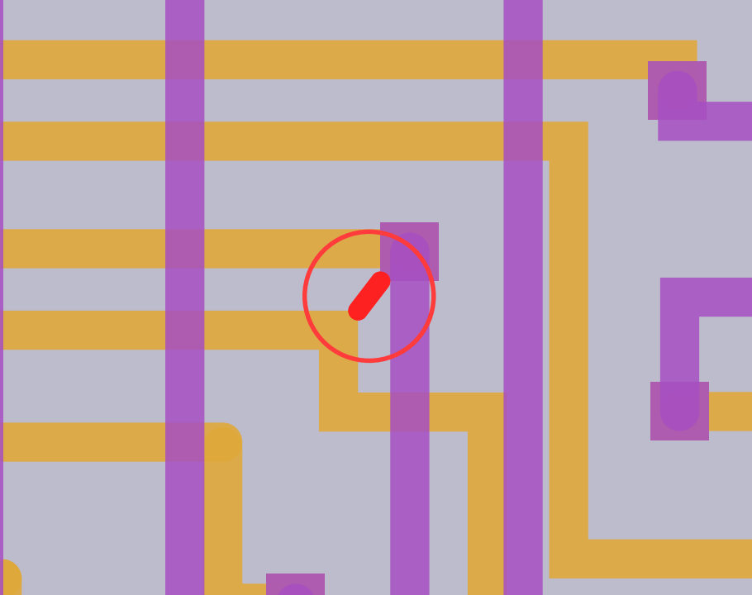
The DRC violation in CP3, ringed: 1st-conductor copper closer than 200 µm
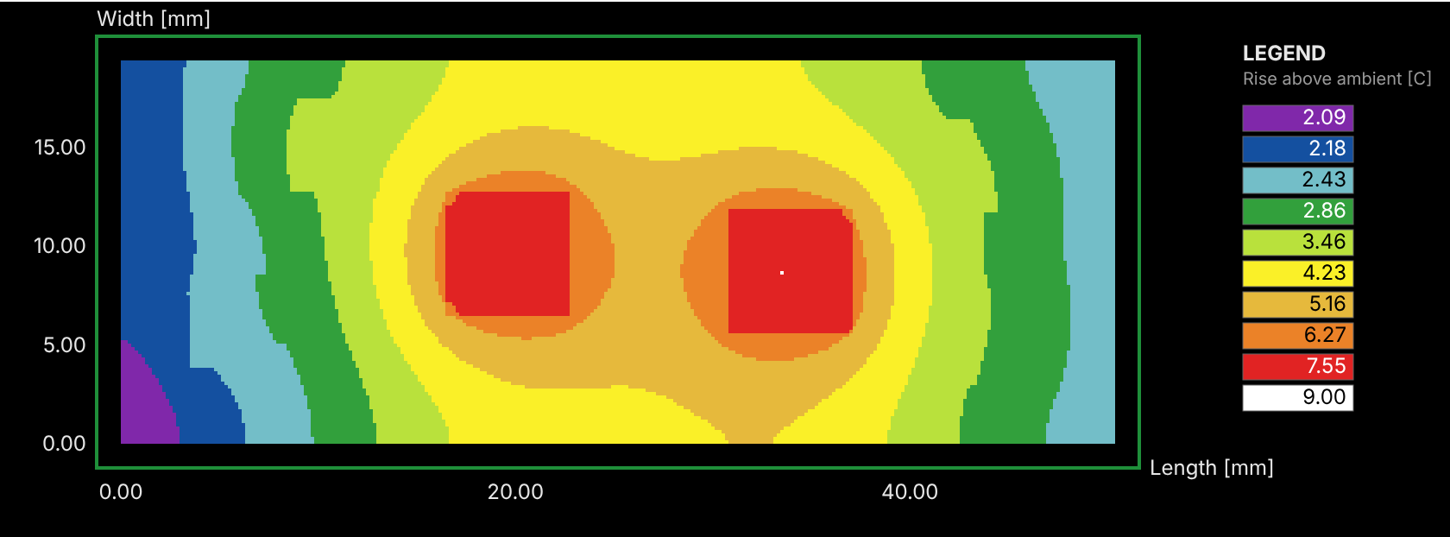
Temperature rise with the base cooled at 200 W/m²K
About the powers
The die powers here are representative values for the exercise, not datasheet figures. The model leaves out the package, wire bonds and airflow: treat the result as a design-stage estimate.

Die | Power | Fixed base (°C) | Cooled base (°C)
U1 | 400 mW
U2 | 400 mW
U3 | 25 mW
U4 | 15 mW
U5 | 40 mW
U6 | 20 mW

Check it worked
☐ DRC reports no violations
☐ No opens or shorts
☐ U1 about 34 °C with the cooled base

Your notes and answers
DRC violations found, rule and location:

How did you fix them?

Lab 13: Make the output set
Module | Time | Start from
15 · Manufacturing outputs | Day 3, 10:35 · 25 min | my_alu8_checked.gds, or CP3 with the DRC fixed

Goal. Produce every file the print line, the bonder and the tester need.

Steps
- File → Gerber Export Sets…: run the set 1-CON into a folder named out.
- Count the .gbr files and note which layers they are.
- File → DXF Export Sets…: export the conductors as DXF.
- File → Export Pick and Place… as out\alu8_pnp.csv. Check U1–U6 are listed with kind die.
- Write the bond list for the bonder with the script below (paste it into the Console tab).
- Tools → Extract Netlist… → Export… as CSV.
- File → Archive Design.

Bond list script
import csv, math
rows = s.bond_departures()
with open("out/alu8_bonds.csv", "w", newline="") as f:
w = csv.writer(f)
w.writerow(["die", "x1_um", "y1_um", "x2_um", "y2_um", "length_mm", "angle_deg"])
for b in rows:
w.writerow([b["die"], *b["a"], *b["b"],
round(math.dist(b["a"], b["b"]) / 1000, 3), b["angle_deg"]])
print(len(rows), "bonds")

Why a script?
A design routed with Freerouting keeps no bond diagram, so HYBRID BONDS has nothing to export. HYBRID BONDS and BONDTABLE work on designs from the HLayout chip-and-wire router.

Check it worked
☐ One Gerber per print layer
☐ Six dies in the pick-and-place file
☐ Bond list with 94 rows
☐ Archive zip written

Lab 14: Link 2D cells to 3D models
Module | Time | Start from
16 · Linking 2D cells to 3D STEP models | Day 3, 11:50 · 40 min | checkpoints\CP3_routed.gds, saved as my_alu8_3d.gds

Goal. Check the package link, add a part that links automatically, and break and fix a link.

How 2D becomes 3D
- Films: each drawn layer is extruded at its fired thickness, in print order. The dielectric uses only the generated fill (datatype 1).
- Bonds: gold loops landing on the surface under each end.
- Parts: each cell instance is replaced by its linked STEP model, or drawn as a box of its footprint.
- The link is the origin: the STEP model is placed at the instance origin, so its origin must match the 2D cell origin, with z = 0 on the seating surface.

Table 14.1 Component model fields
Field | Meaning | ALU8 KOVAR_DIP40
mode | model (STEP file) or box | model
model_path | STEP file; relative to the design folder or absolute | C:/dev/HLayout/examples/step_models/kovar_dip/KOVAR_DIP40_0.9in.step
rotation_deg | Correction when the model's axes differ from the cell | 0
z_ref | surface, or substrate_bottom for headers | substrate_bottom
z_offset_um | Shift up or down | 0
height_um | Box height, or model height hint | 1000

Automatic matching: passives match a STEP file by the EIA size code in the cell name (CAP_0805 → CAP_0805.step); packages by pin count and pitch. A manual link always wins. Build the shared library once with python build_STEP_parts\build_all.py.

Steps
- File → Component Library Manager…: which file is KOVAR_DIP40 linked to? Is the link manual or auto?
- Setup → Attach Library…: hlayout\examples\chip_wire.gds. Place CAP_0805 near U1 as C1, a decoupling capacitor.
- Press Refresh in the Library Manager: does C1 match CAP_0805.step automatically?
- Set a rotation correction of 90° on CAP_0805 and export to FreeCAD. What happens? Then Clear Override.
- Copy KOVAR_DIP40_0.9in.step next to your design and Set STEP File… to it. Note the path is now relative.
- File → Export to FreeCAD (3D Macro)…. Check C1 sits on its pads and the substrate sits in the package well.
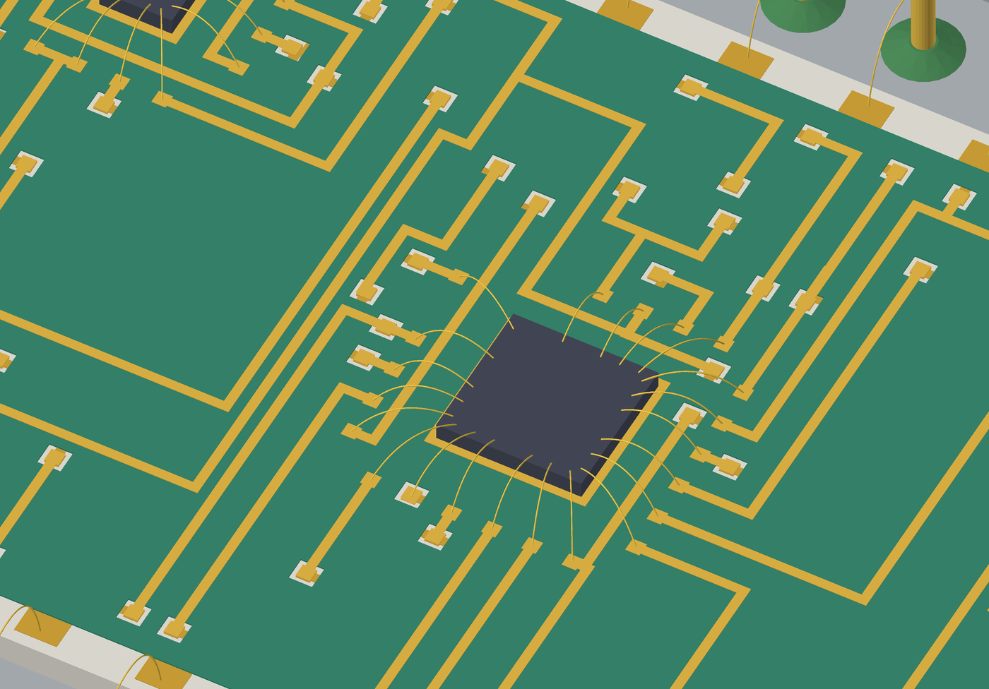
A 54AS181 die, its bonds and the printed films in 3D

Check it worked
☐ C1 auto-matched to CAP_0805.step
☐ Package linked with a relative path
☐ Model looks right in FreeCAD

Your notes and answers
What did the 90° correction do to C1, and why?

Why is a relative path better for a design you share?

Lab 15: Draw it and see it in 3D
Module | Time | Start from
17 · Documentation and 3D | Day 3, 13:35 · 25 min | my_alu8_checked.gds, or CP3

Goal. Build the assembly drawing and the 3D model of your ALU8.

Steps
- Tools → Top View…: build it on layer 56 with conductor hatching on.
- Tools → Assembly Drawing…: A3, portrait. Title 8-bit ALU (the example still says 4 bit ALU), drawing number ALU8-001, your initials and today's date.
- Pin functions: enter at least 18 = VCC and 3 = GND; the full list is in Appendix B.
- Press Build, then Print Preview.
- File → Export to FreeCAD (3D Macro)…. Run the macro in FreeCAD and orbit the model.
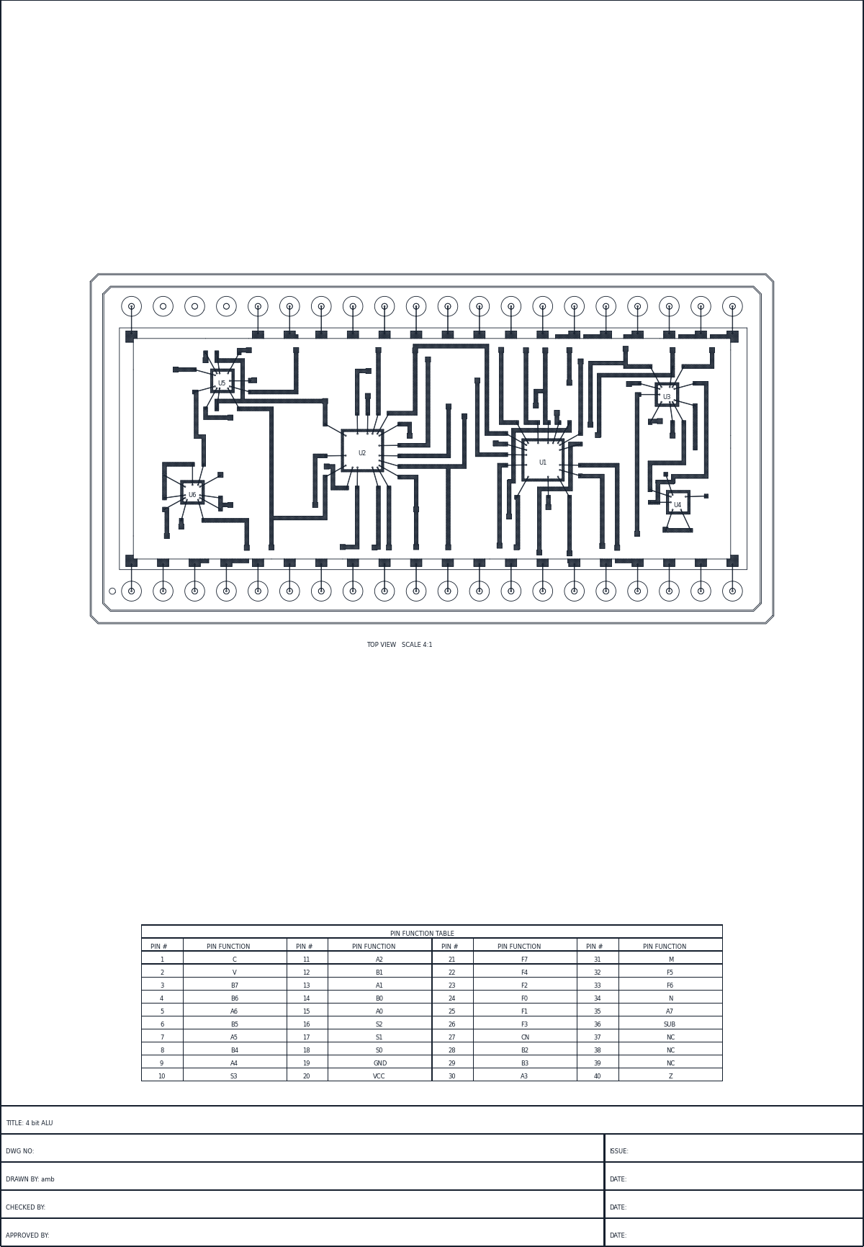
The ALU8 assembly drawing
The ALU8 in FreeCAD, seated in its Kovar DIP40

Check it worked
☐ Title block reads 8-bit ALU
☐ Sheet has the top view and the pin table
☐ The ALU8 opens in FreeCAD

Lab 16: Optional: script the build
Module | Time | Start from
18 · Automation and support | Day 3, 14:10 · 20 min | checkpoints\CP2_bonded_ready_to_route.gds

Goal. Run routing, checks and outputs from a script.

Steps
- Open CP2 and the Console tab.
- On the command bar run FREEROUTE RUN fresh=1 fingerlayer=2.
- In the console run print(s.sli()["complete"]) and print(len(s.run_drc())).
- Save the script below as build_alu8.py next to CP2 and run it with Tools → Run Script File….
- Open Help → Report Bug… and press Preview to see what a report would contain. Close it without sending.
from hlayout.scripting.api import Session
s = Session.open_design("CP2_bonded_ready_to_route.gds")

s.freeroute(remove_existing=True) # uses the saved Autoroute settings
print(s.sli()["complete"], "of 46 nets")
print(len(s.run_drc()), "DRC violations")

s.export_gerber("out/alu8")
s.export_pick_and_place("out/alu8_pnp.csv")
s.generate_assembly_drawing(size="A3", title="8-bit ALU")
s.save_design("alu8_scripted.gds")

Check it worked
☐ 46 of 46 from the script
☐ Outputs in the out folder
☐ You have seen a bug report preview

Capstone: the ALU8 on your own
When | Time | Start from
Day 3 afternoon | 14:30 · 105 min | checkpoints\CP1_dies_on_substrate.gds and alu8_tech.json

Brief. Take the ALU8 through the whole flow without step-by-step help. Work alone or in pairs.
Engineering change
U4's five unused inputs (pads 4, 5, 6, 11 and 12) are no longer tied straight to VCC. They go to VCC through a printed 1 kΩ ±5 % pull-up resistor, R1, rated 25 mW.

Tasks
- Size R1 in the Resistor Designer and place it near U4.
- Make the new net PU: U4.4, U4.5, U4.6, U4.11, U4.12 and R1.2. R1.1 joins VCC. Update the net names (NETNAMES IMPORT).
- Auto Place, bond, remove unused bonds and route: 47 of 47 nets.
- DRC clean, no shorts, the dielectric keep-out round R1 opened in the fill, thermal check.
- Outputs, an assembly drawing titled 8-bit ALU, and a 3D model with R1 visible.

R1 sizing
Width (mm) | After-trim rating (mW) | Aim (Ω) | Ink (Ω/□) | Squares | L (mm)

Hand in
☐ Your .gds and its .hlaux
☐ Gerber and DXF set
☐ Pick and place file and bond list
☐ Assembly drawing as PDF
☐ A screenshot of the 3D model

Your notes

Quick reference

Menus you will use most
Task | Menu
Open, save, archive | File → Open GDS… / Save GDS… / Archive Design
Technology | Setup → Layers… / Technology Properties… / Save Technology File…
Shapes | Create → Rectangle / Polygon / Path / Circle / Text · Setup → Path Style… · Edit → Continue Path…
Cells | Create → Create Cell from Selection… · Edit → Smash Selected to SRefs / Merge Selected…
Mask operations | Tools → Mask Operations… / Mask Operation Batch…
Dielectric | Tools → Generate Dielectric Fill… / Remove Dielectric Fill · Tools → Fix Vias…
Resistors | Tools → Thick-Film Resistor Designer… → Design Rules… / Place All in Layout… / Trim Simulator…
Wizards | Tools → Via Wizard… / Pad Wizard… / Chip Wizard… (attach a library first) · Setup → Library Cells…
Placement | Tools → Auto Place… · View → Straight-Line Interconnects
Bonds | Create → Wire Bond · Edit → Move / Delete Wire Bond · Tools → Remove Unused Bonds… / Bond Header Pins…
Nets | Edit → Highlight Net · View → Unrouted Nets…
Routing | Tools → Autoroute (Freerouting)… · Edit → Rip Up and Reroute · Tools → Fix Vias…
Checks | Tools → DRC… / Extract Netlist… / Thermal Analysis…
Outputs | File → Gerber Export Sets… / DXF Export Sets… / Export Pick and Place…
Drawings and 3D | Tools → Top View… / Assembly Drawing… · File → Export to FreeCAD (3D Macro)…
3D links | File → Component Library Manager… → Set STEP File… / Clear Override / Refresh
Help | Help → User Manual · Command Reference (F1) · Report Bug…

Command bar
Coordinates and sizes on the command bar are in microns (1 DBU = 1 µm).
Command | Does
FIT · ZOOM IN|OUT · ZOOM WINDOW x1,y1 x2,y2 | View control
RECT · POLY · PATH layer width cap … · CIRCLE · TEXT | Draw primitives
SREF cell x,y [rot] · AREF cell x,y cols rows dx dy · SMASH | Place and break instances
VIA 3 5 shape=round size=300 dielectric_layer=4 dielectric_window=500 | Via Wizard from the command bar (µm)
PAD name 5 20 1.0 1.4 0.1 cols=2 pitch_x=1.9 | Pad Wizard from the command bar (mm)
CELLSTAMPS | Created / modified date of every cell
MOVE · COPY dx,dy · ROTATE deg · UNION | Edit selection
MASKOP OVERSIZE 3 result=55 amount=100 | Mask operation
DIELECTRIC · DIELECTRIC CLEAR | Generate or delete the dielectric fill
RESGEN x,y width length ink=1000 ref=R1 | Place a sized resistor
HILITE <net>|<RefDes.Pin> · HILITE OFF | Highlight a net
NETNAMES IMPORT file.csv | Load net names from a pad,net CSV
AUTOPLACE RUN|IMPROVE file.net [seed=] [effort=] | Auto Place
AUTOPLACE WEIGHT <net> <w> | Weight one net
SLI ON|OFF · UNROUTED [NEXT] | Straight-line interconnects, unrouted nets
BOND x1,y1 x2,y2 | Draw a wire bond
UNUSEDBONDS [REMOVE] | List or remove unused bonds
IOPADS BOND all=1 | Bond the header pins
FREEROUTE RUN [fresh=1] [fingerlayer=2] | Route with Freerouting
FREEROUTE VIAOPT | SHORTEN | DEJOG | Tidy existing routing
RIPUP x1,y1 x2,y2 · SHORTS · VIA FIX | Edit and check routing
DRC RUN error=6 | Run every DRC rule, markers on layer 6
NETLIST RUN 3 5 bonds=1 | Extract the netlist
GERBER prefix · PNP EXPORT file.csv | Outputs
ASSEMBLY size=A3 title="8-bit ALU" | Assembly drawing

Resistor sizing
Step | Rule
Value | R = Rsh × squares; squares = L / W
Width | Smallest width whose after-trim rating (half the full rating) covers the power: Table 5.1
Aim | value × (aim % + tolerance %); aim 75 %
Ink | squares = aim / Rsh within 0.25–4; pick the one closest to 1 square
Length | L = squares × W
Layout | A 0.3 ink into pad · B 0.5 pad beyond · C 0.3 pad wider each side · D 0.3 glaze · E 1.0 keep-out (mm)
Shapes | Top-hat, roof, U, angles: sized as a sheet, a corner ≈ 0.56 sq; Edit… → Shape; allowed shapes: Setup → Technology Properties → Resistor Shapes
Trim | Plunge for speed, L-cut to finish; the value only goes up

Keyboard
Key | Action | Key | Action
F | Fit view | Ctrl+Z / Ctrl+Y | Undo / redo
G | Grid on/off | Ctrl+S | Save
W | Zoom window | R | Rotate selection 90°
P | Pan tool | Delete | Delete selection
M | Measure | Arrow keys | Nudge one grid step
Space | Drop a via while routing | Esc | Cancel the current tool
Enter | Finish a path or route | Backspace | Remove last point
F1 | Command Reference | Mouse wheel | Zoom at cursor

Glossary
Term | Meaning
ARef | Array reference: one instance placing a cell in columns and rows at a fixed pitch.
Aspect window | The allowed range of squares for a printed resistor, 0.25 to 4 by default.
Bond finger | Small conductor pad where a wire bond lands on the substrate; the router connects to it.
Bond reach | How far from a die its bond fingers sit; Auto Place grows each die by it.
Chip and wire | Building with bare dies glued down and wire-bonded, instead of packaged parts.
Checkpoint | A saved design at a known stage, used to restart a lab.
DBU | Database unit: 1 µm in HLayout.
Departure angle | Angle a wire leaves a die pad, measured from straight out of the die edge.
Die-attach pad | Conductor pad under a die, larger than the die, carrying its epoxy.
Dielectric | Printed insulating layer between the two conductors, with a window at each via.
Dielectric inputs / fill | Inputs (datatype 0) are the boundary, windows and keep-outs; the fill (datatype 1) is generated from them.
DRC | Design rule check: widths, spacings, edge clearance, bond rules.
End cap | How a path ends: flush, square (extended half the width) or round.
Glaze | Glass overprint covering a resistor, larger than the ink by D.
Header | The package pins; here the 40 pins of the Kovar DIP.
.hlaux | Sidecar file next to a .gds holding the technology, net names and settings.
I/O pad | Pad at the substrate edge that a header pin is bonded to.
Isolated pad layer | A layer whose pads sit above the substrate and join a net only through bonds.
Kerf | Width of the laser cut when trimming.
Land pattern | The conductor pads a part is attached to; made with the Pad Wizard.
Kovar | Iron-nickel-cobalt alloy that expands like glass and ceramic; used for hermetic packages.
L-cut | Trim cut that plunges, then turns 90° and runs along the resistor for fine adjustment.
Mask operation | A layer calculation: OVERSIZE, UNDERSIZE, AND, OR, NOT, XOR.
Paste / epoxy pad | The smaller pad the Pad Wizard draws inside each conductor pad: solder paste, or conductive epoxy on a hybrid.
Plunge cut | Straight trim cut into the resistor width; fast but increasingly sensitive.
Sheet resistance | Resistance of one square of fired ink, in Ω/□.
SLI | Straight-line interconnect: the drawn connection still to route.
Smash | Break an ARef into separate SRefs.
Specctra DSN / SES | The design and session files HLayout and Freerouting exchange.
Roof | Pin-less conductor capping a resistor's crown or skirt, so a trim cut can run deep without opening it.
Square | A resistor length equal to its width; resistance = Rsh × number of squares.
SRef | Structure reference: one placed instance of a cell, with rotation, magnification and mirror.
STEP | 3D model file format; HLayout places the STEP model of a cell at the cell origin.
Top-hat | Resistor shape with a crown on its bar; the trim plunge runs up into the crown for more range.
Technology file | A .json holding a process: layers, rules and settings, without a design.
Trim | Cutting resistor ink with a laser to raise its value to target.
Via | A window in the dielectric joining the two conductors.
Wizard | A Tools-menu form that builds a part (via, pad, die) and saves it into an attached library.
z_ref | The vertical reference of a 3D part: the surface, or the substrate bottom for headers.

Appendix A ALU8 net list
Die pins are given as RefDes.DiePad, the numbering in alu8_die.net. I/O pads are given as IO.n, where n is the package pin.
Net | I/O pad | Die pins
GND | IO.3 | U1.12, U2.12, U3.7, U3.11, U4.7, U5.7, U6.7, U6.12, U6.13
VCC | IO.18 | U1.24, U2.24, U3.14, U4.4, U4.5, U4.6, U4.11, U4.12, U4.14, U5.13, U5.14, U6.14
A0 | IO.26 | U1.2
A1 | IO.1 | U1.23
A2 | IO.34 | U1.21
A3 | IO.16 | U1.19
A4 | IO.9 | U2.2
A5 | IO.20 | U2.23
A6 | IO.40 | U2.21
A7 | IO.36 | U2.19, U5.4
B0 | IO.14 | U1.1
B1 | IO.5 | U1.22
B2 | IO.17 | U1.20
B3 | IO.15 | U1.18
B4 | IO.8 | U2.1
B5 | IO.19 | U2.22
B6 | IO.7 | U2.20
B7 | IO.6 | U2.18, U5.1
B7X |  | U5.3, U5.9
C | IO.4 | U6.8
C4 |  | U1.16, U2.7
CN | IO.29 | U1.7
CN8 |  | U2.16, U6.9, U6.10
F0 | IO.24 | U1.9, U3.1
F1 | IO.25 | U1.10, U3.2
F2 | IO.12 | U1.11, U3.13
F3 | IO.13 | U1.13, U3.3
F4 | IO.32 | U2.9, U3.4
F5 | IO.33 | U2.10, U3.5
F6 | IO.21 | U2.11, U3.9
F7 | IO.22, IO.23 | U2.13, U3.10, U5.5, U5.10
M | IO.31 | U1.8, U2.8
N0 |  | U3.12, U4.1
N1 |  | U3.6, U4.2
N2 |  | U3.8, U4.3
S0 | IO.28 | U1.6, U2.6
S1 | IO.27 | U1.5, U2.5
S2 | IO.11 | U1.4, U2.4
S3 | IO.10 | U1.3, U2.3
SUB | IO.35 | U5.2
V | IO.2 | U6.6
VA |  | U5.6, U6.1
VB |  | U5.8, U6.2
VN |  | U6.3, U6.4, U6.5
Z | IO.30 | U5.11
ZN |  | U4.8, U5.12

Appendix B Package pinout
KOVAR_DIP40, from io_pinout.csv. Pin 1 is bottom left; numbering runs counter-clockwise. Pins 37–39 are not used.
Pin | Net | Pin | Net | Pin | Net | Pin | Net
1 | A1 | 11 | S2 | 21 | F6 | 31 | M
2 | V | 12 | F2 | 22 | F7 | 32 | F4
3 | GND | 13 | F3 | 23 | F7 | 33 | F5
4 | C | 14 | B0 | 24 | F0 | 34 | A2
5 | B1 | 15 | B3 | 25 | F1 | 35 | SUB
6 | B7 | 16 | A3 | 26 | A0 | 36 | A7
7 | B6 | 17 | B2 | 27 | S1 | 37 | –
8 | B4 | 18 | VCC | 28 | S0 | 38 | –
9 | A4 | 19 | B5 | 29 | CN | 39 | –
10 | S3 | 20 | A5 | 30 | Z | 40 | A6
F7 appears on pins 22 and 23: one is the F7 output and the other the N (negative) flag, which is the same signal.

Assessment quiz
Circle one answer for each question. 16 or more correct to pass. Time: 20 minutes.
- Which netlist file should Auto Place use for the ALU8 bare dies?
  - alu8.net
  - alu8_die.net
  - alu8_netlist.txt
  - io_pinout.csv
- In the netlist text U1.14[12](GND), what is 12?
  - The LCC terminal
  - The die pad (DIP pin)
  - The net number
  - The header pin
- Why are layers 58 and 49 isolated pad layers?
  - They are documentation only
  - They are printed under the dielectric
  - They sit above the substrate and connect only through wire bonds
  - They hold DRC markers
- How much larger than the die is the die-attach pad?
  - 0.05 mm all round
  - 0.1 mm all round
  - 0.2 mm all round
  - 1.5 mm all round
- On which layer are the ALU8 bond fingers laid by the router?
  - 1st conductor
  - 2nd conductor
  - Dielectric
  - Die-pad layer
- What is the ALU8 maximum wire-bond departure angle?
  - 30°
  - 45°
  - 60°
  - 90°
- Why does Auto Place grow each die by the bond reach?
  - To keep the dies cool
  - To leave room for the bond fingers and measure nets to them
  - To meet the DRC spacing rule
  - To align dies to the grid
- What does Tools → Remove Unused Bonds need first?
  - A routed design
  - Net names
  - A DRC run
  - A thermal model
- Which statement about Freerouting in HLayout is true?
  - It ignores your DRC rules
  - Your DRC width and spacing rules set the router widths and clearance
  - It routes wire bonds
  - It runs only on one conductor
- Why can spacing DRC not find a short circuit?
  - Shorts are on the dielectric
  - Touching copper merges into one shape, so there is no gap to measure
  - DRC skips power nets
  - Shorts only show in 3D
- What does via optimisation do?
  - Adds vias at every turn
  - Moves tracks to the other conductor so vias can be removed
  - Enlarges every via window
  - Converts vias to bond fingers
- Outside the printed dielectric, which conductor may carry tracks?
  - Only the 1st conductor
  - Only the 2nd conductor
  - Both
  - Neither
- What does the .hlaux file hold?
  - Only the geometry
  - The technology, net names, libraries and settings for the design
  - The Gerber files
  - The FreeCAD model
- With a cooled base, roughly how hot did U1 run in Lab 12?
  - 26 °C
  - 34 °C
  - 85 °C
  - 125 °C
- Where does the assembly drawing take its pin count from when Pins is blank?
  - The netlist
  - The package placed in the design
  - The DRC rules
  - The technology file
- Which path end cap extends half the path width past the end point with a square end?
  - Flush
  - Square (extended)
  - Round
  - Mitred
- You enlarge the pad in the PAD cell. What happens to the 10 PAD instances in an ARef?
  - Nothing; instances are copies
  - Only the first one changes
  - All of them change
  - The ARef is smashed
- What does Tools → Remove Dielectric Fill delete?
  - Everything on layer 4
  - Only the generated fill; the inputs stay so you can generate it again
  - Only the via windows
  - The dielectric layer from the technology
- Why is a 1 kΩ ±5 % resistor printed at about 800 Ω?
  - To save ink
  - Firing always raises the value 25 %
  - Laser trimming can only raise resistance, so it is printed low and trimmed up
  - To stay inside the 0.25–4 squares window
- A STEP model sits in the wrong place in 3D. What must match first?
  - Its file name and the cell name
  - Its origin and the 2D cell origin
  - Its colour and the layer colour
  - Its units and the Gerber units

Course feedback
Please rate each item from 1 (poor) to 5 (excellent).
Item | 1 | 2 | 3 | 4 | 5
The course met its objectives
The pace was right
The labs were clear
The ALU8 example was useful
The trainer explained things well
I can now use HLayout on my own designs
What was most useful?

What should change?

What would you like to learn next?

