
HLayout in Practice
Designing a chip-and-wire hybrid, from netlist to 3D
Trainer guide
Three-day course · HLayout 0.8 · built around the ALU8 example
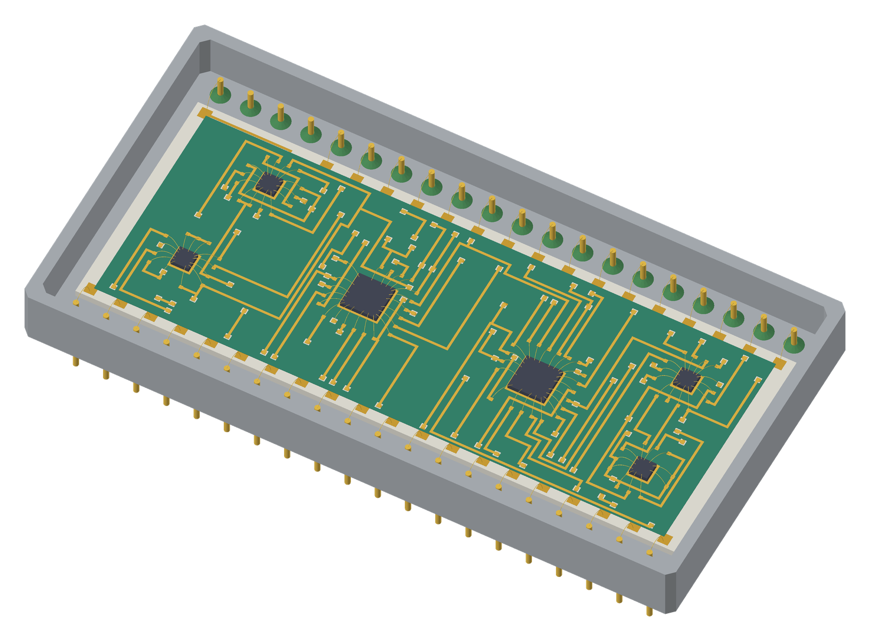

Setup checklist, timing, checkpoint map, lab and capstone answers, quiz key and known issues. Use with the slide deck HLayout_Training_ALU8.pptx, whose speaker notes carry the talk for every slide.

Before the course
Room and machines
☐ One PC per student, Windows 10/11 64-bit (or Linux/macOS with the matching installer)
☐ HLayout 0.8 installed (installer, or the portable 64-bit zip where students have no admin rights: unzip and run hlayout.exe); check Help → About shows 0.8
☐ Freerouting installed (Java build, freerouting.exe). A .jar needs Java 25 or later
☐ FreeCAD installed for Labs 14 and 15 (or demo them on the projector)
☐ STEP models built: python build_STEP_parts\build_all.py; check examples\step_models\chip_wire and kovar_dip exist
☐ C:\dev\HLayout\training\checkpoints copied to every machine, including CP0_shapes_reference.gds and a fresh my_parts.gds for each student (the wizards write into it)
☐ Projector, flipchart, printed student handouts, one per student
☐ A test run of Lab 10 on the trainer machine (route time on this hardware)

Day before
☐ Open each checkpoint and confirm it loads with its sidecar
☐ Run DRC on CP3: two violations, both 1st con metal_2_metal
☐ Open the Resistor Designer and Trim Simulator once: they need numpy and scipy (included in the installers)
☐ Check the KOVAR_DIP40 STEP path in the Component Library Manager resolves on the training PCs
☐ Print the quiz answer key (this guide) separately
☐ Check Wi-Fi is not needed: the labs run offline

Timing
Three days, 18 modules, 16 labs and a capstone. The deck has 101 slides: about 40 % talk and demo, 60 % hands-on. Day 1 covers the foundations (shapes and cells, technology, mask operations and dielectric, printed resistors); day 2 takes the ALU8 from netlist to a routed design; day 3 verifies it, makes the outputs, links the 3D models and ends with the capstone and quiz.
Day | Runs long most often | Where to recover time
1 | Lab 2 (shapes) for students new to CAD; Lab 5 (resistors) | Shorten module 2 (hybrids) or the day 1 review
2 | Lab 8 (Auto Place) and Lab 10 (routing) | Demo Lab 11 instead of running it in full
3 | Lab 14 (3D linking) if FreeCAD is slow | Lab 16 is optional; the capstone can stop at routing

Checkpoint map
Checkpoint | Copied from | State | Facts checked
my_parts.gds | hlayout\examples\chip_wire.gds | Example parts library: packages, chip capacitors, dies, chip_pin_1 and chip_pin die-pad cells, VIA_Layer3_to_Layer5 | Students add VIA_R300, LAND_0805, MY_54LS00
CP0_shapes_reference.gds | Built for the course | Cell PAD (0.6 mm pad with triangle); TOP with a rectangle, polygon, circle, three paths with flush, square and round caps, three PAD SRefs and a 5 × 2 ARef | Compare only
CP1_dies_on_substrate.gds | alu8_dies.gds | Six dies and I/O pads on a 30 × 30 mm substrate; not placed by Auto Place | 0 of 46 nets routed; DRC clean
CP2_bonded_ready_to_route.gds | pre_route_hold.gds | Reference placement in the DIP40; dies and header bonded; fingers fanned out on the 2nd conductor | 6 of 46 nets complete; DRC clean; no shorts
CP3_routed.gds | 8bit_alu.gds | Fully routed with dielectric | 46 of 46 complete; no shorts; 2 DRC violations; dielectric 94 inputs, 23 fill pieces
8bit_alu.gds | 8bit_alu.gds | Reference design, identical to CP3 | As CP3
alu8_tech.json | 8bit_alu.json | ALU8 technology file | 5 DRC rules
CP1 uses the 30 × 30 mm working substrate from build_alu8_dies.py; CP2 onwards uses the final 21.7 × 14.9 mm substrate in the KOVAR_DIP40. Explain the jump on day 2: everyone restarts from the same reference placement.

Lab answer key
Lab | Answers and notes
Lab 1 | C4 joins U1 pad 16 (Cn+4) to U2 pad 7 (Cn). Bonds measure 1.65–1.89 mm. Console prints 46. To see the 2nd conductor alone hide layers 3 and 4. The status bar shows the distance and dx, dy while measuring.
Lab 2 | A square cap on a 0.4 mm path reaches 0.2 mm past the end point; round also reaches 0.2 mm, flush 0. After Smash the pads are separate SRefs of PAD, so editing PAD still changes all of them, but moving one no longer moves the rest. The triangle shows rotation and mirroring. Early finishers: Tools → Via Wizard and place the via as an SRef.
Lab 3 | Five rules as Table 3.3. Common error: wire width entered as 30 instead of 0.03 mm. The dielectric margin (0.2 mm) is the margin round the boundary; the via window margin (0.1 mm) is added to each side of the via pad.
Lab 4 | Layer 54 is the bare substrate not covered by 1st conductor. After Remove Dielectric Fill only the 94 input shapes on layer 4 remain (boundary, via windows, keep-outs); Generate gives 23 fill pieces again. A bond moved outside 1.0–2.5 mm shows in DRC as BOND.L.MIN or BOND.L.MAX; a steep move as BOND.ANGLE. Make sure students work on the copy.
Lab 5 | R1: 1.4 mm (62.5 mW after trim), aim 800 Ω, 1 kΩ/□, 0.80 sq, 1.12 mm; ink 1.72 × 1.40 mm, pads 0.80 × 2.00 mm, overall 2.72 × 2.00 mm. R2: 1.8 mm, aim 7.6 kΩ, 10 kΩ/□, 0.76 sq, 1.37 mm. R3: 2.8 mm (2.4 mm is only 187.5 mW after trim), aim 37.6 Ω, 30 Ω/□, 1.25 sq, 3.51 mm. R4: 1.0 mm, aim 187 kΩ, 300 kΩ/□, 0.62 sq, 0.62 mm. Trim R1: printed 793 Ω; plunge 25 % → 913 Ω, sensitivity 0.42 Ω/µm; L-cut 400 µm → 995 Ω, 0.09 Ω/µm. The L-cut finishes because its sensitivity is low, so the laser can stop accurately. Shape step: as a top-hat with roof R1 takes 300 Ω/□ ink, 2.67 squares, bar L 4.53 mm; printed about 797 Ω, it reaches 1 kΩ at about 1.24 mm of plunge and about 1330 Ω at the full 2.66 mm, and never opens: the roof keeps a path round the cut. A plain angle of the same squares tops out at about 935 Ω and cannot reach value.
Lab 6 | GND has 11 pins: J1, J2 and nine die pins (U1.12, U2.12, U3.7, U3.11, U4.7, U5.7, U6.7, U6.12, U6.13) across all six dies. C4: U1 pad 16, U2 pad 7. U1 and U2 share S0–S3, M and C4. F7 has 6 pins (J2.8, J2.11, U2.13, U3.10, U5.5, U5.10); two header pins because N, the negative flag, is the same signal as F7. U4 pads 4, 5, 6, 11, 12 (inputs D–H) are tied to VCC with pad 14 (VCC): the 8-input NAND uses only three inputs, so the unused ones are held high.
Lab 7 | VIA_R300: round 300 µm pads on 3 and 5, 500 µm window on 4 (pad + 2 × the 0.1 mm via window margin, the Dielectric tab). The default name VIA_Layer3_to_Layer5 already exists in chip_wire.gds, so the wizard would ask to overwrite it. LAND_0805: two 1.0 × 1.4 mm pads on 5 at x = ±0.95 mm, epoxy 0.8 × 1.2 mm on 20, pins 1 (left) and 2 numbered automatically. MY_54LS00: attach pad 1.9 mm on 5, epoxy 1.4 mm on 20, outline 1.53 mm on 61, 14 pins labelled 1–14; the script-built DIE_54LS00 has its top and bottom pads at 0.225 and 0.45 mm, off the 0.1 mm grid, so positions differ slightly. Pins follow the LCC terminal order so bonds fan out without crossing. CP2 has the smaller 21.7 × 14.9 mm substrate inside the KOVAR_DIP40. Common faults: no library attached (step 1 skipped); everyone sharing one my_parts.gds on a network drive.
Lab 8 | Results vary with hand moves. U1 and U2 should end side by side; raising C4 to weight 3 pulls them closer.
Lab 9 | On a 54AS181 the unused die pads are 14 (A=B), 15 (P) and 17 (G). In CP2 these bonds may already be removed; then UNUSEDBONDS lists nothing. Removing them frees routing channels round the die. After removal the dies get their own part copies, e.g. DIE_54AS181_U1.
Lab 10 | 46 of 46 with the Table 10.1 settings. Fewer usually means fingers on the 1st conductor or Remove ALL not ticked. Via windows are 500 µm (300 µm pad + 2 × 0.1 mm).
Lab 11 | C4 appears in Unrouted Nets after the rip-up. Routing it back gives 46 complete and total 0.
Lab 12 | CP3 has 2 violations of 1st con metal_2_metal (MIN_SPACE_BETWEEN layer 3, 200 µm) at about x 55.1 mm, y −7.8 mm (DBU 55115, −7845), just left of U3: a short diagonal 1st-conductor segment. Thermal, fixed base 25 °C: U1 and U2 26.0 °C, U5 25.2 °C, others 25.1 °C. Cooled base, 200 W/m²K: U1 34.0, U2 33.9, U5 28.7, U3 28.8, U4 28.7, U6 28.0 °C (±1 °C with grid size). 900 mW total.
Lab 13 | Pick and place lists U1–U6 as kind die; U1 at (34.02, 8.80) mm rotated 270°, U2 at (19.52, 9.55) mm rotated 180° from the substrate corner. The bond list has 94 rows: U1 and U2 21 each, U3 and U5 14, U6 13, U4 11; lengths 1.65–1.89 mm; steepest angle 29.3°.
Lab 14 | KOVAR_DIP40 is linked manually (mode model) to C:/dev/HLayout/examples/step_models/kovar_dip/KOVAR_DIP40_0.9in.step, z_ref substrate_bottom so the substrate sits in the package well. C1 matches CAP_0805.step automatically by its EIA code. With a 90° correction the capacitor body turns across its pads: the correction is applied on top of the instance rotation. After Set STEP File… to a copy next to the design the path is stored relative, so the design works on another PC. No FreeCAD: use File → 3D View in SolidCraft or the projector.
Lab 15 | The example title block says "4 bit ALU"; students change it to 8-bit ALU. Pin table from Appendix B.
Lab 16 | The script needs the Freerouting path saved in Lab 10. 46 of 46; two DRC violations remain unless fixed (they come from the router, so a new route may differ).
Capstone | R1, 25 mW: 1.0 mm (31.3 mW after trim), aim 800 Ω, 1 kΩ/□, 0.80 squares, 0.80 mm long. The new net PU makes 47 nets, so routing should report 47 of 47. The keep-out round R1 is drawn on the dielectric layer as an input; the regenerated fill opens over it. Check each hand-in against the list. The capstone is not marked; it is practice for the quiz and real work. Strong finishers can add C1 from Lab 14 to the netlist.

Quiz answer key
Q | Answer | Q | Answer
1 | b) alu8_die.net | 11 | b) Moves tracks to the other conductor so vias can be removed
2 | b) The die pad (DIP pin) | 12 | a) Only the 1st conductor
3 | c) They sit above the substrate and connect only through wire bonds | 13 | b) The technology, net names, libraries and settings for the design
4 | c) 0.2 mm all round | 14 | b) 34 °C
5 | b) 2nd conductor | 15 | b) The package placed in the design
6 | b) 45° | 16 | b) Square (extended)
7 | b) To leave room for the bond fingers and measure nets to them | 17 | c) All of them change
8 | b) Net names | 18 | b) Only the generated fill; the inputs stay so you can generate it again
9 | b) Your DRC width and spacing rules set the router widths and clearance | 19 | c) Laser trimming can only raise resistance, so it is printed low and trimmed up
10 | b) Touching copper merges into one shape, so there is no gap to measure | 20 | b) Its origin and the 2D cell origin
Pass mark: 16 of 20.

Known issues and tips
- No bond diagram for Freerouting designs. HYBRID BONDS and BONDTABLE need a design imported from the chip-and-wire router; the ALU8 is routed with Freerouting, so Lab 13 writes the bond list from Python, and the assembly drawing has no bond table.
- Example title block. The ALU8 example's assembly drawing is titled "4 bit ALU". Lab 15 fixes it; consider fixing the example itself.
- Resistor shapes. Shapes other than the rectangle are new in this release (manual §11.9 and §12.5). The shape trim window cuts a plunge only; the L-cut is for rectangles.
- Absolute STEP path. The ALU8 example links the package to C:/dev/HLayout/… with an absolute path. On a PC with HLayout elsewhere the package draws as a box. Lab 14 shows the fix: a relative path.
- Via cell window. The stored VIA_Layer3_to_Layer5 cell carries a 400 µm window from an older setting; the dielectric generator cuts 500 µm windows (pad + 2 × via window margin). If a student spots the difference, that is the reason.
- Representative values. Die sizes and pad positions are representative (TI publishes no die drawings), and the thermal powers are exercise values. Say so when students ask.
- Freerouting builds. Use the Java build. The native CLI build crashes on multi-pass runs, so HLayout limits it to one pass and fewer nets complete.
- Netlist extraction needs layers 58 and 49 ticked as Isolated; without them the die pads merge with the copper underneath and every net joins.
- Sidecars. A .gds copied without its .hlaux loses net names and technology; most "nothing works" cases in labs come from this.
- Units. Dialogs use mm, the command bar and technology file µm.

