

**DEDAN KIMATHI UNIVERSITY OF TECHNOLOGY**

**PROJECT PROPOSAL FOR THE STUDY OF BACHELOR OF SCIENCE IN INFORMATION TECHNOLOGY**

**BY**

**ALVIN ONDIEKI C025-01-0623/2020**

**PROJECT TITLE**:

**DEDAN KIMATHI UNIVERSITY OF TECHNOLOGY STUDENTS’ ONLINE VOTING SYSTEM**

**SUBMITTED IN PARTIAL FULFILLMENT OF THE REQUIREMENTS FOR THE**

**AWARD OF BACHELOR OF SCIENCE IN INFORMATION TECHNOLOGY FOR THIRD YEAR.**

# DECLARATION

I hereby affirm that this proposal” Proposal Report for Students Online Voting System” has been carried out by me **ALVIN ONDIEKI** with the registration number **C025-01-0623/2020** and is a personal best of my study work.

NAME: **ALVIN ONDIEKI**

REG NO: **C025-01-0623/2020**

Signature: …………………. Date: …………………

Supervisor’s Approval

NAME: DR. JANE KURIA

Signature: …………………… Date: …………………..

# DEDICATION

Countless sense of happiness, I consecrate this work to the Supreme God who by His grace and compassions I was able to carry out this project.

# ACKNOWLEDGEMENT

In completing this project have been fortunate enough to have help, support and encouragement from many people. I would like to acknowledge them for their cooperation.

I would like to thank my project advisor for guiding me through each and every step of the process with knowledge and support. Thank you for your guidance, advice and assistance.

Finally, I would like to dedicate this project to my parents for their financial assistance and my friend Zebulon for the motivation and assistance throughout the project.

# ABSTRACT

Paper ballot voting system brings with it a number of problems such as; slow rate of counting and tabulation of casted votes, inaccurate results due to human error, poor presentation of the ballot paper, inconvenience for the voter to cast a vote, poor participation and turnout, fraud in polling station and during the transmission and tabulation of result, increase in spoilt ballot, increase in the long-term cost of production and distribution of ballot papers.

This dissertation aims at the following research objectives: to investigate how electronic voting system are implemented around the world, to develop a web based electronic voting system and to test and evaluate the developed web based electronic voting system

The dissertation presents a secure web based electronic voting system, a case study of Dedan Kimathi University of Technology student council election. The system is inspired by the Estonian Internet voting system architecture with major changes; it can be customized and implemented for a variety of election such as: large institutions elections, party elections, parliamentary election or even the national elections.

The web based electronic system is secured by use of secure socket layer protocol, hashing, public key encryption and secure electronic transmission protocol. These helped achieve the following security properties: authenticity, confidentiality, integrity, verification and anonymity.

The researcher reviewed relevant literature that was used in designing of the system prototype, this was then followed by a system testing that aimed at measuring the efficiency, effectiveness, easy to learn, interactivity and convenience of the system to the voters. The system testing targeted the Dedan Kimathi University of Technology students who interacted with the system and filled in questionnaires. The respondents found the system to be very effective, very efficient, extremely easy to learn how to use, very good to interact with and very useful.

TABLE OF COTENT

Contents

DECLARATION 2

DEDICATION 3

ACKNOWLEDGEMENT 4

ABSTRACT 5

CHAPTER ONE: INTRODUCTION 8

1.0: INTRODUCTION 8

1.1: PROBLEM STATEMENT 8

Paper ballot voting system employed in the management of electioneering procedures is prone to inconsistencies. It does not offer a platform where both candidates and voters can be registered, election malpractices such as fraud and favoritism for certain candidates and untimely delivery of results leading to questions at to the credibility and validity of the results the returning officer announces. Much expense was in incurred in the production, transportation, storage and destruction of the ballot papers and ballot boxes. Paper ballot system is also slow and inconveniencing because the voter is required to queue and vote at the polling station hence poor participation and turnout. 8

1.2: OBJECTIVES 9

1.3: SIGNIFICANCE OF THE PROJECT 9

1.4: JUSTIFICATION 9

1.5: SCOPE AND LIMITATIONS OF THE PROJECT 9

1.6: SIGNIFICANCE OF THE STUDY 10

1.7: ASSUMPTIONS 10

1.8: CONCEPTUAL FRAMEWORK 11

CHAPTER TWO: LITERATURE REVIEW 12

2.0: INTRODUCTION 12

2.1. Election and Voting 12

2.1.2. Requirements of a Voting System 13

2.2. Electronic Voting 14

2.2.1. Definition of Electronic Voting 14

2.3. Online voting 15

2.4. Conclusion 17

CHAPTER 3: METHODOLOGY 18

3.0: SYSTEM DEVELOPMENT TECHNIQUE 18

3.0.1: Prototyping 18

3.0.2: Modeling 18

3.1: SYSTEM DEVELOPMENT METHODS 18

3.1.0: Waterfall model 18

3.1.1: Advantages of waterfall model 18

3.1.2: Disadvantages of waterfall model 18

3.2: CODING LANGUAGES TO BE USED 18

3.2.1: Database management system 18

3.2.2: Back-end technology 19

3.2.3: Front-end technology 19

3.3: TESTING PLAN FOR THE SYSTEM 20

3.3.1: Unit testing 20

3.3.2: Component testing 20

3.3.3: Integration testing 20

3.3.4: System testing 20

3.4: SYSTEM REQUIREMENTS ANALYSIS 20

3.4.1: Functional requirements 21

3.4.2: Non-functional requirements 21

REFERENCES 22

# CHAPTER ONE: INTRODUCTION

## 1.0: INTRODUCTION

“DIGITAL VOTING SYSTEM” is a voting web application that works to address the issue of recording, casting and counting of votes. The system has been optimized on different screen sizes to enhance user experience. In this system people who have been enrolled, on session and are registered on the system can give their vote digitally without using ballot paper in polling station. There is a database which is maintained in which all names of voters with complete information is stored. In digital voting system, a voter can use his or her voting rights without any difficulty. He\she has to be registered first in order to vote. Registration is mainly done by the system administration for security reasons. Students seeking registration are expected to visit the electoral body office that has been set aside to submit their details. After the validity of them being an ongoing student of Dedan Kimathi University of Technology has been confirmed by the system administrator through comparisons with those in existing database such as those at the registrar’s office, the student is then registered as voter. After registration, the voter gets a card containing details which he/she will use to log in the system during election period. If invalid/wrong details are submitted by the citizen during registration then he/she wouldn’t be registered as a voter.

## 1.1: PROBLEM STATEMENT

Paper ballot voting system employed in the management of electioneering procedures is prone to inconsistencies. It does not offer a platform where both candidates and voters can be registered, election malpractices such as fraud and favoritism for certain candidates and untimely delivery of results leading to questions at to the credibility and validity of the results the returning officer announces. Much expense was in incurred in the production, transportation, storage and destruction of the ballot papers and ballot boxes. Paper ballot system is also slow and inconveniencing because the voter is required to queue and vote at the polling station hence poor participation and turnout.

The said problems can be solved by creating and designing a digital voting system which will allow the voter to make any changes before submitting and it’s faster.

## 1.2: OBJECTIVES

The aim of the project is to analyze the current election system and suggest and develop the digital voting system in such a way that Voter may cast votes in a more convenient way, by using available resources which could facilitate the voters during elections

The main objective is: To design, develop and implement an efficient, user friendly, interactive web-based student voting system.

The specific objectives of the project include:

1. To develop a system where both candidates and voters can be registered, added and updated.
2. Develop a system that will generate reports for the entire election process in a secure way
3. To reduce cost that would have been incurred in the production, transportation, storage and destruction of the ballot papers and ballot boxes.
4. To develop a system that facilitates a faster means for voters to cast their votes at their own comfort hence increasing number of participants.

## 1.3: SIGNIFICANCE OF THE PROJECT

1. It will help in reducing paper work during election
2. It will help secure election data
3. It will allow the organization to keep real-time election data. ty
4. It will keep track of election/votes during election.
5. It will increase voter turnout as it faster and less strenuous

## 1.4: JUSTIFICATION

The various users of the system will benefit from it in the following ways:

1. Enable voters and candidates’ interactions
2. Provide a faster way of voting
3. Satisfying results since no human errors are experienced

## 1.5: SCOPE AND LIMITATIONS OF THE PROJECT

The project target was to create a system to be used for election.

The project includes research, design and prototyping, system implementation as well as report to describe the final product.

The project has been tried by a few people to evaluate its acceptability.

The limitation of the project is that voters can only vote when there is availability of internet connection.

## 1.6: SIGNIFICANCE OF THE STUDY

The success of this project will ensure the scalability of the web based electronic voting system to be used in other different types of election such as: parliamentary elections, referendums and the national elections. Its success can also be replicated in other countries.

### 1.7: ASSUMPTIONS

The assumptions of the study are:

1. Every user has a smartphone
2. The user has good internet connection

## 1.8: CONCEPTUAL FRAMEWORK



# CHAPTER TWO: LITERATURE REVIEW

## 2.0: INTRODUCTION

This chapter highlights the definition of voting, the different types of voting, requirements of a voting system, electronic voting, functional and security requirements of an electronic voting system, successful electronic voting systems. This chapter also provides a review of the already existing literature about online voting system done by previous writers. This chapter documents the available relevant literature concerning the problem domain. The implication was that the researcher devoted sufficient time to reviewing research already undertaken on related problems. This was done to find out what data and other materials are already available from earlier research, and identify gaps that the present research may fill

Related information was mainly extracted from the Internet.

## 2.1. Election and Voting

Election is the process that gives the citizens the rights to select candidates to represent them in a democratic pattern. Election deals with the democracy and freewill of citizens, for this reason voting process is considered to be very critical and sensitive process.

Voting is a process at the heart of a democratic society. Voting schemes have evolved from

counting hands, to system including paper, punch card, mechanical lever, and optical-scan

machines.

Online voting refers to the use of hardware and software to establish an electronic system, useful in voting process, by generating an electronic ballot that replaces the paper ballot. These systems will increase voter’s participation and will speed up the votes counting. Introducing remote voting technique over the internet (e-voting) will serve voter’s convention. The main idea of this technology is to speed up the ballot counting and increase voters’ participation by providing remote voting process and social interaction platforms.

2.1.1. Types of Voting

Different types of voting:

1. Paper-based voting system (PVS) – this voting system is also referred to as document ballot voting system, a voter casts his vote on a ballot paper (paper card or sheets). Casted votes are counted manually hence easy target to election fraud.
2. Lever voting machine (LVM) ­­­­­­­­­­­­­­­­­­­­­­-they completely eliminated most approaches of manipulating vote count; they could also be configured to handle complex elections. They were expensive to move, store, difficult to test, complex to maintain and were prone to fraud. Votes once counted cannot be recounted.
3. Direct Recording Electronic voting system (DRE) - this voting system records votes by means of a ballot display that a voter activates by the press of a button. The voting records are then recorded in a removable memory component, and after the casting of the vote process the DRE produces a tabulation of the voting records.
4. Public network DRE voting system (PNDRE) – this voting system makes use of electronic ballots and transmits vote data from the polling stations to other locations over a public network. The votes may be transmitted as individual ballots as they are cast, or periodically as batches of ballots, or as one single batch, at the end of voting.
5. Precinct voting systems (PCVS) - this voting system puts the ballots in a tabular form at a particular place (a polling station). It then provides mechanisms that store vote count electronically and transmit the results to a central location over public telecommunication network.
6. Central Count Voting Systems (CCVS) - this voting system tabulates ballots from multiple precincts at a central location. Voted ballots are safely stored temporarily at the polling station. These ballots are then transported or transmitted to a central counting location. CCVSs may, in some cases, produce printed reports on the vote count.

### 2.1.2. Requirements of a Voting System

All voting system should satisfy the following requirements, whether traditional or electronic

1. Fail safe voter privacy – this is assuring the inability to link a voter to a vote.
2. Collusion-free vote secrecy – this is assuring the inability to know what the casted vote by the voter is.
3. Verifiable election integrity – to verify that no party has influenced the outcome of the election.
4. Fail – safe privacy in verification – ensuring the voter’s name for each ballot must not be revealed.
5. Physical recounting and auditing.
6. 100% accuracy – the counting of votes and absence of vote should correctly count.
7. Represent blank votes – a voter is allowed to change choice at will before casting the ballot.
8. Prevent over votes.
9. Provide for null ballots – to allow voters to null races or entire ballot as an option.
10. Allow under votes.
11. Authenticated ballot styles – ballot styles and ballot rotation to be used by each voter must be authenticated.
12. Manifold of links – must use a manifold of redundant links and keys to securely define, authenticate and control ballots, also must prevent a single point of failure.
13. Off-line secure control structure – must provide an off-line secure end-to-end control structure for ballots.
14. Technology independent – must allow ballots and their control to be used off-line and/or in dial up and /or in networks.
15. Authenticated user – defined presentation – must enable the ballots to dynamically support multiple languages, font size and layout so that voter could choose one that they are comfortable with.
16. Open review, open code – Allow all source code to be publicly known and verified.

## 2.2. Electronic Voting

### 2.2.1. Definition of Electronic Voting

Electronic voting (e-voting) is a voting system where the recording, casting and counting of

votes involve information and communication. In a nutshell, e-voting strives to be uniform and secret, only eligible persons are to be allowed to vote and a voter should only cast one vote and the collections are to be secure, reliable and accountable.

2.2.2. Loopholes

[1] This system gives loopholes to election theft and manipulation of votes especially during the collection of votes. The proposed research works on filling this gap.

[2] The process of this system is ambiguous in a manner that a voter has to register and keep confirming whether his/her details are in the system and on the voting day, voters have to cast their votes in the ballot.

[3] It is proved to be challenging for the system to accommodate the disabled and multilingual voters hence it is also time consuming.

For the e-voting system to function properly, it should ensure error-free and robust electronic voting over the internet which has been a difficult for this system hence it could not be implemented in most of the institutions.

## 2.3. Online voting

This is a web -based voting system. It is important to note that the other voting systems do not provide all the security features of advanced online voting systems, such as end-to-end encryption, anonymization techniques and key sharing mechanisms, nor do they provide individual or universal verifiability mechanism. In this paper a new easy to use, secure and transparent online voting system is proposed. The new scheme can be easily used by colleges and universities worldwide. The new scheme most notable allows voters to interact, participate in campaigns and political rallies virtually by use of a web -based system.

2.3.1. Case Study of Trent University System

Overview:

Ayepoll was a name given to an online voting system for Trent University. All user interaction was performed remotely through the user's web browser. Users of AyePoll were categorized into three classes: Administrator, Returning Officers and Voters. A running version of the system had only one Administrator but it typically had multiple returning officers and voters. The administrator was responsible for managing user accounts, polls, system resources and logs and for the health and safekeeping of the system. Returning officers had the responsibility of managing a poll as assigned by the administrator, whereas voters only had the ability to submit ballots on polls in which they are admitted.

Hierarchy of GUI Screens

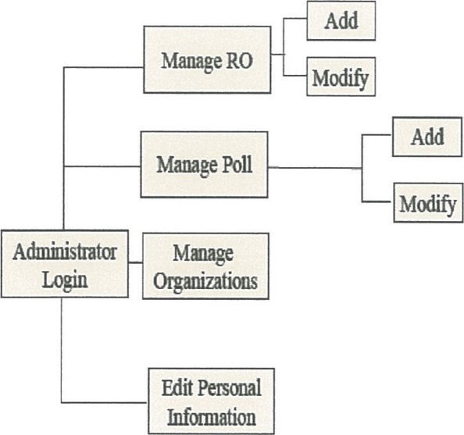

Source: (http:/hvww.ayepoll.trent.ac/online voting.html).

System Security

The security of the system rotated around the administrator. It was the responsibility of the administrator to ensure that the system operates securely. The administrator maintained a strong password (preferably one with more than 6 characters including numbers and not comprised of words from the dictionary) and ensured no one gets access to this; He regularly reviewed event logs in the system and ensured that no suspicious activity takes place such as repeated failed attempts to login etc. It was also the responsibility of the administrator also to ensure that no person gets direct access to the machine in which the system is running be it physical or remote access as data integrity cannot be guaranteed when people tamper with the system from the outside. It was also the responsibilities of the administrator to ensure that all packages and systems in which ayePoll depend on are present at the time of polling. In this regard, the administrator had the responsibility to ensure that bugs in PI-IP, PostgreSQL, Debian GNU/Linux, Apache are patched quickly as unpatched systems can open doors to intruders. Available online: (http://www.ayepoll.trent.ac/online_voting.html).

The voter had to use correct user name and the password in order to login the system as seen below;

The ayepoll login form.

|  |
| --- |
| a epoll Administrative Lo in - Mozilla Firefox  Edit Yiew Go Bookmarks 1001s Help |
| : |
|  |

Source: (http://www.ayepoll.trent.ac/online voting.html).

After logging into the system, a voter went direct to vote a candidate of his choice as seen below;

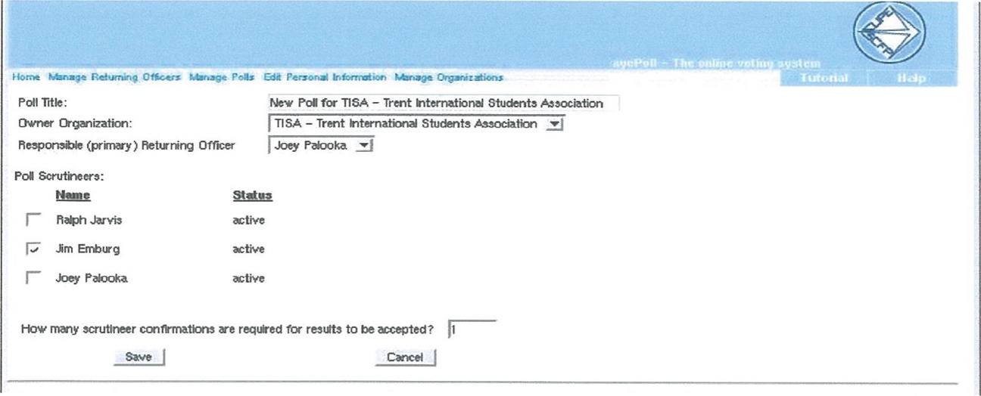

Source: (http://www.ayepoll.trent.ac/online voting.html).

## 2.4. Conclusion

Out of all the electronic voting systems reviewed, the Estonia Internet Voting Architecture has proven to be successful in terms of security over several years of elections including the last Estonia Elections. The Estonia Voting System being Internet Voting, really fits well in the context of the study.

# CHAPTER 3: METHODOLOGY

This chapter will deal with the system development technique, tools used, the coding languages used, the testing plan of the system and the system requirement analysis.

## 3.0: SYSTEM DEVELOPMENT TECHNIQUE

### 3.0.1: Prototyping

It tests system concepts and provides an opportunity to examine input, output and user interfaces before final decisions are made. A prototype can serve as an initial model that is used as benchmark to evaluate the finished system or the prototype itself can develop into the final version of the system.

### 3.0.2: Modeling

It produces a graphical representation of a concept or process that system developers can analyze, test and modify. A system analyst can describe and simplify an information system by using a set of business, data, object, network and process models

## 3.1: SYSTEM DEVELOPMENT METHODS

### 3.1.0: Waterfall model

It is a rigid linear model that consists of sequential phases that focuses on distinct goals. Each phase must be complete before the next phase starts. We will use this model to develop our project because it is well suited for teams.

### 3.1.1: Advantages of waterfall model

1. It uses a clear structure and has a defined set of steps
2. It determines the end goal early
3. Allows for easy transfer of information from one step to another
4. Testing is easy

### 3.1.2: Disadvantages of waterfall model

1. It delays testing until after completion.
2. It makes changes difficult.

## 3.2: CODING LANGUAGES TO BE USED

### 3.2.1: Database management system

1. MS SQL (Microsoft SQL server)

It is a Microsoft’s relational web hosting database used to store website information like user information, it’s mostly used on windows servers and it is not free. It has advanced features such as a buffer management, logging and transaction, concurrency and locking and stored procedures and triggers. MS SQL databases work well with ASP.NET and also integrate well with other Microsoft products.

It has been used to support large enterprise applications worldwide, it’s most common use is to store data for customer relationship management systems in large organizations that need to keep track of their customer’s data.

### 3.2.2: Back-end technology

1. PHP (Hypertext Preprocessor)

It is an open source server-side scripting language that is platform independent, meaning it can work on all major operating systems. It supports many types of databases including MS SQL and is supported by large community of users and developers.

It is an excellent choice for developing web-based systems because it is an open source technology and has a large community of users and developers, this makes PHP a language that is easy to learn and understand, and furthermore coding solutions and bugs are resolved quickly. PHP has the ability to integrate with most web technologies thus it can be used as a middleware.

### 3.2.3: Front-end technology

1. HTML

It stands for Hyper Text Markup Language. It is used to design the front-end portion of web pages using markup language. HTML is easy to use and learn by anyone. Hypertext defines the link between the web pages. The markup language is used to define the text documentation within tag which defines the structure of web pages.

1. CSS

Cascading Style Sheets fondly referred to as CSS is a simply designed language intended to simplify the process of making web pages presentable. CSS allows you to apply styles to web pages. More importantly, CSS enables you to do this independent of the HTML that makes up each web page.

1. JavaScript

It is a famous scripting language used to beautify sites and make the site interactive for the user. It is used to enhancing the functionality of a website to running cool games and web-based software.

It is a runtime language for web browsers. This means that when you open a web page the page will load both the foundational JavaScript that is standard with the page and any new JavaScript added to the page. It is very fast, has less server interaction, has increased interactivity making it efficient to use.

## 3.3: TESTING PLAN FOR THE SYSTEM

A system test plan details the complete approach to the validation of the system under test. It generally contains glossary terms, the objectives of the system test, the testing approach risks, deliverables and defect management

### 3.3.1: Unit testing

It ensures that each part of the code developed in a component delivers the desired output. In unit testing, developers only look at the specification and interface of a compound. It provides documentation of the code development as each unit of the code is tested alone before progressing to another unit.

### 3.3.2: Component testing

It is testing a module independently to verify its output. It is done to verify the usability and functionality of a module

### 3.3.3: Integration testing

It is performed to test individual modules and check how they function together. This type of testing will be done once each module is complete

### 3.3.4: System testing

It is done on a complete system to evaluate its compliance with the specified requirements. It verifies that the system needs the functional and technical requirements that were set by the developers.

## 3.4: SYSTEM REQUIREMENTS ANALYSIS

It focuses on the tasks that determine the conditions to be met on the project taking account of the possibly conflicting requirements

### 3.4.1: Functional requirements

1. Conductus module - It will allow the voter to contact the admin in case of any problem encountered with during the voting process.
2. Login module - It will help the voter and the admin to access the system in order to use it.
3. Ballot module - It will allow the voter to choose the best their best candidate at each category.
4. Voter registration module - It will provide an interface for an admin to be able to registered new voters into the system.
5. Candidate registration module - It will provide an interface for an admin to be able to registered new candidate and the position they what into the system.
6. Election name module - It will provide an interface for an admin to be able to set and change election name.
7. Votes module - It will provide an interface for an admin to be able to keep track of election and see people that have voted.

### 3.4.2: Non-functional requirements

* The system will be user friendly
* The system will help in reducing paper work in the organization.
* The system will be secure hence protecting the voter data.
* The system will be portable hence can be used on different devices.

# CHAPTER 4: SYSTEM DESIGN AND ARCHITECTURE

## 4.1. System Analysis

After the researcher had reviewed different electronic voting systems implemented globally, he acknowledged five key components that make an electronic voting system. These components are:

1. A component that the voter interacts with to perform the following functionalities: to login, to select candidate, and to cast a vote.
2. A component that authenticates the voter’s login credentials.
3. A component that sends a candidate listing to an authorized voter to select the preferred candidates and cast a vote.
4. A component that stores the casted votes.
5. A component that tallies the casted votes.

The researcher looked into the security requirements of the five key components.

### 4.1.1. Voter Interacting Component

The voter interacts with the electronic voting system through this component, for the voter to access the services of this component; the voter must be authorized. The services of this component are such as voter login, candidate selection and vote casting. This component should ensure that the casted ballots are transmitted securely:

* To ensure that no one can read the casted vote except the intended receiver, in this case the component that will tally the votes.
* To ensure that the casted votes would not be tampered or altered with during transmission from one component to another.
* To ensure the identity of the voter who casted the ballot can be proved.

### 4.1.2. Voter Authenticating Component

The Voter Authenticating Component’s key role is to authenticate the voter as valid; this component also receives the casted ballot from the Voter Interacting Component and forwards it to the Votes Storing Component, and hence the Voter Authenticating Component should not

be able:

* To read the casted vote details.
* To tamper or alter the casted vote details.

### 4.1.3. Votes Storing Component

The Votes Storing Component’s key roles are to prevent the voter from double voting, to verify that the casted vote is valid, and finally to store all the valid casted votes and forward (after the election period elapses) them to the component that will tally the valid votes. Similar to the Votes Authenticating Component, the Votes Storing Component should not be able:

* To read the casted vote details.
* To tamper or alter the casted vote details.

### 4.1.4. Votes Tallying Component

The Votes Tallying Component’s key roles is to tally the votes, before performing its key role, this component should:

* Be able to verify that the received casted votes have not been read during transmission through the network and the other components of the system.
* Be able to verify that the received casted votes have not been altered during transmission through the network and the other components of the system.
* Be able to verify the identity of the voter who casted the vote.

## 4.2. System Design

After reviewing a number of E-Voting Systems, the researcher settled on Estonia E-Voting System, Estonia is one of the few countries that use an Internet Voting System. The researcher used the same framework with major changes to develop the Web Based Electronic Voting System.

VOTER DETAILS

Login

ADMIN

New voter details

Register voter

Log in details

***Voter registration***

Results collected from the system and arranged

vote

Casted vote

Log in

**Admin**

**Voter**

Log out

Candidate details

***Casting of vote***

**Candidate**

**Admin**

Register candidate

Feedback (reg. successful)

## 4.2: CODE

The system will be implemented using different coding languages for front end and backend so as to generate the desired output.

4.2.0: Home



4.2.1: Registration Interface

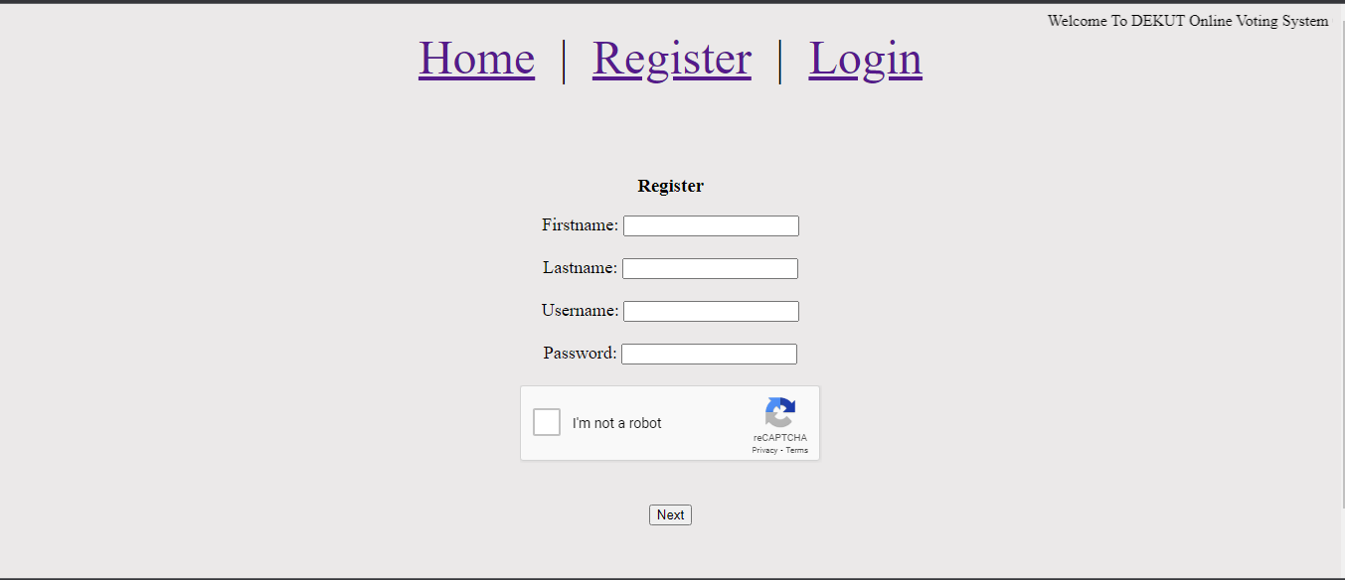

### 4.2.2: Login Interface

The login interface will allow a user to login to the system after being registered in the system.

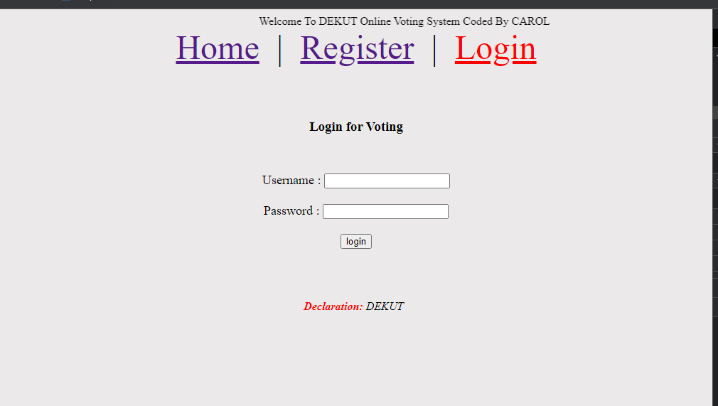4.2.3: Ballot Interface

The ballot interface will display the names and position of the candidates.

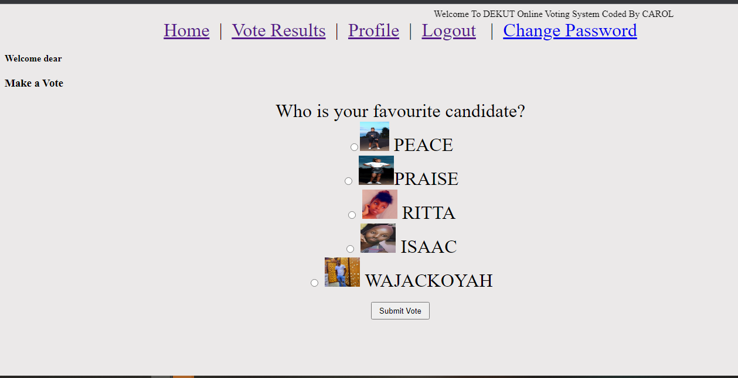

### 4.2.3: Results Interface

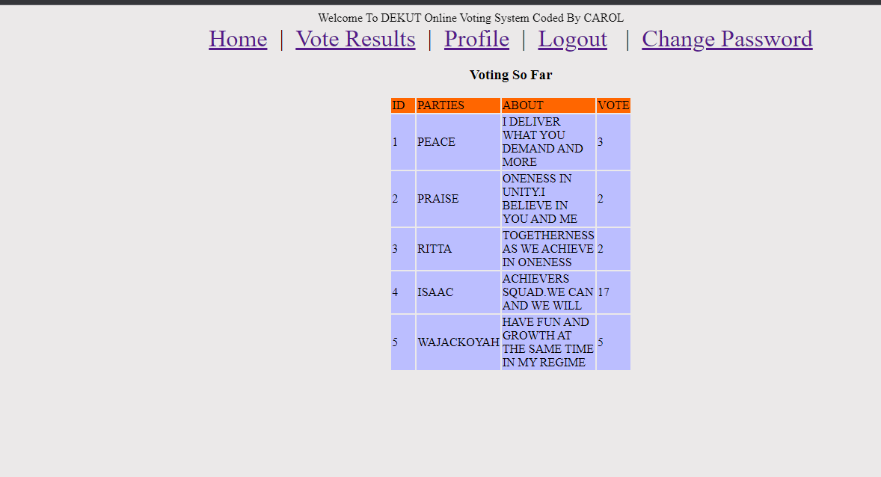

# CHAPTER 5: SYSTEM IMPLEMENTATION AND TESTING

### 5.1. System Implementation

The system was implemented in three phases:

Database creation phase – this was implemented using MS SQL (Microsoft SQL server)

Backend creation phase – this was implemented PHP (Hypertext Preprocessor) and the key functionalities such as logging in, managing candidates’ details, managing voter details and viewing of elections results.

Frontend creation phase – this was implemented using HTML, CSS and JavaScript

### 5.2. System Testing

A system testing was done for the Web Based Electronic Voting System; this took place at Zetech University.

The testing of the system mainly focused on the following key objectives: -

* To measure the effectiveness of the system to the user.
* To measure the efficiency of the functionalities of the system.
* To measure the ease to learn how to use the system by the user.
* To measure the interactivity of the system.
* To measure the utility of the system.
* To measure the convenience brought about by the system.

### 5.2.1. The Effectiveness of the System to the User

Effectiveness of the functionalities measures the ability of the functionalities in meeting their tasks objectives. The researcher took the respondents through the task objectives of all the functionalities, and then gave the respondents a chance to interact with the system, and later on the filled the user testing questionnaire form.

### 5.2.2. The Efficiency of the Functionalities of the System

Efficiency of the functionalities measured the speed of the functionalities in carrying out their key tasks. The respondents interacted with all the functionalities of the system, and later on filled the user testing questionnaire form.

### 5.2.3. The Ease to Learn How to Use the System

The respondents interacted with all the functionalities of the system, and later on filled the user testing questionnaire form.

# CHAPTER 6: CONCLUSIONS, RECOMMENDATIONS AND FURTHER WORK

## 6.1: Conclusions

The researcher was able to achieve all the three set objectives: -

1. To create a system where a voter can register and login.
2. To develop a system where a voter can cast a vote
3. To check the progress of election results
4. The researcher reviewed the following: the definition of voting and electronic voting, types of voting systems, the requirements of a voting system, an electronic voting system, the basic principles of an electronic voting system, functional and security requirements of a voting system, Internet Voting, a review on the implementation of Electronic Voting Systems

The researcher reviewed the following: the definition of voting and electronic voting, types of voting systems, the requirements of a voting system, an electronic voting system, the basic principles of an electronic voting system, functional and security requirements of a voting system, Internet Voting, a review on the implementation of Electronic Voting Systems around the world, security risks in web applications and finally security algorithms. After reviewing a number of E-Voting Systems, the researcher settled on Estonia E-Voting System, Estonia is one of the few countries that use an Internet Voting System. The researcher used the same framework with major changes. A system testing to measure the efficiency, effectiveness, utility, interactivity, convenience and easy to learn of the system to the user was carried out. The respondents of the system testing were students from Kiriri Women’s University. They interacted with the prototype then they filled a questionnaire afterwards. The results were positive; the respondents found the system to be very effective, very efficient, extremely easy to learn how to use, very good to interact with, very useful and extremely convenient.

## 6.2. Recommendations

Create a fingerprint sensor where the voter will just have to use his or her fingerprint to log in into the system.

**APPENDICES**

Budget

|  |  |
| --- | --- |
| Item | Amount |
| 1. Stationaries   * Full 50 papers@ 2/= * Biros 2 @20/= | 140  40 |
| 2. Internet service 4GB | 400 |
| 3. Typing @ 20/= per page | 1000 |
| 4.Printing @ 5/= per page | 330 |
| 5.Binding | 150 |
| 6.Other expenses | 3500 |
| **TOTAL** | **6000** |

**REFERENCES**

O'brien,A.J. (2011). Management Information Systems.Newyork: NY Publishers

Rhodes, E.C.(2010). Electronic commerce technologies and changing product distribution.

international journal of technology management, 10-11.

Wiley,Y.M. (2011). Creating the Virtual Store: Taking Your Website. Loreen Publishers.

H.Bidgoli. (2011). Essentials of Software Engineering.

# V.DeBolt. (2007). Mastering Intergrating Html, and CSS, ISBN: 978_0_470_09754_0,2007 (5) REFERENCES

ACE Project. (2018a). Opportunities, Risks and Challenges of e-voting. Retrieved from <http://aceproject.org/ace-en/focus/e-voting/e-voting-opportunities>

CUEA, C. U. o. E. A. (2016). Student Electronic Voting System. Retrieved from [http://www.cuea.edu/index.php/news-and-events/173-student-electronic-votingsystem-](http://www.cuea.edu/index.php/news-and-events/173-student-electronic-voting-system-lauded)

International Institute for Democracy and Electoral Assistance. (2011). *Introducing Electronic voting: Essential Considerations*. Retrieved from Stockholm, Sweden:

Al-Ameen, A.; Talab, S.A., "E-voting systems vulnerabilities," Information Science and Digital Content Technology (ICIDT), 2012 8th International Conference on , vol.1, no., pp.67,73, 26-28 June

2012 URL: http://ieeexplore.ieee.org/stamp/stamp.jsp?tp=&arnumber=6269229&isnumber =6269212

TahaKh. Ahmed and Mohamed Aborizka (2011), ―Secure Biometric E-Voting Scheme‖, ICICIS

2011, Part I, CCIS 134, pp. 380–388, 2011. © Springer-Verlag Berlin Heidelberg 2011