CS 541

Project4

Han Chen

4/21/2014

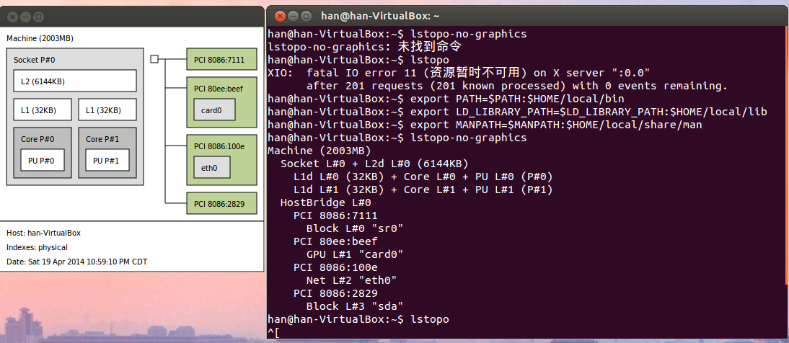

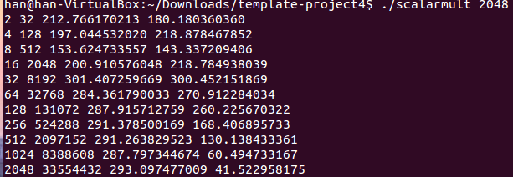

Which experiment produces the best overall performance?

When the multiplication was executed in bigger number of size in second time.

Describe the cause of the divergence of performance between the experiments.

Prepaging during working set time.

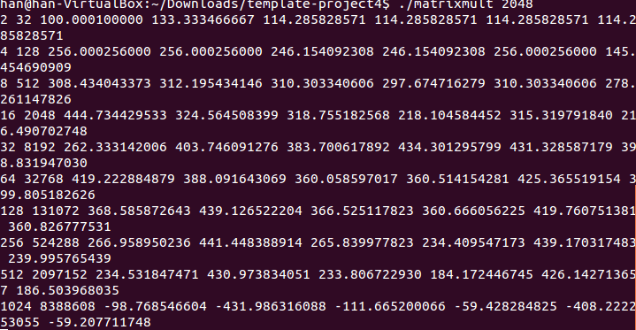

Which experiment(s) produces the best overall performance? Why?

FLOPS_kji. Prepaging.

Rank the six experiments from best to worst in terms of MFLOPS.

Kji, jki,jik,ijk,ikj,kij.

Describe the cause of the divergence of performance between the experiments.

Prepaging during working set time.

You may notice that some of the experiments pair up. Why does that happen?

Slab Allocator.