Artikel

https://www.brainpickings.org/2014/01/29/carol-dweck-mindset/

1. embrace challenges

<https://www.psychologytoday.com/us/blog/headshrinkers-guide-the-galaxy/201412/7-strategies-face-lifes-challenges> - 7 Strategies to Face Life's Challenges



2. learn from criticism and feedbacks

<https://zenhabits.net/how-to-accept-criticism-with-grace-and-appreciation/>

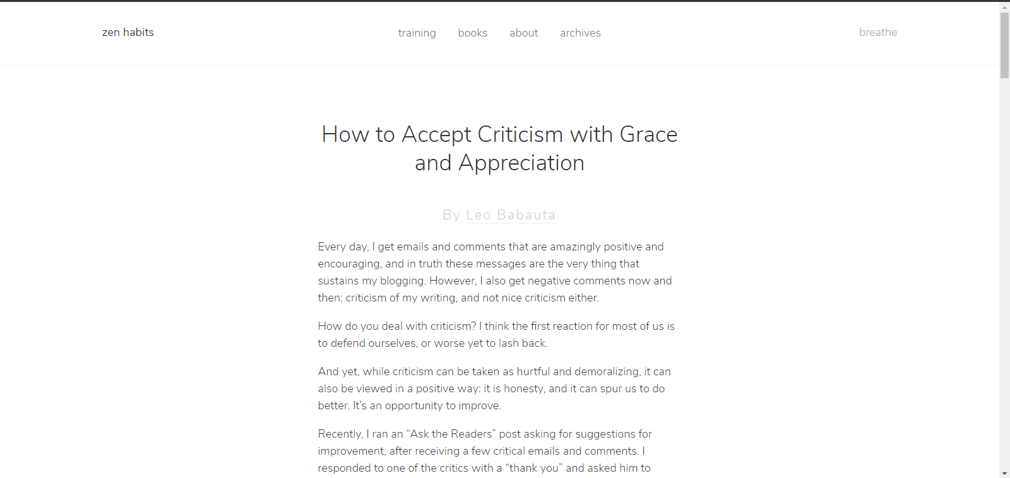

3. Persists in the face of setbacks

<https://medium.com/personal-growth/persist-it-matters-7e4270f7c078>



<https://www.lifehack.org/articles/productivity/6-effective-ways-to-become-persistent.html>

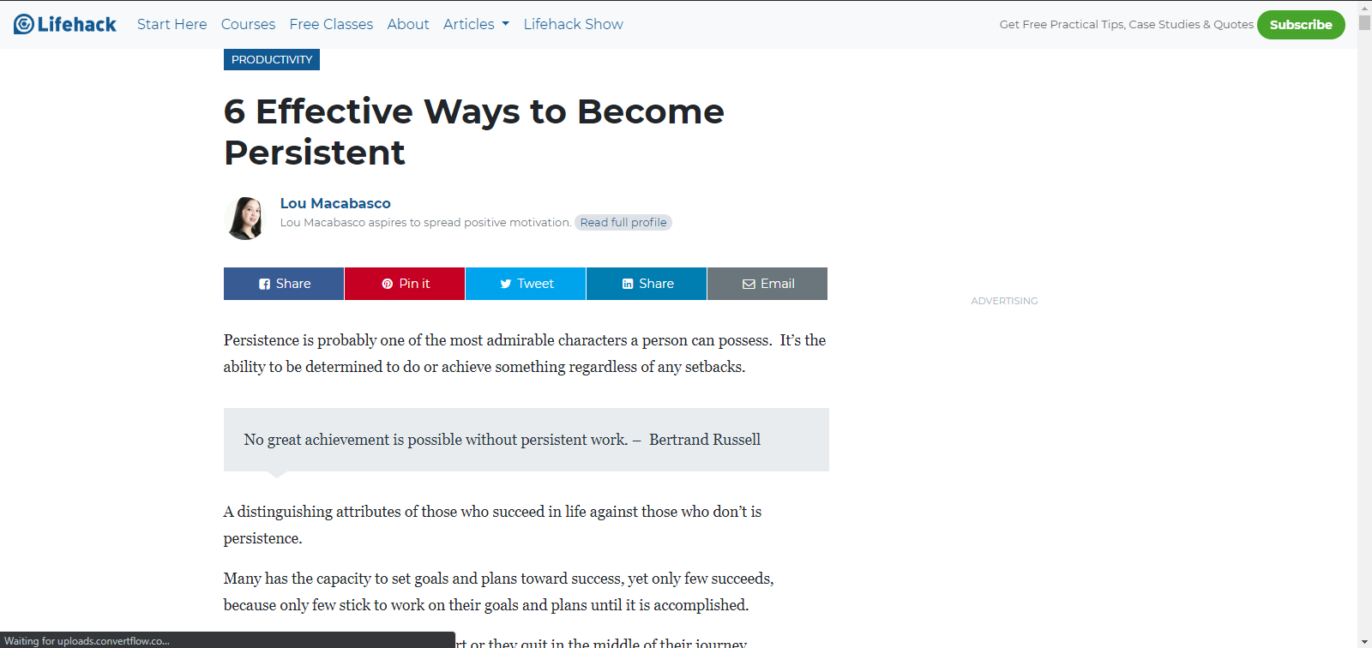

4. see effort as the path to mastery

<https://medium.com/@sangraminglama/keep-pushing-yourself-to-the-limits-651191e641dc>



5. Find inspiration in the success of others

<https://medium.com/the-ascent/seeing-others-succeed-can-hurt-dd146bc9ca25>



<https://thoughtcatalog.com/mark-derian/2014/04/6-ways-to-be-happy-for-other-peoples-success/>



Videos

Growth Mindset

https://youtu.be/hiiEeMN7vbQ - Developing a Growth Mindset with Carol Dweck



https://youtu.be/KUWn_TJTrnU - Growth Mindset vs. Fixed Mindset



Perfectionist

Strive for progress, not perfection. We often feel that our effort doesn't pay off, or that our results aren't really good compared to others. But we don’t have to feel that way. Why? See this video for further explanation.

https://youtu.be/BY6bGhcnDDs - The Perfectionist Trap

