**White noise:**

**No Filter:**

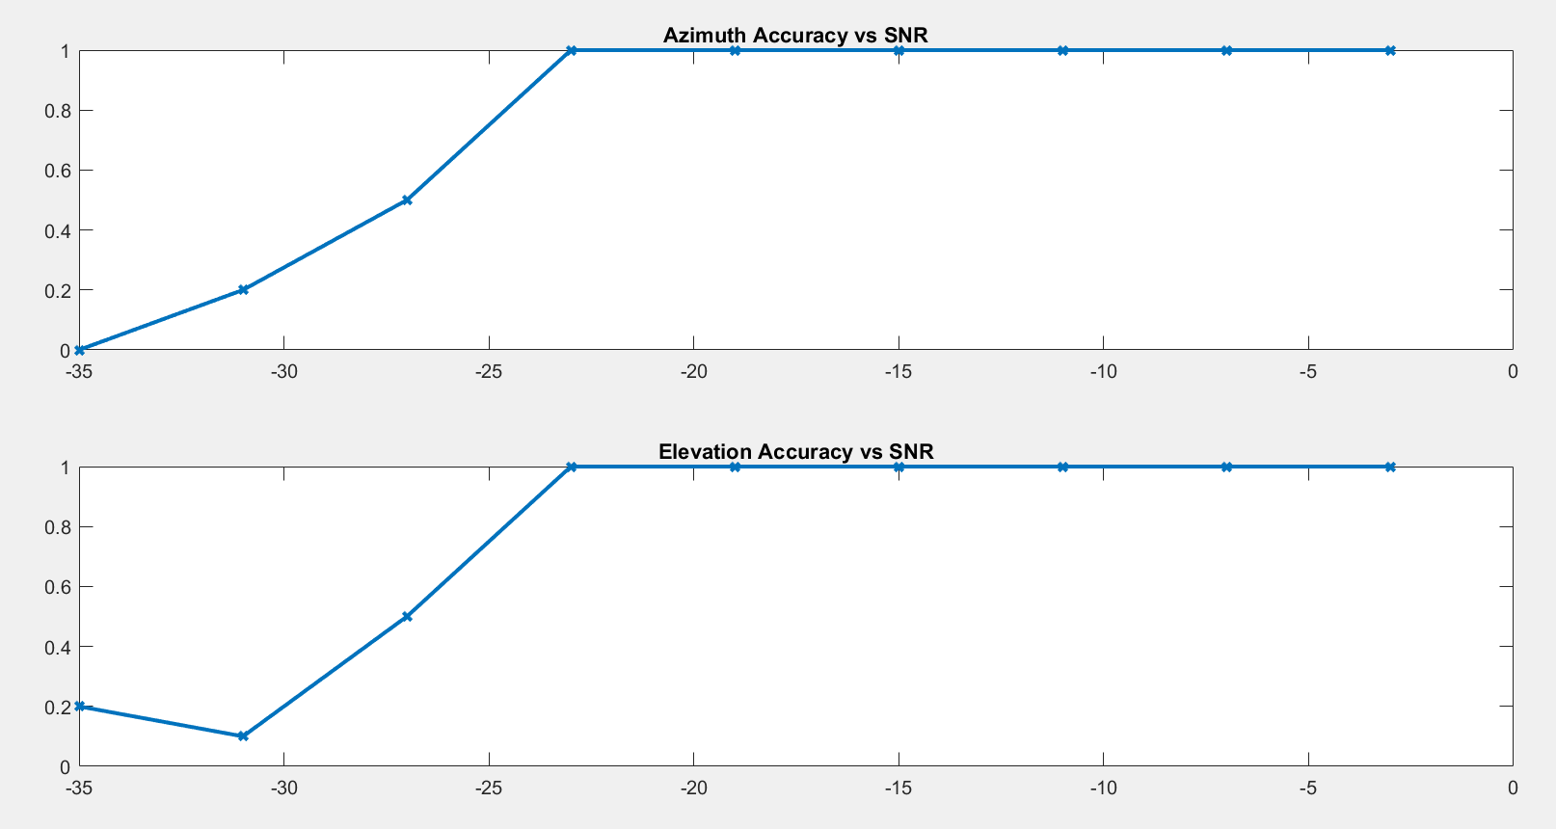

**Attenuation:**

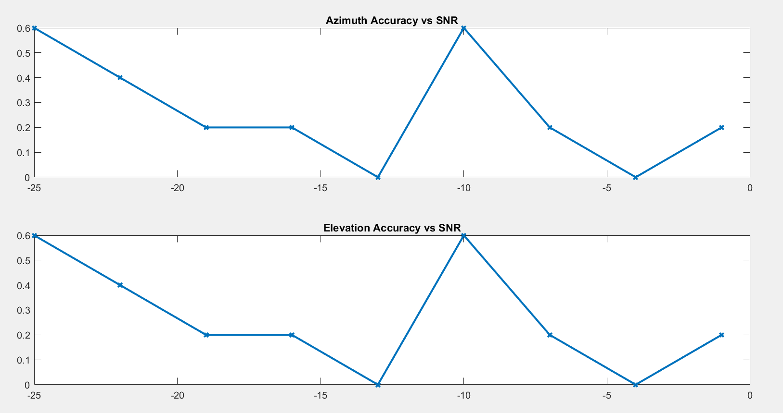

**Emphasis:**

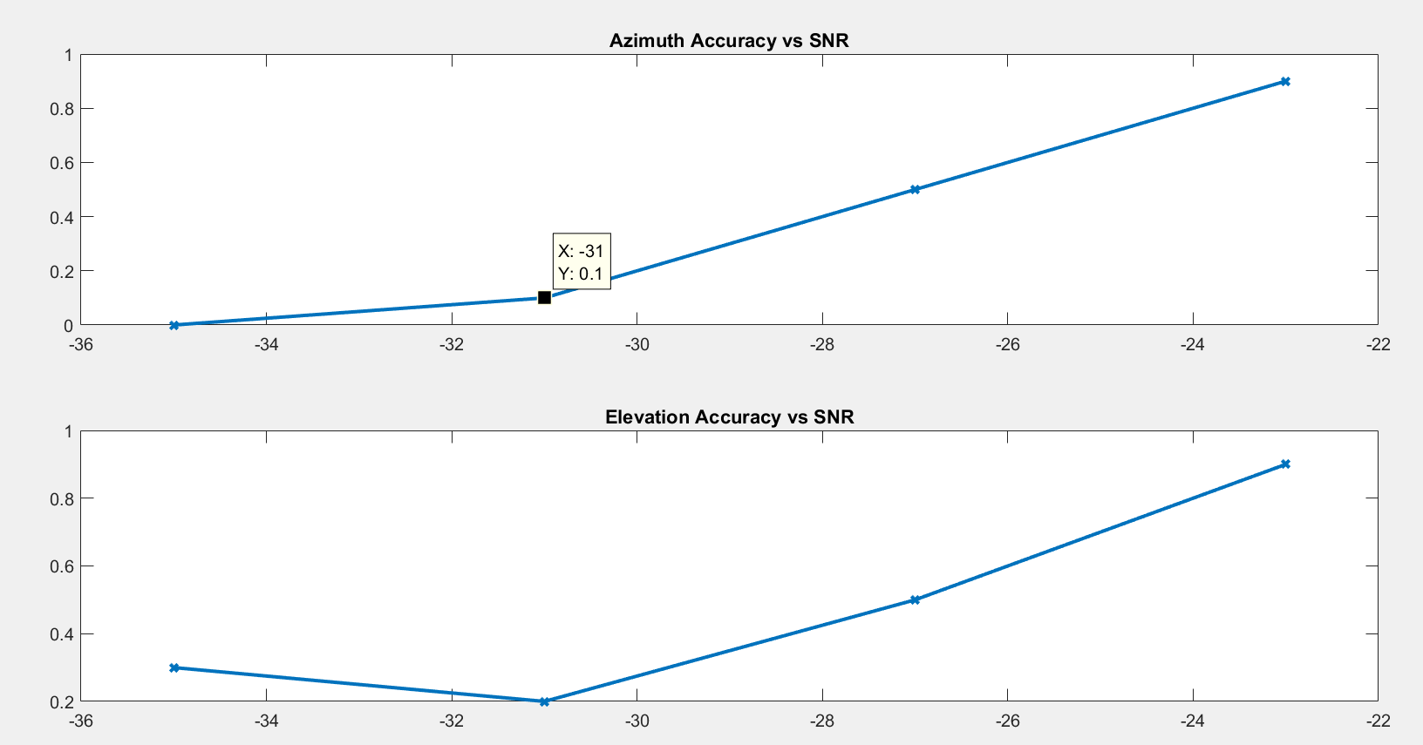

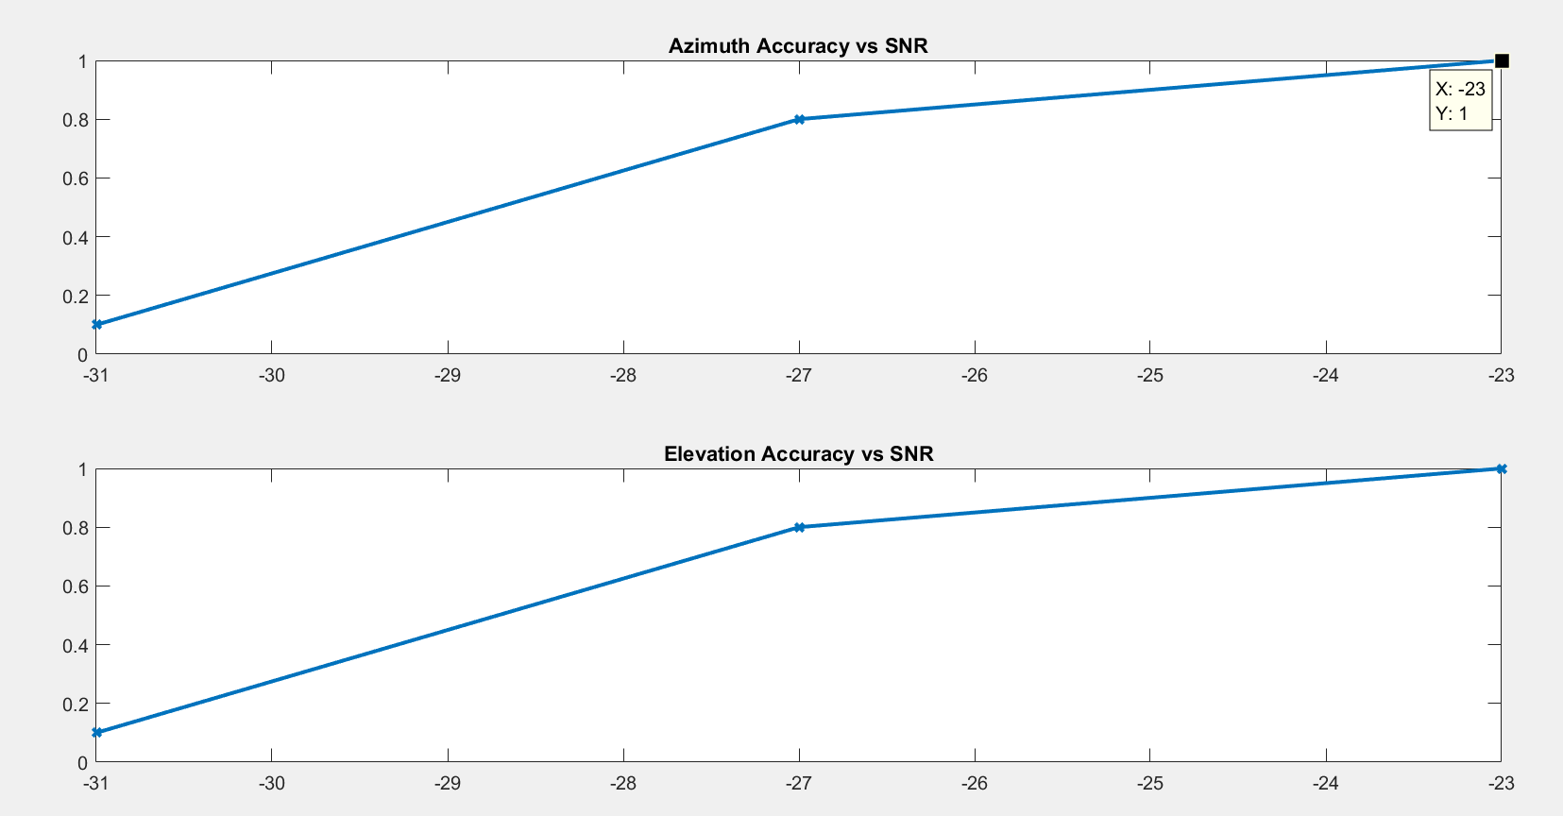

**Speech:**

**No wiener:**

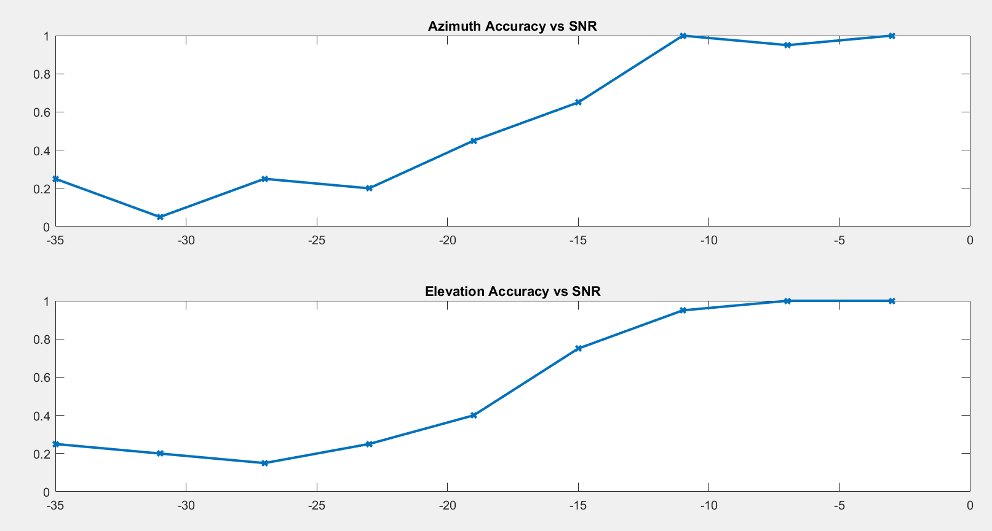

**Attenuation:**

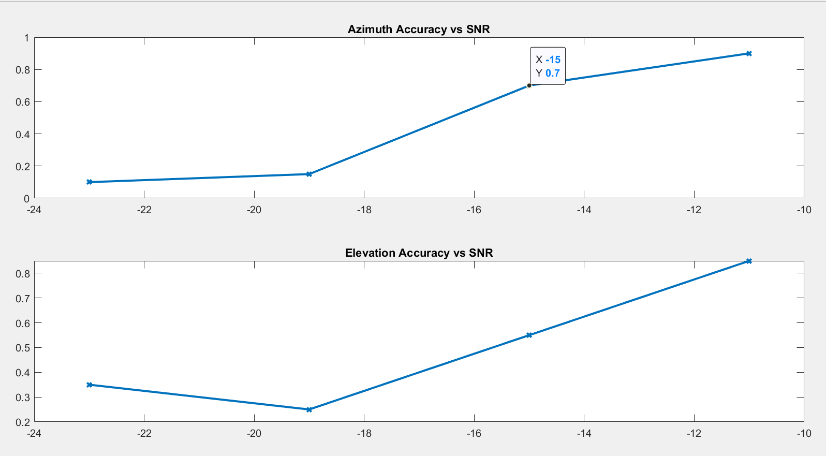

Method does a good job at lower SNRs.

**Emphasis:**

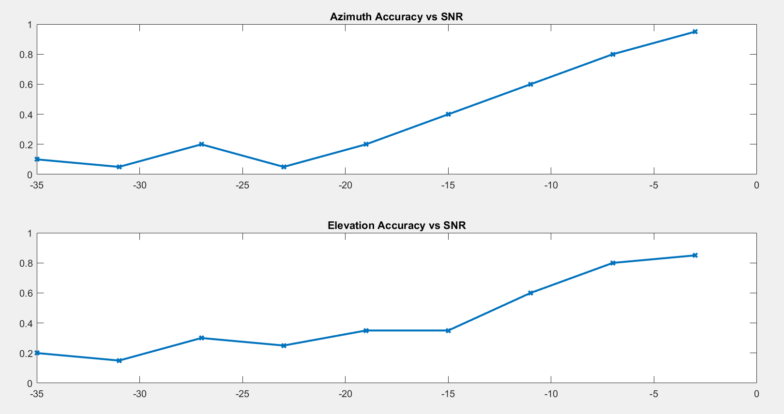

**New method:**

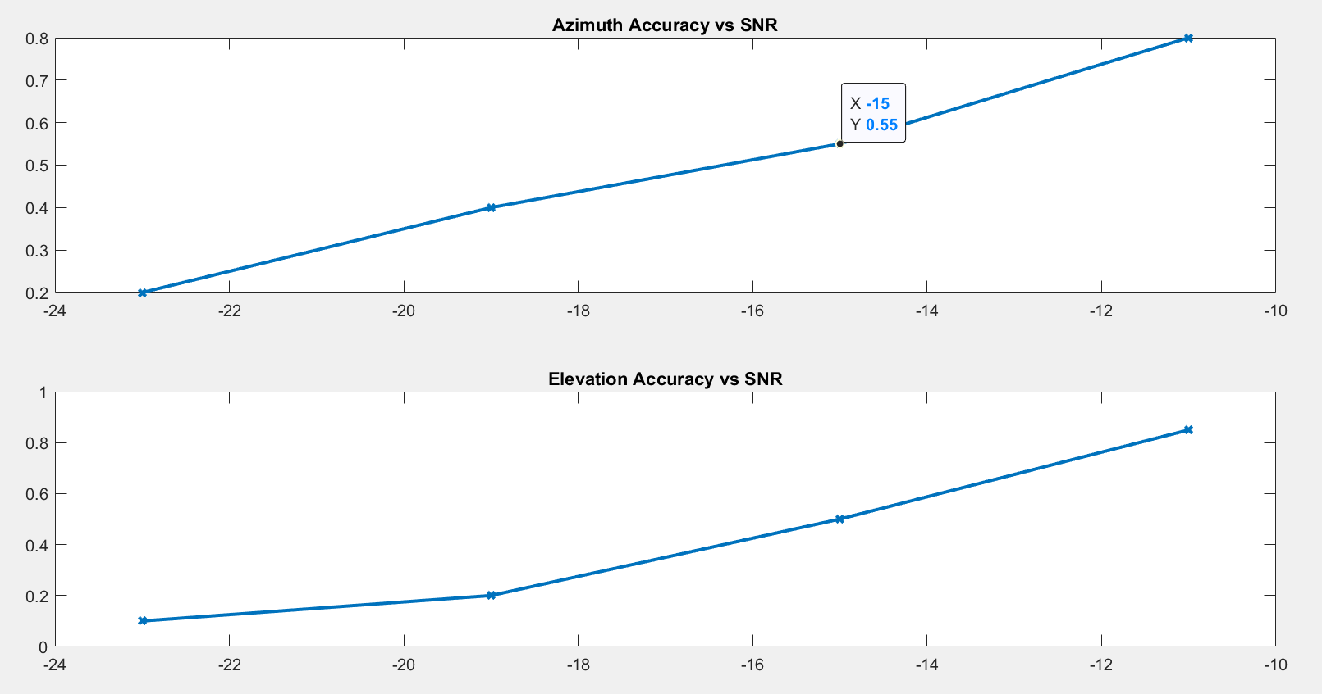

**With bandpass:**

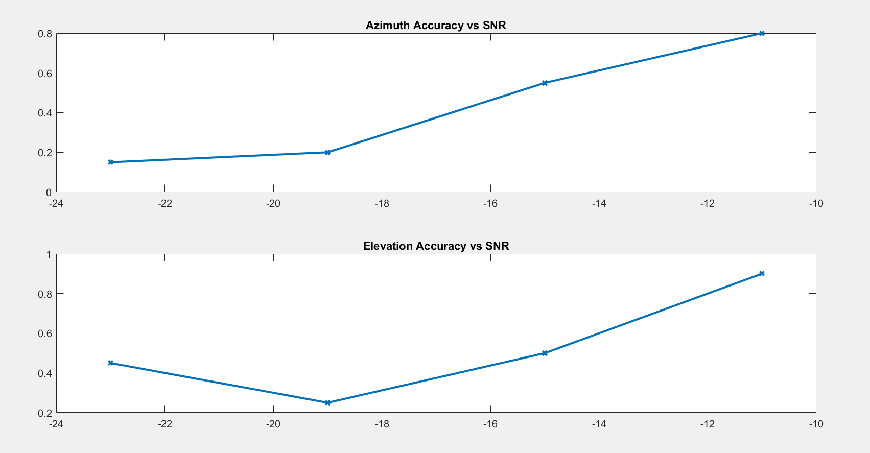

Why would band passing it be effective

Three main components can be identified: mechanical noise (ego-noise), air flow noise created by the propellers and wind noise.

Among the different components, wind noise, located below 1 kHz, is by far the loudest one when present. However, we observed that wind noise was rarely present in more than 4 out of 8 channels at once. This deserves further investigation and could be exploited by removing corrupted channels using a wind detection method. I got Nors to start reading through that paper [12].

This latter estimation can be done recursively in an efficient way for real-time applications. See [10] for more details.

**This is how they do it:**

The Wiener filter noise covariance matrix is estimated from a 7s noise-only recording in free-flight. For the speech scenario, the 3 channels containing heaviest wind-noise are manually removed and the search grid does not includes elevations above 20◦ to avoid spurious localizations.

10 – 90 degress is purely noise. Estimate noise here and use that for the rest. Spatial filtering.

Take a pair of microphones -> write equations on how noise will effect this, knowing noise characteristics.

Test it with Nors’ one. Is it an FIR filter?

Focus on -10 and -20db.

**Wind Noise.**

Without Nors’ code:

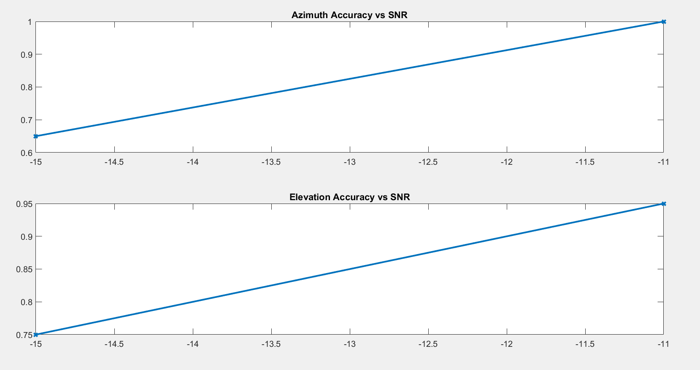

With Nors’ code:

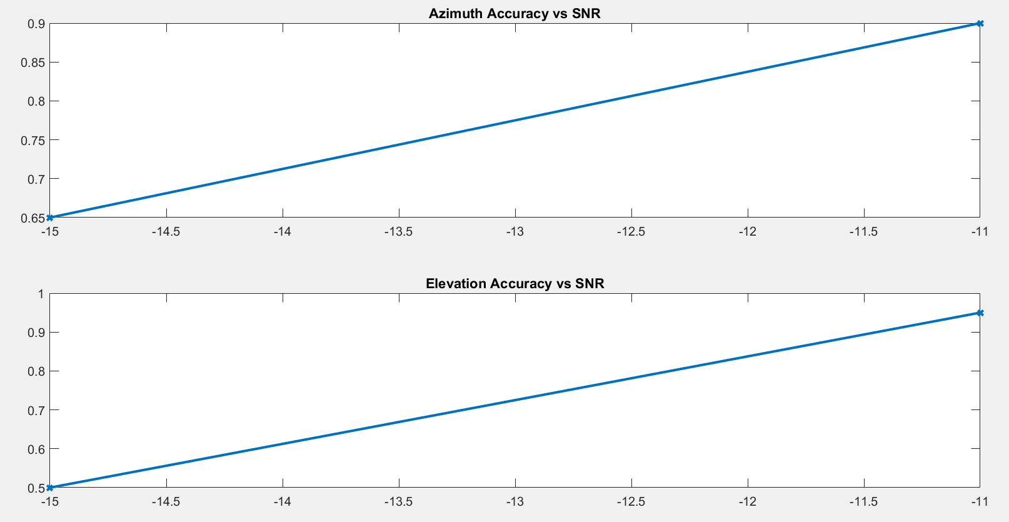

**1/02/19**

**Need to beat:**

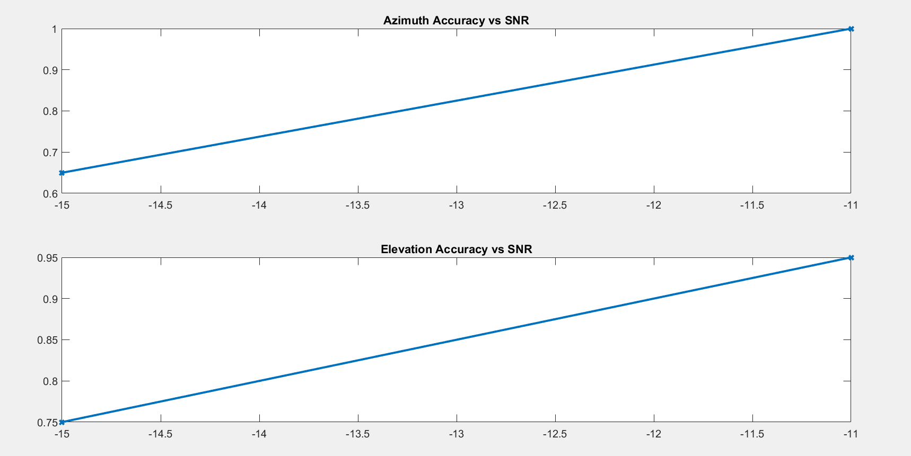

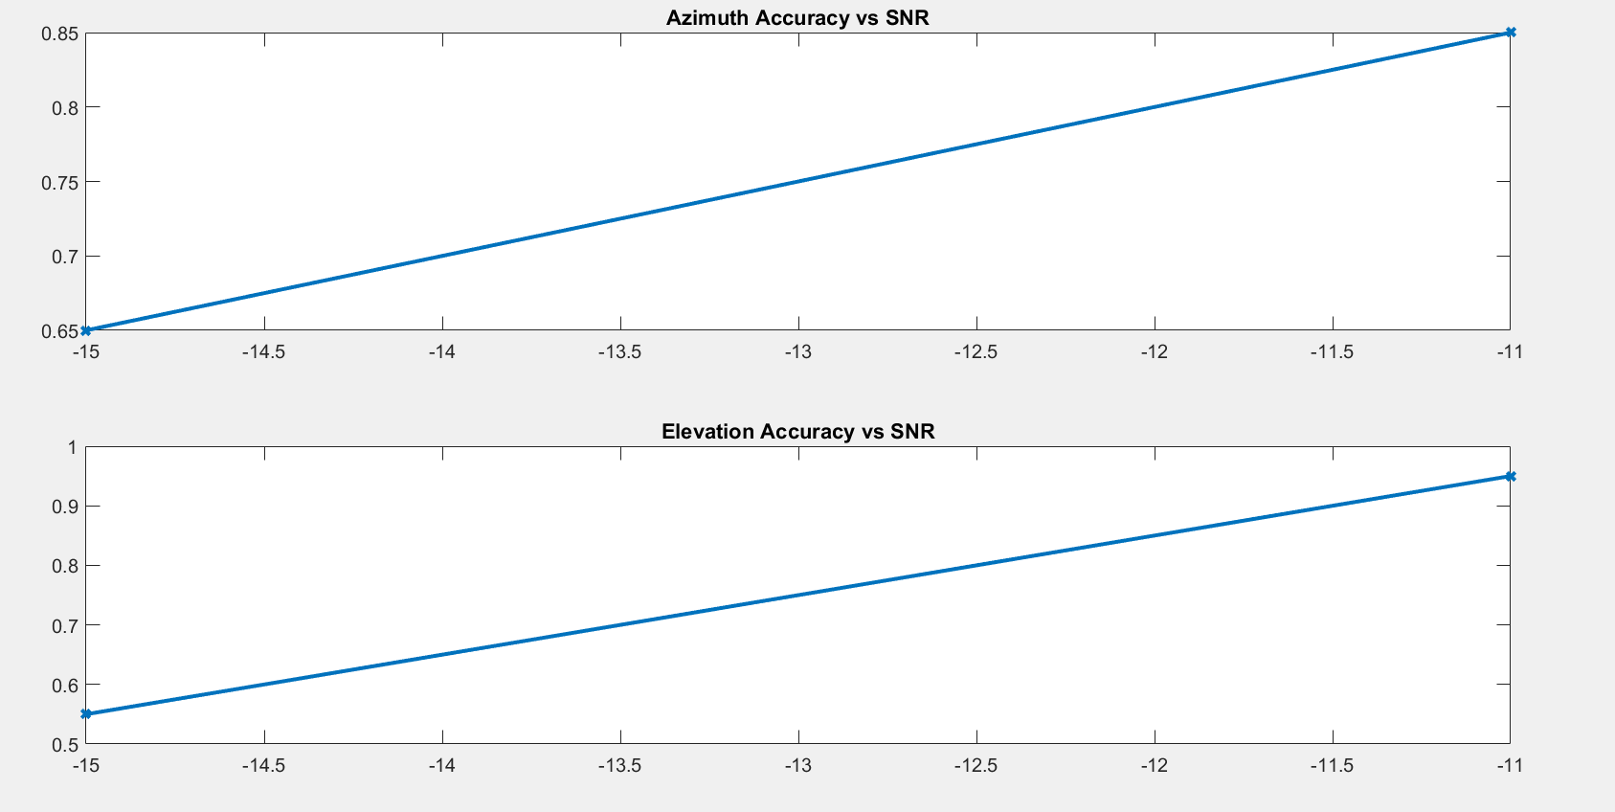

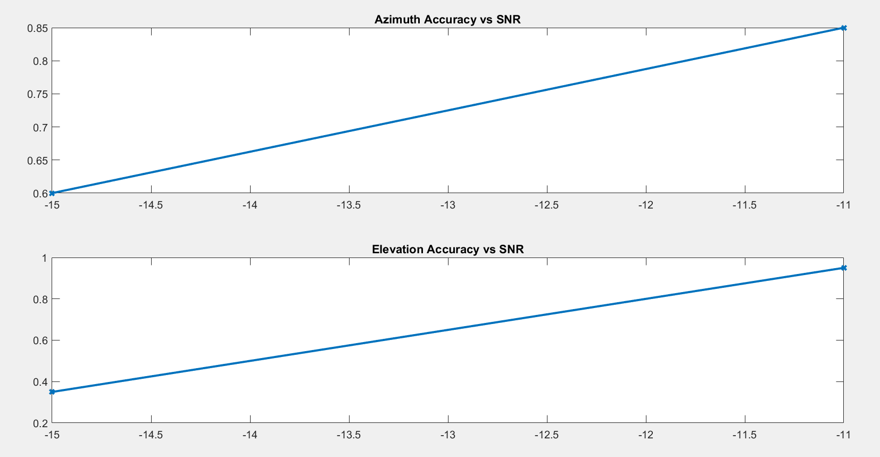

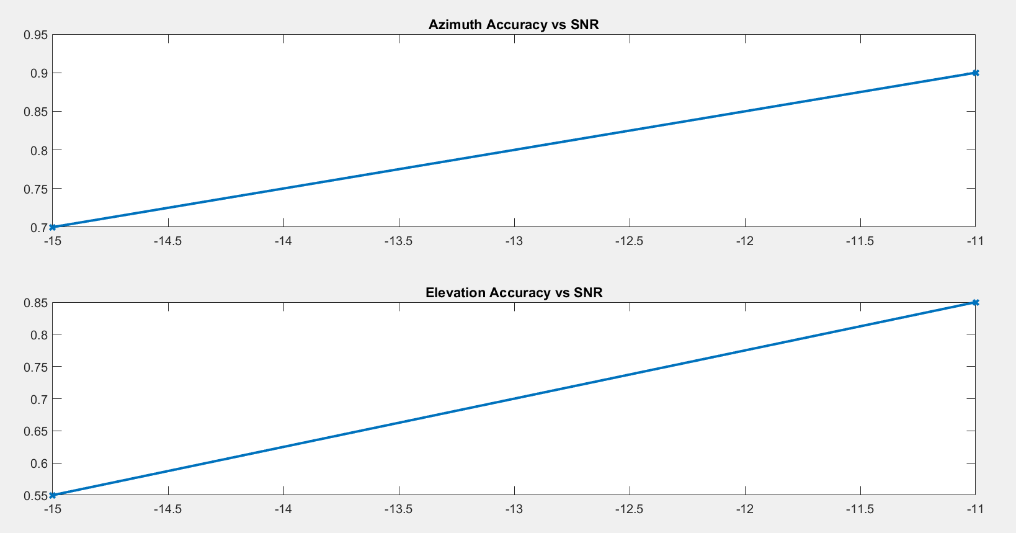

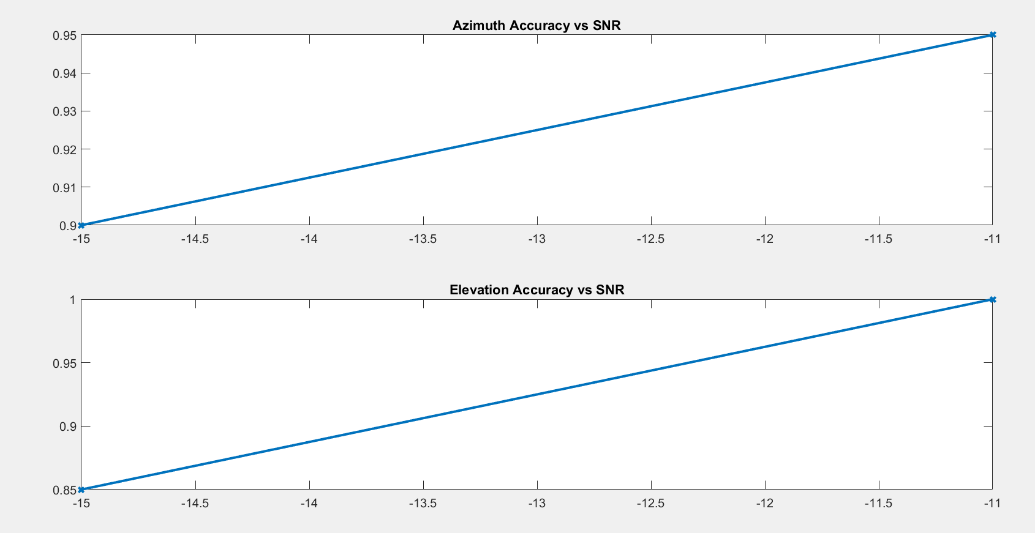

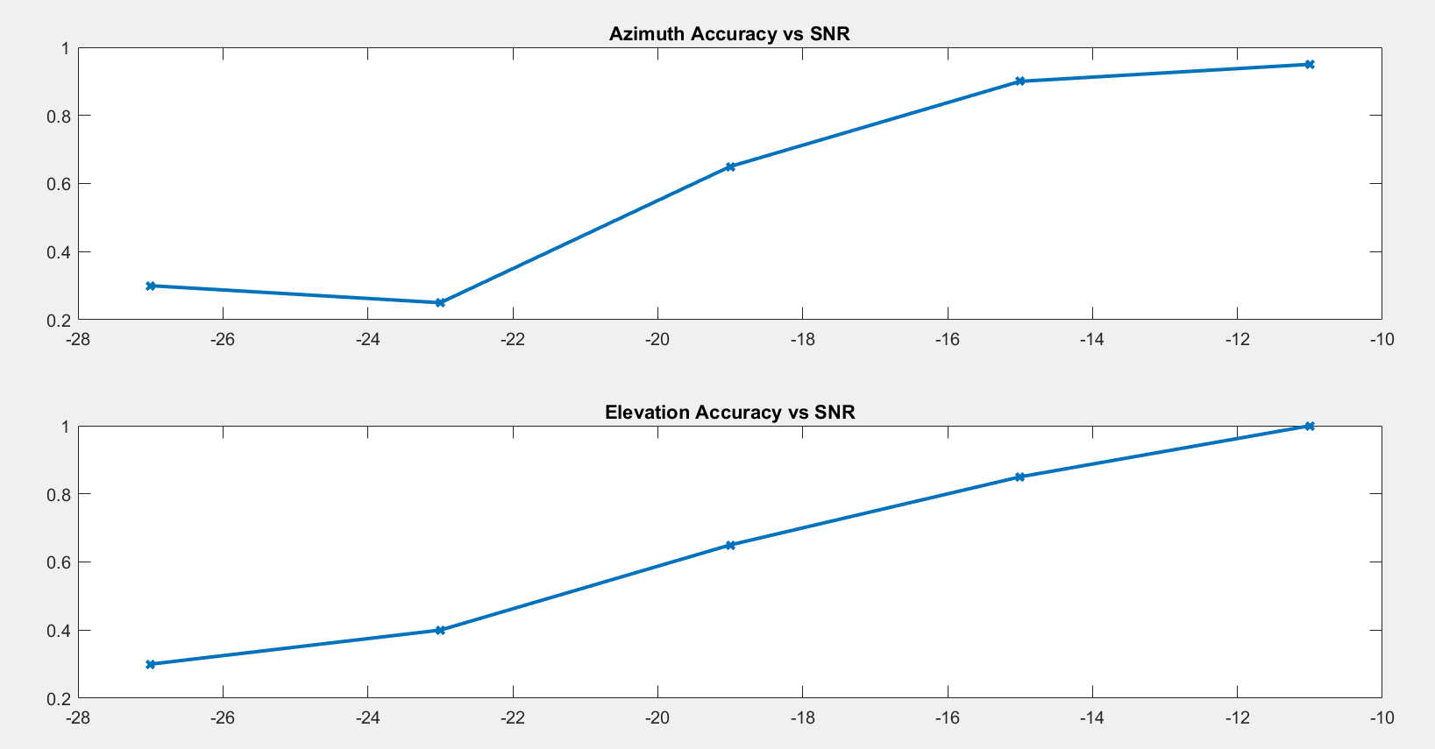

No LPC.

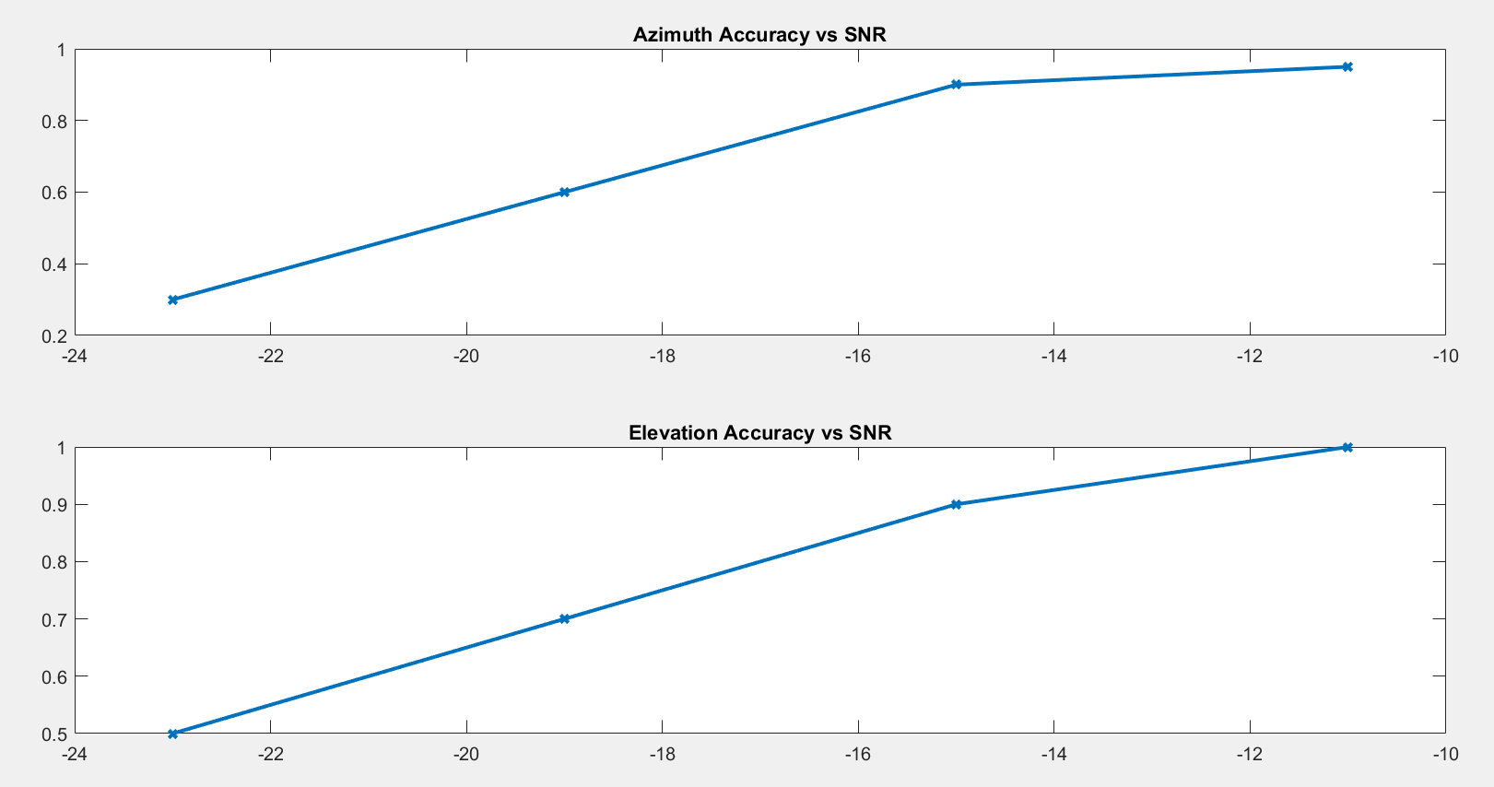

Removing only a two recordings:

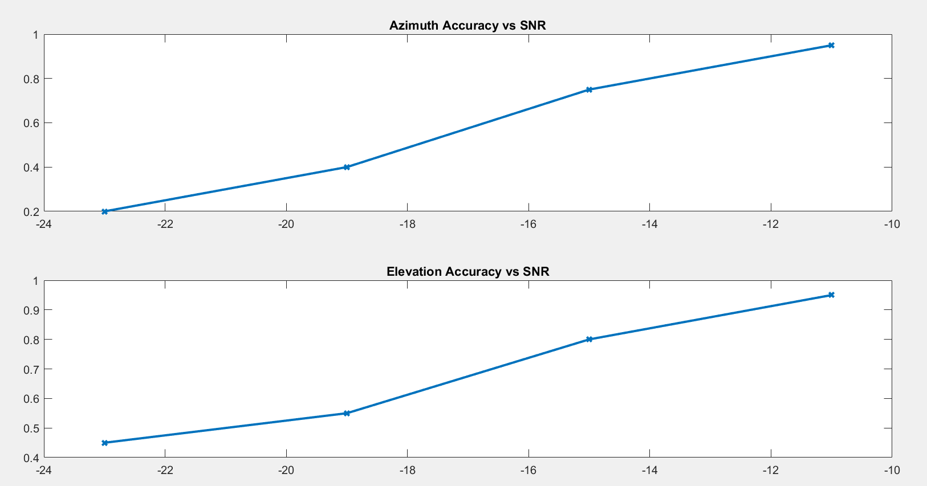

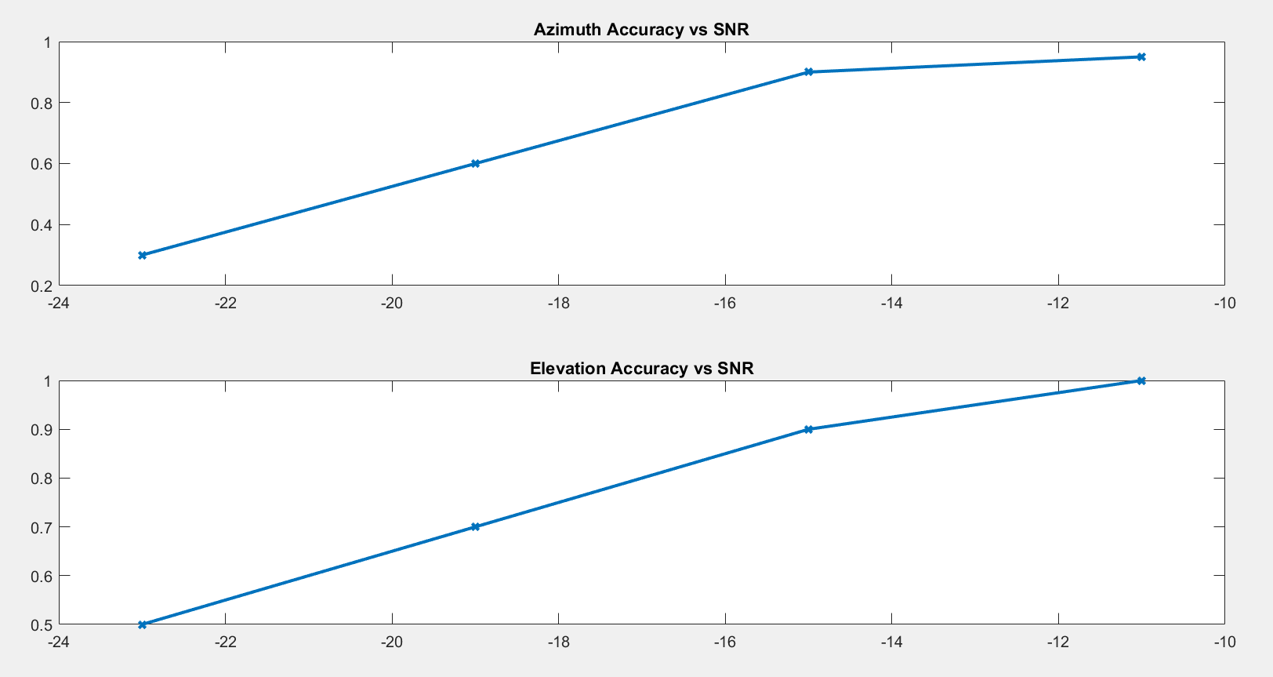

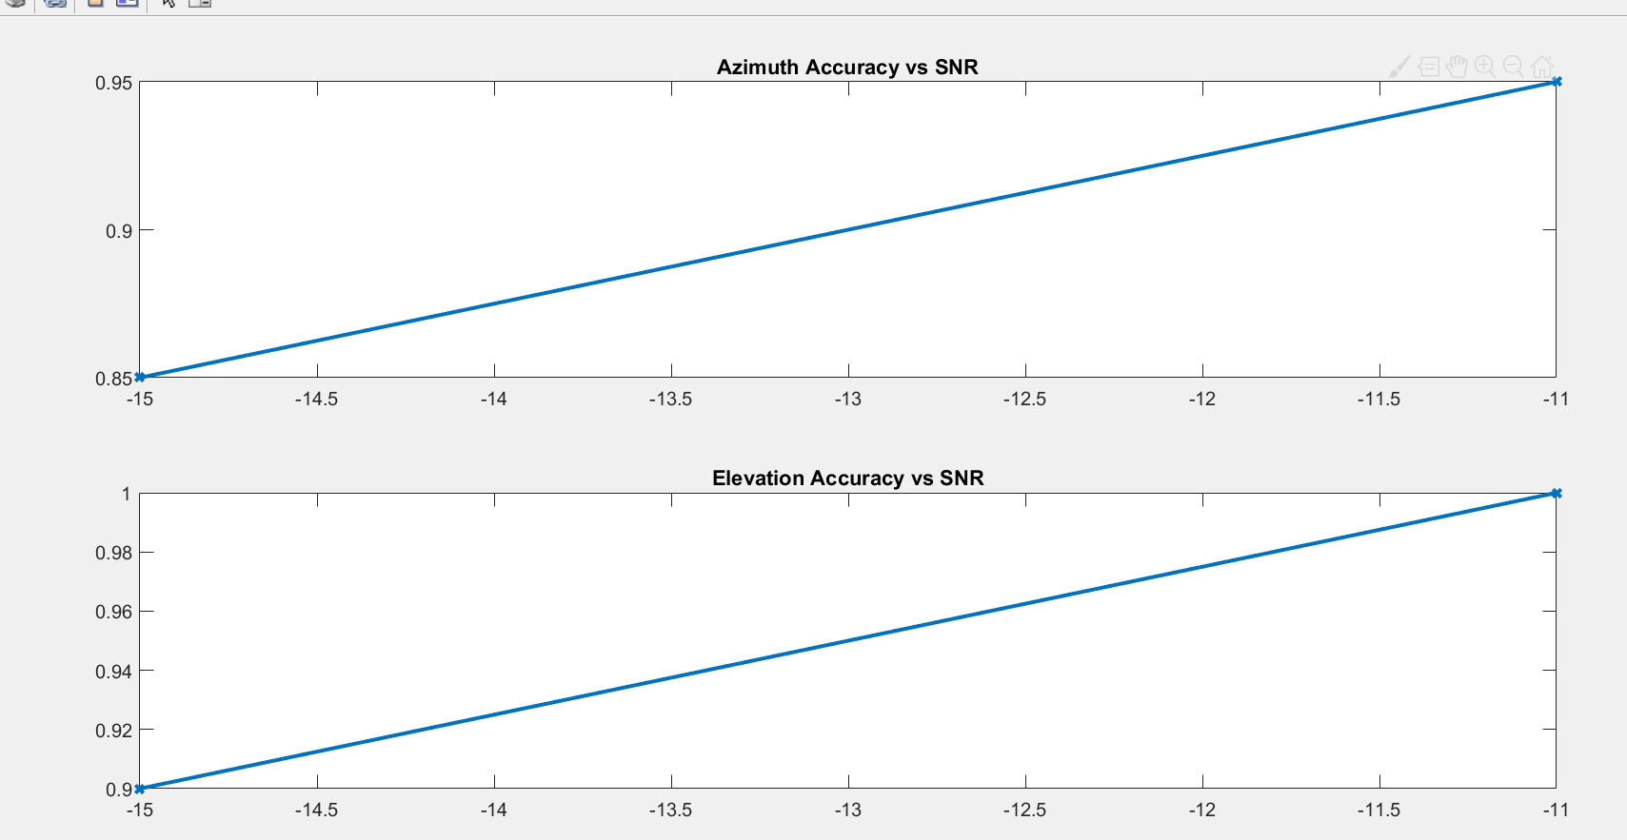

No filtering:

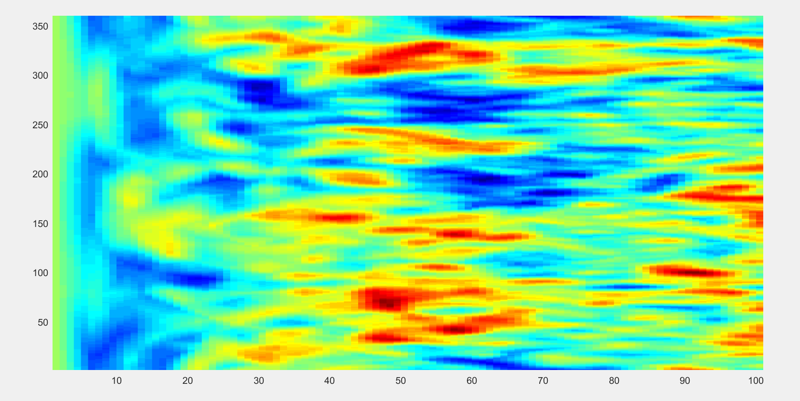

Motor 4 removed:

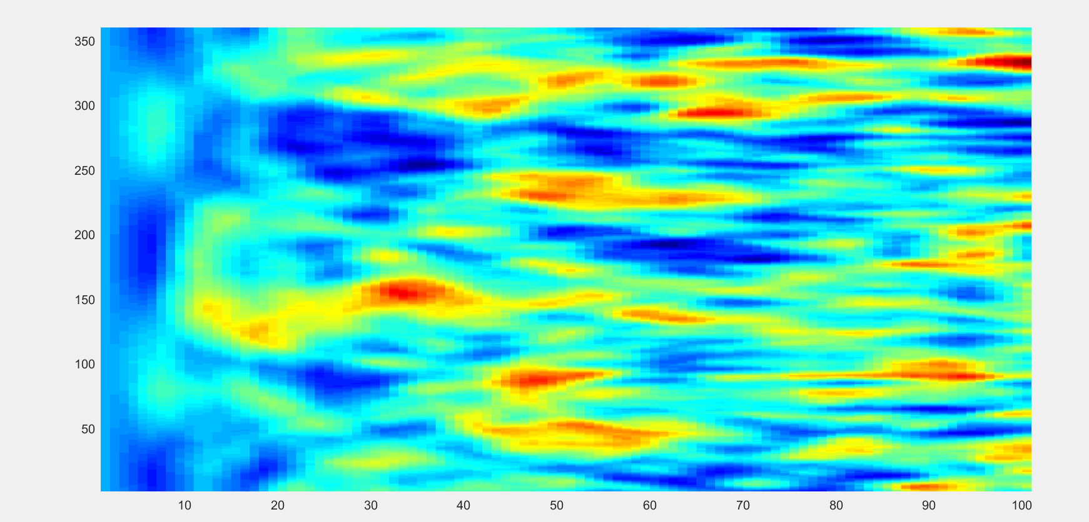

Motor 2 removed:

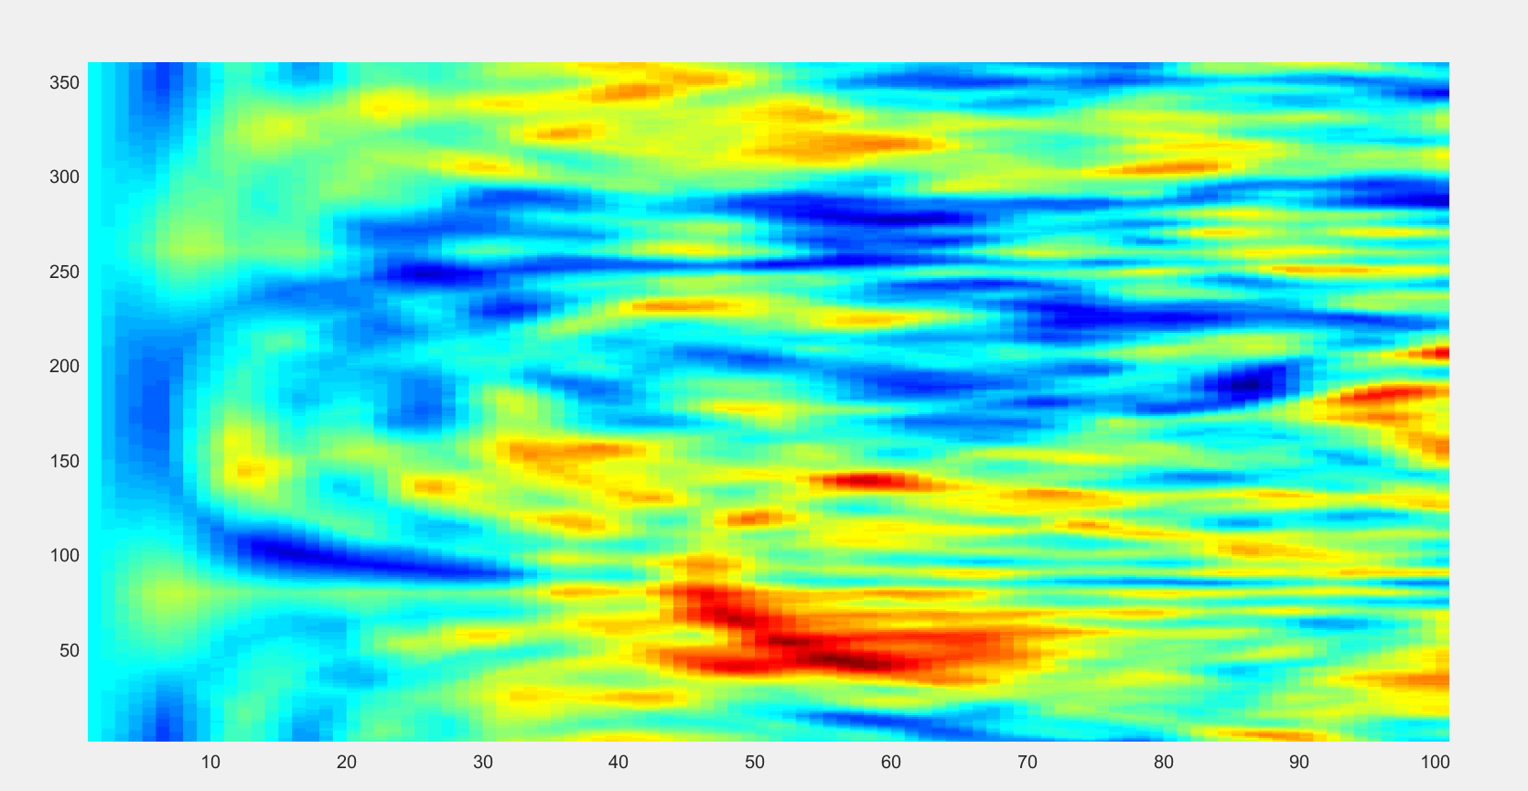

**22/02/2019**

Motor 4

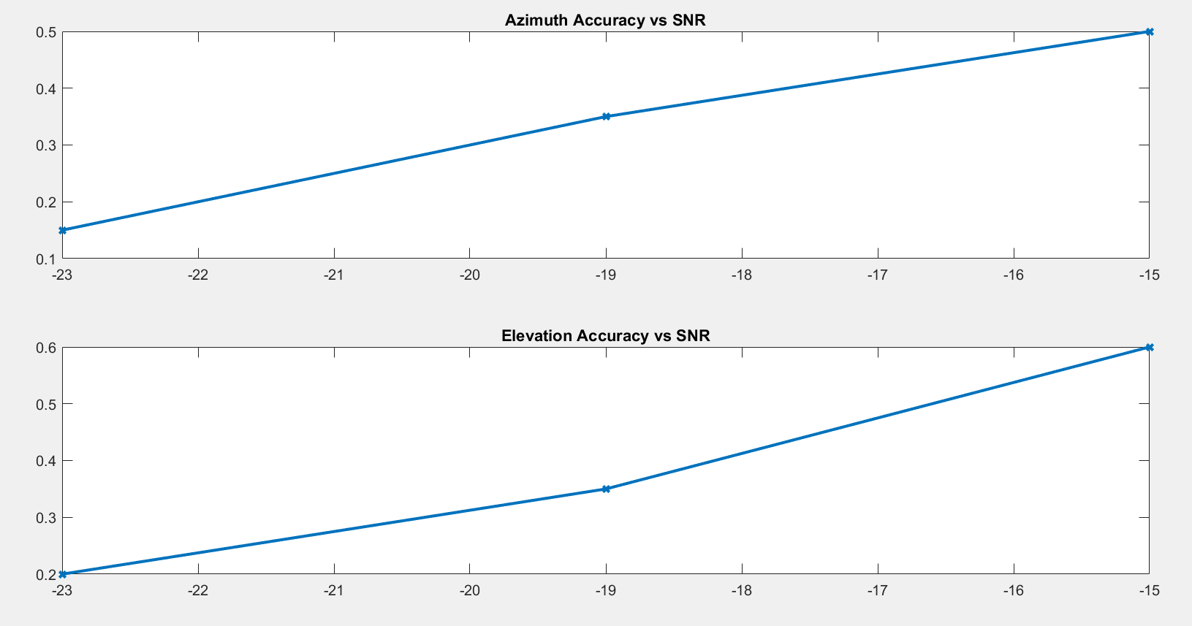

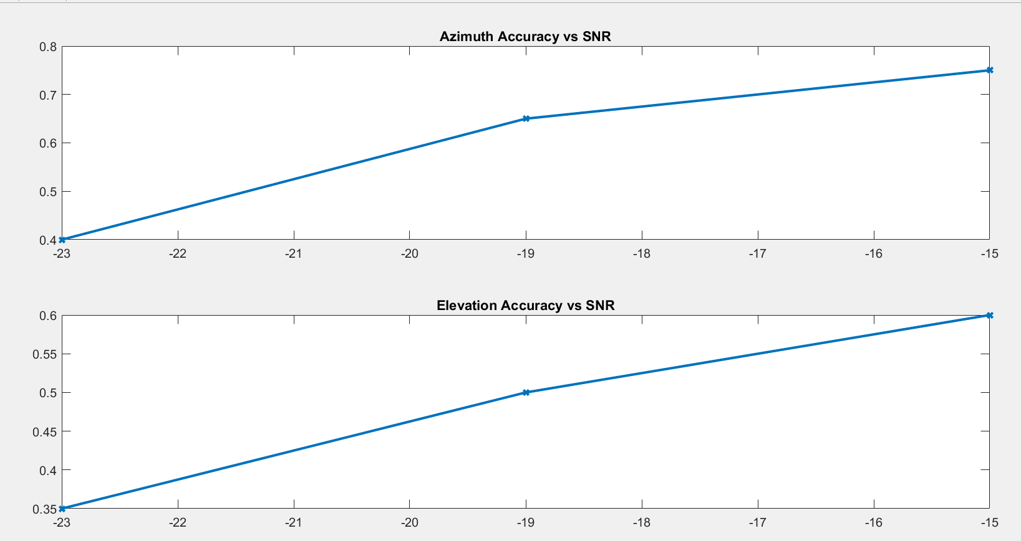**tracking + wiener**

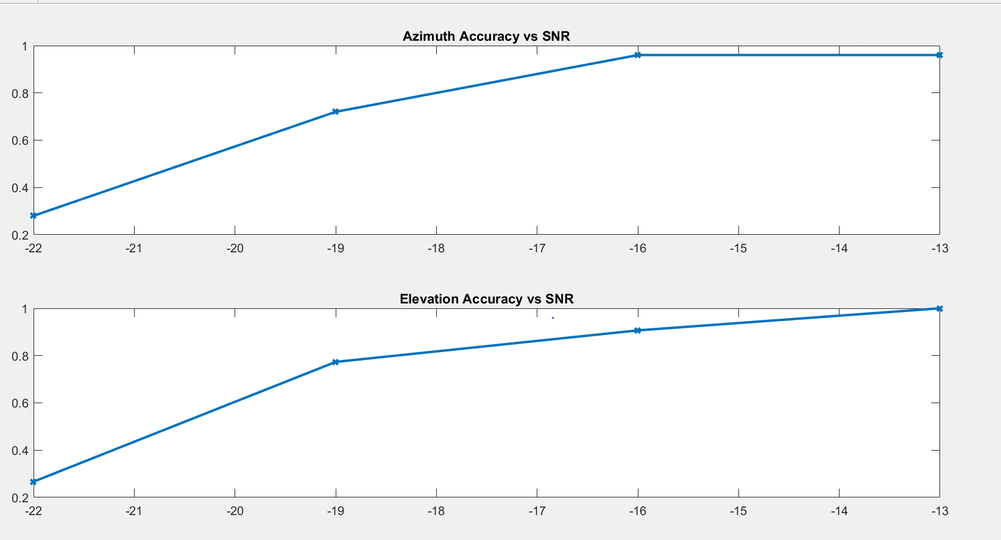

**tracking + wiener + highpass**

