Mumbaking Menu
Home | Order Now | Now Baking | FAQS | Blog | Contact Us

Under Order Now (shop in the present menu) following categories
The subcategory for Cakes will only be present

Cakes
  - Every day celebration
  - Bento Cake
  - Birthday Cake
  - Kids Cake
  - Wedding cake
  - Baptism Cake
  - Baby shower Cake
  - Engagement Cake
  - Corporate cake
  - Eggless cake
  - Gluten free cake
  - Carrot Cake
  - Tea Cake

For the menus below only the categories will be present in Order Now

The sub categories will come as drop down menu

For cookies there will be a box for number .
For Sugar Cookies there will be a box to upload image
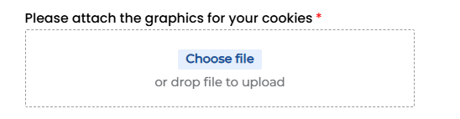
The user will be able to either add or select from some prescribed images
There will also be a colour scheme.
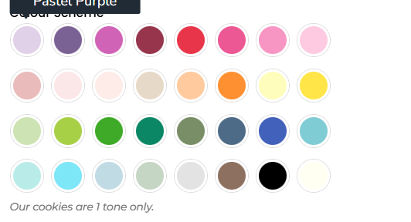

Cookies
  - Chunkey Cookies
  - Sugar Cookies

For Cupcakes there will be a drop down menu for number which will have 6,12,18,24
Similar to above sugar cookies for Custom Cupcakes there will be a box to upload image

The user will be able to either add or select from some prescribed images

Cupcakes
  - Vanilla
  - Chocolate
  - Caramel
  - Strawberry
  - Lemon Coconut
  - Red Velvet
  - Dubai Chocolate
  - Pineapple
  - Biscoff
  - Ferrero Rocher
  - Vanilla M&H
  - Orange Chocolate
  - Choco Mint
  - Coffee
  - Pandan Coconut
  - Mango Passion Fruit
  - Choco KitKat
  - Cookies & Cream
  - White Chocolate Raspberry swirl
  - Pistachio with Rose
  - Rainbow cupcakes
  - Sprinkle Star
  - Custom Cupcake

For Desert tubs there will be a box for numbers.

Dessert Tubs
  - Cookies & Cream
  - Biscoff pleasure
  - Strawberry charlotte
  - Vanilla bean dream
  - Midnight Velvet
  - Lemon Drop

