Bitonic Sort Testing
I constructed my program to pick a partner processor based on the rank of each processor. If the partner processor was larger than processor i, half cleaner was called to trade the larger numbers of processor i with with the lower numbers with the partner processor and vice verse if the partner processor was lower than processor i. I tested the program with a function that would check if the resulting array was correctly sorted. For the purposes of measuring speedup and run time, my program output the time, the number of elements and the number of processors.

The half cleaner function also functions as a reverse half cleaner: the only thing that changes is the partner processor that is chosen. Since the local array of each processor is sorted prior to calling the half cleaner, the partner processor is chosen to fit a reverse half cleaner. The reverse half cleaner function trades the largest numbers of the lower processor to the beginning of the higher processor. This creates a non-bitonic array for each processor, necessitating a recursive call until the smallest number in the array of processor i is larger than the largest number of in the array of processor i-1.

I was unable to achieve linear speedup running the program in parallel. As the number of processors increased, the level of speedup decreased. The decreasing rate of speedup increased as the number of elements increased. The following table details the speedup gained by increasing processors and increasing the number of elements for the resulting array. Representational graphs can be found on the next page. As the graphs indicate, the rate of speedup decreases as the number of elements

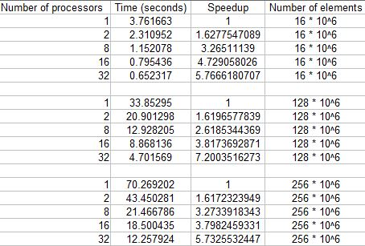
Cost of Quick-Merge
The theoretical cost of a quick-merge sort is:
communication: (p)(n/p)
local sort: (n/p)(log n/p)
execution costs: (n/p^2)
Note: In this program I did not send the resulting arrays back to processor 0, so the cost of sending results back should be omitted when comparing costs.

Cost of Bitonic
The half cleaner call is inside two loops:
    - for i = 0 to log2 of p (number of processors)
2. for j = i to 0
Each half cleaner call makes 4 communications to partner processors. The local sort for each processor uses quick sort, the same as Quick-Merge. The same number of executions made by each processor is the same as the number of communications. Thus:
Communication: (p)(∑ log p)
local sort: (p)(n log n)
execution costs: (p)(∑ log p)
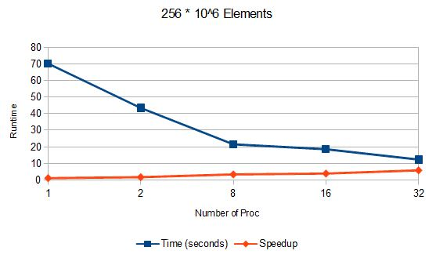
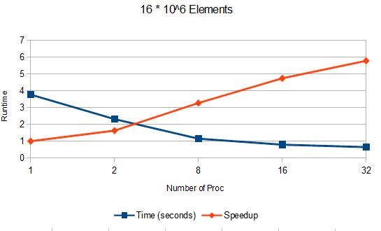
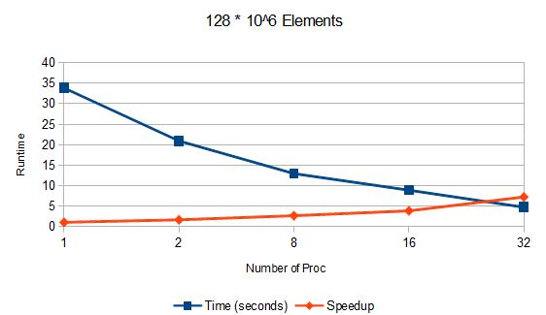

The code for my program follows. Some testing elements, such as processor 0 receiving each array and checking if the array is sorted, is omitted.

#include <stdio.h>
#include <time.h>
#include <math.h>
#include <stdlib.h>
#include "mpi.h"
//global local_size to be accessed without sending as arg
int local_size;
int compareMyType(const void * a, const void * b) {
return ( * (int *)a - * (int *)b );
}
int getMax(const int * arr, int size){
int max = 0;
for (int i = 1; i < size; i++){
if (arr[i] > max){
max = arr[i];
}
}
return max;
}
int getMin(const int * arr, int size){
int min = local_size + 1;
for (int i = 1; i < size; i++){
if (arr[i] < min){
min = arr[i];
}
}
return min;
}
void HalfCleaner(bool up, int j, int partner, int*local_array){
int i, buf, *send;
//printf("me: %d, partner: %d\n", j, b);

if(up){ //if sending to higher proc, send the lowest number in array
send = &local_array[0];
}else { //else send largest number in array
send = &local_array[local_size - 1];
}

int send_counter = 0;
int * buffer_send = new int[local_size+1];

//send either the smalles number or largest number in array
MPI_Send(send, 1, MPI_INT, partner, 0, MPI_COMM_WORLD);

// Receive new min of sorted numbers
int recv_counter;
int * buffer_recieve = new int[local_size+1];
//get number from partner
MPI_Recv(&buf, 1, MPI_INT, partner, 0, MPI_COMM_WORLD, MPI_STATUS_IGNORE);
//get all numbers in array that are larger or smaller than number recvd
for (i = 0; i < local_size; i++) {
if ((up && local_array[i] > buf) || (!up && local_array[i] < buf)) {
send_counter++;
buffer_send[send_counter] = local_array[i];
} else { break; }
}
buffer_send[0] = send_counter; //how many we are sending
// send numbers to partner
MPI_Send(buffer_send,send_counter, MPI_INT, partner,0, MPI_COMM_WORLD);
// get numbers from partner
MPI_Recv(buffer_recieve, local_size, MPI_INT, partner, 0, MPI_COMM_WORLD, MPI_STATUS_IGNORE);
recv_counter = buffer_recieve[0]; //how many we are recving
if (up){
local_array[0] = getMax(buffer_recieve, recv_counter);
} else{
local_array[local_size - 1] = getMin(buffer_recieve, buffer_recieve[0]);
}
// resort the array
qsort(local_array, local_size, sizeof(int), compareMyType);
return;
}
int main(int argc, char * argv[]) {
double start;
double stop;
int my_rank;
int p;
int tag = 0;
int * local_array;
int num_elements;
MPI_Init(&argc, &argv);
MPI_Comm_size(MPI_COMM_WORLD, &p);
MPI_Comm_rank(MPI_COMM_WORLD, &my_rank);
num_elements = atoi(argv[1]);
local_size = num_elements / p;
local_array = new int[local_size];
//each proc generates its own local array so proc 0 doesn't waste time scattering one
srand(time(0));
for (int i = 0; i < local_size; i++) {
local_array[i] = rand() % num_elements;
}
if (my_rank == 0) {
start = MPI_Wtime();
}
// local sort
qsort(local_array, local_size, sizeof(int), compareMyType);
// half cleaner calls
for (int i = 0; i < (int)(log2(p)); i++) {
for (int j = i; j >= 0; j--) {
int partner = my_rank ^ ((j << 1) + (j+1)); //reverse half cleaner partner
//int partner = my_rank ^ (1 << j); for half cleaner calls
if (my_rank > partner) {
HalfCleaner(false, j, partner, local_array); //lower proc
} else {
HalfCleaner(true, j, partner, local_array); //higher proc
}
}
}
MPI_Barrier(MPI_COMM_WORLD);
if (my_rank == 0) {
stop = MPI_Wtime();
printf("time: %f\n", stop - start);
printf("p: %d\n", p);
printf("n: %d\n", num_elements);
}
MPI_Finalize();
return 0;
}
The following is the output file from my submit script. The number of processors used (p), the number of elements (n), and the resulting time (time) are output.

workdir is: /scratch/rga001/bitonic
/scratch/rga001/bitonic
time: 2.310952
p: 2
n: 16000000
time: 1.152078
p: 8
n: 16000000
time: 0.795436
p: 16
n: 16000000
time: 0.652317
p: 32
n: 16000000
time: 20.901298
p: 2
n: 128000000
time: 12.928205
p: 8
n: 128000000
time: 8.868136
p: 16
n: 128000000
time: 4.701569
p: 32
n: 128000000
time: 43.450281
p: 2
n: 256000000
time: 21.466786
p: 8
n: 256000000
time: 18.500435
p: 16
n: 256000000
time: 12.257924
p: 32
n: 256000000
time: 3.761663
p: 1
n: 16000000
time: 33.852950
p: 1
n: 128000000
time: 70.269202
p: 1
n: 256000000
PBS Job Statistics:
PBS Input:
#PBS -N bitonic
#PBS -q tiny12core
#PBS -j oe
#PBS -m abe
#PBS -M f
#PBS -o BITONIC.$PBS_JOBID
#PBS -l nodes=3:ppn=12
#PBS -l walltime=00:05:00
cd $PBS_O_WORKDIR
echo "workdir is: $PBS_O_WORKDIR"
echo $PBS_O_WORKDIR
mpirun -np 2 -machinefile $PBS_NODEFILE /scratch/rga001/bitonic/bitonic 16000000
mpirun -np 8 -machinefile $PBS_NODEFILE /scratch/rga001/bitonic/bitonic 16000000
mpirun -np 16 -machinefile $PBS_NODEFILE /scratch/rga001/bitonic/bitonic 16000000
mpirun -np 32 -machinefile $PBS_NODEFILE /scratch/rga001/bitonic/bitonic 16000000
mpirun -np 2 -machinefile $PBS_NODEFILE /scratch/rga001/bitonic/bitonic 128000000
mpirun -np 8 -machinefile $PBS_NODEFILE /scratch/rga001/bitonic/bitonic 128000000
mpirun -np 16 -machinefile $PBS_NODEFILE /scratch/rga001/bitonic/bitonic 128000000
mpirun -np 32 -machinefile $PBS_NODEFILE /scratch/rga001/bitonic/bitonic 128000000
mpirun -np 2 -machinefile $PBS_NODEFILE /scratch/rga001/bitonic/bitonic 256000000
mpirun -np 8 -machinefile $PBS_NODEFILE /scratch/rga001/bitonic/bitonic 256000000
mpirun -np 16 -machinefile $PBS_NODEFILE /scratch/rga001/bitonic/bitonic 256000000
mpirun -np 32 -machinefile $PBS_NODEFILE /scratch/rga001/bitonic/bitonic 256000000
mpirun -np 1 -machinefile $PBS_NODEFILE /scratch/rga001/bitonic/bitonic 16000000
mpirun -np 1 -machinefile $PBS_NODEFILE /scratch/rga001/bitonic/bitonic 128000000
mpirun -np 1 -machinefile $PBS_NODEFILE /scratch/rga001/bitonic/bitonic 256000000
PBS Job ID: 692647.sched
Resource List: neednodes=3:ppn=12,nodes=3:ppn=12,walltime=00:05:00
Resources Used: cput=00:23:00,mem=1557152kb,vmem=4094020kb,walltime=00:02:55
Queue Name: tiny12core
Program Return Code: 0
Head Node:
compute1141
Slave Nodes:
compute1135
compute1140
nnodes= 3 ncores= 36 njobs=1

