Project Testing
For my project I parallelized depth first search. I accomplished this initializing a binary tree and splitting the vertexes evenly across the processors. The master process does not take part in the search. The only jobs the master process has are to initialize and distribute the graph, and compile the paths the other processors have found. Because of this, the number of processors used were powers of 2 plus 1 (1,3,5,17,...). The time of the entire algorithm, from initializing the graph to compiling the paths, was compared to the varying number of processors.
The ID or value of the nodes in the initialized tree are in increasing order with the root node having a value of 0. The nodes are separated evenly depending of the number of processors used. In other words, the height in the tree at which each processor determine its roots corresponds to the number of processors used. Once the vertexes are distributed, each process can run depth first search to determine the path. If any vertexes are not connected, the search can be called for each vertex not yet visited. This means that the path read when the tree is complete is the same as the path read when no edges exist (but the value of the nodes are the same).
Processor 0 determines which edges go to each processor, and sends them out. Processor 0 also has to run depth first search on a small part of the graph starting at the root (node 0) and reading until the first root of the first processor is reached. After depth first search is called by each processor, the path found is sent back to the master process which compiles the path. For error checking, the path can be printed or checked against the searched ran with 1 processor.
The program was tested using n^16 and n^20 number of nodes. Processor 0 examines each node to determine which processor root it belongs to. Because of this, the runtime of the program was rather large. This could have been compensated by starting the timer right before the edges were sent out. However, the goal of the program was to measure the difference in run time across varying number of processors. Since processor 0 runs the exact algorithm for initializing the graph regardless of the number of processors, the effect is irrelevant (except the the overall runtime is increased).
Communication
The only communications in the program are sending p-1 arrays of size n/p-1 and receiving the same number and size of arrays.
Computation
Processor 0 handles the processor root find. For each node, processor 0 follows its parent until a root is found that has been assigned to a processor. In depth first search, nodes are recursed and marked as visited

.
Memory
Processor 0 contains the entire edge list. Every other processor has e/p-1 vertexes where e is the total number of edges. The long data type was used instead of int to accommodate the large number of nodes.
Test table
Number of Proc | Time (seconds) | Speedup | n
1 | 14.17 |  | 65536
3 | 3.56 |  | 65536
5 | 0.92 |  | 65536
9 | 0.27 |  | 65536
17 | 0.11 |  | 65536
33 | 0.09 |  | 65536
65 | 0.13 |  | 65536
3 | 1919.58 |  | 1048576
5 | 597.52 |  | 1048576
9 | 125.39 |  | 1048576
17 | 15.57 |  | 1048576
33 | 36.8 |  | 1048576
65 | 39.91 |  | 1048576
*speedup was measured against 3 processors instead of 1 with n = 2^20
Speedup vs Runtime Graphs
As can be be seen in the graphs, the speedup gained was better than the expected time. When 65 processors were used, however, the speedup was not as great. This is when the communication costs came in to play. The greatest efficiency was achieved when using 17 and 33 processors. The efficiency decreases when more or less processors are used. However, with a larger number of nodes, the efficiency would most likely increase with more processors.
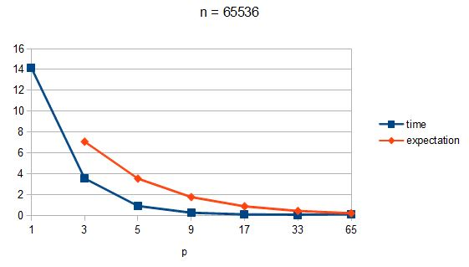
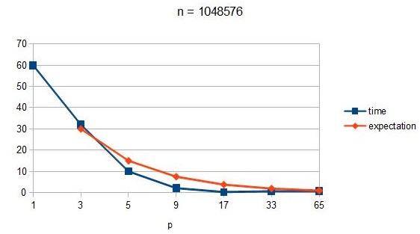
Code:
*some verification and comments for testing were removed
#include <iostream>
#include <list>
#include "mpi.h"
#include <cstdlib>
using namespace std;

int rank;
int p;
long n;
long local_n;

struct Edge
{
long v;
long w;
};

class Graph
{
long V; // No. of vertices
void depth_recurse(long v, bool visited[]); // A function used by depth_search
public:
Graph(long V, long l); // Constructor
void addEdge(long v, long w); // function to add an edge to graph
void depth_search(long v, int stop); // prints depth_search traversal of the complete graph
void OrderList();
list<long> *adj; // Pointer to an array containing adjacency lists
list<long> path;
long *pathTaken;

};

Graph::Graph(long V, long l)
{
this->V = V;
adj = new list<long>[V];
pathTaken = new long[l + 1];
}

void Graph::addEdge(long v, long w)
{
adj[v].push_back(w);
}

void Graph::depth_recurse(long v, bool visited[])
{
// Mark the current node as visited and print it
visited[v] = true;
path.push_back(v);
pathTaken[path.size()-1] = v;
//cout << rank << "\t" << v << "\n";

list<long>::iterator i;
for(i = adj[v].begin(); i != adj[v].end(); ++i)
if(!visited[*i])
depth_recurse(*i, visited);
}

void Graph::depth_search(long v, int stop = -1)
{
//printf("rank:\t%d\tin depth_search\n", rank);
// Mark all the vertices as not visited
bool *visited = new bool[V];
for(long i = 0; i < V; i++)
if (stop != -1 && i > stop)
visited[i] = true;
else
visited[i] = false;
//when edges are removed
/*for(int i = 0; i < V; i++)
if(visited[i] == false)
depth_recurse(i, visited);*/
//while(path.size() < V){
// depth_recurse(v, visited);
//v += 1;
//}
depth_recurse(v, visited);
}
//order adj list
void Graph::OrderList(){
for(long i =0; i < V; i++){
adj[i].sort();
}
}
//print path taken
void PrintPath(list<int> path){
//cout << rank << endl;
list<int>::const_iterator i;
for(i = path.begin(); i != path.end(); i++)
cout << *i << " ";
cout << endl;
}
void ComparePaths(list<int> sequential, list<int> parallel){
bool result = true;
list<int>::const_iterator seq_it;
list<int>::const_iterator par_it;
for(seq_it = sequential.begin(), par_it = parallel.begin(); seq_it != sequential.end(); seq_it++, par_it++){
if (*seq_it != *par_it)
result = false;
}
if (result)
printf("path successful");
else
printf("FAILURE!");
}
//if (v, w) belongs to root
bool BelongsToRoot(int root, long v){
bool result = false;
while(v > root){
if (v%2==0)
v = (v/2) - 1;
else
v = ((v+1)/2) - 1;
}
if (v == root)
result = true;

return result;
}
int GetProcIndexByRoot(int *procRoots, int node){
int index = -1;
while (index == -1 && node > 0){
for (int i = 0; i < (p-1); i++){
if (procRoots[i] == node)
index = i;
}
if (node%2==0)
node = (node/2) - 1;
else
node = ((node+1)/2) - 1;
}
return index;
}

int main(int argc, char* argv[])
{
n = atoi(argv[1]);
double start, stop;
int *procRoots;
long edgesPerProc;
list<int> finalPath;
Edge * localEdges;
MPI_Status status;
MPI_Init(&argc, &argv);
MPI_Comm_rank(MPI_COMM_WORLD, &rank);
MPI_Comm_size(MPI_COMM_WORLD, &p);

//custom edge data type
const int items = 3;
int blocks[3] = {1, 1, 1};
MPI_Datatype type[3] = {MPI_INT, MPI_INT, MPI_INT};
MPI_Datatype MPI_EDGE;
MPI_Aint offset[3];
offset[0] = offsetof(Edge, v1);
offset[1] = offsetof(Edge, v2);
offset[2] = offsetof(Edge, weight);
MPI_Type_create_struct(items, blocks, offset, type, &MPI_EDGE);
MPI_Type_commit(&MPI_EDGE);

if (rank==0)
local_n = p-2;
else
local_n = (n-((p-1)*2))/(p-1);

Graph g(n, local_n);

if (rank == 0){
start = MPI_Wtime();
Edge ** edges;
edges = new Edge*[p-1];
edgesPerProc = (n-((p-1)*2))/(p-1);
procRoots = new int[p-1];
long counter = 1;
int root = 0;
long *edgeCounter;
edgeCounter = new long[p-1];
for (long i=0; i < n/2 - 1; i++, counter++){
g.addEdge(i, i + counter);
g.addEdge(i, i + counter + 1);
}
for (int i = 0; i < p - 1; i++){
edges[i] = new Edge[edgesPerProc];
procRoots[i] = (i+1) + (p-3);
edgeCounter[i] = 0;
}
list<long>::iterator k;
int procIndex = -1;
for (long j = 0; j < n; j++){
for(k = g.adj[j].begin(); k != g.adj[j].end(); k++){
procIndex = GetProcIndexByRoot(procRoots, j);
if (procIndex != -1){
Edge e;
e.v = j;
e.w = *k;
counter = edgeCounter[procIndex];
edges[procIndex][counter] = e;
counter++;
edgeCounter[procIndex] = counter;
}
}
}
for (int i = 1; i < p; i++){
MPI_Send(&edges[i-1][0], edgesPerProc, MPI_EDGE, i, 0, MPI_COMM_WORLD);
}
g.depth_search(0, procRoots[p-2]);
}
else{
localEdges = new Edge[local_n];
MPI_Recv(localEdges, local_n, MPI_EDGE, 0, 0, MPI_COMM_WORLD, &status);

for (long i = 0; i < local_n; i++){
g.addEdge(localEdges[i].v, localEdges[i].w);
}
g.depth_search(rank + (p-3));
}
//MPI_Barrier(MPI_COMM_WORLD);
if(rank==0){
long ** paths;
paths = new long*[p-1];
for (int i = 1; i < p; i++){
paths[i-1] = new long[edgesPerProc + 1];
MPI_Recv(paths[i-1], edgesPerProc + 1, MPI_LONG, i, 2, MPI_COMM_WORLD, &status);
}
stop = MPI_Wtime();
printf("n:\t%d\tp:\t%d\ttime:\t%f\n", n, p, stop - start);

} else {

MPI_Send(&g.pathTaken[0], local_n + 1, MPI_LONG, 0, 2, MPI_COMM_WORLD);

}
MPI_Finalize();
return 0;
}
Submission Result:

workdir is: /scratch/rga001/project
/scratch/rga001/project
n: 1048576 p: 3 time: 1919.577485
n: 1048576 p: 5 time: 597.518325
n: 1048576 p: 9 time: 125.391712
n: 1048576 p: 17 time: 15.566790
n: 1048576 p: 33 time: 36.798722
n: 1048576 p: 65 time: 39.910471
workdir is: /scratch/rga001/project
/scratch/rga001/project
n: 65536 p: 3 time: 3.561975
n: 65536 p: 5 time: 0.915972
n: 65536 p: 9 time: 0.266614
n: 65536 p: 17 time: 0.113206
n: 65536 p: 33 time: 0.093642
n: 65536 p: 65 time: 0.129521

