CUSTOMER CHURN ANALYSIS
Telco Customer Dataset — Exploratory Data Analysis

1. Executive Summary

This report documents the exploratory data analysis (EDA) conducted on the IBM Telco Customer Churn dataset as part of a paid data analytics internship. The primary objective was to identify patterns and key drivers behind customer churn, enabling the business to develop targeted retention strategies.

The dataset comprises 7,043 customer records with 21 features spanning demographics, account details, subscribed services, and churn status. After performing structured data cleaning and validation, the analysis revealed several actionable insights:
- Overall churn rate stands at 26.54%, indicating significant revenue leakage.
- Month-to-month contract customers churn at a rate of ~42.71%, nearly 15× higher than two-year contract holders.
- Fiber optic internet service users exhibit the highest churn rate (~41.9%).
- Customers paying via electronic check churn at ~45.29%, the highest among all payment methods.
- Senior citizens are significantly more likely to churn (~42%) compared to non-senior customers (~24%).
- Short-tenure customers (0–1 year) are the most at-risk segment, with a 47.44% churn rate.
- Customers with Tech Support churn far less (~15%) vs those without (~42%).

2. Dataset Overview

2.1 Source & Context
The dataset used is the publicly available IBM Sample Dataset — Telco Customer Churn, commonly used for churn prediction and customer analytics studies. It simulates a telecommunications company's customer base with detailed service and demographic attributes.

2.2 Dataset Dimensions
Property | Value
Total Records | 7,043 customers
Total Features | 21 columns
Target Variable | Churn (Yes / No)
Numeric Features | tenure, MonthlyCharges, TotalCharges
Categorical Features | 18 (gender, Contract, PaymentMethod, etc.)
Missing Values | 11 records in TotalCharges (removed)
Duplicate Records | 0

2.3 Feature Glossary
Column | Type | Description
customerID | String | Unique identifier per customer
gender | Categorical | Male / Female
SeniorCitizen | Binary (0/1) | Whether the customer is a senior citizen
Partner | Categorical | Has a partner (Yes/No)
Dependents | Categorical | Has dependents (Yes/No)
tenure | Numeric | Number of months with the company
PhoneService | Categorical | Has phone service (Yes/No)
MultipleLines | Categorical | Has multiple phone lines
InternetService | Categorical | DSL / Fiber optic / No
OnlineSecurity | Categorical | Has online security add-on
OnlineBackup | Categorical | Has online backup add-on
DeviceProtection | Categorical | Has device protection plan
TechSupport | Categorical | Has tech support plan
StreamingTV | Categorical | Has streaming TV service
StreamingMovies | Categorical | Has streaming movies service
Contract | Categorical | Month-to-month / One year / Two year
PaperlessBilling | Categorical | Uses paperless billing (Yes/No)
PaymentMethod | Categorical | Electronic check / Mailed check / Bank transfer / Credit card
MonthlyCharges | Numeric | Monthly bill amount in USD
TotalCharges | Numeric | Total amount charged over tenure
Churn | Categorical (Target) | Whether the customer churned (Yes/No)

3. Data Cleaning & Preprocessing

Prior to analysis, a structured data cleaning pipeline was implemented in Python using the Pandas library. The following steps were performed to ensure data integrity:

3.1 Type Correction
The TotalCharges column was stored as an object (string) type due to whitespace entries in the raw CSV. It was converted to a numeric float type:
df["TotalCharges"] = pd.to_numeric(df["TotalCharges"], errors="coerce")

3.2 Missing Value Treatment
Column | Missing (Before) | Missing (After)
TotalCharges | 11 | 0
All other columns | 0 | 0
Final dataset size | 7,043 → 7,032 rows | —

3.3 Duplicate Check
A full duplicate check was performed across all columns. No duplicate records were found in the dataset, confirming data uniqueness at the customer ID level.

3.4 Column Preservation
All 21 original column names were preserved in their raw form — no encoding, dummy variable creation, or column transformations were applied during the cleaning phase. This ensures the cleaned dataset remains fully compatible with SQL-based analysis in PostgreSQL (pgAdmin) and Power BI dashboards.

4. Exploratory Data Analysis

4.1 Overall Churn Distribution
Churn Status | Customer Count | Percentage
No (Retained) | 5,174 | 73.46%
Yes (Churned) | 1,869 | 26.54%

4.2 Churn by Contract Type
Contract Type | Total | Churned | Churn Rate
Month-to-month | 3,875 | 1,655 | 42.71%
One year | 1,473 | 166 | 11.27%
Two year | 1,695 | 48 | 2.83%

4.3 Churn by Tenure Group
Tenure Group | No Churn % | Churned % | Risk Level
0–1 Year | 52.56% | 47.44% | CRITICAL
1–2 Years | 71.29% | 28.71% | HIGH
2–4 Years | 79.61% | 20.39% | MEDIUM
4+ Years | 90.49% | 9.51% | LOW

4.4 Churn by Payment Method
Payment Method | No Churn % | Churn % | Risk
Electronic check | 54.71% | 45.29% | HIGH
Mailed check | 80.89% | 19.11% | LOW
Bank transfer (auto) | 83.29% | 16.71% | LOW
Credit card (auto) | 84.76% | 15.24% | LOW

4.5 Impact of Tech Support
Tech Support Status | No Churn % | Churn %
No | 58.36% | 41.64%
Yes | 84.83% | 15.17%
No internet service | 92.60% | 7.40%

4.6 Average Monthly Charges vs Churn
Churn Status | Avg Monthly Charges | Observation
No (Retained) | $61 | Lower monthly bill
Yes (Churned) | $74 | ~21% higher — price sensitivity signal

5. SQL-Based Analysis (PostgreSQL / pgAdmin)

The cleaned dataset was exported and loaded into PostgreSQL for structured querying. Below are key analytical queries and their findings. Note: Column names are case-sensitive and require double quotes in PostgreSQL.

5.1 Overall Churn Rate Query
SELECT COUNT(*) AS total, SUM(CASE WHEN "Churn"='Yes' THEN 1 ELSE 0 END) AS churned, ROUND(100.0 * SUM(CASE WHEN "Churn"='Yes' THEN 1 ELSE 0 END)/COUNT(*), 2) AS churn_rate FROM customer_churn;

5.2 Revenue Lost to Churn
SELECT ROUND(SUM(CASE WHEN "Churn"='Yes' THEN "MonthlyCharges" END)::numeric,2) AS lost_monthly, ROUND(SUM(CASE WHEN "Churn"='Yes' THEN "TotalCharges" END)::numeric,2) AS lost_total FROM customer_churn;
Note: ::numeric cast is required in PostgreSQL for ROUND() with decimal columns.

6. Power BI Dashboard Analysis

A comprehensive interactive dashboard was created in Power BI to visualize all churn dimensions simultaneously. The dashboard includes filters for Contract type, Internet Service, Payment Method, Gender, and Tech Support — enabling dynamic segment exploration.

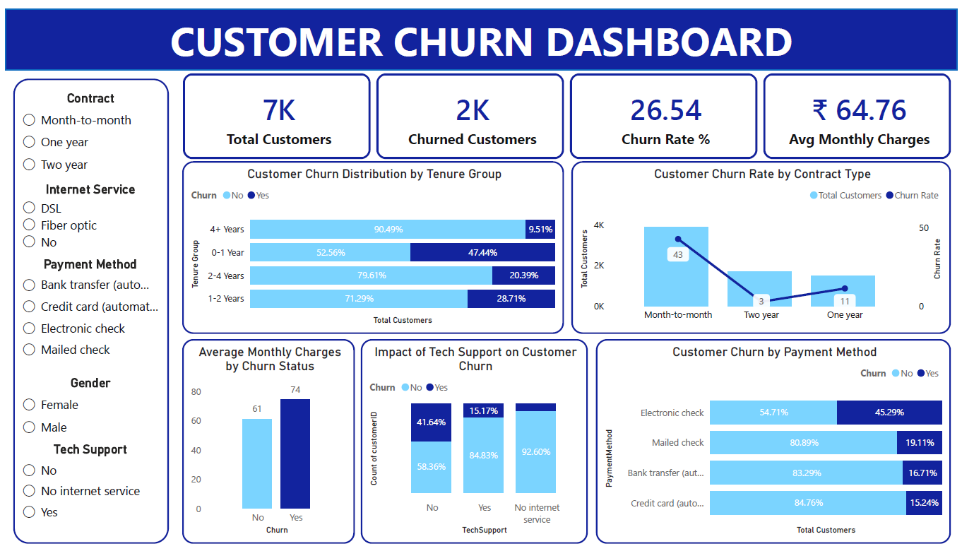
Figure 1: Customer Churn Dashboard — Power BI

6.1 Dashboard KPI Cards
KPI | Value | Metric Type | Significance
Total Customers | 7K | Volume | Full customer base size
Churned Customers | 2K | Volume | Active revenue loss
Churn Rate % | 26.54% | Rate | 1 in 4 customers churned
Avg Monthly Charges | ₹64.76 | Financial | Baseline for revenue modeling

6.2 Tenure Group Distribution (Bar Chart)
The stacked bar chart confirms early-stage customers are most at risk. Customers in the 0–1 year group have a 47.44% churn rate — nearly half the segment. Churn steadily declines with each tenure tier, reaching just 9.51% for customers with 4+ years of tenure.

6.3 Contract Type — Dual-Axis Chart
The combo chart plots both total customer count (bars) and churn rate (line) per contract type. Month-to-month customers dominate volume (~3,875) but also carry the highest churn rate at 42.71%. The sharp downward line towards two-year contracts (2.83%) clearly visualizes the loyalty effect of long-term commitments.

6.4 Tech Support Impact (Clustered Bar)
Customers without tech support churn at 41.64%, while those enrolled in tech support churn at only 15.17% — a 26-point reduction. Customers with no internet service churn the least at 7.40%, serving as a natural benchmark for digital service-related churn drivers.

6.5 Payment Method — Horizontal Bar Chart
Electronic check users lead churn at 45.29%, more than double the rate of auto-pay customers (~16%). The dashboard makes this disparity visually compelling and supports the recommendation to drive auto-pay enrollment among high-risk segments.

6.6 Monthly Charges vs Churn (Bar Chart)
Churned customers pay an average of $74/month versus $61 for retained customers — a 21% premium. This confirms that price dissatisfaction and perceived value mismatch are active churn drivers, particularly for fiber optic subscribers.

7. Key Insights & Business Recommendations

The following recommendations are derived from both the EDA findings and the Power BI dashboard analysis. Each recommendation maps directly to a data-validated finding and includes a proposed action, expected impact, and priority level.

7.1 Priority Action Matrix
# | Finding | Recommended Action | Expected Impact | Priority
1 | Month-to-month churn: 42.71% | Offer 2–3 month free discount to upgrade to annual contracts | Reduce churn by 15–20% in this segment | Critical
2 | 0–1 Year tenure: 47.44% churn | Implement 90-day onboarding program + loyalty reward at 6 months | Reduce early-stage churn by 10–15% | Critical
3 | Electronic check: 45.29% churn | Promote auto-pay (bank transfer/credit card) with ₹5/month discount | Reduce payment-method churn by ~30% | High
4 | No Tech Support: 41.64% churn | Bundle 3-month free Tech Support trial for at-risk customers | Reduce churn by ~26 points for enrolled users | High
5 | Fiber optic: ~42% churn | Investigate pricing vs. DSL — offer competitive lock-in rate | Address value perception gap | High
6 | Senior citizens: ~42% churn | Create senior-specific support tier with simplified billing | Capture underserved high-value demographic | Medium
7 | Avg charges: Churned $74 vs $61 | Introduce price-matched retention offers for high-paying churners | Prevent high-ARPU customer loss | Medium
8 | No Dependents = highest churn | Launch solo-customer loyalty program (points, exclusive perks) | Improve single-customer stickiness | Low

7.2 Retention Framework
Based on the dashboard and EDA data, a three-tier retention framework is recommended:

Tier | Segment Profile | Strategy
TIER 1 — Immediate Action | Month-to-month + Electronic check + 0–1yr tenure | Proactive outreach, contract upgrade offer, auto-pay incentive
TIER 2 — Engagement Program | No Tech Support + Fiber optic + Senior citizen | Tech support trial, fiber pricing review, senior helpline
TIER 3 — Loyalty Building | No Dependents + 1–2yr tenure + Above-avg charges | Loyalty points, mid-tenure rewards, personalized pricing

7.3 Estimated Revenue Impact
If the Tier 1 interventions reduce churn by even 20% in the month-to-month segment:
- Current month-to-month churners: ~1,655 customers
- 20% reduction = ~331 customers retained
- Avg Monthly Charges of churned customers: $74.44
- Estimated monthly revenue recovery: ~$24,640 / month
- Annual impact: ~$295,680 in prevented revenue loss

8. Tools & Methodology

Tool / Technology | Purpose | Usage in Project
Python 3.x | Core programming language | Data loading, cleaning, EDA
Pandas | Data manipulation library | Type conversion, null handling, groupby analysis
NumPy | Numerical computing | Statistical computations
Seaborn / Matplotlib | Data visualization | Churn countplots, boxplots
Google Colab | Notebook environment | Interactive code execution
PostgreSQL (pgAdmin) | Relational database & SQL IDE | Structured querying & reporting
SQLAlchemy + psycopg2 | Python–PostgreSQL connector | DataFrame export to PostgreSQL
Power BI | Business intelligence & dashboard | Interactive churn dashboard with slicers

9. Conclusion

This internship project delivered a comprehensive exploratory data analysis of the Telco Customer Churn dataset, covering data ingestion, cleaning, univariate and bivariate analysis, SQL-based reporting, and an interactive Power BI dashboard.

The analysis confirmed that churn is not random — it is systematically driven by contract type, internet service, payment method, tenure, tech support enrollment, and demographic characteristics. The Power BI dashboard makes these patterns immediately interpretable for business stakeholders without requiring technical expertise.

The proposed 3-tier retention framework provides a practical, data-backed roadmap for reducing churn. Conservative estimates suggest that even a 20% improvement in the highest-risk segment (month-to-month customers) could recover nearly $295,000 in annual revenue.

Future work may include predictive churn modeling using classification algorithms (Logistic Regression, Random Forest, XGBoost), customer lifetime value segmentation, real-time churn scoring dashboards, and A/B testing of the recommended retention interventions.

