ZEPTO SALES & DELIVERY
PERFORMANCE ANALYSIS
Quick-Commerce Operations — Sales, Delivery & Revenue Intelligence

1. Executive Summary

This report documents the exploratory data analysis (EDA) conducted on the Zepto quick-commerce dataset as part of a paid data analytics internship. The primary objective was to evaluate how operational efficiency — specifically delivery time — impacts revenue outcomes, and to identify actionable improvements for the business.

The dataset comprises 41,000 order records spanning sales volume, delivery time, customer ratings, payment methods, product categories, and customer segments. After performing structured data cleaning and analysis, the findings consistently point to one central conclusion: delivery speed is the dominant driver of revenue in quick-commerce, outweighing demographic and payment factors. Key findings include:
- Total revenue of ₹24.36M across 41,000 orders with an average order value of ₹594.
- 5-minute deliveries contribute the highest revenue (₹15.3M) — 62.8% of total revenue.
- On-time deliveries (≤15 min) generate ₹22M vs. just ₹2M from late deliveries — an 11× gap.
- Average customer rating of 3.20/5 signals significant room for satisfaction improvement.
- Revenue distribution is consistent across age groups and payment methods, confirming that operational speed matters more than demographic targeting.
- Core grocery categories drive stable, recurring demand across all customer segments.

2. Dataset Overview

2.1 Source & Context
The dataset is a simulated quick-commerce operational dataset modeled on Zepto's business structure, sourced from Kaggle. It captures end-to-end order data including delivery performance, customer behavior, and revenue metrics — making it well-suited for operational efficiency analysis.

2.2 Dataset Dimensions
Property | Value
Total Orders | 41,000
Total Revenue | ₹24.36M
Average Order Value (AOV) | ₹594
Average Customer Rating | 3.20 / 5.00
Late Delivery Threshold | > 15 minutes
On-Time Revenue | ₹22M
Late Delivery Revenue | ₹2M

2.3 Feature Scope
Feature | Type | Description
Order ID | String | Unique identifier per order
Order Date / Time | DateTime | Timestamp of the order placement
Delivery Time (min) | Numeric | Time from order placement to delivery
Revenue (₹) | Numeric | Revenue generated per order
Product Category | Categorical | Category of items ordered (Grocery, Dairy, etc.)
Customer Segment | Categorical | New / Returning / Loyal
Age Group | Categorical | Engineered feature — Youth / Adult / Senior
Payment Method | Categorical | UPI / Credit Card / Debit Card / COD
Customer Rating | Numeric (1–5) | Post-delivery satisfaction score
Late Delivery Flag | Binary | Engineered — 1 if delivery time > 15 min

3. Data Cleaning & Feature Engineering

The raw dataset was processed through a structured cleaning and feature engineering pipeline using Python (Pandas). The following steps were applied:

3.1 Missing Value Treatment
Issue | Count | Resolution
Missing values (all columns) | 37 records | Imputed using column median / mode based on dtype
Duplicate records | 0 | Validated clean
Final dataset size | 41,000 orders | No rows dropped

3.2 Feature Engineering
Two new features were engineered to enable richer segmentation and analysis:

# Age group segmentation df['age_group'] = pd.cut(df['customer_age'], bins=[0,25,45,100], labels=['Youth','Adult','Senior']) # Late delivery binary flag df['late_delivery'] = (df['delivery_time_min'] > 15).astype(int)
The age_group feature enabled demographic revenue segmentation. The late_delivery flag enabled direct on-time vs. late revenue comparison — the most significant analytical finding in this project.

4. Exploratory Data Analysis

4.1 Revenue by Delivery Time
Delivery time is the single strongest driver of revenue in this dataset. The relationship is clear and steep: revenue drops dramatically as delivery time increases beyond 10 minutes.
Delivery Window | Revenue | % of Total | Risk Label
5 minutes | ₹15.3M | 62.8% | 🟢 Peak Performance
10 minutes | ₹5.8M | 23.8% | 🟢 Acceptable
15 minutes | ₹0.9M | 3.7% | 🟡 Threshold
20+ minutes | ₹2.0M (late) | 8.2% | 🔴 Revenue Risk
25 minutes | ~Negligible | <1% | 🔴 Critical Loss

4.2 On-Time vs. Late Delivery Revenue
Defining late delivery as any order taking more than 15 minutes reveals a stark revenue gap:
Delivery Status | Total Revenue | Observation
On-Time (≤15 min) | ₹22M | 91.8% of all revenue
Late (>15 min) | ₹2M | 8.2% of all revenue — 11× gap

Insight: Improving late delivery rates from the current level to near-zero has a direct, quantifiable revenue impact of up to ₹2M in recovery potential per equivalent order cycle.

4.3 Revenue by Product Category
Core grocery categories — staples, dairy, and household essentials — drive consistent revenue contribution across all customer segments, confirming stable recurring demand patterns typical of quick-commerce models.
Category Type | Revenue Pattern | Demand Characteristic
Grocery / Staples | Highest & consistent | Recurring, habitual purchase
Dairy & Beverages | High frequency, lower AOV | Daily-use, impulse-friendly
Personal Care | Moderate, spiky | Periodic need-based purchase
Snacks & Packaged | High volume, low margin | Impulse + convenience-driven

4.4 Customer Ratings Distribution
Metric | Value | Interpretation
Average Rating | 3.20 / 5.00 | Below-average satisfaction
Likely driver of low ratings | Late deliveries | Delivery experience is the primary satisfaction lever
Improvement target | ≥ 4.00 / 5.00 | Achievable by reducing late delivery %

4.5 Demographics & Payment Method
A key finding of this analysis is the absence of significant variation in revenue or ratings across demographic and payment dimensions:
Dimension | Variation Found? | Implication
Age Group | Minimal | No age-specific targeting required
Payment Method | Minimal | All payment modes perform similarly
Gender | Minimal | Revenue evenly distributed
Customer Segment | Moderate | Loyal customers have higher AOV

Insight: This confirms that operational performance (delivery speed) — not demographic profile — is the primary lever for revenue optimization in this business model.

5. SQL-Based Analysis (PostgreSQL)

The cleaned dataset was loaded into PostgreSQL for structured querying. Key analyses performed:

5.1 Revenue by Delivery Time Bucket
SELECT CASE WHEN delivery_time_min <= 5 THEN '0-5 min' WHEN delivery_time_min <= 10 THEN '6-10 min' WHEN delivery_time_min <= 15 THEN '11-15 min' ELSE '15+ min (Late)' END AS delivery_bucket, ROUND(SUM(revenue)::numeric, 2) AS total_revenue, COUNT(*) AS total_orders FROM zepto_orders GROUP BY delivery_bucket ORDER BY total_revenue DESC;

5.2 On-Time vs. Late Delivery Revenue Split
SELECT CASE WHEN delivery_time_min > 15 THEN 'Late' ELSE 'On-Time' END AS status, COUNT(*) AS orders, ROUND(SUM(revenue)::numeric, 2) AS total_revenue, ROUND(AVG(customer_rating)::numeric, 2) AS avg_rating FROM zepto_orders GROUP BY status;

5.3 Customer Segment Revenue Analysis
SELECT customer_segment, COUNT(*) AS total_orders, ROUND(AVG(revenue)::numeric, 2) AS avg_order_value, ROUND(SUM(revenue)::numeric, 2) AS total_revenue FROM zepto_orders GROUP BY customer_segment ORDER BY total_revenue DESC;

6. Power BI Dashboard Overview

An interactive executive dashboard was built in Power BI to visualize all key operational and revenue dimensions simultaneously. The dashboard enables real-time KPI monitoring with dynamic filters for product category, customer segment, payment method, age group, and delivery status.
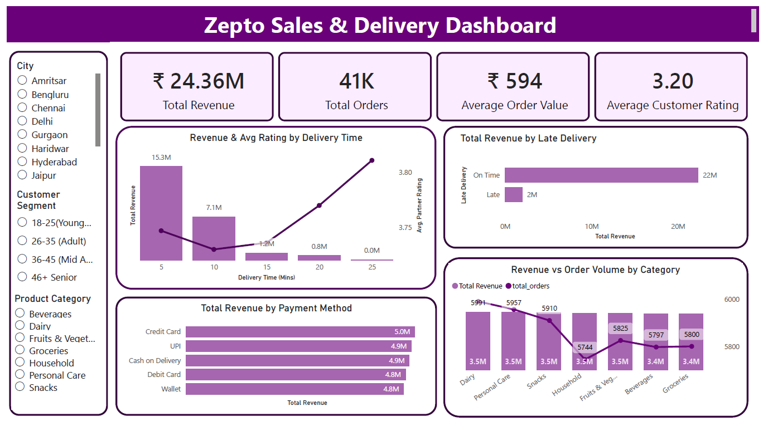

6.1 Dashboard KPI Cards
KPI | Value | Metric Type | Business Significance
Total Revenue | ₹24.36M | Financial | Overall business scale
Total Orders | 41K | Volume | Order throughput baseline
Avg Order Value (AOV) | ₹594 | Financial | Revenue per transaction
Avg Customer Rating | 3.20 / 5 | Satisfaction | Below benchmark — improvement needed

6.2 Revenue by Delivery Time (Line/Bar Chart)
The revenue-by-delivery-time chart is the centerpiece of the dashboard. It plots revenue contribution against delivery time in minutes, revealing a steep downward curve beyond 10 minutes. The ₹15.3M contribution from 5-minute deliveries vs. near-zero at 25 minutes makes the business case for operational efficiency visually undeniable.

6.3 On-Time vs. Late Delivery Comparison
A side-by-side revenue and rating comparison between on-time and late deliveries. The ₹22M vs. ₹2M split and the corresponding rating differential provide direct evidence for prioritizing delivery SLA compliance as a core business KPI.

6.4 Revenue by Product Category
A category-level revenue breakdown confirms that grocery and dairy categories are the highest-volume, most consistent revenue contributors. This informs inventory prioritization and dark store stocking strategy.

6.5 Customer Segment Performance
Revenue and AOV by customer segment (New, Returning, Loyal) shows that loyal customers generate higher average order values — validating investment in loyalty and retention programs over acquisition-only strategies.

7. Key Insights & Business Recommendations

All recommendations are derived directly from the data. The core theme is consistent: operational speed is the primary business lever in quick-commerce — more impactful than demographic targeting or payment optimization.

7.1 Priority Action Matrix
# | Finding | Recommended Action | Expected Impact | Priority
1 | 5-min deliveries = ₹15.3M (62.8% of revenue) | Set 5-minute delivery as the operational SLA standard; invest in dark store proximity and rider density | Protect and grow the highest-revenue window | Critical
2 | Late deliveries (>15 min) = only ₹2M revenue | Implement real-time delivery time monitoring dashboard; trigger alerts at 12-minute mark | Recover up to ₹2M in at-risk revenue per cycle | Critical
3 | Avg rating 3.20/5 — below benchmark | Tie rider incentives to on-time rate and customer rating; target ≥4.0 rating | Improve retention and repeat order rate | High
4 | Revenue drops sharply after 10 minutes | Optimize peak-hour staffing — add surge riders during high-demand windows | Shift more orders into the 5–10 min window | High
5 | Grocery & dairy = highest consistent revenue | Prioritize stock availability for top-10 SKUs in grocery/dairy at all dark store locations | Reduce out-of-stock cancellations | Medium
6 | Loyal customers have higher AOV | Launch a loyalty tier program with free priority delivery for repeat customers | Increase Loyal segment share and LTV | Medium

7.2 Operational Efficiency Framework
Tier | Focus Area | Key Actions
TIER 1 — Speed Optimization | Delivery time reduction | Dark store placement, rider density, real-time SLA monitoring
TIER 2 — Quality Improvement | Customer satisfaction | Rating-linked incentives, late delivery follow-up credits, feedback loops
TIER 3 — Revenue Deepening | Category & loyalty growth | Top-SKU availability, loyalty tier program, upsell at checkout

7.3 Estimated Revenue Impact
If late delivery rate is reduced by 50% (from current levels to half the volume):
- Current late delivery revenue: ₹2M
- Orders shifted to on-time window: ~50% of late orders
- On-time AOV uplift: assumed equivalent to current on-time avg
- Estimated additional revenue: ~₹1M per equivalent order cycle
- Annual impact (assuming 12 cycles): ~₹12M in recovered/incremental revenue

This is a conservative estimate — it excludes the compounding effect of improved ratings on repeat order frequency and customer LTV.

8. Tools & Methodology

Tool / Technology | Purpose | Usage in Project
Python 3.x | Core programming language | Data loading, cleaning, EDA
Pandas | Data manipulation library | Missing value imputation, feature engineering, groupby analysis
Matplotlib / Seaborn | Data visualization | Delivery time vs. revenue plots, distribution charts
Google Colab | Notebook environment | Interactive code execution
PostgreSQL | Relational database & SQL IDE | Revenue aggregation, delivery bucket analysis, segment queries
Power BI | Business intelligence dashboard | KPI cards, delivery time charts, category and segment breakdowns

9. Conclusion

This internship project delivered a comprehensive analysis of Zepto's quick-commerce sales and delivery performance, covering data cleaning, feature engineering, exploratory analysis, SQL-based querying, and an interactive Power BI dashboard.

The central finding is clear and actionable: delivery speed is the dominant revenue driver in quick-commerce. The ₹15.3M contribution from 5-minute deliveries versus near-negligible revenue from 25-minute deliveries, combined with the ₹22M vs. ₹2M on-time/late split, establishes delivery SLA compliance as the single highest-priority operational KPI.

Demographic factors (age, gender, payment method) showed minimal impact on revenue — meaning targeted demographic campaigns are a lower-ROI investment compared to operational infrastructure improvements. Resources are better directed at dark store placement, rider density, and real-time delivery monitoring.

The 3-tier operational framework proposed here — Speed Optimization → Quality Improvement → Revenue Deepening — provides a practical, sequenced roadmap for the business. A conservative execution of Tier 1 alone could recover approximately ₹12M in annual revenue from late delivery losses.

Future work may include predictive delivery delay modeling, demand forecasting by category and time-of-day, and dynamic pricing optimization based on delivery time slots.

