eixport: An R package to export emissions to atmospheric models

23 February 2018

# Summary

Emissions are the pollutant mass released into the atmosphere (Pulles and Heslinga 2010). The origin of the emissions can be human-made or anthropogenic or biogenic. The consequences of this pollution are complex affecting the atmosphere, human health, ecosystems, and infrastructure (Seinfeld and Pandis 2016). In fact, pollution caused 9 million premature deaths in 2015, 16% of all deaths worldwide (Landrigan et al. 2017).

An important tool for policy decision is air quality models. They have been used not only to study the impact of different emissions scenarios for policy making but also to understand the dynamics of air pollutants in various parts of the world (M. de F. Andrade et al. 2015). The inputs for an air quality models are meteorology and emissions. Currently, there are tools for developing emissions inventories such as the VEIN (Ibarra-Espinosa et al. 2017) and the EmissV models (Schuch 2017). However, the existing tools for inputting the emissions into the air quality models are not written with a high-level language, such as PREP-Chem written in Fortran and C (S. Freitas et al. 2011). Therefore, we developed **eixport**, a tool for doing the mentioned task, using R (R Core Team 2017), a high-level programming.

eixport imports functions form the R packages sf (E. Pebesma 2017) which provides functions for spatial vector data, providing bindings to the GDAL, GEOS, and Proj.4 C++ libraries. Also, eixport import functions from the package ncdf4 (Pierce 2017), which interface to Unidata netCDF Format Data Files, and from the raster package (Hijmans 2017), which provides functions to gridded data.

## Functions and data

eixport count with the folllwing functions:

|  |  |
| --- | --- |
| Function | Description |
| emisco | Dataset of Emissions from VEIN demo |
| emis_opt | List of WRF emission species |
| rawprofile | A matrix to temporally distribute emissions |
| to_brams_spm | Produce inputs for BRAMS SPM (E. D. de Freitas et al. 2005) |
| to_rline | Produce inputs for R-Line (Snyder et al. 2013) |
| to_wrf | Distribution of emissions for WRF-Chem (G. A. Grell et al. 2005) |
| wrf_create | Create WRF-Chem inputs based on a WRFinput file |
| wrf_get | Reads variables from WRF-Chem inputs |
| wrf_grid | Creates spatial feature (sf) polygon grid from WRFinput file |
| wrf_plot | Simple plot from wrf emission file |
| wrf_profile | returns a traffic intensity profile (based on wrf file Times) |
| wrf_put | Function to write variables in WRF-Chem inputs |

## Examples

The following example creates a directory **EMISS** and then create a wrfchem input in that file. The package already counts with wrfinput files required to run eixport and create inputs for WRF-Chem. The line data(Lights) load a matrix of night light to spatially distribute the emissions. The perfil argument is used to temporally distribute the emissions. Lastly, the function to_wrf in one line reads the 1521983 $t⋅y^{−1}$ of CO, spatially distribute it using nighttime traffic matrix Lights, temporally distribute it with the perfil, injecting the array of emissions directly into the wrfchemi file.

library(eixport)  
dir.create("EMISS")  
wrf_create(wrfinput_dir = system.file("extdata", package = "eixport"),  
 wrfchemi_dir = "EMISS",  
 frames_per_auxinput5 = 24)  
  
# get the name of created file  
files <- list.files(path = "EMISS",pattern = "wrfchemi",full.names = T)  
  
data(Lights)  
  
perfil <- c(0.010760058, 0.005280596, 0.002883553, 0.002666932,  
 0.005781312, 0.018412838, 0.051900411, 0.077834636,  
 0.067919758, 0.060831614, 0.055852868, 0.052468599,  
 0.050938043, 0.051921718, 0.052756244, 0.052820165,  
 0.058388406, 0.072855890, 0.075267137, 0.063246412,  
 0.042713523, 0.029108975, 0.022091855, 0.015298458)  
  
plot(perfil,ty = "l",col= "purple",xlab = "Hour",main = "Time profile",  
 ylab = "Weight",axes = F,xlim = c(0,24))  
axis(2)  
axis(1,at = c(0,6,12,18,24),labels = c("00:00","06:00","12:00","18:00","00:00"))  
  
to_wrf(Lights,files[1],total = 1521983,profile = perfil,names = "E_CO")  
wrf_plot(files[1])  
# [1] "EMISS/wrfchemi_d01_2011-08-01_00:00:00"  
# [1] "E_CO"  
# [1] "Max value: 26.6966304779053, Min value: 0"

The resulting plot can be seen in the Fig. 1.

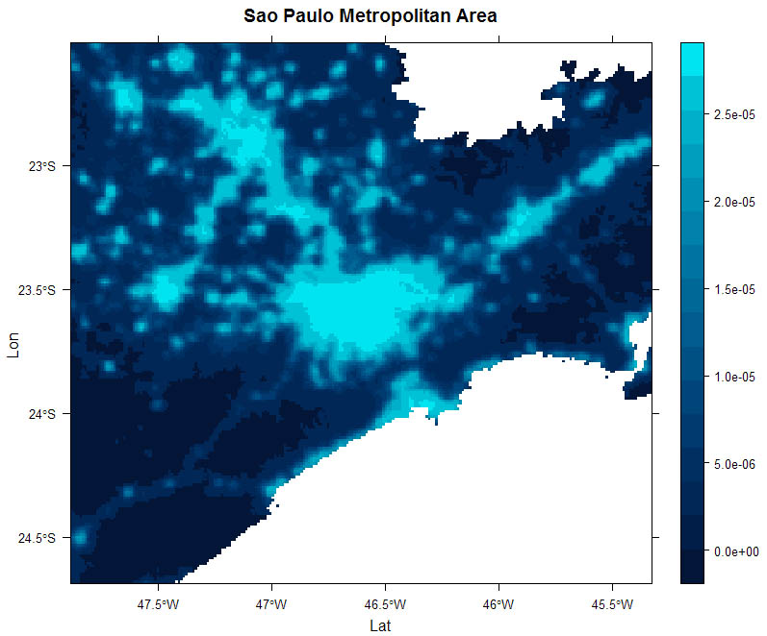

WRF-Chem emisisons of CO

The R package eixport is available at the repository <https://github.com/atmoschem/eixport>. To ensure the usability of the package, in any commit to GitHub, eixport is installed in Ubuntu via Travis-CI (<https://travis-ci.org/atmoschem/eixport>) and Windows via Appveyor (<https://ci.appveyor.com/project/Schuch666/eixport>). Also, eixport is already on CRAN <https://CRAN.R-project.org/package=eixport>.

# Acknowledgements

The development of eixport was supported by postdoc grans fro the Fundação de Universidade de São Paulo and Fundação Coordenação de Aperfeiçoamento de Pessoal de Nível Superior.

# References

Andrade, Maria de Fatima, Rita Y Ynoue, Edmilson Dias Freitas, Enzo Todesco, Angel Vara Vela, Sergio Ibarra, Leila Droprinchinski Martins, Jorge Alberto Martins, and Vanessa Silveira Barreto Carvalho. 2015. “Air Quality Forecasting System for Southeastern Brazil.” *Frontiers in Environmental Science* 3. Frontiers: 1–12. doi:[10.3389/fenvs.2015.00009](https://doi.org/10.3389/fenvs.2015.00009).

Freitas, Edmilson Dias de, Leila Droprinchinski Martins, Pedro Leite da Silva Dias, and Maria de Fátima Andrade. 2005. “A Simple Photochemical Module Implemented in Rams for Tropospheric Ozone Concentration Forecast in the Metropolitan Area of Sao Paulo, Brazil: Coupling and Validation.” *Atmospheric Environment* 39: 6352–61.

Freitas, SR, KM Longo, MF Alonso, M Pirre, V Marecal, G Grell, R Stockler, RF Mello, and M Sánchez Gácita. 2011. “PREP-Chem-Src-1.0: A Preprocessor of Trace Gas and Aerosol Emission Fields for Regional and Global Atmospheric Chemistry Models.” *Geoscientific Model Development* 4 (2). Copernicus GmbH: 419.

Grell, Georg A, Steven E Peckham, Rainer Schmitz, Stuart A McKeen, Gregory Frost, William C Skamarock, and Brian Eder. 2005. “Fully Coupled ‘Online’ Chemistry Within the Wrf Model.” *Atmospheric Environment* 39 (37). Elsevier: 6957–75.

Hijmans, Robert J. 2017. *Raster: Geographic Data Analysis and Modeling*. <https://CRAN.R-project.org/package=raster>.

Ibarra-Espinosa, S., R. Ynoue, S. O’Sullivan, E. Pebesma, M. D. F. Andrade, and M. Osses. 2017. “VEIN V0.2.2: An R Package for Bottom-up Vehicular Emissions Inventories.” *Geoscientific Model Development Discussions* 1: 1–29. doi:[10.5194/gmd-2017-193](https://doi.org/10.5194/gmd-2017-193).

Landrigan, Philip J, Richard Fuller, Nereus JR Acosta, Olusoji Adeyi, Robert Arnold, Abdoulaye Bibi Baldé, Roberto Bertollini, et al. 2017. “The Lancet Commission on Pollution and Health.” *The Lancet*. Elsevier.

Pebesma, Edzer. 2017. *Sf: Simple Features for R*. <https://github.com/r-spatial/sf/>.

Pierce, David. 2017. *Ncdf4: Interface to Unidata netCDF (Version 4 or Earlier) Format Data Files*. <https://CRAN.R-project.org/package=ncdf4>.

Pulles, Tim, and Dick Heslinga. 2010. “The Art of Emission Inventorying.” *TNO, Utrecht*.

R Core Team. 2017. *R: A Language and Environment for Statistical Computing*. Vienna, Austria: R Foundation for Statistical Computing. <https://www.R-project.org/>.

Schuch, Daniel. 2017. *EmissV: Top-down Methods to Create Vehicular Emissions*. <https://github.com/atmoschem/EmissV>.

Seinfeld, John H, and Spyros N Pandis. 2016. *Atmospheric Chemistry and Physics: From Air Pollution to Climate Change*. John Wiley & Sons.

Snyder, Michelle G, Akula Venkatram, David K Heist, Steven G Perry, William B Petersen, and Vlad Isakov. 2013. “RLINE: A Line Source Dispersion Model for Near-Surface Releases.” *Atmospheric Environment* 77. Elsevier: 748–56.