**Lab 1.**

1. Create table congress_employee

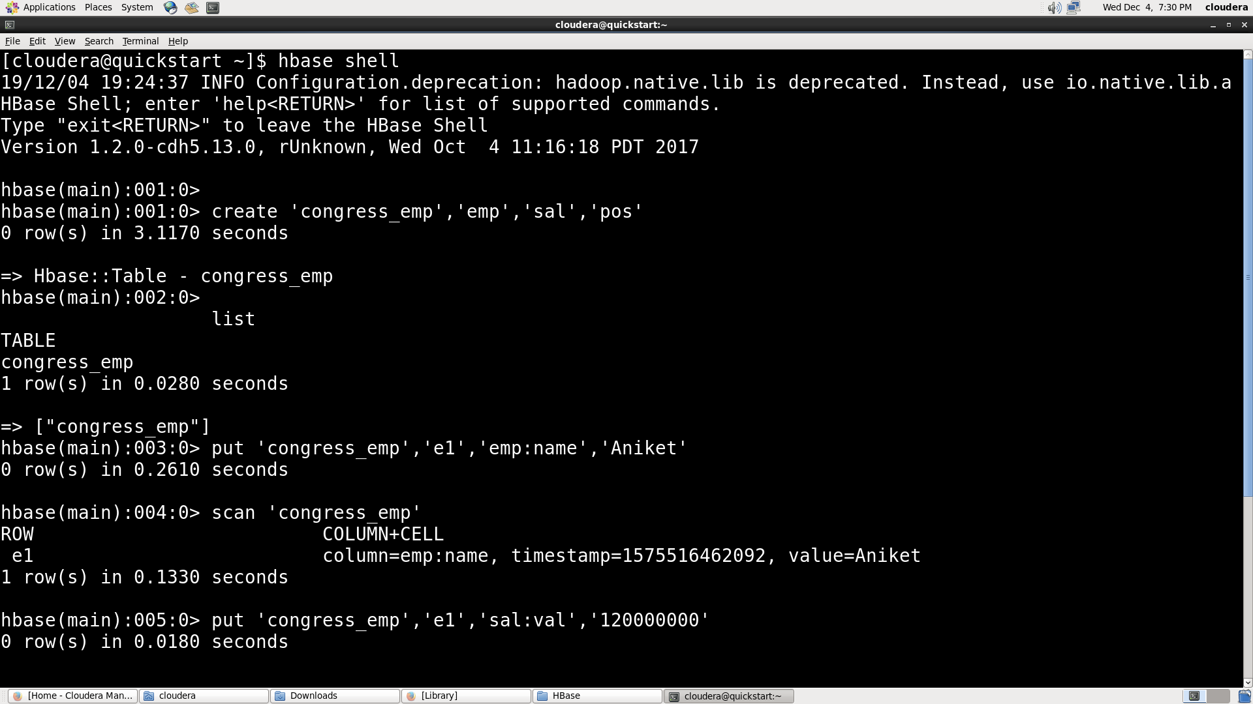

1. Put some rows in tables.

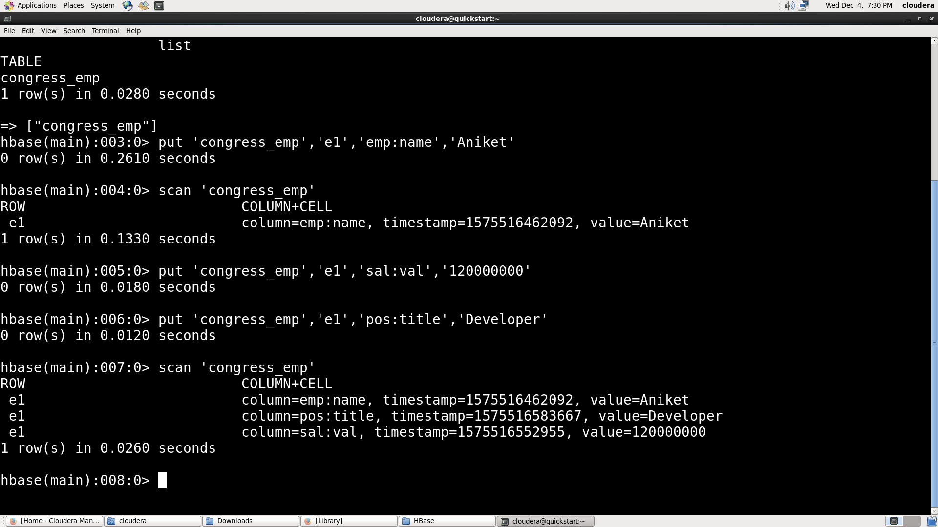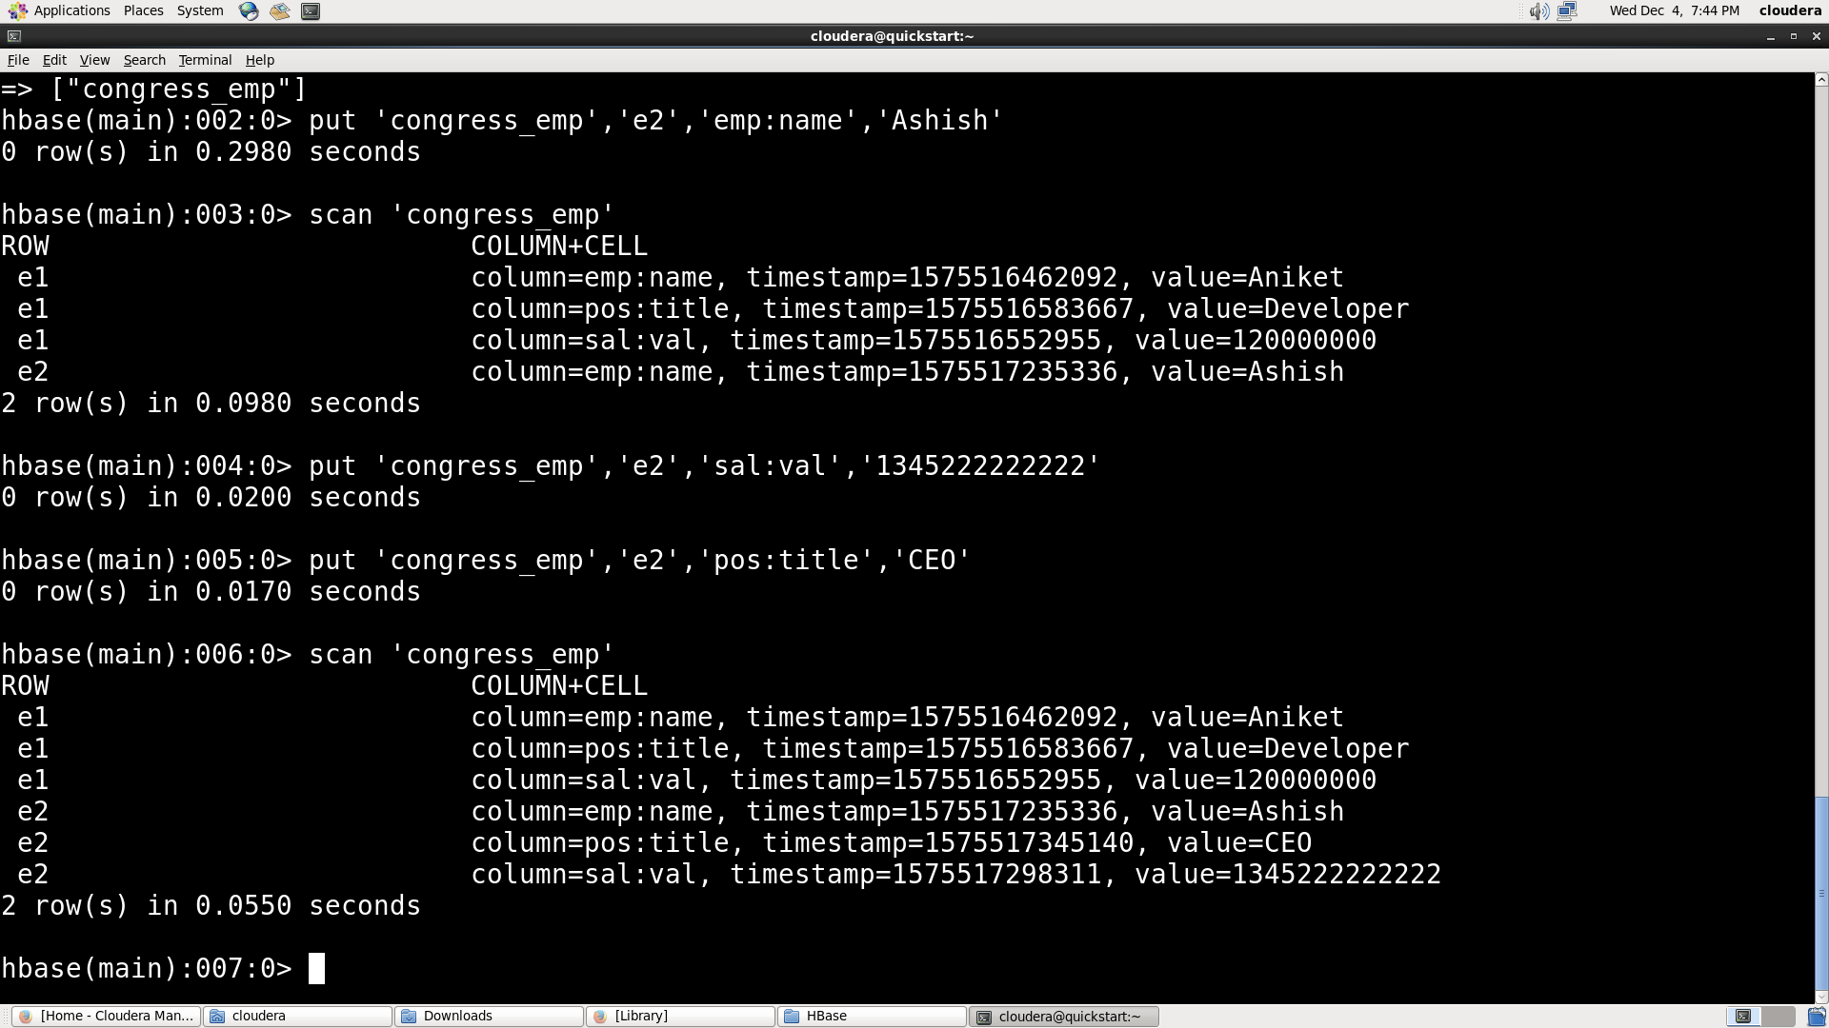

1. Scan the table.

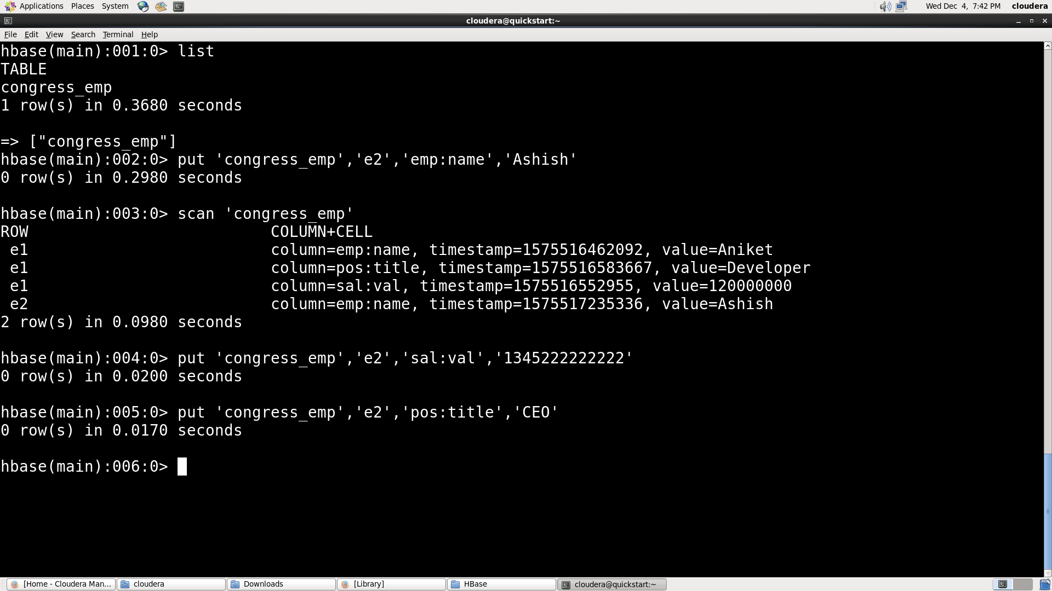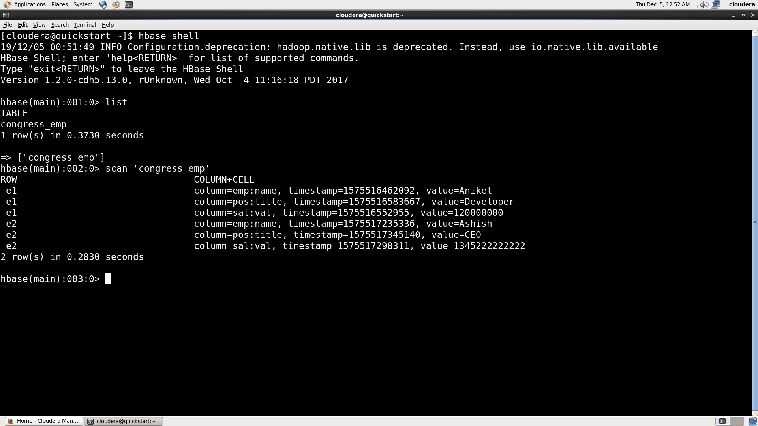

1. disable, enable, get table.

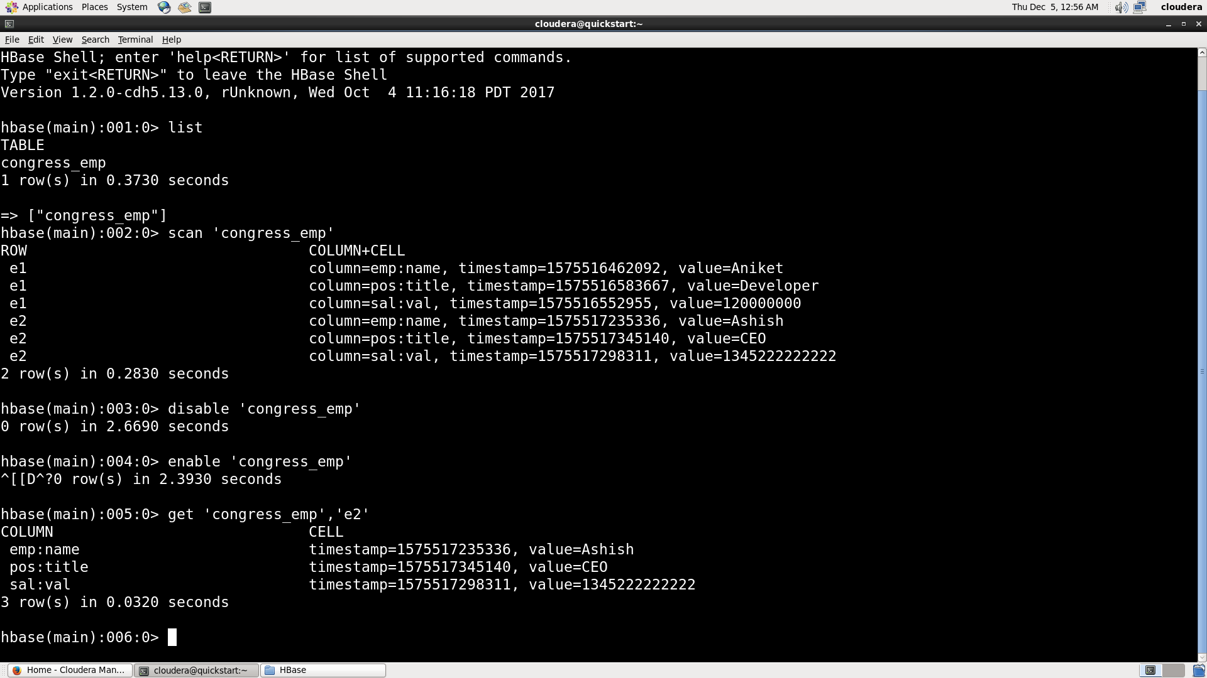

1. Delete table.

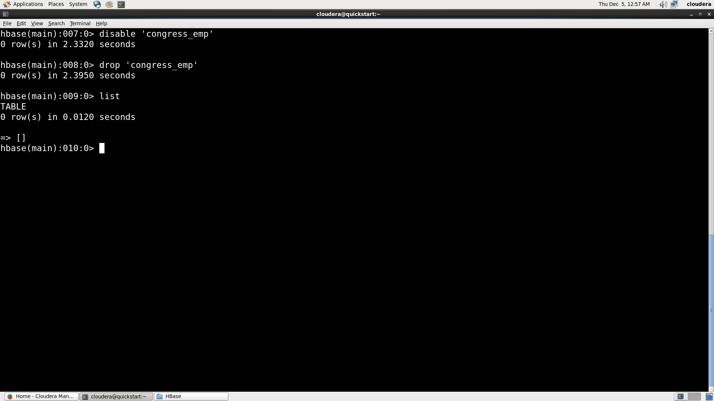

**Lab 2.**

1. **By looking at provided labour data csv come up with table and column family structure**
2. **Copied ‘labour_data.csv’ from local to ‘HDFS’:**

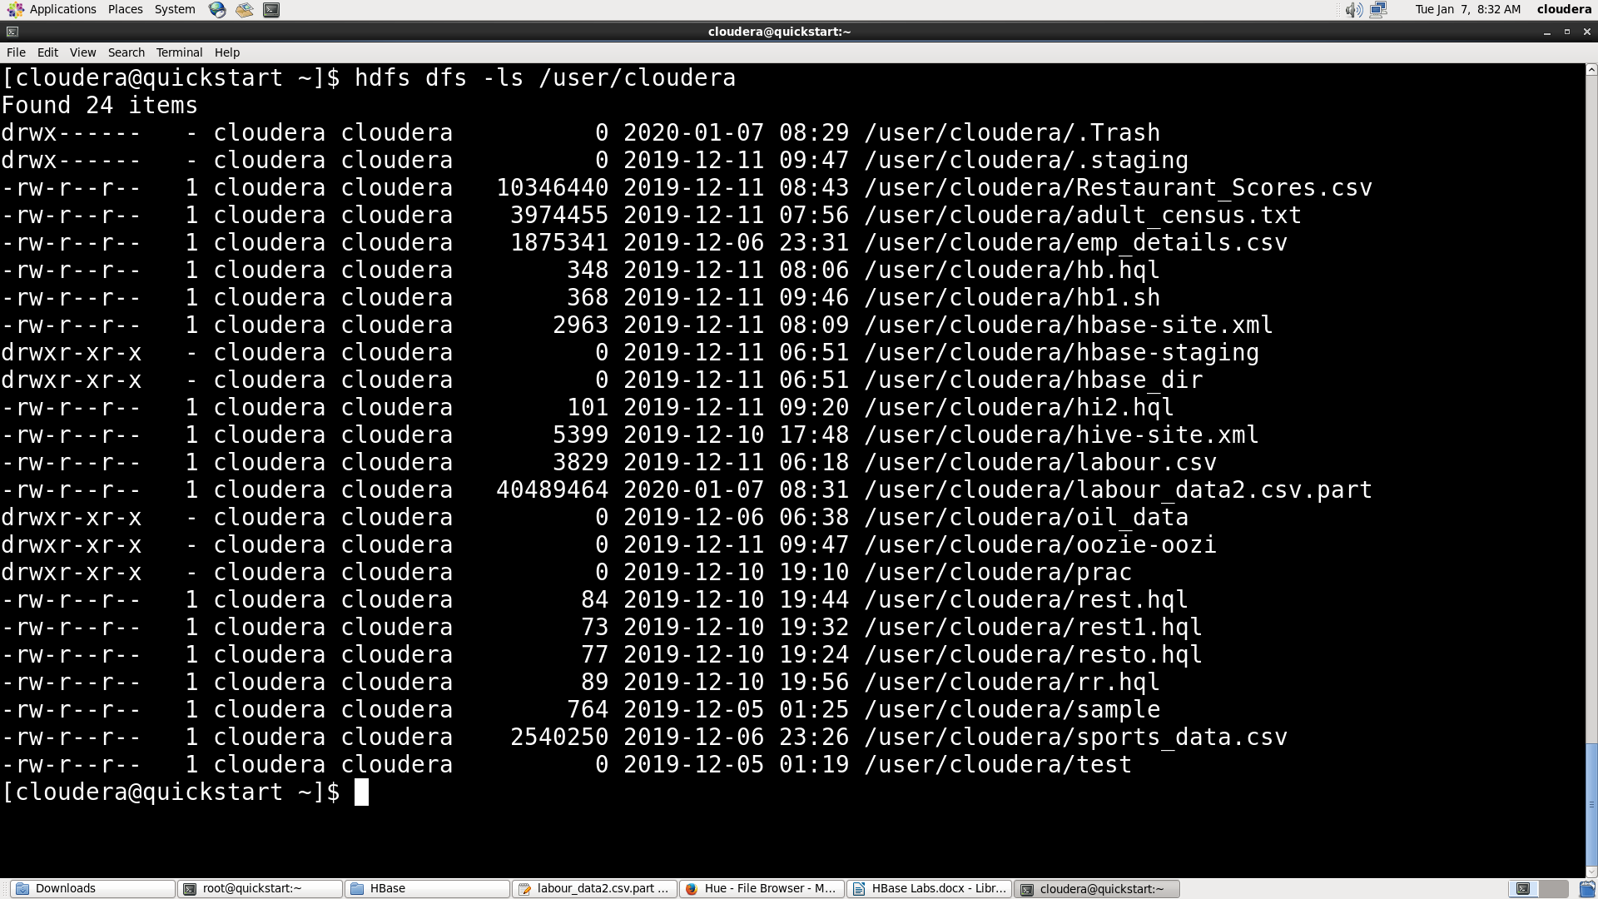

1. **Listing the tables created in HBase:**

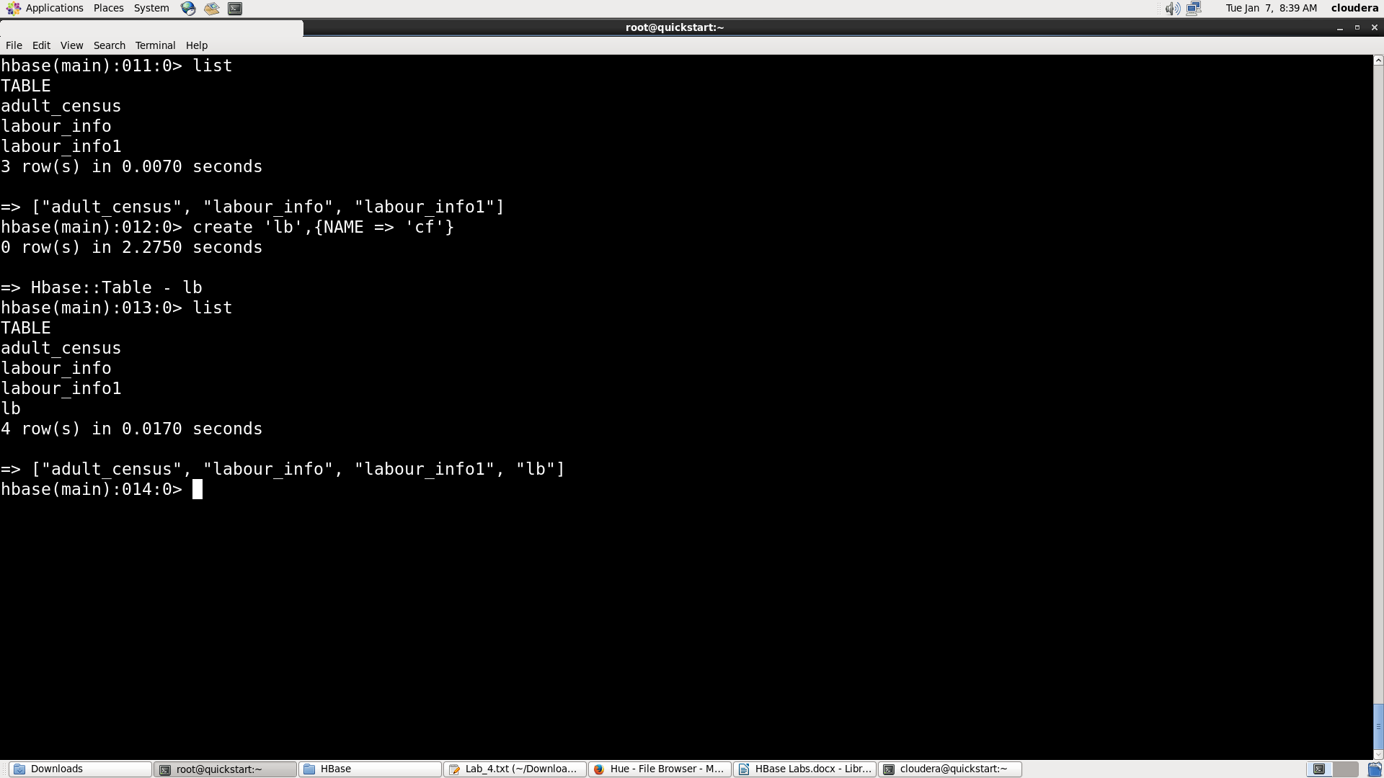

1. **Importing the data from ‘Labour_data.csv’ to ‘lb Table’ of HBase:**

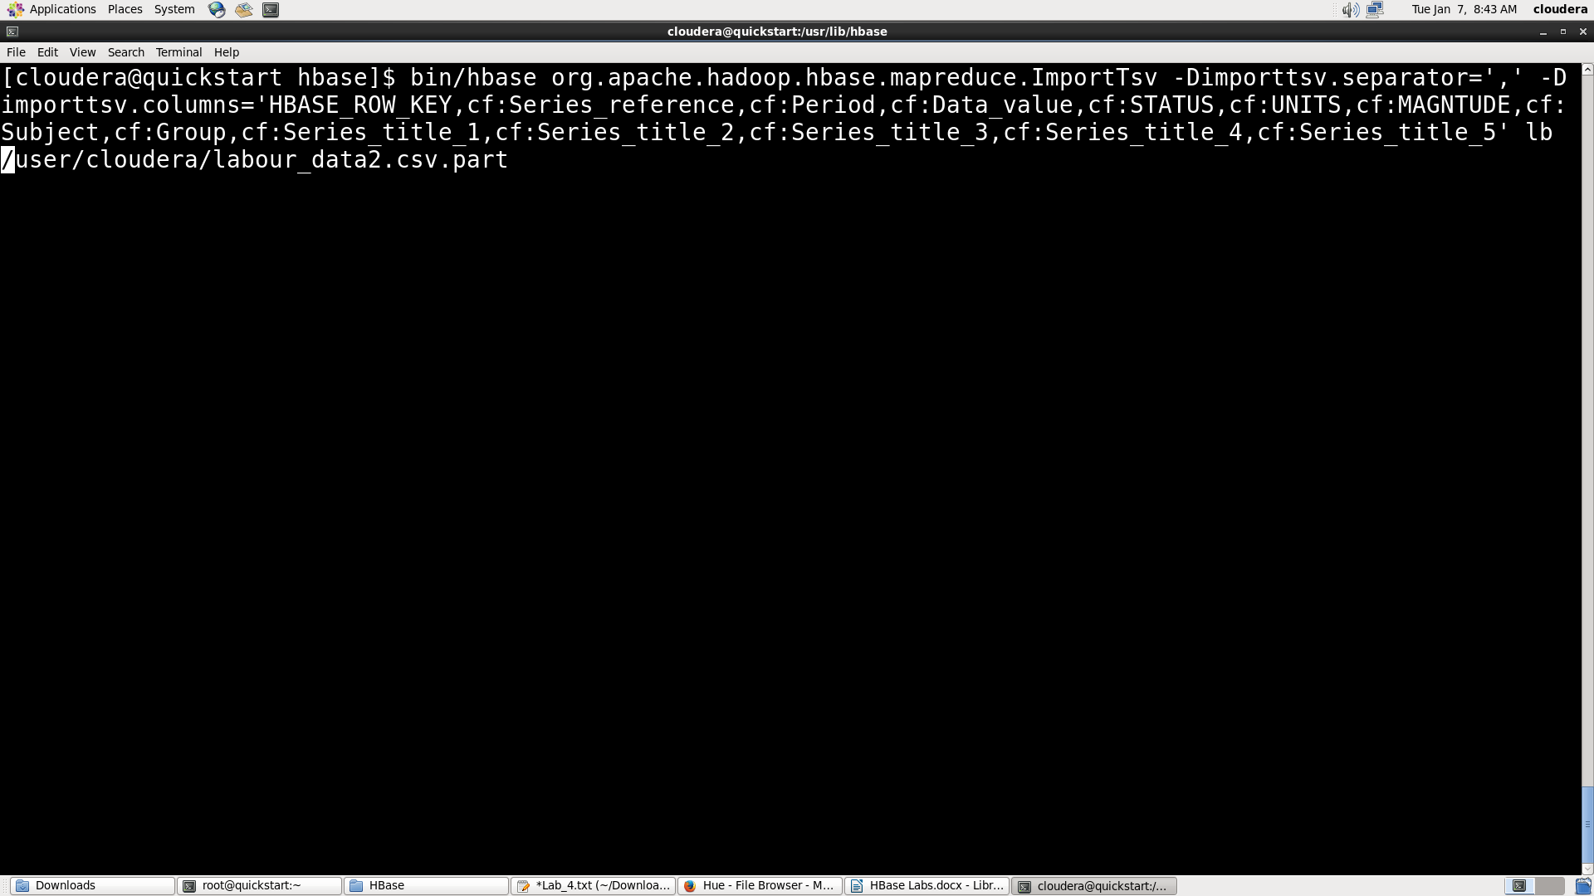

1. **Loading of labour data into HBase’s ‘lb Table’ done successfully:**

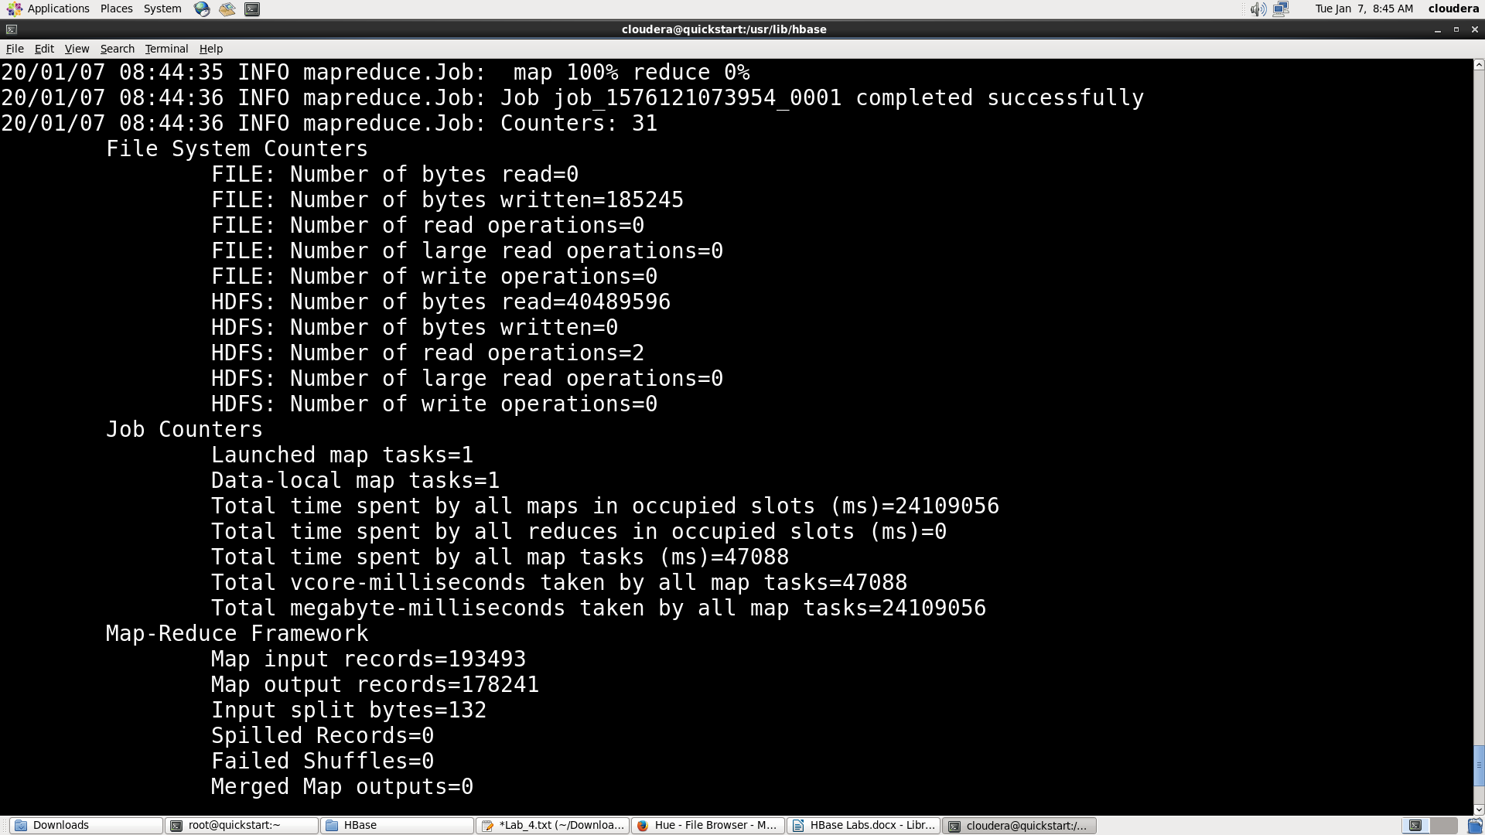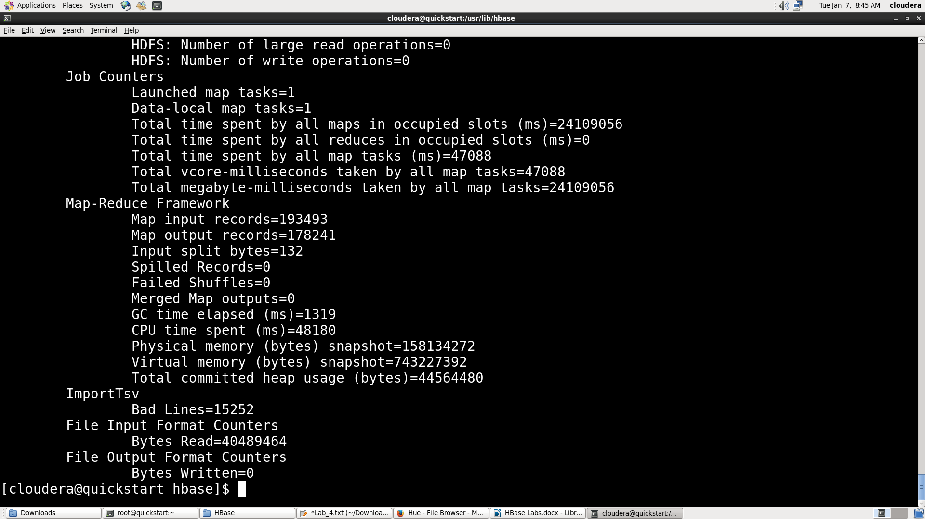

1. **Display the imported data:**

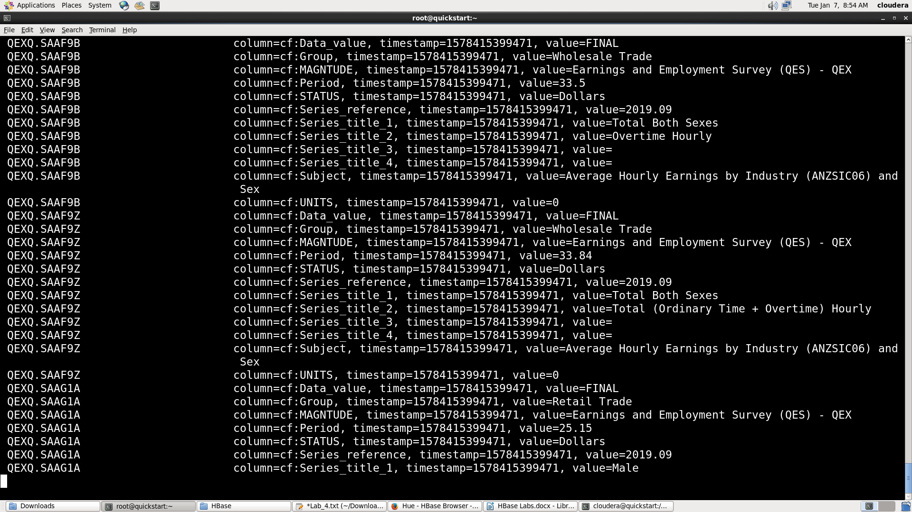

1. **Creating new table ‘lb1’ in HBase for bulkfileupload:**

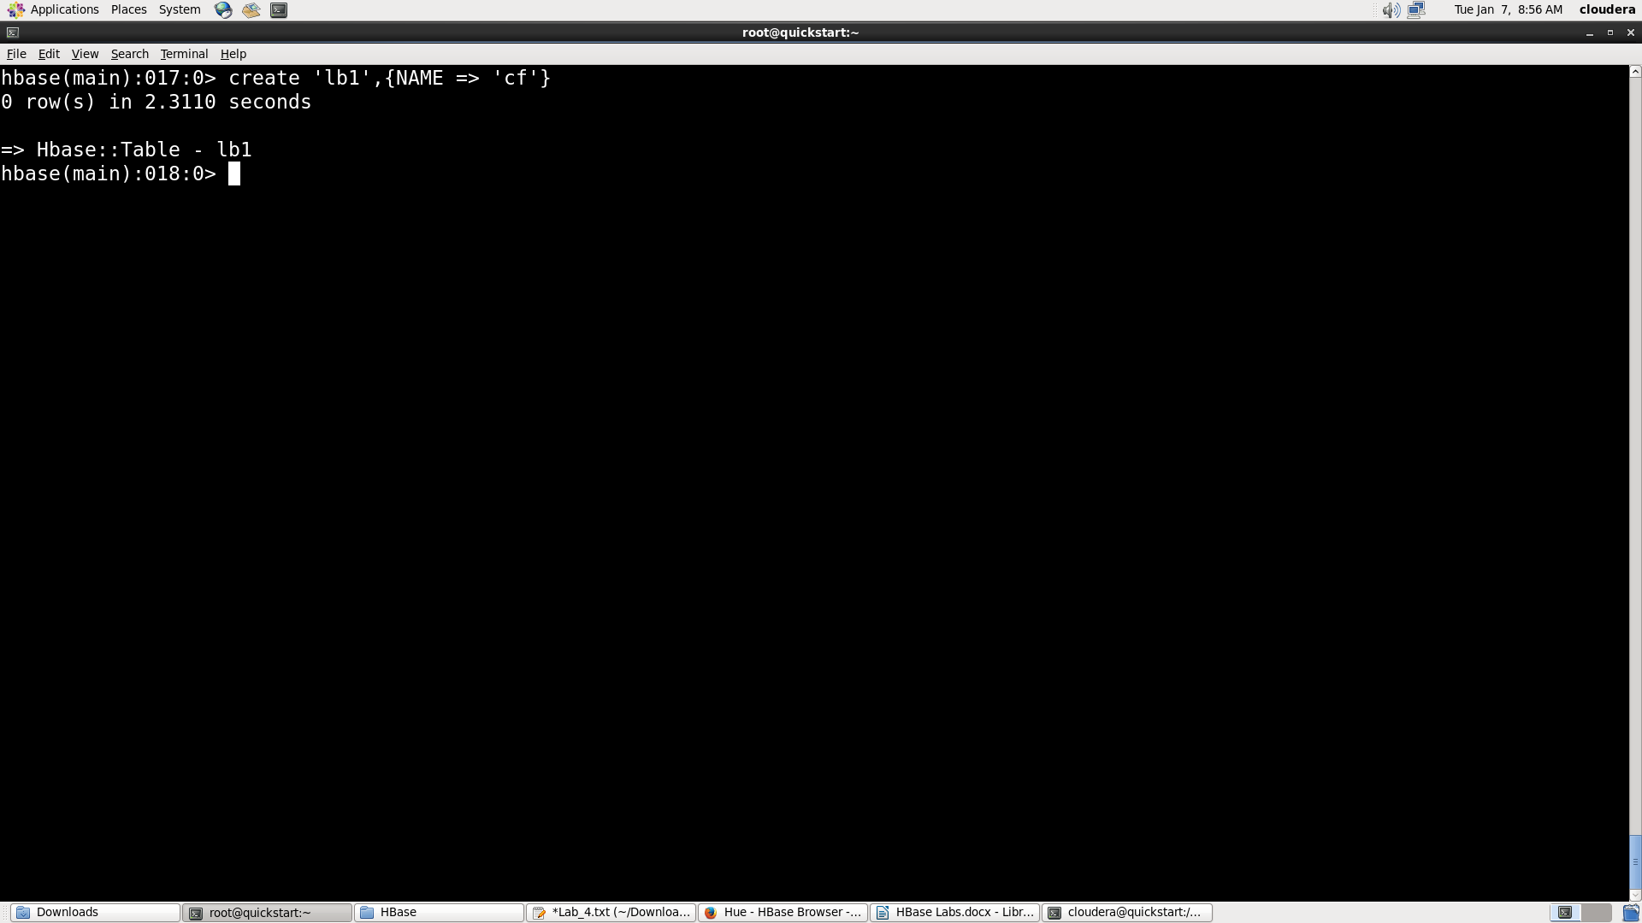

1. **Performing BulkFileUpload and storing the o/p in ‘hbase_dir22’ directory :**

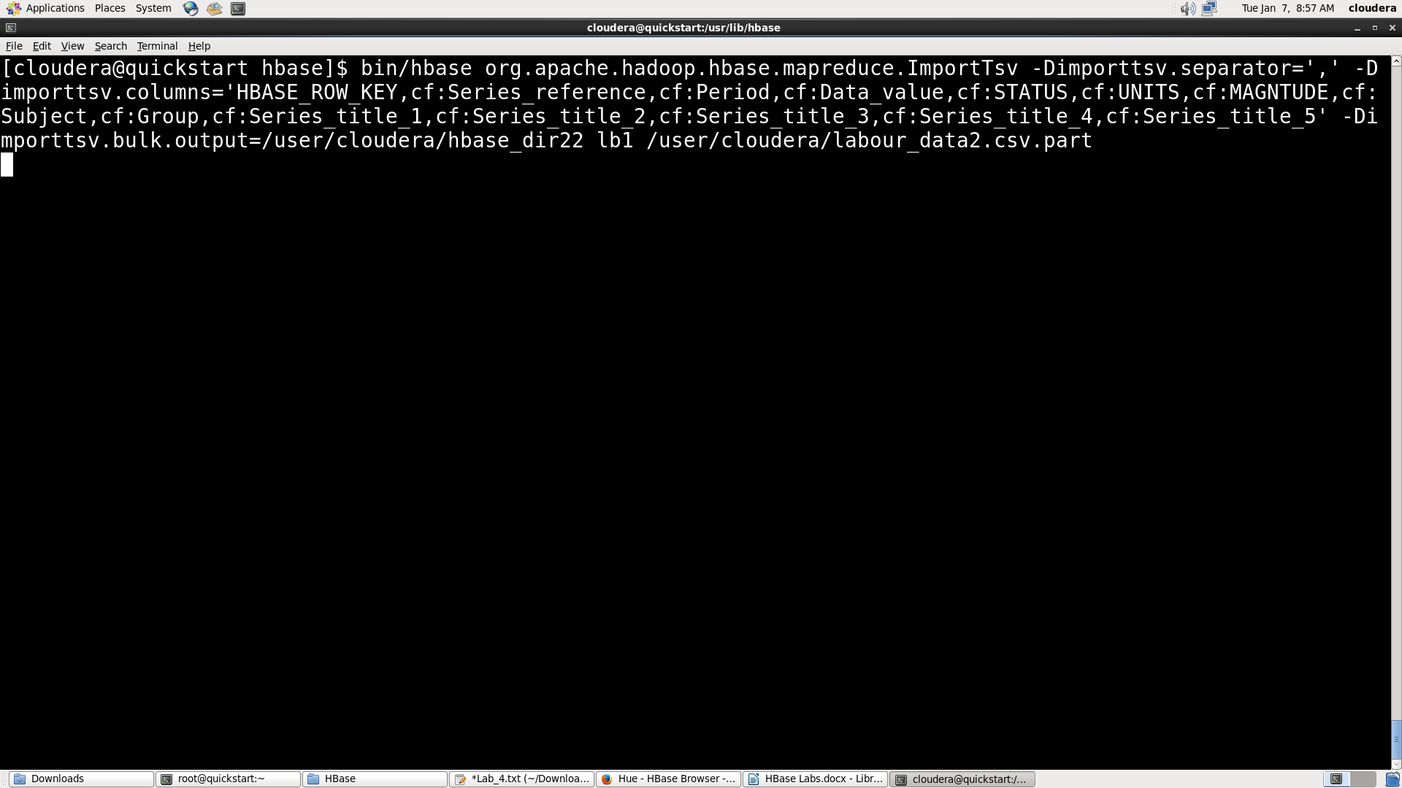

1. **Job completed successfully:**

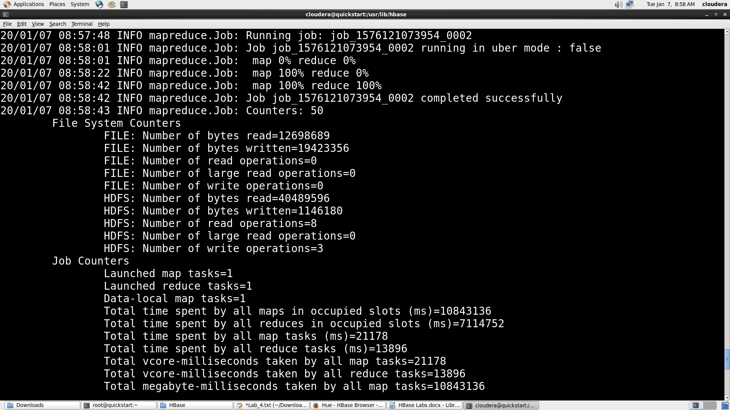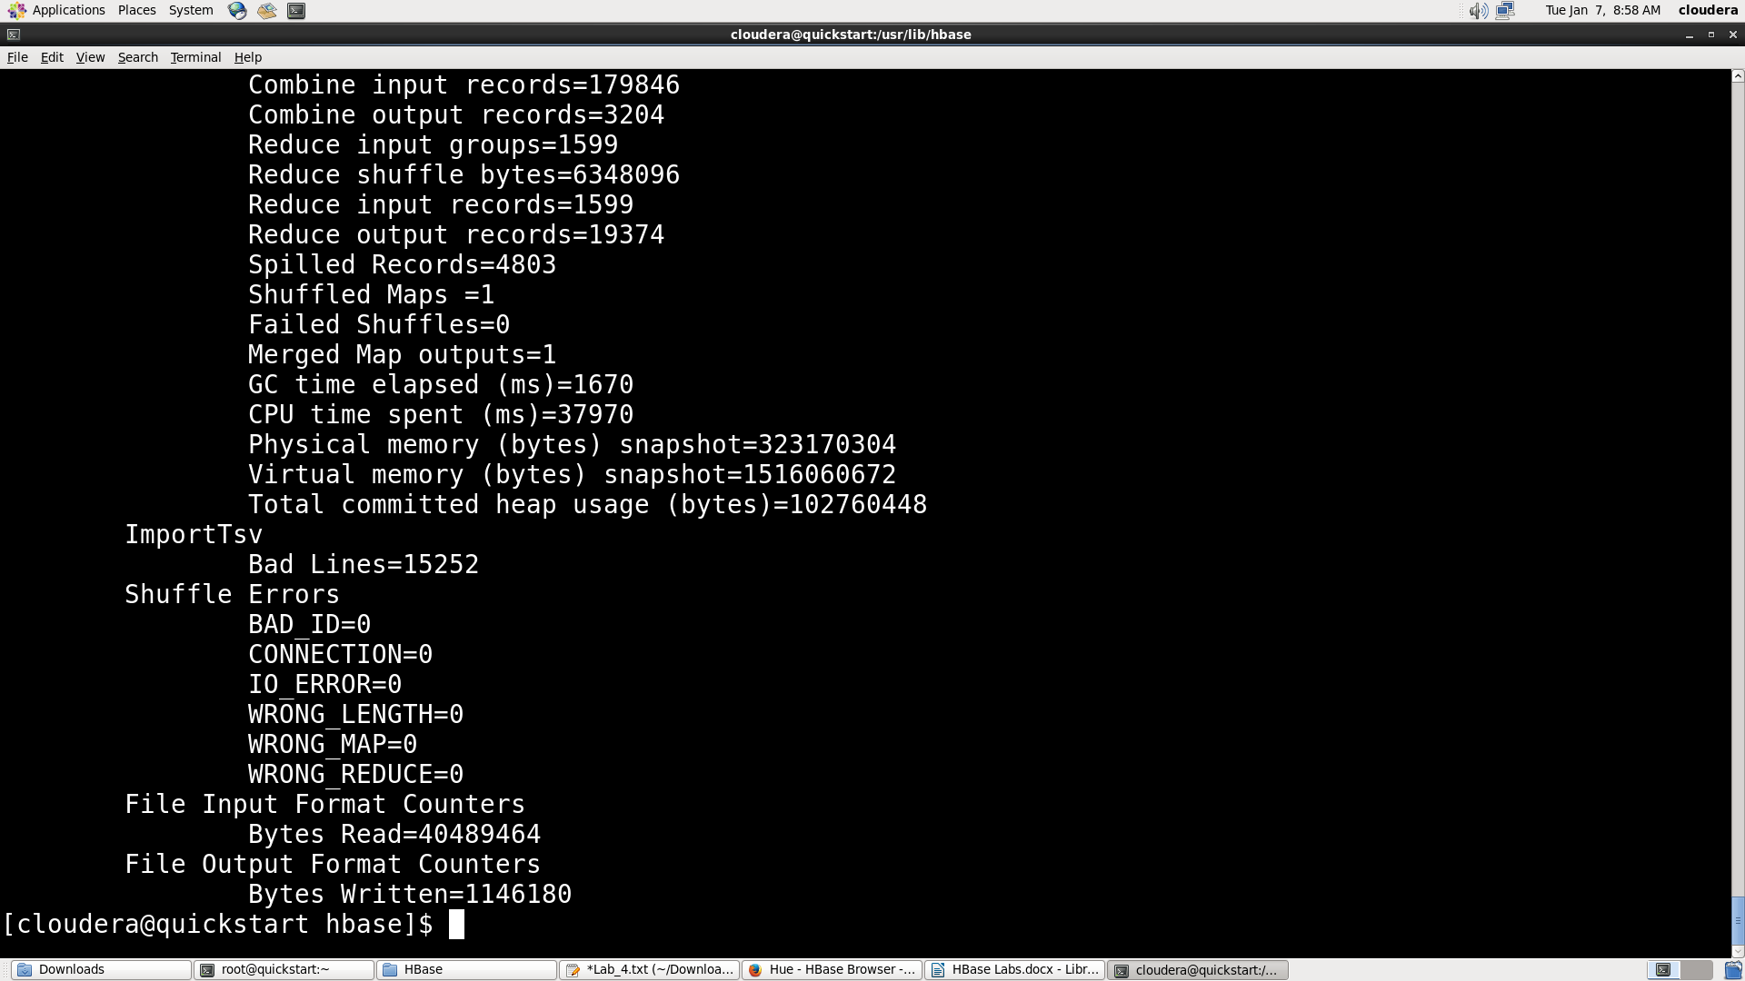

1. **Displaying the o/p for bulkfile through HUE:**

