PROJECT REPORT

bike rental system

Roll No.

1916, Mugdha Jagirdar

1934, Baburam Nabik

1938 Prathmesh Naik



# **INDEX**

|  |  |  |
| --- | --- | --- |
| Sr.no | Title | Page no. |
| 1) | **ABSTRACT** | **2** |
| 2) | **INTRODUCTION** | **3** |
| 3) | **SOFTWARE SPECIFICATION** | **5** |
| 4) | **MODULES** | **6** |
| 5) | **SUMMARY** | **8** |
| 6) | **APPLICATIONS** | **9** |
| 7) | **CONCLUSIONS** | **10** |
| 8) | **IMPROVEMENTS** | **11** |
| 9) | **BIBLIOGRAPHY** | **12** |
| 10) | **ANNEXURE** | **13** |

# **ABSTRACT**

Our Aim is to design and create a data management System for a bike rental company. This enables admin can rent a vehicle that can be used by a customer. By paying the money for a specified period of time. This system increases customer retention and simplify vehicle and staff Management in an efficient way. This software, Superbike Rental System has a very user friendly interface. Thus the users will feel very easy to work on it. By using this system admin can manage their rental, Bookings, customer issues and vehicle issues etc…. The Superbike information can be added to the system, or existing superbike information can be edited or deleted too by the Administrator. The transaction reports of the bike rental system can be retrieved by the admin, when it is required. Thus, there is no delay in the availability of any bike information, whenever needed the superbike information can be captured very quickly and easily. The customers can also use the system to rent a superbike. The customer should create a new account before logging in or he/she can log into the system with his/her created account.

**INTRODUCTION**

A bike rental agency rents vehicles for short of time, generally ranging from a few hours to few weeks hours to few weeks it is often organized with numerous local branches (which allow a user to return vehicle to different location),and primarily located near airports or busy city areas and often complemented by website allowing online reservations.

Bike rental agency primarily serve people who require a temporary vehicle, for example, those who do not own their own bike, travelers who are out of town, or owners of damaged or destroyed vehicles who are awaiting repair or insurance compensation.

This project is designed so as to be used by Bike Rental Company specializing in renting bikes to customers. It is an online system through which customers can view available bikes, register, Reason for the Project. The advancement in Information Technology and internet penetration has greatly enhanced various business processes and communication between companies (services provider) and their customers of which bike rental industry is not left out. This E-Bike Rental System is developed to provide the following services:

* **Enhance Business Processes:** To be able to use internet technology to project the rental company to the global world instead of limiting their services to their local domain alone, thus increase their return on investment (ROI).
* **Customer’s registration:** A registration portal to hold customer’s details, monitor their transaction and used same to offer better and improve services to them.
* **Group bookings:** Allows the customer to book space for a group in the case of weddings or corporate meetings.

**SOFTWARE SPECIFICATIONS**

**Functionality: -** the software must function mostly. In case of an error occurred it must close with exact error provided

**Performance: -** the software should perform well, which means the software should function as per user needs with lesser time consumption i.e. high speed.

**Maintenance: -**the software should be updated from time to time

**Safety: -**the software must provide safety to user in terms of data entrusted by them towards the software while using it.

**Quality: -**the software should be of good quality which means it must be ensure speed, better portability, user friendly interface etc.

**Reliability: -** the software must be reliable in terms of results. They should provide optimum solution with minimum error.

**MODULES**

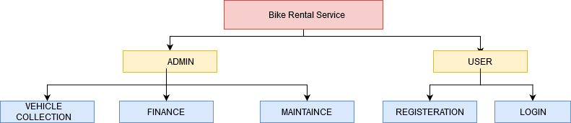

The two main modules of our Rental bike system is Admin and User. They our further divided into its sub module.Under the admin module we have theree sub modules such as Vehicle collection, Finance and Maintence.In User module we have two important sub module like Registeration and Login.

1. Vehicle collection: - in this sub module admin can add/remove the entry of vehicles . He can also view and update the status of vehicle data.
2. Finance :- In this sub module admin can view bills, sales and handle tax related data.
3. Maintaince: - In this sub module admin mostly recive signals during the time of servicing, P.U.C expiry, insurance expiry etc.
4. Registration**: -** customers have to register in this module to access the features of the software. They need to provide their personal details like name contact number etc.
5. Login: - in this sub module users credential are verified and then they can access services like renting vehicle, bill payments etc.

**SUMMARY**

The implementation of our project “Bike Rental System” is in progress. We are using modules which are programed on the topics like process handling, signal handling etc.

First we conducted research and analysis on problems related to Bike Rental system. Later we started to find optimum solutions to this problems. Now we trying to program modules. Further we are going to maintain the software by handling issues like debug error if present, updating features etc.

**APPLICATIONS**

* Offer friendly customer support: - these feature allows users of application to directly contact the service provider whenever they face any problems with renting a bike.
* Provide trip details: - this feature provides a detail overview of the trip, so user and service provider have an idea of where they started their journey and where they are traveling.
* Lock bike via bike number: - In order to manually lock the bike at the end of the trip.

**CONCLUSION**

The aim of our project is to design a software for bike rental agency.it will be accomplished before the deadline.

This software is designed to reach a large audience by best possible way.it help local authorities when they engaged in the usage of public funds, public land and government agencies.

**IMPROVEMENTS**

Multiple payment options: - it can be very important for Rental Bike System to offer a feature that allows user to easily pay after the trip comes to end.

Provide the “book in Advance” feature: - users will be able to book in advance, thus there is no requirement for waiting.

Use of QR code to book a bike: -it will allow users to book bikes simply scanning a QR code.

**BIBLIOGRAPHY**

**Reference sites**

* [www.geekforgeek.com](http://www.geekforgeek.com)
* [www.wikipedia.org](http://www.wikipedia.org)
* https://blog.testlodge.com
* https://echoinovateit.com

Reference books

* Advanced Programing in UNIX Environment by W. Richard Stevens and Stephen A Rago
* How Linux works by Brian Werd
* Operating system concept by Abraham Silberschatz

**ANNEXURE**

So far we have designed the menu for the software. Modules are distributed among the group students.

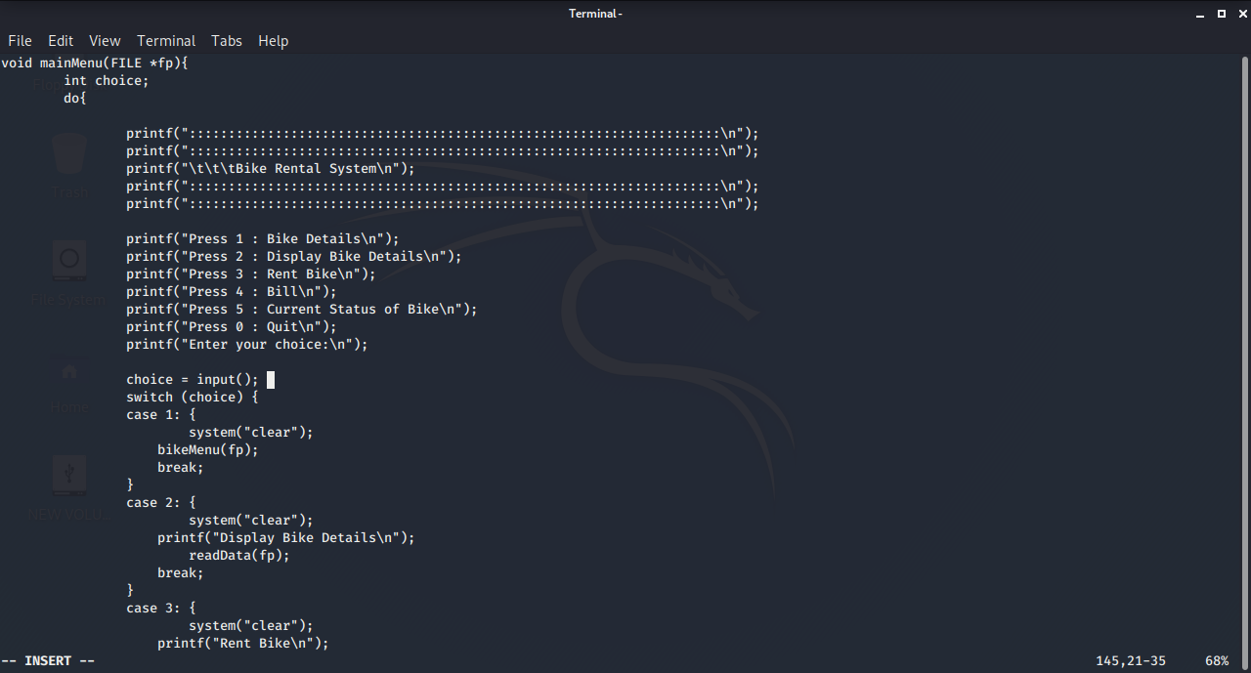Following are some screenshot of project.

