Python Tuples

**Tuple**is a collection of Python objects much like a list. The sequence of values stored in a tuple can be of any type, and they are indexed by integers.  
Values of a tuple are syntactically separated by ‘commas’. Although it is not necessary, it is more common to define a tuple by closing the sequence of values in parentheses. This helps in understanding the Python tuples more easily.

**Creating a Tuple**

In Python, tuples are created by placing sequence of values separated by ‘comma’ with or without the use of parentheses for grouping of data sequence.

**Note –**Creation of Python tuple without the use of parentheses is known as Tuple Packing.

**Python program to demonstrate addition of elements in a Tuple.**

filter_none

edit

play_arrow

brightness_4

|  |
| --- |
| #Creating an empty Tuple  Tuple1 = ()  print("Initial empty Tuple: ")  print (Tuple1)    #Creatting a Tuple  #with the use of string  Tuple1 = ('Geeks', 'For')  print("\nTuple with the use of String: ")  print(Tuple1)    # Creating a Tuple with  # the use of list  list1 = [1, 2, 4, 5, 6]  print("\nTuple using List: ")  print(tuple(list1))    #Creating a Tuple  #with the use of built-in function  Tuple1 = tuple('Geeks')  print("\nTuple with the use of function: ")  print(Tuple1) |

**Output:**

Initial empty Tuple:

()

Tuple with the use of String:

('Geeks', 'For')

Tuple using List:

(1, 2, 4, 5, 6)

Tuple with the use of function:

('G', 'e', 'e', 'k', 's')

**Creating a Tuple with Mixed Datatypes.**

**Tuples**can contain any number of elements and of any datatype (like strings, integers, list, etc.). Tuples can also be created with a single element, but it is a bit tricky. Having one element in the parentheses is not sufficient, there must be a trailing ‘comma’ to make it a tuple.

filter_none

edit

play_arrow

brightness_4

|  |
| --- |
| #Creating a Tuple  #with Mixed Datatype  Tuple1 = (5, 'Welcome', 7, 'Geeks')  print("\nTuple with Mixed Datatypes: ")  print(Tuple1)    #Creating a Tuple  #with nested tuples  Tuple1 = (0, 1, 2, 3)  Tuple2 = ('python', 'geek')  Tuple3 = (Tuple1, Tuple2)  print("\nTuple with nested tuples: ")  print(Tuple3)    #Creating a Tuple  #with repetition  Tuple1 = ('Geeks',) * 3  print("\nTuple with repetition: ")  print(Tuple1)    #Creating a Tuple  #with the use of loop  Tuple1 = ('Geeks')  n = 5  print("\nTuple with a loop")  for i in range(int(n)):      Tuple1 = (Tuple1,)      print(Tuple1) |

**Output:**

Tuple with Mixed Datatypes:

(5, 'Welcome', 7, 'Geeks')

Tuple with nested tuples:

((0, 1, 2, 3), ('python', 'geek'))

Tuple with repetition:

('Geeks', 'Geeks', 'Geeks')

Tuple with a loop

('Geeks',)

(('Geeks',),)

((('Geeks',),),)

(((('Geeks',),),),)

((((('Geeks',),),),),)

**Accessing of Tuples**

**Tuples** are immutable, and usually, they contain a sequence of heterogeneous elements that are accessed via [unpacking](https://www.geeksforgeeks.org/unpacking-a-tuple-in-python/)or indexing (or even by attribute in the case of named tuples). Lists are mutable, and their elements are usually homogeneous and are accessed by iterating over the list.

**NOTE** : In unpacking of tuple number of variables on left hand side should be equal to number of values in given tuple a.

filter_none

edit

play_arrow

brightness_4

|  |
| --- |
| #Accessing Tuple  #with Indexing  Tuple1 = tuple("Geeks")  print("\nFirst element of Tuple: ")  print(Tuple1[1])      #Tuple unpacking  Tuple1 = ("Geeks", "For", "Geeks")    #This line unpack  #values of Tuple1  a, b, c = Tuple1  print("\nValues after unpacking: ")  print(a)  print(b)  print(c) |

**Output:**

First element of Tuple:

e

Values after unpacking:

Geeks

For

Geeks

**Concatenation of Tuples**

Concatenation of tuple is the process of joining of two or more Tuples. Concatenation is done by the use of ‘+’ operator. Concatenation of tuples is done always from the end of the original tuple. Other arithmetic operations do not apply on Tuples.  
**Note-** Only same datatypes can be combined with concatenation, an error arises if a list and a tuple are combined.  
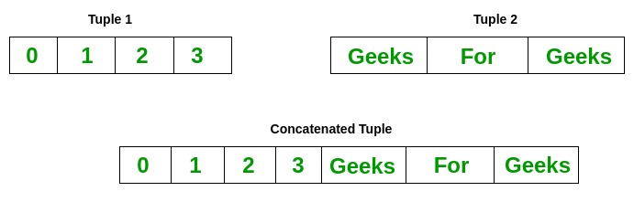

filter_none

edit

play_arrow

brightness_4

|  |
| --- |
| # Concatenaton of tuples  Tuple1 = (0, 1, 2, 3)  Tuple2 = ('Geeks', 'For', 'Geeks')    Tuple3 = Tuple1 + Tuple2    # Printing first Tuple  print("Tuple 1: ")  print(Tuple1)    # Printing Second Tuple  print("\nTuple2: ")  print(Tuple2)    # Printing Final Tuple  print("\nTuples after Concatenaton: ")  print(Tuple3) |

**Output:**

Tuple 1:

(0, 1, 2, 3)

Tuple2:

('Geeks', 'For', 'Geeks')

Tuples after Concatenaton:

(0, 1, 2, 3, 'Geeks', 'For', 'Geeks')

**Slicing of Tuple**

Slicing of a Tuple is done to fetch a specific range or slice of sub-elements from a Tuple. Slicing can also be done to lists and arrays. Indexing in a list results to fetching a single element whereas Slicing allows to fetch a set of elements.  
**Note-** Negative Increment values can also be used to reverse the sequence of Tuples  
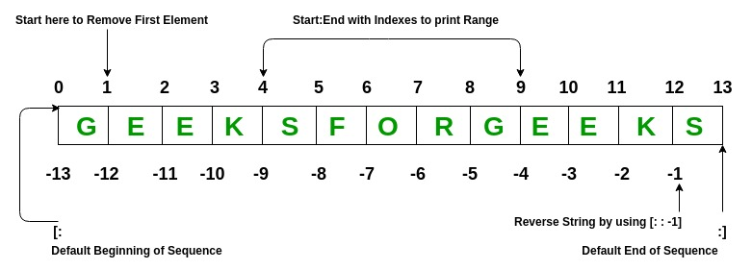

filter_none

edit

play_arrow

brightness_4

|  |
| --- |
| # Slicing of a Tuple    # Slicing of a Tuple  # with Numbers  Tuple1 = tuple('GEEKSFORGEEKS')    # Removing First element  print("Removal of First Element: ")  print(Tuple1[1:])    # Reversing the Tuple  print("\nTuple after sequence of Element is reversed: ")  print(Tuple1[::-1])    # Printing elements of a Range  print("\nPrinting elements between Range 4-9: ")  print(Tuple1[4:9]) |

**Output:**

Removal of First Element:

('E', 'E', 'K', 'S', 'F', 'O', 'R', 'G', 'E', 'E', 'K', 'S')

Tuple after sequence of Element is reversed:

('S', 'K', 'E', 'E', 'G', 'R', 'O', 'F', 'S', 'K', 'E', 'E', 'G')

Printing elements between Range 4-9:

('S', 'F', 'O', 'R', 'G')

**Deleting a Tuple**

Tuples are immutable and hence they do not allow deletion of a part of it. Entire tuple gets deleted by the use of del() method.  
**Note-** Printing of Tuple after deletion results to an Error.

filter_none

edit

play_arrow

brightness_4

|  |
| --- |
| # Deleting a Tuple    Tuple1 = (0, 1, 2, 3, 4)  del Tuple1    print(Tuple1) |

*Traceback (most recent call last):  
File “/home/efa50fd0709dec08434191f32275928a.py”, line 7, in  
print(Tuple1)  
NameError: name ‘Tuple1’ is not defined*

**Built-In Methods**

|  |  |
| --- | --- |
| **BUILT-IN FUNCTION** | **DESCRIPTION** |
| all() | Returns true if all element are true or if tuple is empty |
| any() | return true if any element of the tuple is true. if tuple is empty, return false |
| len() | Returns length of the tuple or size of the tuple |
| enumerate() | Returns enumerate object of tuple |
| max() | return maximum element of given tuple |
| min() | return minimum element of given tuple |
| [sum()](https://www.geeksforgeeks.org/sum-function-python/) | Sums up the numbers in the tuple |
| [sorted()](https://www.geeksforgeeks.org/sorted-function-python/) | input elements in the tuple and return a new sorted list |
| [**tuple()**](https://www.geeksforgeeks.org/python-tuple-function/) | Convert an iterable to a tuple. |