SYSTEM ADMINSTRATION I

NSSA 221 LABS –

SITE BOOK
DOMAIN: mwk7820.com
Bsc Cybersecurity
764003058

Table of Contents
Lists of Tables and Figures 3
Change Control Section 4
Overview 7
RLES Deployment & Configuration & Virtual Environment Setup 7
Network Topology and Device Configurations 7
Servers 9
Windows Server 2022 9
Storage Server 10
RAID and Partition Setup 10
File Transfer and Sharing Services 11
Active Directory 13
Setup and Configuration 13
Group Policies 14
Appendix 18
List of Tables and Figures
Figure 1: Network Topology 8
Table 1: Hardware Specifics 8
Figure 2: AD and DHCP Server Information 9
Figure 2.1 9
Figure 2.2 10
Figure 3:RAID 1 and RAID 5 Mount Verification 10
Figure 3.1 10
Figure 3.1 11
Figure 4: Transfer Log Verification 11
Figure 5: Server Samba Status 12
Figure 6: Windows NFS Write Verification 12
Figure 7: Network Connection Verification 13
Figure 8: First Organizational Unit 14
Figure 9: Second Organizational Unit 14
Table 2: Group Policies 15
Figure 10: Active Directory Topology 15
Figure 12: GPO Wallpaper Report 16
Figure 12.1 16
Figure 13: GPO Control Panel Report 17
Appendix 18
Change Control
Creation: | Date: | By: | Update:
Creation of Sitebook | 23/09/2025 | Mutete Kimweli | -Create cover page
Lab 01: RLES Deployment | 10/09/2025 | Mutete Kimweli | -Deployed RLES  -Launched and deployed NSSA Vms from RLES including Rocky Linux, Windows 2022 server, Windows 11, and a pfSense router  -Performed network configurations on Pfsense router  - Logged into Win22 and statically assigned IP for Win22 including subnet mask, default gateway, and configuredDNS settings  -Updated pfSense after configuration  -Renamed Win22 hostname  -Launched and manually assigned network configurations and hostnames for Win11 and Rocky linux Vms.  -Updated Rocky Linux  -
Lab 02: Active Directory & Group Policy | 30/09/2025 | Mutete Kimweli | -Launched Server Manager  -Configured AD, DNS, and DHCP on Win22  -Promoted Win22 server to DC, and creating a new forest with mwk7820.com as domain name  -Created DHCP scope including exclusions for default gateway(pfSense) and isolated range for server Ips only  - Created a test user account named Naruto Uzumaki(will use test user to refer to it) and added it to Domain Admins group  -Configured DHCP on both Rocky Linux and Win11  -Joined Win11 to domain mwk7820.com using Add-Computer command and configured and confirmed its DHCP settings  -Joined Rocky linux to domain mwk7820.com using realm join command and logged in as AD user nmaki(Naruto Uzumaki aka test user) using UPN.  -Installed RSAT tools on Win11 to remotely access AD services  -Established Powershell remote connection with Enter-PSSession command  - Manually created first OU called Leaf by the ADUC and added 4 users to it  -Created second OU called Sand using New-ADOrganizationalUnit command and added 4 new users to it via New-ADUser and added attributes like OfficePhone using Set-ADUser  -Created and linked GPO named NINJA WAY to domain to prohibit access to control panel  -Used command gpupdate to enforce and test GPO  -Created and linked second GPO to set standard wallpaper for Leaf OU  -Used Gpresult /R and Gpupdate /force to view policy and update the panel to include the background for the Leaf OU  -
Lab 03: Partitioning and RAID | 12/10/2025 | Mutete Kimweli | NOTE MDADM VERSION IS V4.3 – 2024.02-15 - 3  Formatted drive /dev/sdb with XFS and mounted to /media/samba  Created RAID 0 array /dev/md0 using /dev/sdc & /dev/sdd  Partitioned /dev/md0 into 1GB primary partition and extended/logical partitions  Formatted primary /dev/md0p1 and logical /dev/md0p5 paritions with ext4 and mounted them to /media/nfs1 and /media/nfs2 respectively  Created RAID 5 array /dev/md1 using /dev/sde , /dev/sdf , and /dev/sdg  Used gdisk to create GPT partition table on /dev/md1 with 2GB partitions /dev/md1p1 & /dev/md1p2  Formatted both partitions RAID 5 with ext4 and mounted them to /media/samba1 & /media/samba2 respectively.  Added persistent mount entries using UUIDs for all 5 partitions: /dev/sdb , /dev/md0p1, /dev/md0p5/ /dev/md1/1 , and /dev/md1p2 to /etc/fstab and tested with mount -a to verify it was successful then rebooted.  Copied JPEG file cat to /media/samba1/test_data and simulated a drive failure on /dev/sdg using sudo mdadm -f /dev/sdg  Removed faulty drive using mdadm -r /dev/sdg and rebuilt the array by using mdadm -a /dev/sdg and the final verification showed that the array state was clean
Lab 04: File services | Mutete Kimweli | 28/10/2025 | - Launched RLES, configured /etc/hosts, and verified connectivity between Windows 11, Linux and Storage server.  - Configured and tested working of rsync for local file backups using multiple commands ( -a, --delete, --exclude, etc)  - Installed and configured vsftpd for FTP service on the Storage server using ss-l | grep ftp and firewalls for FTP service and port 21.  - Tested local and anonymous FTP access using lftp -u and lftp.  - Created an anonymous FTP dropbox with SELinux enforcement and configued with other commands like semanage, restorecon, public_content_rw_t, and ftpd_anon_write manage the SeLinux rules and enable anonymous uploads.  -Verified file upload by checking /var/log/xferlog  -Installed and configured Samba(and nmb) on the Storage server and the firewall and created a ninjas shared directory.  - Created Samba users naruto, sasuke sakura and kakashi and added all(except sakura) to the group ninjas with write access in the smb.conf file.  -Tested remote access to the Samba share from the Windows(New-SmbMapping) and Linux(smbclient) clients and compared the write vs read-only privileges.  -Installed and configured rsync on /media/rsync and checked the remote file transfer.  -Installed and configured the NFS exports (/etc/exports)for /media/nfs1/baka with rw,sync,no_root_squash options and configured the firewall ports for nfs, mountd, and rpc-bind.  - Mounted the NFS shares on Windows and Linux clients, configured _netdev in the /etc/fstab file for mounting every time system boots.  -Configured the registry for NFS export and checked the connections using df -H, stat, netstat -an, ls -la.
Lab 05: Cron Scripting | Mutete Kimweli | 09/11/2025 | -Exported VISUAL and EDITOR environment variables to nano.  - Created data directory in home directory of student and filled it with 5 random text files.  -Downloaded databackup.sh and diskMonitor.sh to Pastebin using curl.  -Used sed -i ‘s/\r//’ on both scripts to fix Windows-style carriage returns.  - Added cronjob for databackup.sh to run every 1 minute  -Added cronjob for diskMonitor.sh to run every 2 minutes.  -Waited 7-8 minutes for jobs to execute multiple times.  -Wrote custom bash script to ping network host and log result (Connection Alive or Connection Failure) to network_ping.logs with date and hostname.  -Added cronjob for network ping script to run every minute.  -Tested script with valid IP for 3 minutes to log connection Alive and modified to non-existent IP address after to check for connection failures.  -Validated list of all running cron jobs using crontab -l  -Deleted all cron jobs using crontab -r

Overview
Remote Learning Emulation System (RLES) or ISchool Private Cloud is a private cloud-based virtualization system that’s used to create, deploy and manage the virtual machines used within. We use this system throughout our labs in order to gain practical experience with networking concepts learned throughout the semester.

RLES Deployment & Configuration & Virtual Environment Setup
RLES was initially used to create and deploy 4 virtual machines:
- Windows Server 2022 (AD, DHCP, DNS server)
- Rocky Linux Client
- pfSense router (gateway and firewall)
- Windows 11 client
After accessing RLES through the website https://rlescloud.rit.edu/ , we click the “vRealize Automation console” and sign-in with our RIT credentials. After, we request the “NSSA-221-VMs” through the “Catalog” link and then we can remotely connect to each machine after.

Network topology and Device Configurations
Five devices were used across all labs:
- pfSense router: The default gateway which routes traffic throughout the network through itself before going out into the RIT network and is also a firewall.
- Windows 2022 Server: Hosts the DHCP, DNS services and acts as domain controller
- Windows 11 client: Used for testing AD policies, network services, and general use throughout labs.
- Rocky Linux Client: Created in Lab 1 for practicing Linux and its commands.
- Rocky Linux Storage Server: Created in Lab 3 for testing RAID setups, cron scripting, and file transfer and sharing services like Samba and FTP.
Hostnames were assigned to each device and initial network configurations were done in Lab 1. The domain of the network is mwk7820.com. Below is the network topology and devices’ configurations.
Figure 1: Network topology
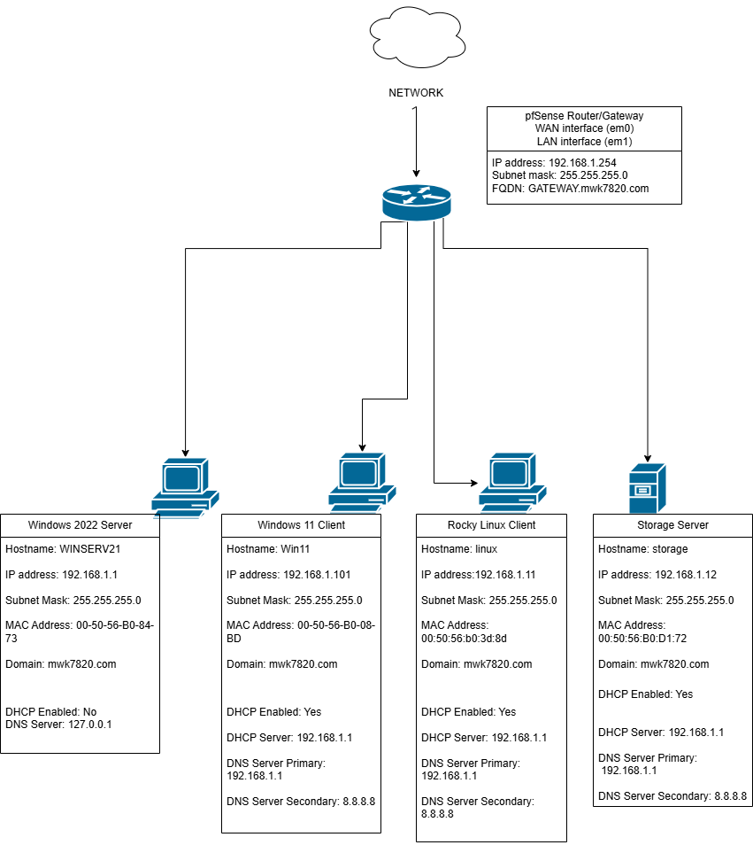
Table 1: Hardware Specifics
Device Name | Device Type | FQDN | OS | Hardware Information
pfSense-4662 | pfSense router | GATEWAY.mwk7820.com | FreeBDS | CPU: 1 Memory(MB): 2048 Storage(GB): 16
RockyLinux-1437 | Rocky Linux | linux.mwk7820.com | Rocky Linux 9.6 (Blue Onyx) | CPU: 1 Memory(MB): 4096 Storage(GB): 72
RockyLinux-1948 | Rocky Linux | storage.mwk7820.com | Rocky Linux 9.6 (Blue Onyx) | CPU: 1 Memory(MB): 4096 Storage(GB): 72
Win11-2110 | Windows 11 | Win11.mwk7820.com | Microsoft Windows 11 Entreprise 10.0.22000 N/A Build 22000 | CPUs: 2 Memory(MB): 8192 Storage(GB): 60
WinServ2022-1610 | Windows Server 2022 | WINSERV21.mwk7820.com | Microsoft Windows Server 2022 Datacenter  10.0.20348 N/A Build 20348 | CPUs: 2 Memory(MB): 16384 Storage(GB): 60

Servers

Windows Server 2022
Windows Server 2022 is the server that provides services to the rest of the network like
- Active Directory Domain Services (AD DS): Centralizes authorization, access, and policy enforcement of network resources for users, Organizational Units (OUs), and groups in the mwk7820.com domain.
- DHCP: For dynamic assignment of IP addresses within domain
  - With lease of 8 days for an IP address and range of usable values from 192.168.1.1 - 192.168.1.254.
  - Excluded range is 192.168.1.1- 192.168.1.10
- DNS: Domain name to IP resolution for devices within domain. Note that for Lab 4, there was configuration of each device’s /etc/hosts for mapping the hostnames of the devices to their IP addresses.
Figure 2: AD and DHCP Server Information
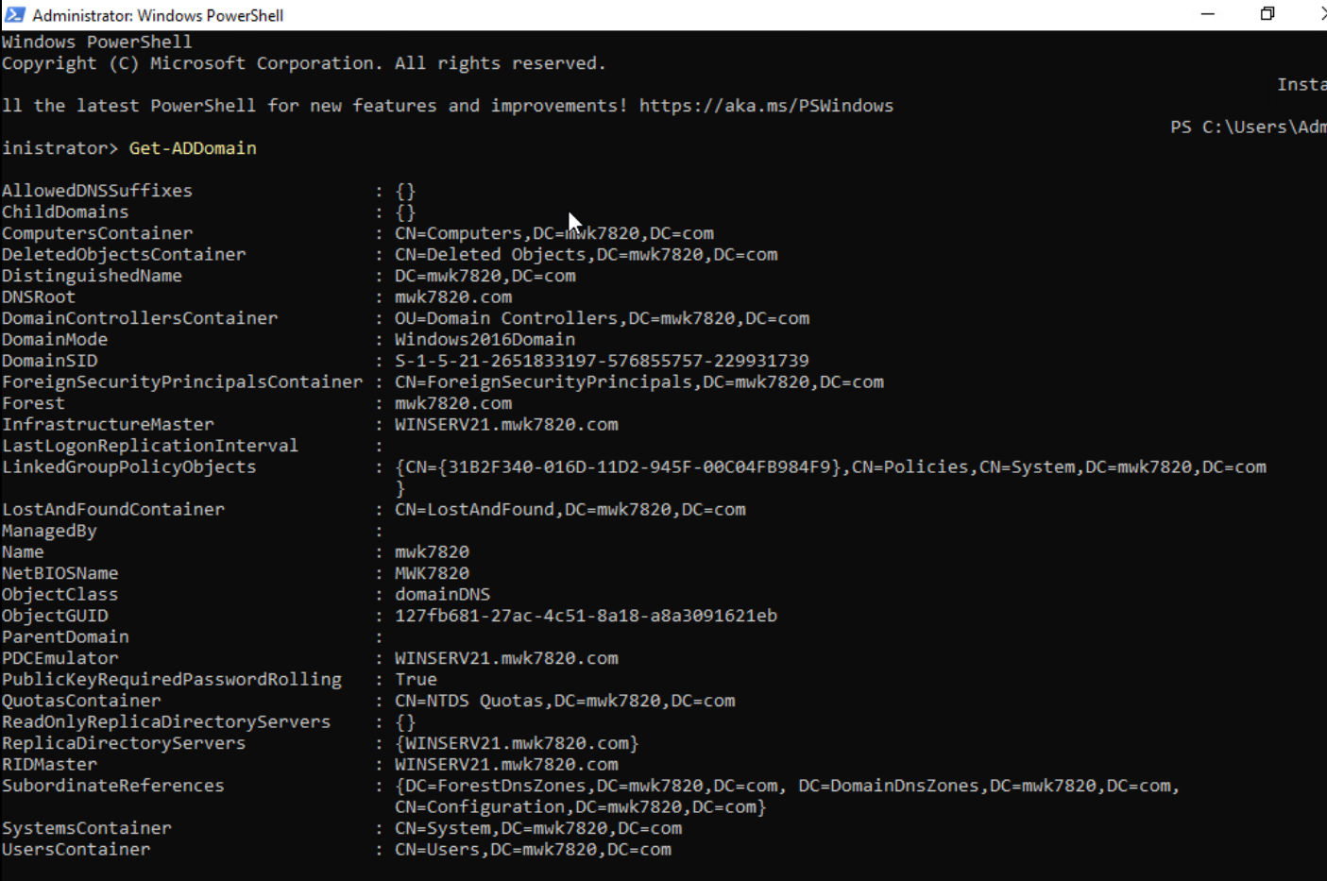
Figure 2.1:
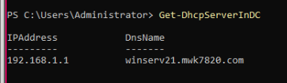
Figure 2.2
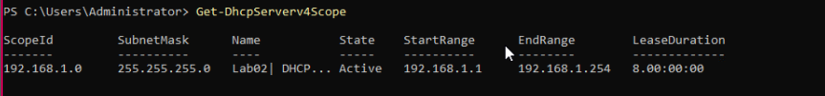
Note that Winserv does not have DHCP enabled since it is a service provider. The above features were configured during Lab 2.

Storage Server
This was created in Lab 3 by duplicating the Rocky Linux client and configuring it with the purposes of:
- Exploring different RAID configurations like RAID 1 and RAID 5.
- Testing and hosting file transfer services like FTP, Samba, and NFS.
- Using commands like rsync for file synchronization and file backups.
- Being the main storage system for the Windows and Linux clients during labs.

RAID and Partition Setup
The Rocky Linux Storage Server uses 9 virtual drives (sda - sdi) for the implementation of the RAIDs’ setup and Logical Volumes (LVs). Below are the RAID configurations and drive details.
- RAID 1 (Mirroring)
  - Uses drives sdc and sdd.
  - Data is duplicated across those two disks.
  - Checked RAID information using command cat /proc/mdstat
  - Created with mdadm command
- RAID 5 (Striping with parity)
  - Uses drives sde - sdf - sdg
  - Includes built-in redundancy and data recovery and integrity
  - Checked RAID information using command cat /proc/mdstat and mdadm –detail /dev/md1
  - Created with mdadm command
Figure 3: RAID 1 and RAID 5 Mount Verification
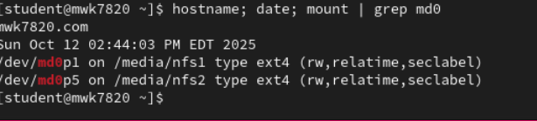
Figure 3.1: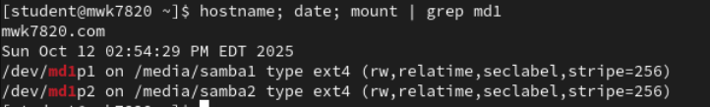
- LV creation
  - Volume Group (VG) was created using RAID 5 with the primary and logical partitions with ext4 file system.
  - Added UUIDs for persistent mounts to the /etc/fstab file.
  - Failed the RAID 5 array to showcase proof of redundancy and function.
Figure 3.2
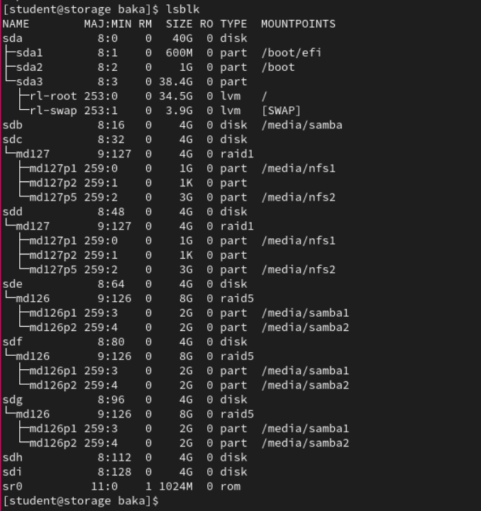

File Transfer and Sharing Services
Below are brief descriptions of each of the file transfer, sharing, and synchronization services Rocky Linux Storage Server hosts:
- FTP (Port 21)
  - Configured for local and anonymous user access
  - Uses vsftpd service
  - Anonymous users only have write privileges to the /var/ftp/dropbox.
  - Verified using transfer log (/var/log/xferlog)
Figure 4: Transfer Log Verification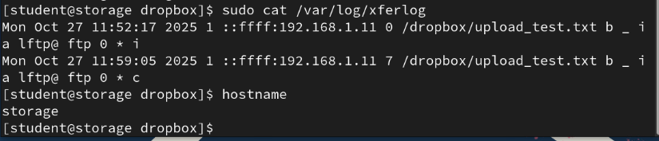
- Samba (Port 445 & Port 139)
  - Configured for file sharing across different OSes like Linux, Windows, etc.
  - Created 4 samba users using smbpasswd and added 3 to the write-access permission of /etc/samba/smb.conf.
  - Verified access of server by checking shares of 2 users from the Windows 11 client and Linux Client (//storage/ninjas)
Figure 5: Server Samba Status
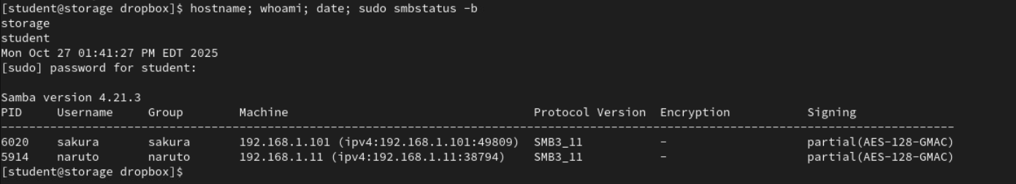
- rsync (Port 873)
  - Configured for file backups and file synchronization
  - Can also be used for copying whole data directory contents efficiently
  - Installed on the /media/rsync directory
  - Useful options like: -a (archive mode), –dry-run (simulates changes of a command), and –delete (matches backup directory to original directory)
- Network File System (NFS) (Port 2049)
  - Configured for access to shared file systems on Linux systems and LDAP user access to home directories
  - Exported shared directories via editing /etc/exports file with the line: /media/nfs1/baka rw,sync,no_root_squash
  - Mounted shares on Linux client persistently on /media/nsfmount and on Windows client via the Z:// drive.
  - Verified it is accessible by creating and reading test files from both clients
Figure 6: Windows NFS Write Verification
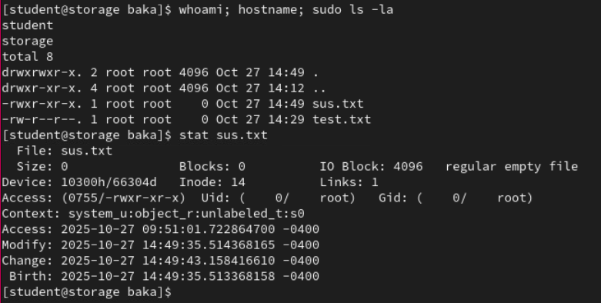
Figure 7: Network Connection Verification
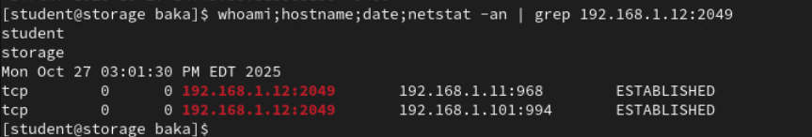
Note that firewall rules were configured to allow connections on ports 21, 139, 445, 873, and 2049 to allow for these services to work.

Active Directory

Setup and Configuration
For Lab 2, Windows Server 2022 was promoted and configured to a domain controller over the domain mwk7820.com and forest. In the process, DNS, DHCP, and AD DS were also installed and configured.
Firstly, when setting up the AD, we created a test user “naruto uzumaki” that was used to successfully login to both Linux client and Windows client for AD testing.
Subsequently, we created two Organizational Units (OUs) called:
- Leaf
- Sand
Using the Remote Server Administration Tool (RSAT) through the Active Directory Users and Computers (ADUC) console which is used for the creation of any user or OU in the domain.
Also, we created a new OU with this command:
- New-ADOrganizationalUnit -Name Sales -Path "dc=mwk7820,dc=com" -ProtectedFromAccidentalDeletion:$true -PassThru
This command creates an OU called “Sales” that is protected from accidental deletion in the domain mwk7820.com.
After this, we added 4 users at least to each OU via the ADUC and each was assigned passwords and grouped according to their role. Below are the images for showcasing this.
Figure 8: First Organizational Unit
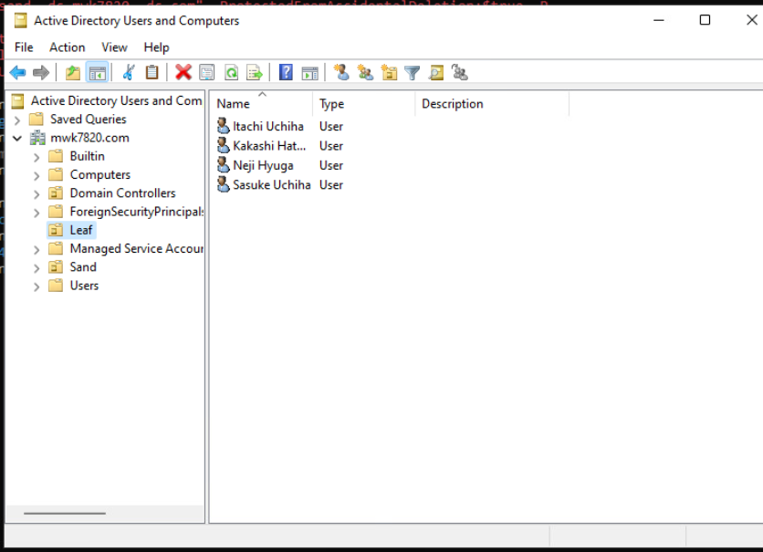
Figure 9: Second Organizational Unit
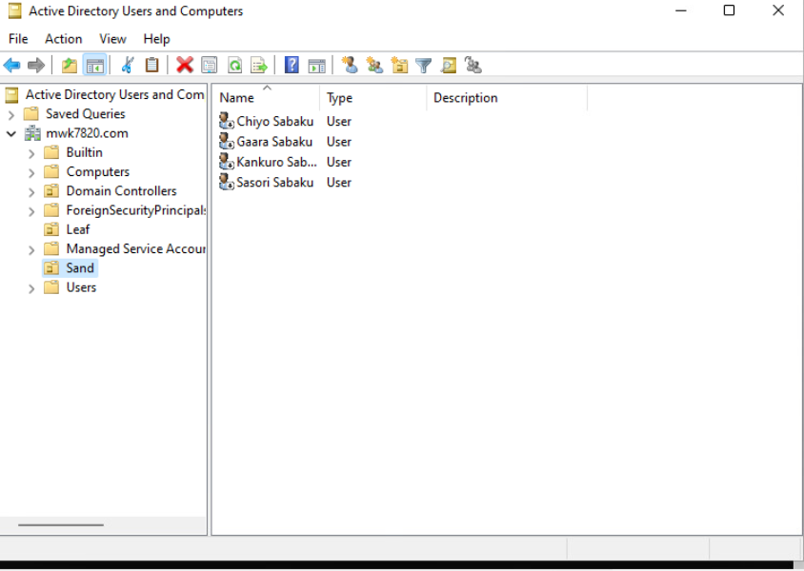

Group Policies
Two Group Policy Objects (GPOs) were created and applied to the respective OUs through the Group Policy Management Console (GPMC). To test if it was applied, the command gpupdate was used after logging on a user from either domain and verifying changes.
Table 2: Group Policies
Group Policy | Purpose
Block Control Panel | Restricts access to control panel for users to disable risk of adverse system wide change.
Set Desktop Wallpaper | Enforce a set desktop wallpaper for consistency across domain and for testing the GPO.
Figure 10: Active Directory Topology
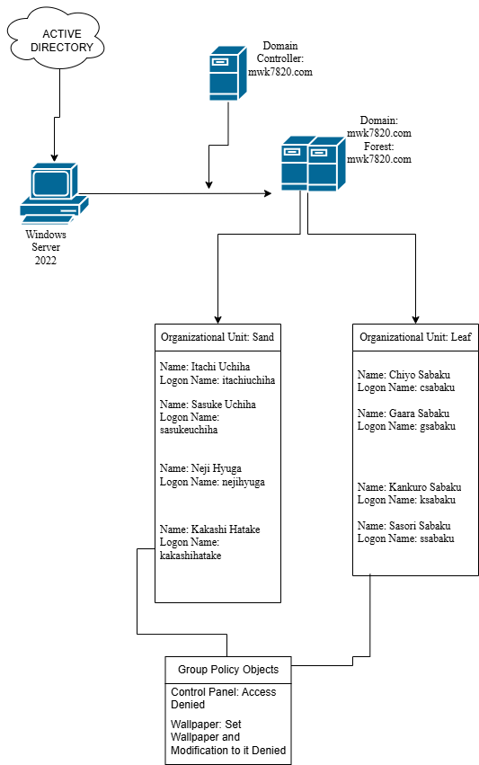
Figure 12: GPO Wallpaper Report
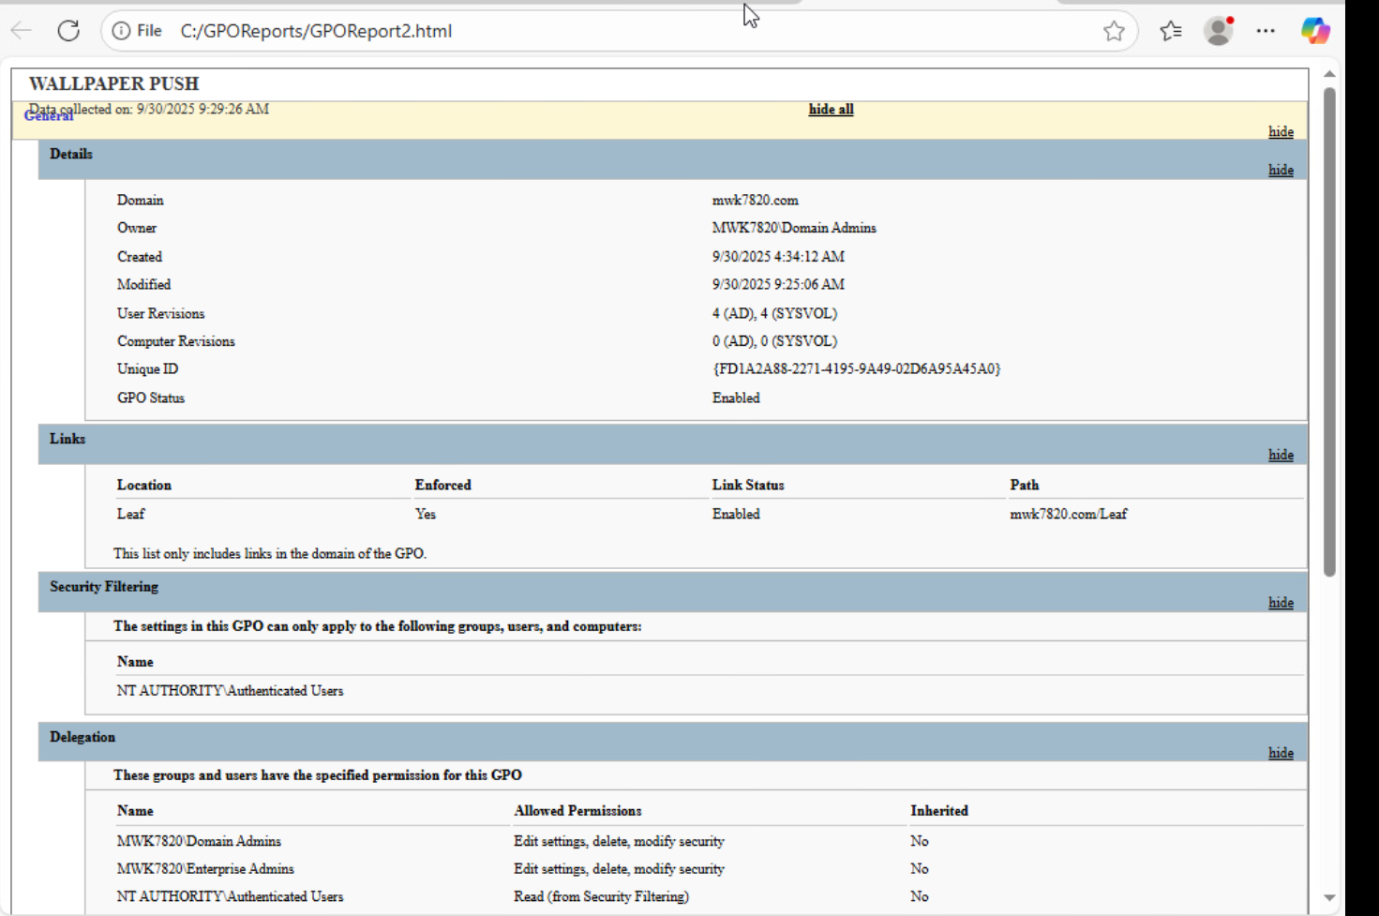
Figure 12.1
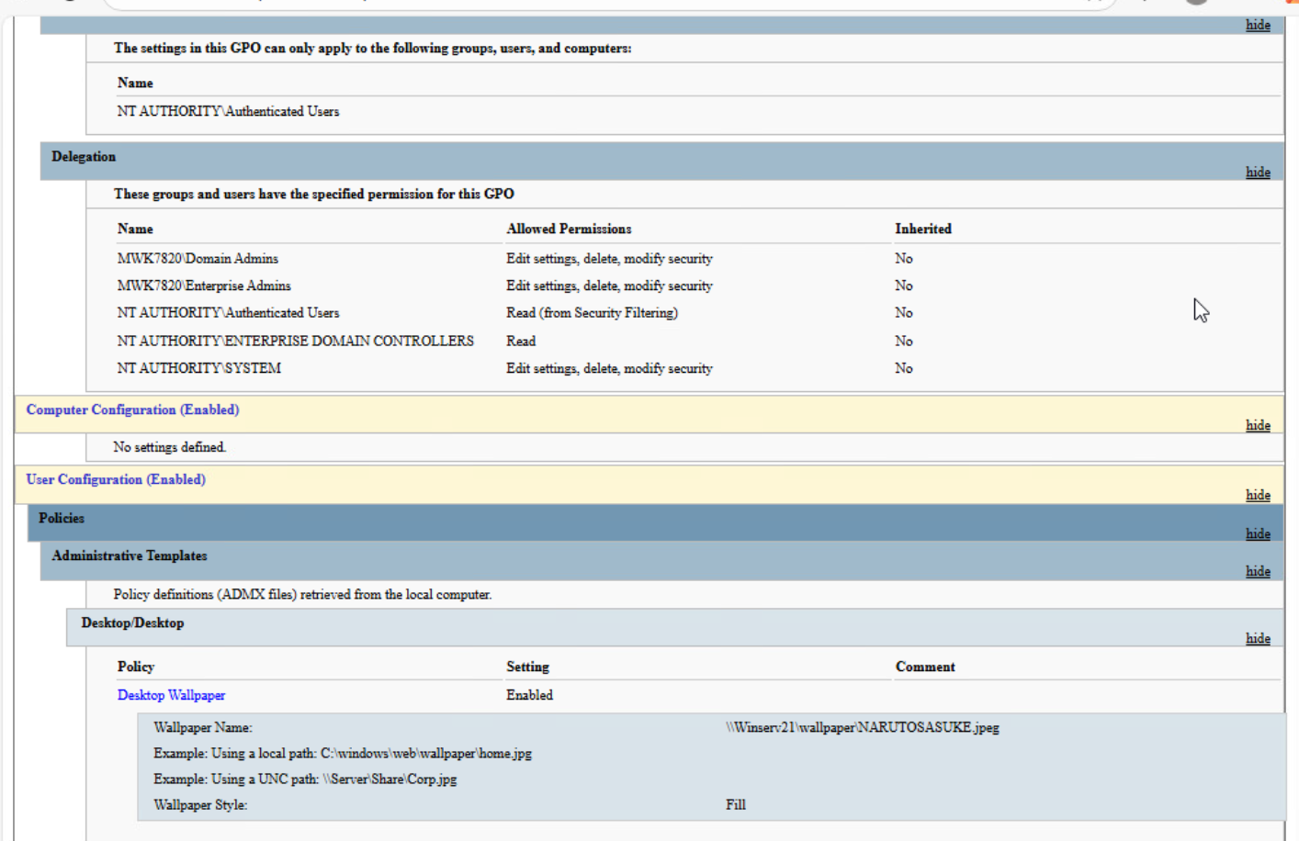
Figure 13: GPO Control Panel Report
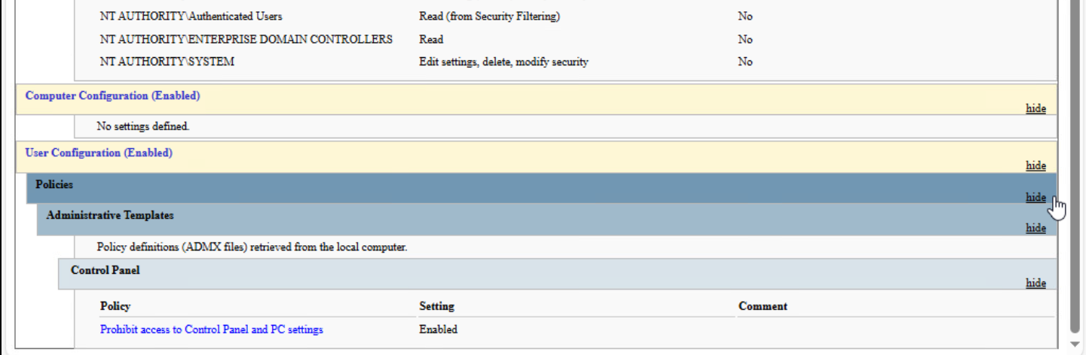

Appendix

Powershell Commands (Windows Server 2022)
Get Domain Information
Get-ADDomain
Check DHCP Server
Get-DhcpServerInDC
View DHCP IPv4 Scope
Get-DhcpServerv4Scope
Create an Organizational Unit:
New-ADOrganizationalUnit -Name Sales -Path "dc=mwk7820,dc=com" -ProtectedFromAccidentalDeletion:$true -PassThru
Add User In OU:
New-ADuser –Name “Chiyo Sabaku” –GivenName Chiyo –Surname Sabaku –UserPrincipalName “csabaku@mwk7820.com”–SamAccountName csabaku –Path “ou=sand,dc=mwk7820,dc=com”
Edit an AD User Attribute:
Set-ADUser –Identity “CN=Chiyo Sabaku, OU=sand, DC=MWK7820, DC=COM” –OfficePhone “5678”
Join Windows 11 client to Domain:
Add-Computer -DomainName mwk7820.com -Credential (Get-Credential)
Update GPO for a user:
gpupdate
or
gpupdate /r (to force the update)
Outputs the FQDN of the domain the user is logged into:
$env:USERDNSDOMAIN
Outputs the NETBIOS name of the local machine:
$env:COMPUTERNAME

Linux Commands (Rocky Linux)
Join Linux Machine to the Domain:
realm join -U <user name> <domain name>
RAID Array Details:
cat /proc/mdstat
or
mdadm –detail /dev/md0 (RAID 1)
or
mdadm –detail /dev/md1 (RAID 5)
Enables Listening on Port 21 and FTP for Firewalls:
firewall-cmd --permanent --add-port=21/tcp
firewall-cmd --permanent --add-service=ftp
firewall-cmd --reload
User Add Script:
for i in joey johnny deedee marky; do useradd -s /sbin/nologin $i; done
Group Add Script:
for i in joey johnny deedee; do usermod -aG writers $i; done
Samba Specific Password Setting Script:
for i in joey johnny deedee marky; do smbpasswd -a $i; done

Bash Scripts
diskMonitor.sh
#!/bin/bash # rashed wuz here
#This is to check the disk usage on your Rocky machine :D
# path to log file
LOG_FILE="disk_usage.log"
‡ Log the date, hostname, and then disk usage to the log file
echo "Date: $(date)" ›› "$LOG FILE'
echo "Hostname: $(hostname)" > "$LOG_FILE"
df -h >> "$LOG_FILE" echo “------------------------------” >> $LOG_FILE
databackup.sh
#!/bin/bash
# Base directory where backups will be stored
BACKUP_DIR="databackup/"
# Create backup directory if user doesnt have it
mkdir -p "$BACKUP_DIR"
# Find last backup number by checking existing directories COUNTER_FILE="$BACKUP_DIR/backup_counter.txt" if [! -f"$COUNTER_FILE" ]; then echo "1" › "$COUNTER_FILE"
fi
# Read counter value
COUNTER=$(cat "$COUNTER_FILE")
# Create a new backup directory with the current counter NEW_BACKUP_DIR="$BACKUP_DIR/data_backup_$COUNTER"
nkdir -p "§NEW_BACKUP_DIR"
# Perform the backup (using rsync to efficiently copy files)
rsync -a --delete data/ "$NEW_BACKUP_DIR/"
# Increment the counter and store it back in the file
COUNTER=$ ( (COUNTER + 1))
echo "$COUNTER" › "$COUNTER_FILE"
# bash sux
network_ping.sh (my script)
#!/bin/bash

ip_address="192.168.1.254"

#if failure for ping: non-existent IP
ip_address_failure = "192.0.2.255"

log_file="/home/student/network_ping.logs"

date_time="$(date "+%Y-%m-%d %H:%M:%S" )"
host_name="$(hostname)"

#conditional statements

#ping once
if ping -c 1 $ip_address &> /dev/null
then
#pingu success
echo "$ip_address Connection Alive $date_time $host_name" >> $log_file
else
#pingu fail
echo "$ip_address Connection Failure $date_time $host_name" >> $log_file
fi

