CSS IA-1

Names and Roll no.s : Nidhi Bhanushali : 1911004

Aditi Paretkar : 1911034

Samiksha Shrimali : 1911048

Topic – File Encryption / Decryption

The program is coded in python . using tkinter module for the User Interface.

We can encrypt a file and make It corrupted using a key , the file can be decrypted only by the same key that was used to encrypt the file

Home page

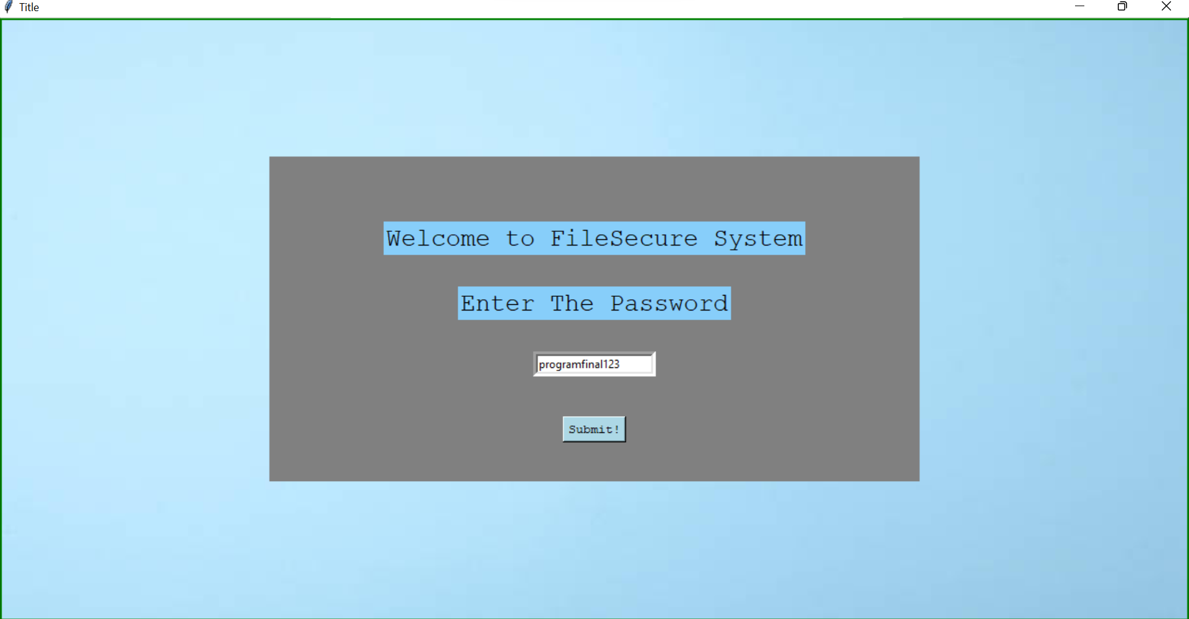

Initially we are asked to enter the password

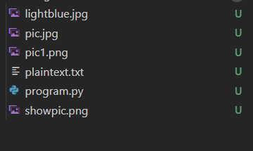

In our directory where the program is located , we have a few files and we can choose to encrypt any one of them. Let us encrypt the file ‘pic.jpg’



Screenshot of pic.jpg

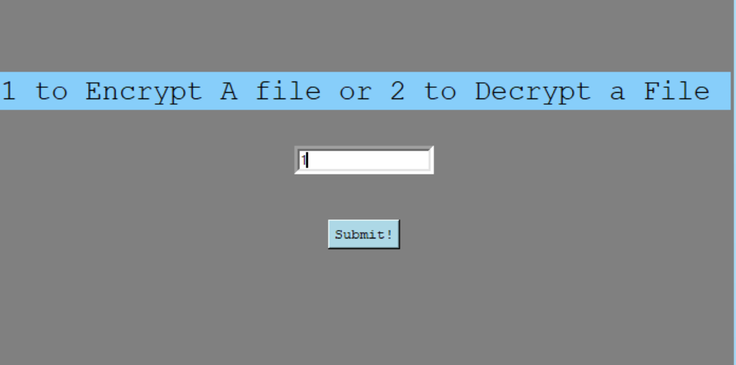

System asks for a filename to encrypt

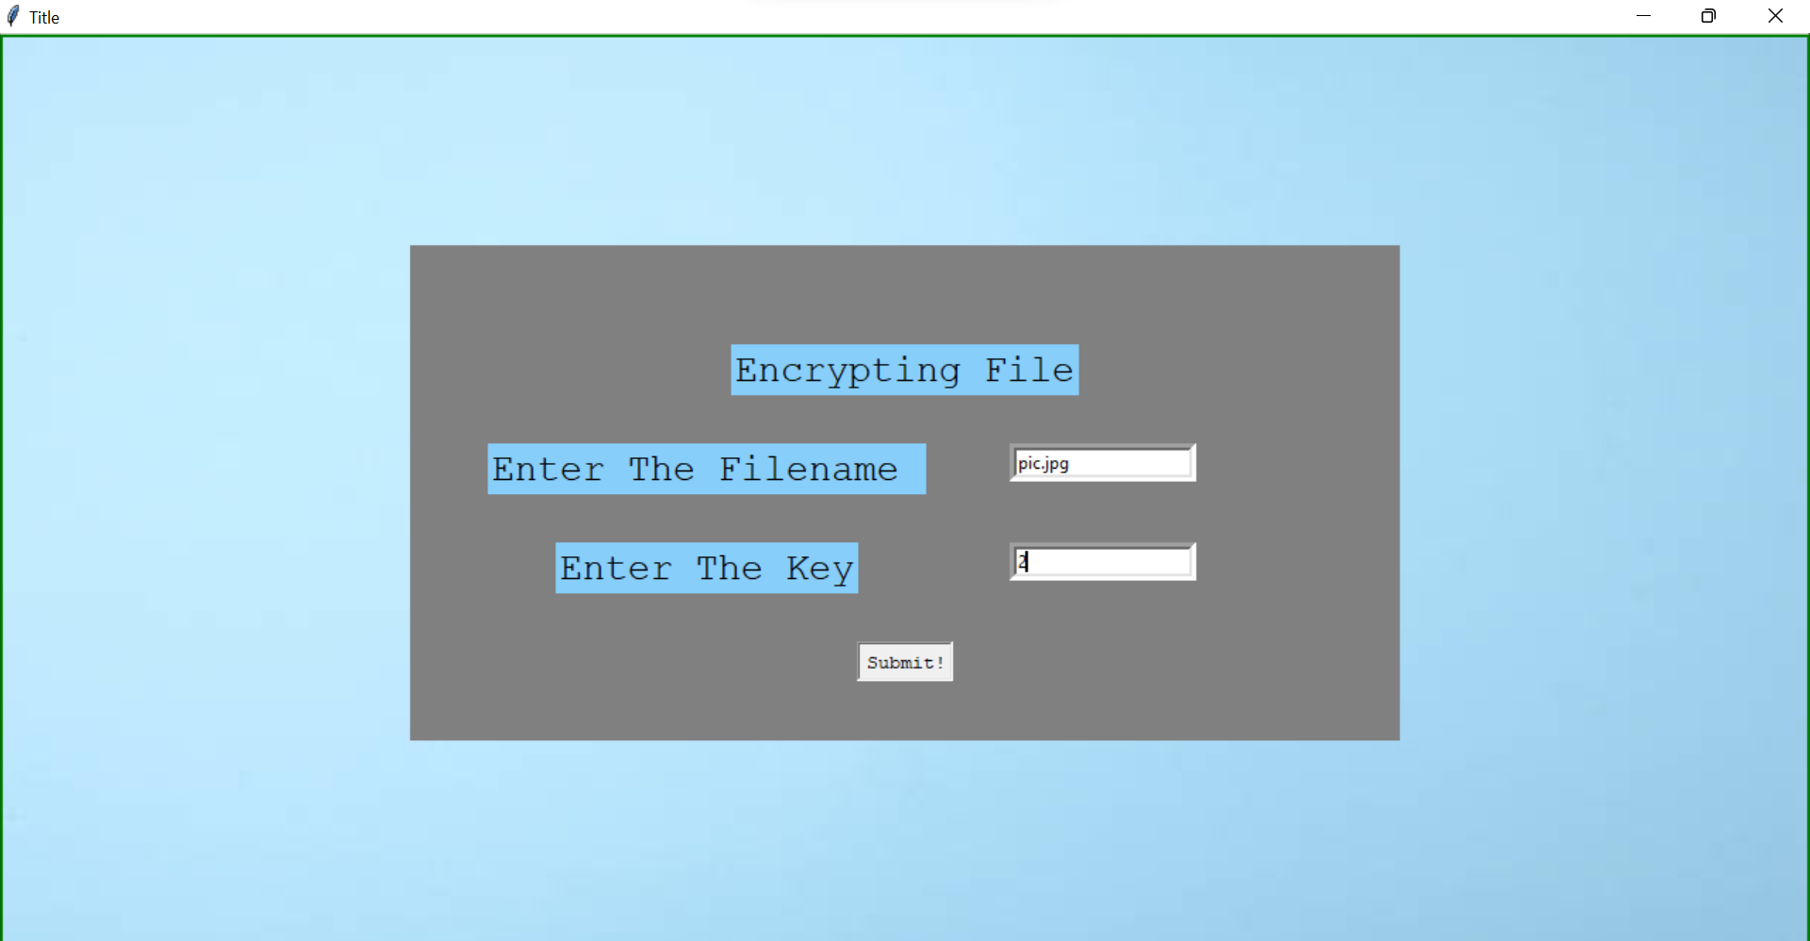

As we can see , a new file ‘corrupted-pic.jpg’ has been created which cannot be opened, because it’s contents are encrypted.

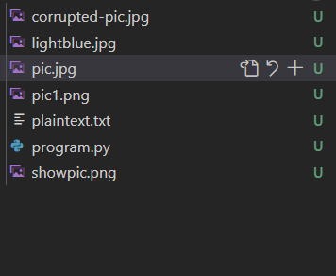

If we try to open the file, we can get an error as shown below

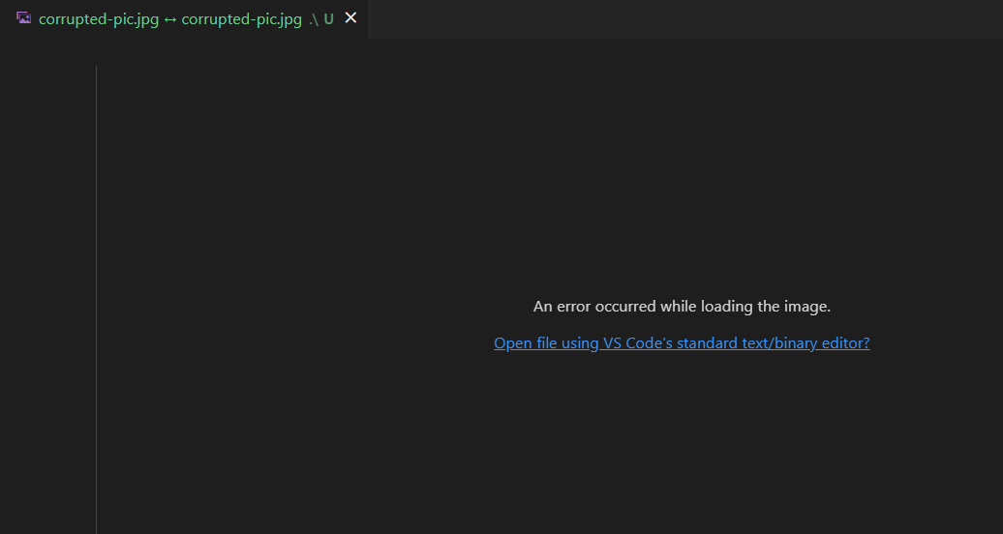

Now we will decrypt the same file using the key used for encryption.

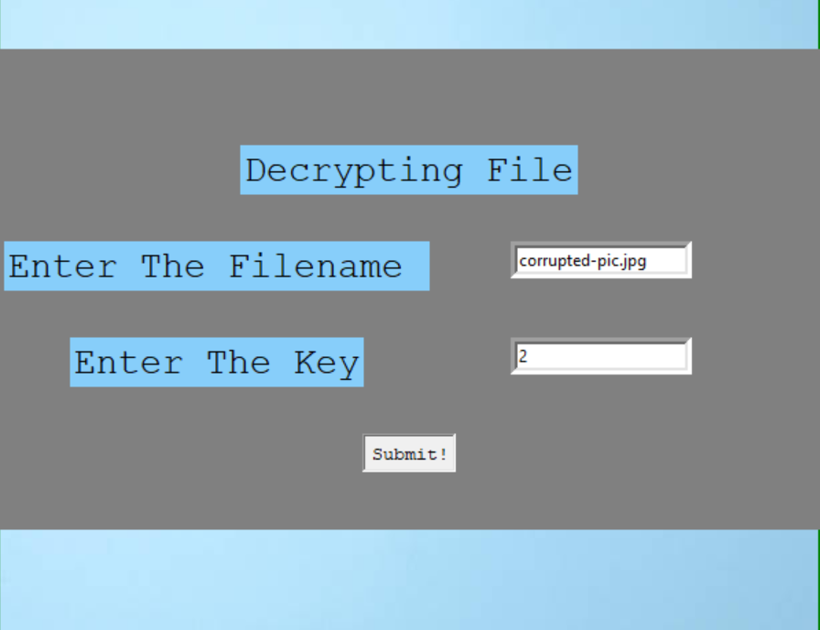

If we view the file ‘corrupted-pic.jpg’ it will now appear as the normal pic



Thus we have performed file-encryption decryption using python.

Note : we initially filled the form for Caesar cipher and were asked to use something more modern. On searching the internet , we found that ‘XOR algorithm’ would be good for file encryption-decryption , hence we have used that .