Kyle Butler

CPE301 – SPRING 2018

Design Assignment X

**DO NOT REMOVE THIS PAGE DURING SUBMISSION:**

The student understands that all required components should be submitted in complete for grading of this assignment.

|  |  |  |  |
| --- | --- | --- | --- |
| **NO** | **SUBMISSION ITEM** | **COMPLETED (Y/N)** | **MARKS**  **(/MAX)** |
| 1 | COMPONENTS LIST AND CONNECTION BLOCK DIAGRAM w/ PINS |  |  |
| 2. | INITIAL CODE OF TASK 1/A |  |  |
| 3. | INCREMENTAL / DIFFERENTIAL CODE OF TASK 2/B |  |  |
| 3. | INCREMENTAL / DIFFERENTIAL CODE OF TASK 3/C |  |  |
| 3. | INCREMENTAL / DIFFERENTIAL CODE OF TASK 4/D |  |  |
| 3. | INCREMENTAL / DIFFERENTIAL CODE OF TASK 5/E |  |  |
| 4. | SCHEMATICS |  |  |
| 5. | SCREENSHOTS OF EACH TASK OUTPUT |  |  |
| 5. | SCREENSHOT OF EACH DEMO |  |  |
| 6. | VIDEO LINKS OF EACH DEMO |  |  |
| 7. | GOOGLECODE LINK OF THE DA |  |  |
|  |  |  |  |
|  |  |  |  |

1. **COMPONENTS LIST AND CONNECTION BLOCK DIAGRAM w/ PINS**

No components or pins were used in the completion of DA1. The purpose of DA1 was to practice managing memory and proper register use.

1. **DEVELOPED CODE OF TASK 1**

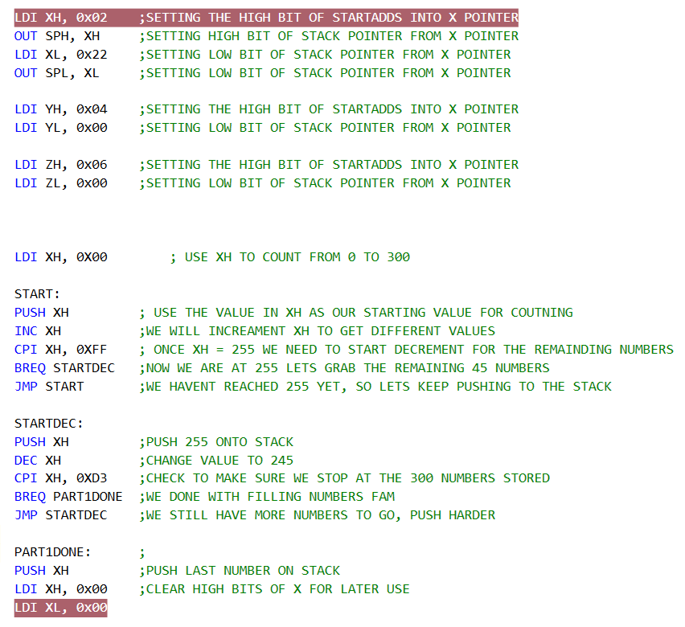

**DEVELOPED CODE OF TASK 2**

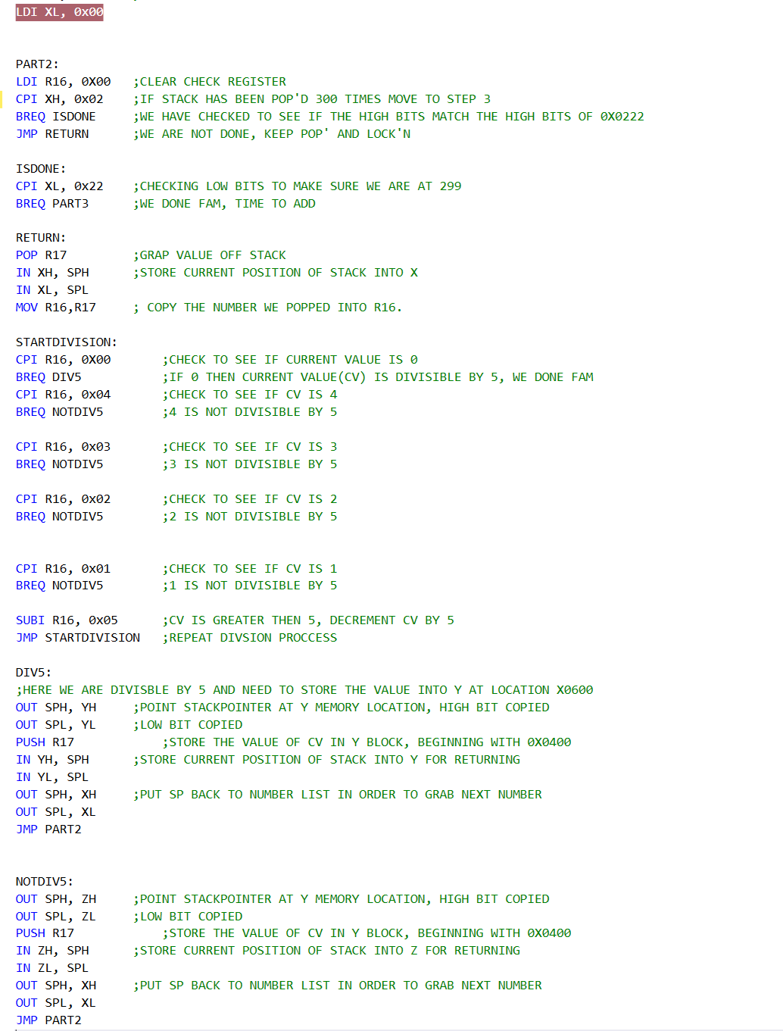

**DEVELOPED CODE OF TASK 3**

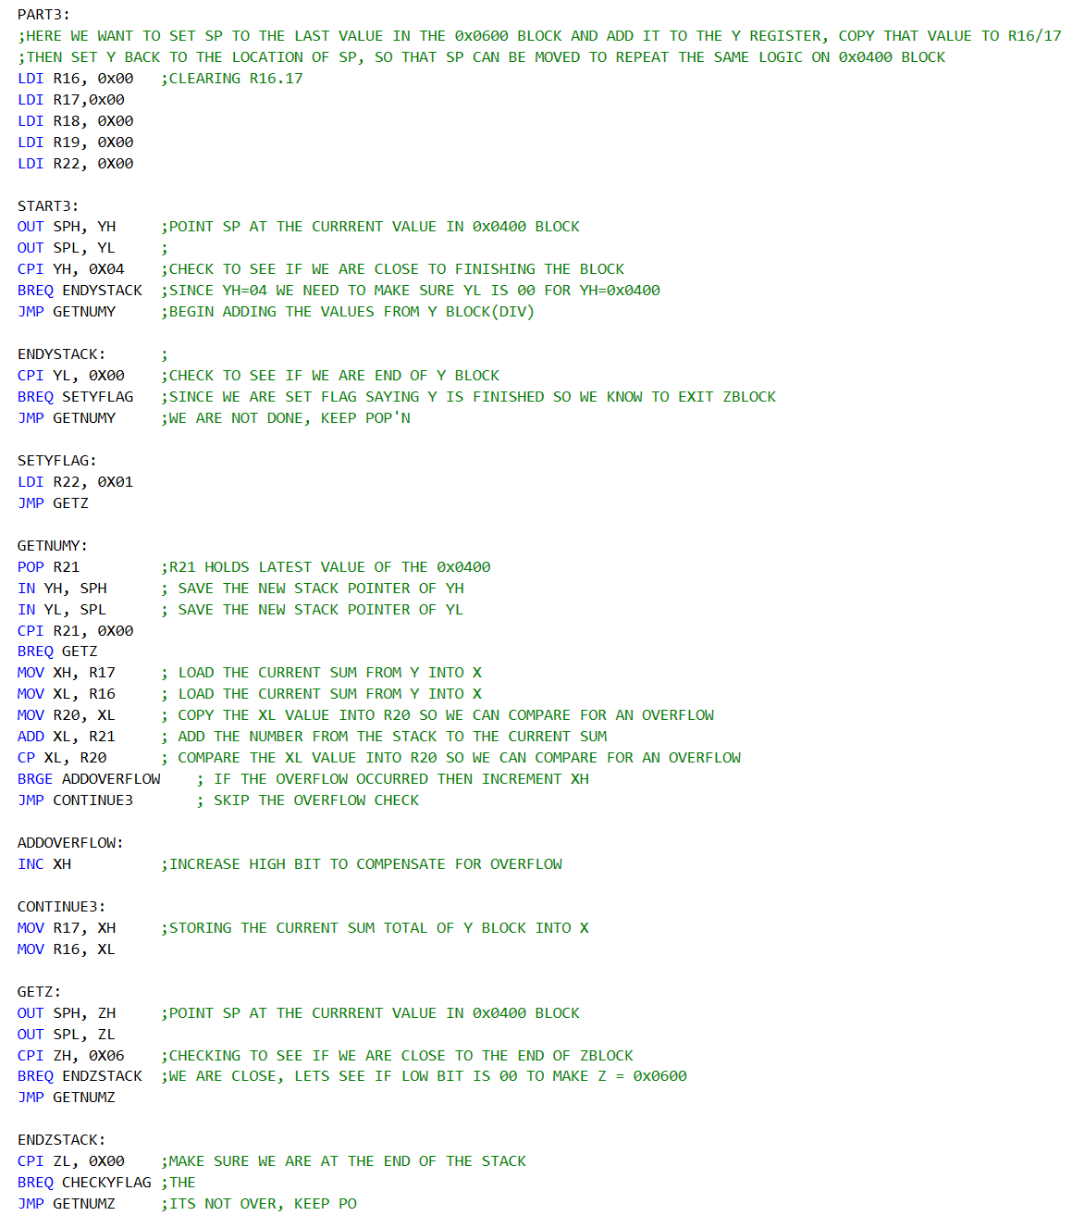

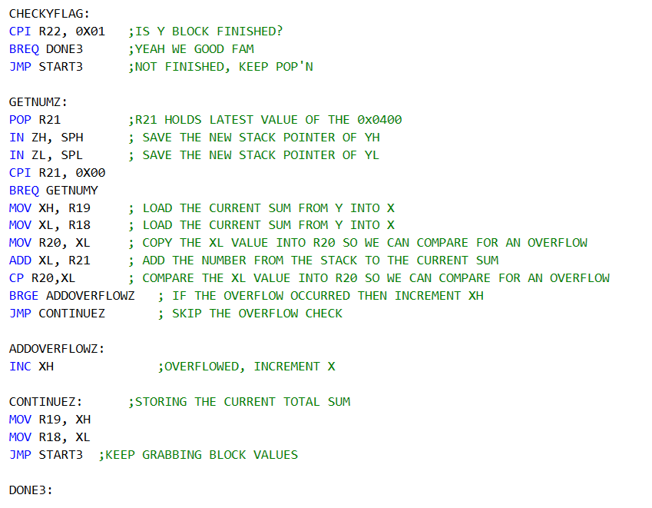

1. **SCREENSHOTS OF EACH TASK OUTPUT (ATMEL STUDIO OUTPUT)**

**TASK 1 (A)**

|  |  |
| --- | --- |
| To begin, fill the X/Y/Z registers with the specified memory location. |  |

**(B)**

|  |
| --- |
| Now with the stack pointer directed at the X-register, let’s reuse X to push 300 values to the stack. Once 0xDC value are pushed to the stack we reach reserved memory, let’s use the values already placed in those locations. Clear X-register when done. |
|  |

**TASK 2**

**Before sort:**

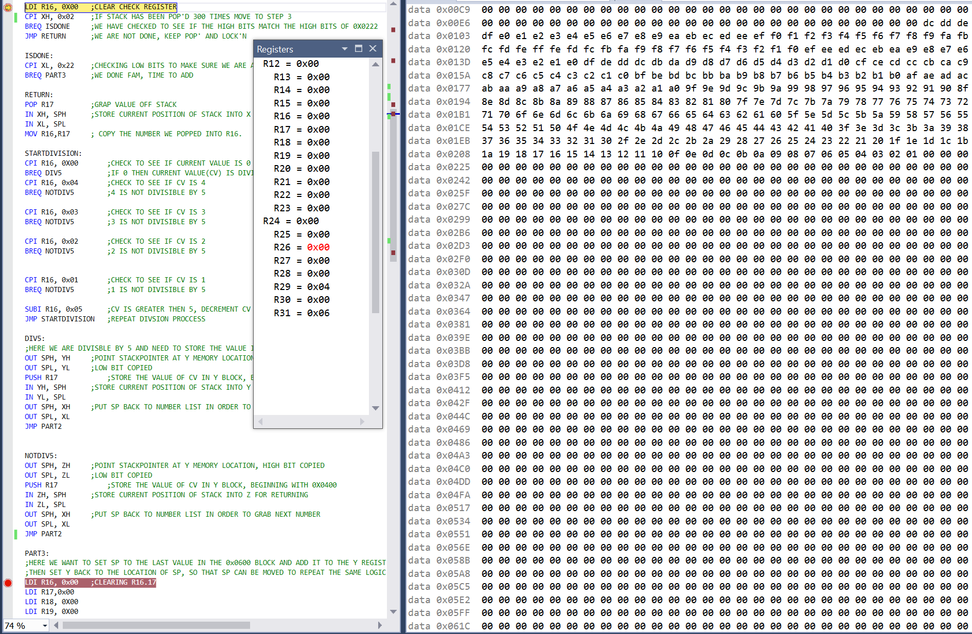

**After sort:**

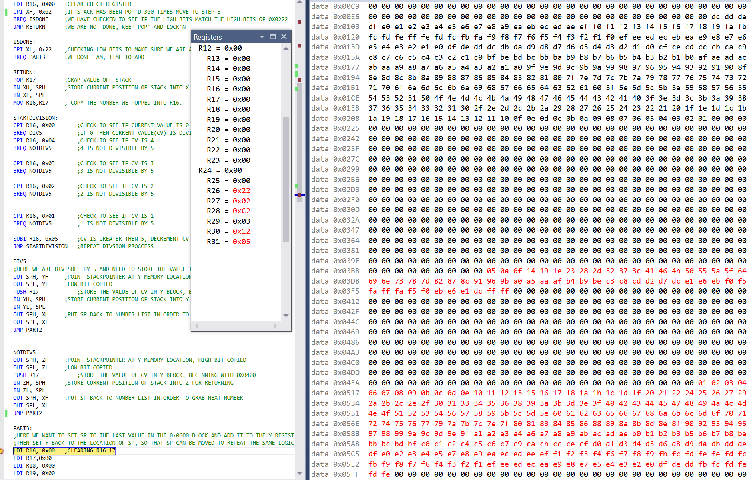

**TASK 3**

**Before summation:**

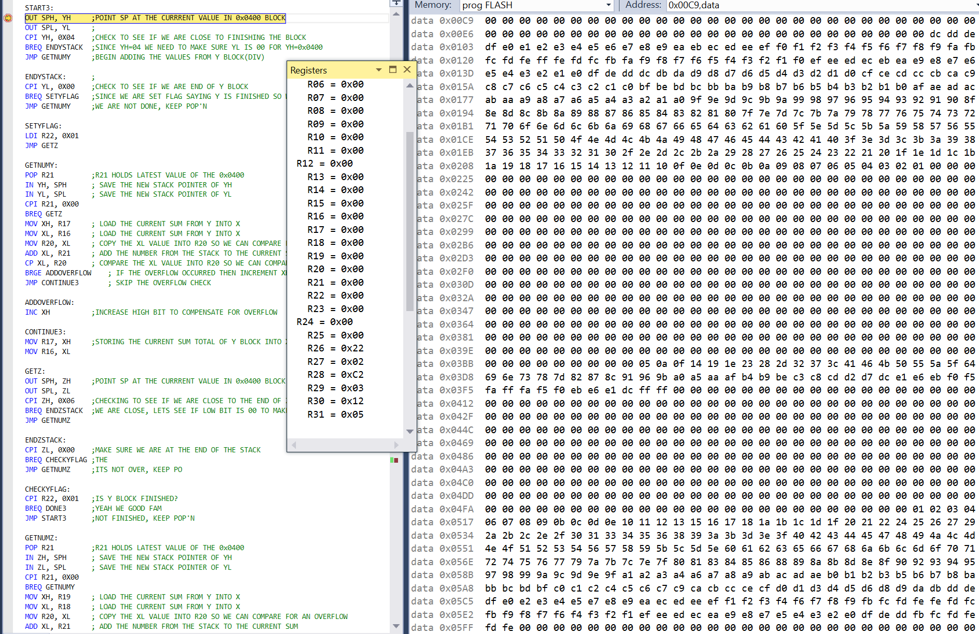

**After with sum total in R16:R17 and R18:R19:**

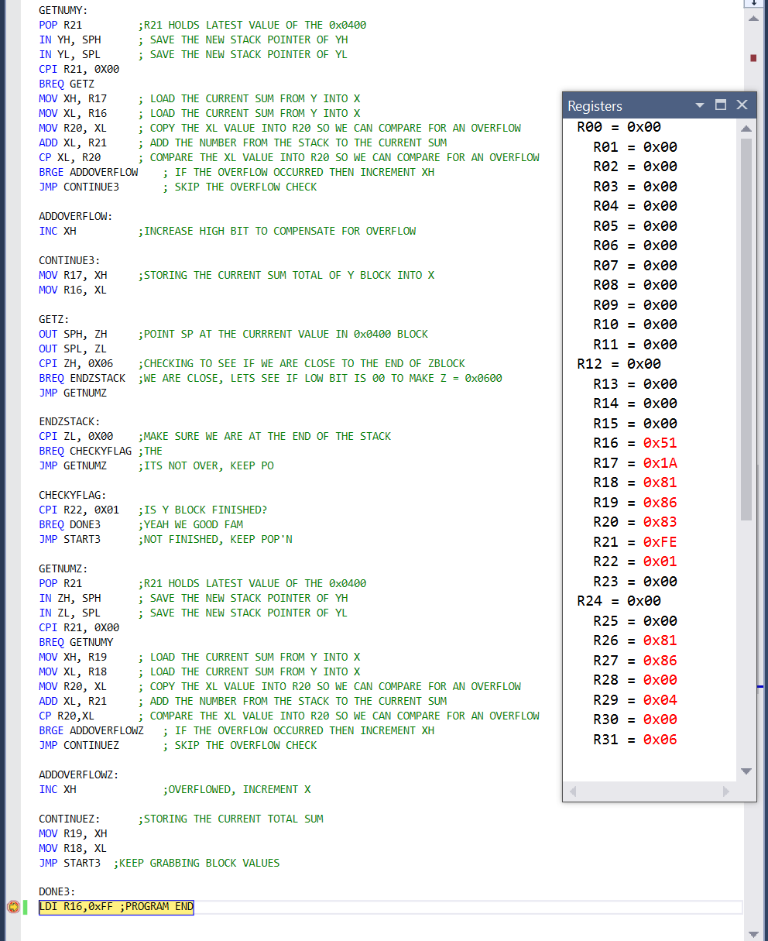

1. **GITHUB LINK OF THIS DA**

<https://github.com/alwayscaps/DAx/tree/master/DAxT1>

**Student Academic Misconduct Policy**

<http://studentconduct.unlv.edu/misconduct/policy.html>

“This assignment submission is my own, original work”.

Kyle Butler