Kyle Butler

CPE301 – SPRING 2018

Design Assignment X

**DO NOT REMOVE THIS PAGE DURING SUBMISSION:**

The student understands that all required components should be submitted in complete for grading of this assignment.

|  |  |  |  |
| --- | --- | --- | --- |
| **NO** | **SUBMISSION ITEM** | **COMPLETED (Y/N)** | **MARKS**  **(/MAX)** |
| 1 | COMPONENTS LIST AND CONNECTION BLOCK DIAGRAM w/ PINS |  |  |
| 2. | INITIAL CODE OF TASK 1/A |  |  |
| 3. | INCREMENTAL / DIFFERENTIAL CODE OF TASK 2/B |  |  |
| 3. | INCREMENTAL / DIFFERENTIAL CODE OF TASK 3/C |  |  |
| 3. | INCREMENTAL / DIFFERENTIAL CODE OF TASK 4/D |  |  |
| 3. | INCREMENTAL / DIFFERENTIAL CODE OF TASK 5/E |  |  |
| 4. | SCHEMATICS |  |  |
| 5. | SCREENSHOTS OF EACH TASK OUTPUT |  |  |
| 5. | SCREENSHOT OF EACH DEMO |  |  |
| 6. | VIDEO LINKS OF EACH DEMO |  |  |
| 7. | GOOGLECODE LINK OF THE DA |  |  |
|  |  |  |  |
|  |  |  |  |

1. **COMPONENTS LIST AND CONNECTION BLOCK DIAGRAM w/ PINS**

The given FTDI chip was producing noise, instead I bought and used an Adafruit CP2104 Friend USB to serial converter. Additionally, puTTy was used for data visualization.

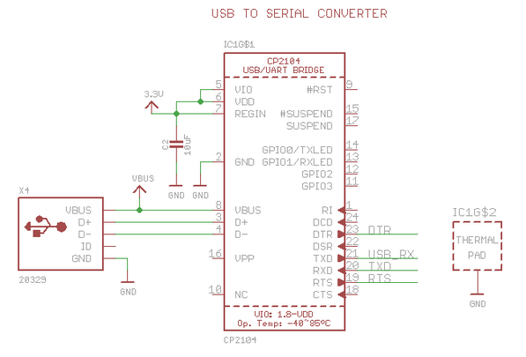

1. **Developed Code for Task 1**

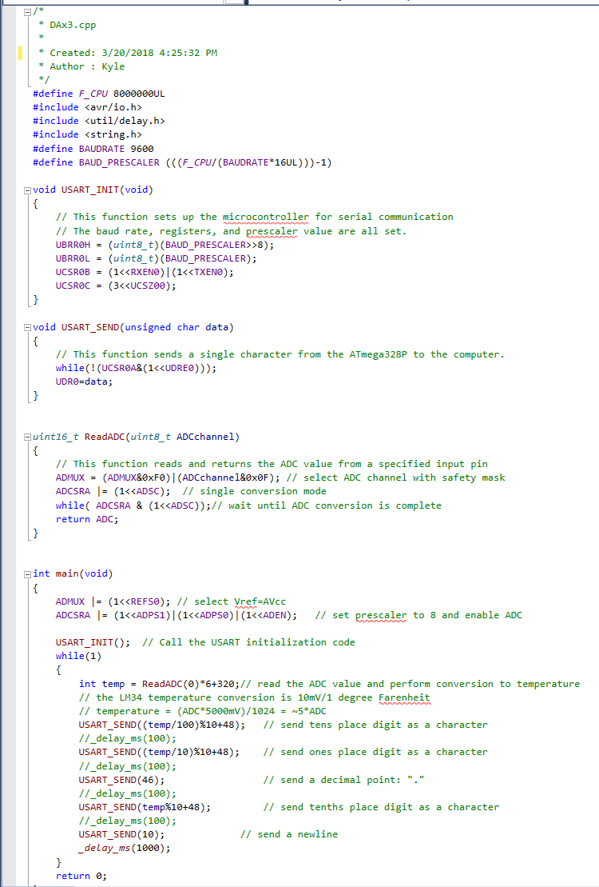

1. **SCHEMATICS**

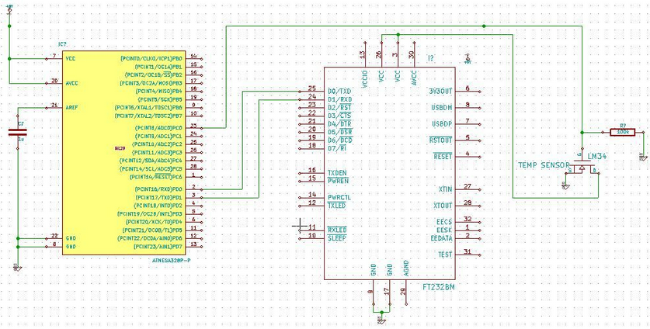

1. **SCREENSHOTS OF TASK OUTPUT (puTTy)**

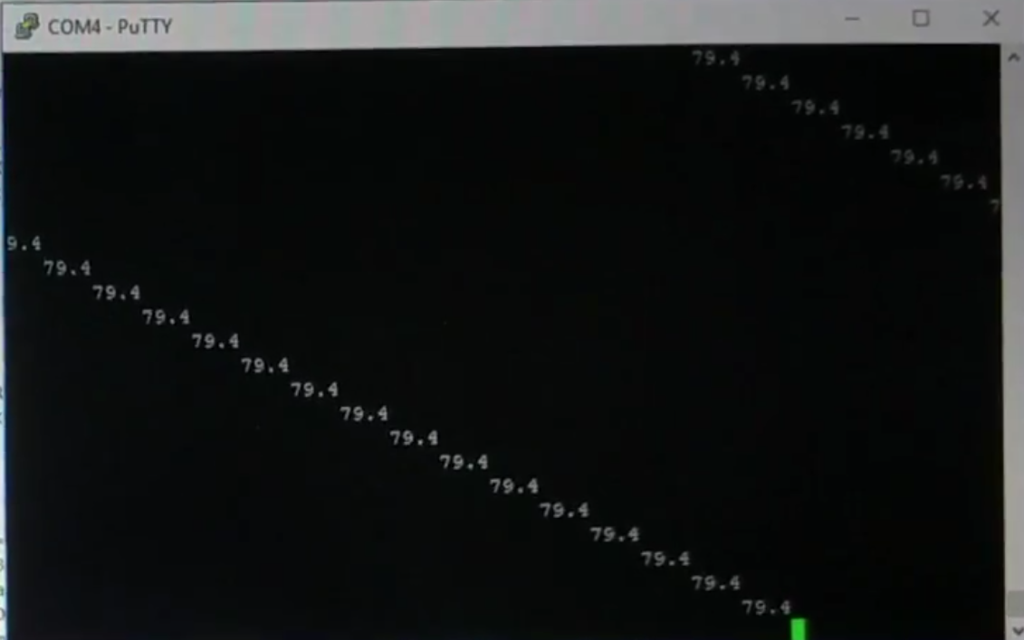

1. **SCREENSHOT OF EACH DEMO (BOARD SETUP)**

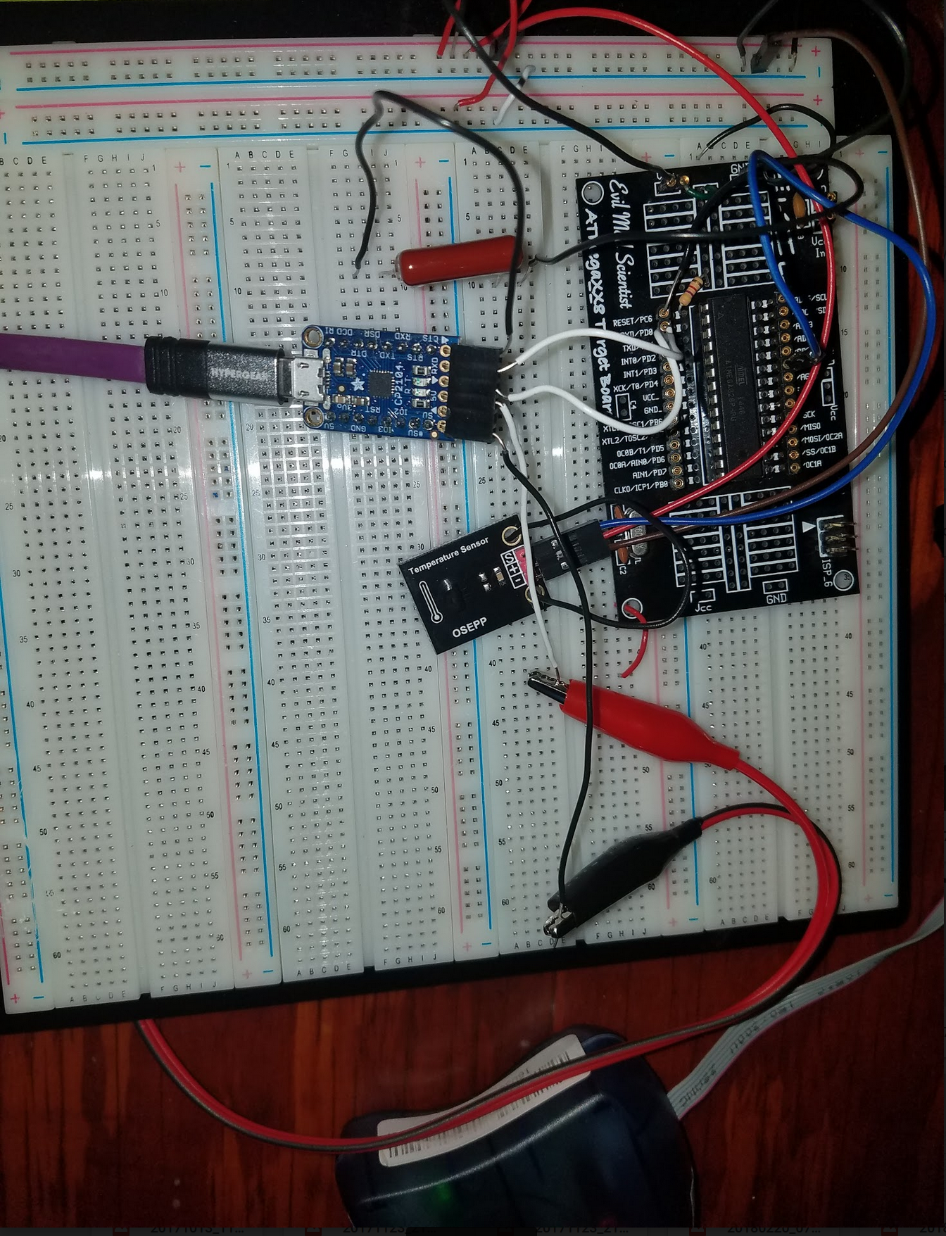

1. **VIDEO LINKS OF EACH DEMO**

<https://www.youtube.com/watch?v=TY9EaCdHRVg>

1. **GITHUB LINK OF THIS DA**

<https://github.com/alwayscaps/DAx/tree/master/DAxT3>

**Student Academic Misconduct Policy**

<http://studentconduct.unlv.edu/misconduct/policy.html>

“This assignment submission is my own, original work”.

Kyle Butler