**Computer Vision HW3 Report**

Student ID: B10901074

Name: 曾柏穎

**Part 1.**

**• Paste your warped canvas**

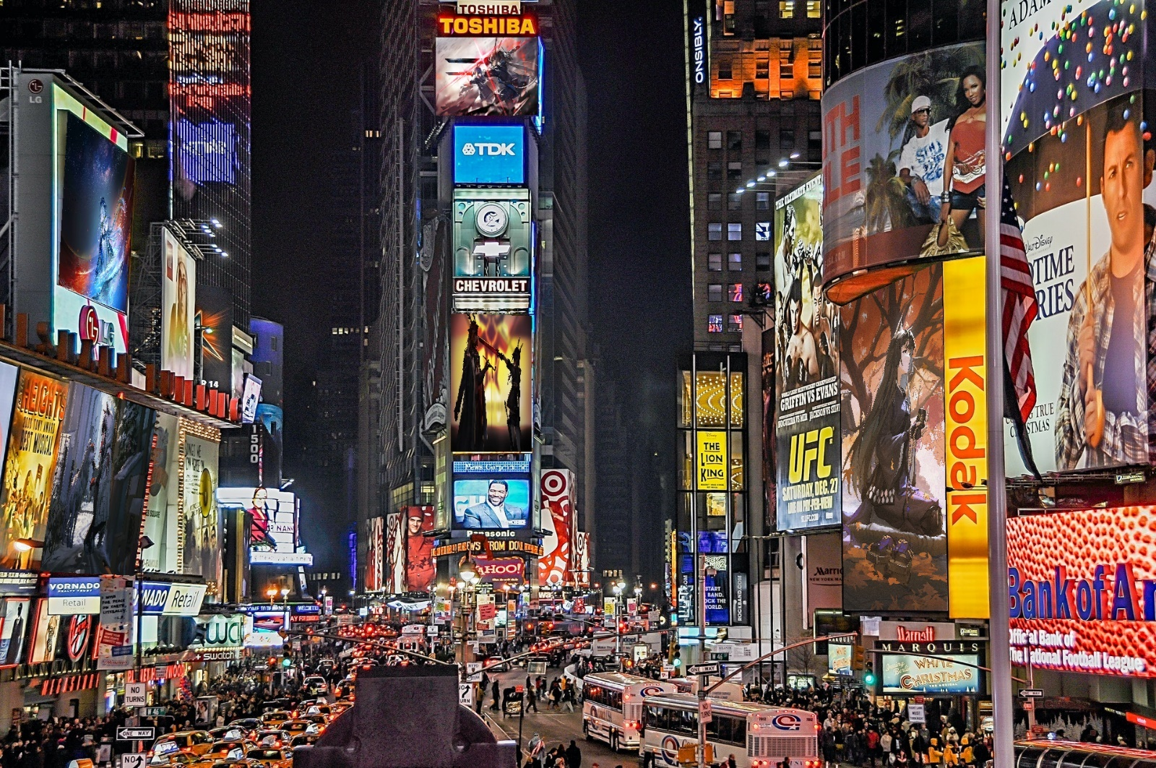

**Part 2.**

**• Paste the function code *solve_homography(u, v)* & *warping( )* (both forward & backward)**

def solve_homography(u, v):

    """

    This function should return a 3-by-3 homography matrix,

    u, v are N-by-2 matrices, representing N corresponding points for v = T(u)

    :param u: N-by-2 source pixel location matrices

    :param v: N-by-2 destination pixel location matrices

    :return:

    """

    N = u.shape[0]

    H = None

    if v.shape[0] is not N:

        print('u and v should have the same size')

        return None

    if N < 4:

        print('At least 4 points should be given')

    # TODO: 1.forming A

    A = np.zeros((2*N, 9))

    for i in range(N):

        A[2*i] = np.array([u[i][0], u[i][1], 1, 0, 0, 0, -u[i][0]*v[i][0], -u[i][1]*v[i][0], -v[i][0]])

        A[2*i+1] = np.array([0, 0, 0, u[i][0], u[i][1], 1, -u[i][0]*v[i][1], -u[i][1]*v[i][1], -v[i][1]])

    # TODO: 2.solve H with A

        U, sigma, V = np.linalg.svd(A)

        H = np.reshape(V[-1], (3, 3))

    return H

def warping(src, dst, H, ymin, ymax, xmin, xmax, direction='b'):

h_src, w_src, ch = src.shape

    h_dst, w_dst, ch = dst.shape

    H_inv = np.linalg.inv(H)

    # TODO: 1.meshgrid the (x,y) coordinate pairs

    x, y = np.meshgrid(np.arange(xmin, xmax), np.arange(ymin, ymax))

    # TODO: 2.reshape the destination pixels as N x 3 homogeneous coordinate

    target_pixels = np.vstack((x.flatten(), y.flatten(), np.ones(x.size)))

    if direction == 'b':

        # TODO: 3.apply H_inv to the destination pixels and retrieve (u,v) pixels, then reshape to (ymax-ymin),(xmax-xmin)

        src_pixels = np.dot(H_inv, target_pixels)

        src_pixels = (src_pixels / src_pixels[2])[:2]

        # TODO: 4.calculate the mask of the transformed coordinate (should not exceed the boundaries of source image)

        mask = (src_pixels[0] >= 0) & (src_pixels[0] < w_src) & (src_pixels[1] >= 0) & (src_pixels[1] < h_src)

        # TODO: 5.sample the source image with the masked and reshaped transformed coordinates

        valid_src_pixels_x = src_pixels[0][mask]

        valid_src_pixels_y = src_pixels[1][mask]

        valid_src_pixels = np.vstack((valid_src_pixels_x, valid_src_pixels_y))

        valid_target_pixels_x = target_pixels[0][mask]

        valid_target_pixels_y = target_pixels[1][mask]

        valid_target_pixels = np.vstack((valid_target_pixels_x, valid_target_pixels_y))

        # TODO: 6. assign to destination image with proper masking

        dst[valid_target_pixels[1].astype(np.int), valid_target_pixels[0].astype(np.int)] = src[valid_src_pixels[1].astype(np.int), valid_src_pixels[0].astype(np.int)]

    elif direction == 'f':

        # TODO: 3.apply H to the source pixels and retrieve (u,v) pixels, then reshape to (ymax-ymin),(xmax-xmin)

        dst_pixels = np.dot(H, target_pixels)

        dst_pixels = (dst_pixels / dst_pixels[2])[:2]

        # TODO: 4.calculate the mask of the transformed coordinate (should not exceed the boundaries of destination image)

        mask = (dst_pixels[0] >= 0) & (dst_pixels[0] < w_dst) & (dst_pixels[1] >= 0) & (dst_pixels[1] < h_dst)

        # TODO: 5.filter the valid coordinates using previous obtained mask

        valid_dst_pixels_x = dst_pixels[0][mask]

        valid_dst_pixels_y = dst_pixels[1][mask]

        valid_dst_pixels = np.vstack((valid_dst_pixels_x, valid_dst_pixels_y))

        valid_target_pixels_x = target_pixels[0][mask]

        valid_target_pixels_y = target_pixels[1][mask]

        valid_target_pixels = np.vstack((valid_target_pixels_x, valid_target_pixels_y))

        # TODO: 6. assign to destination image using advanced array indicing

        dst[valid_dst_pixels[1].astype(np.int), valid_dst_pixels[0].astype(np.int)] = src[valid_target_pixels[1].astype(np.int), valid_target_pixels[0].astype(np.int)]

    return dst

**• Briefly introduce the interpolation method you use**

當轉換後的座標不為整數時，用numpy的astype轉換回整數，astype這個function會把小數部分無條件捨去。

**Part 3.**

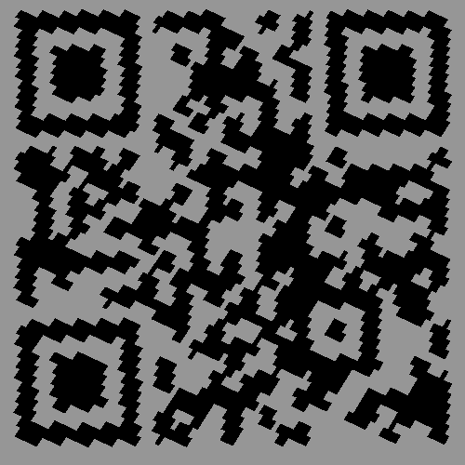**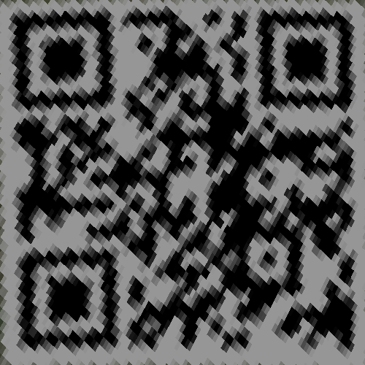• Paste the 2 warped images and the link you find**

link: media.ee.ntu.edu.tw/courses/cv/21S/

**• Discuss the difference between 2 source images, are the warped results the same or different?**

第一張source image的平行線仍大概維持互相平行，幾乎只有affine transformation的效果，而第二張source image則扭曲較多，較接近projective transformation的樣子，不過最後warping的結果都能掃出相同的網站。

**• If the results are the same, explain why. If the results are different, explain why?**

雖然第二張圖片產生的qrcode明顯比較模糊，但因為homography解出的變換包含8 dof，所以能將projection過後的影像恢復至能顯示qrcode的狀態。

**Part 4.**

**• Paste your stitched panorama**

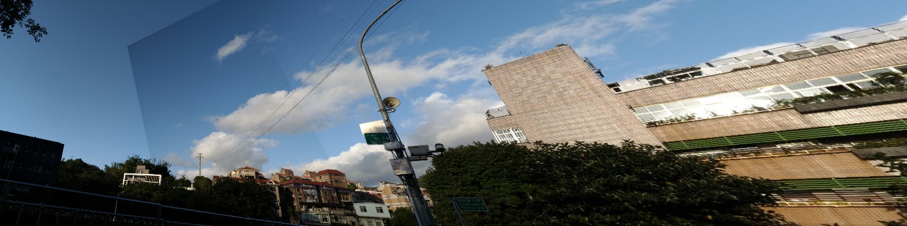

**• Can all consecutive images be stitched into a panorama?**

No

**• If yes, explain your reason. If not, explain under what conditions will result in a failure?**

如果拍攝的鏡頭有經過平移，讓影像不在一個平面上，那麼feature points就無法對應，應該就不能拼接，或是在邊界處的feature points不夠多時，就可能找不到對應的homography，導致無法拼接。