This is the schedule we need to follow.

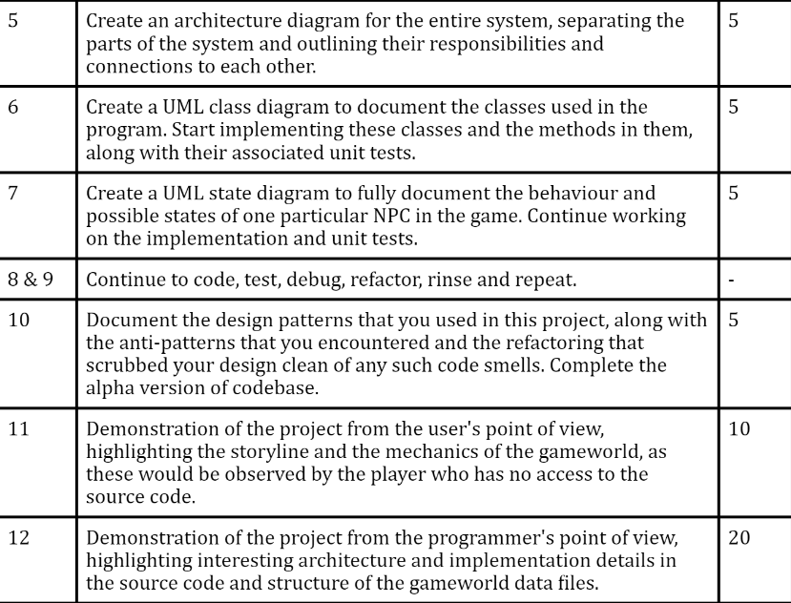

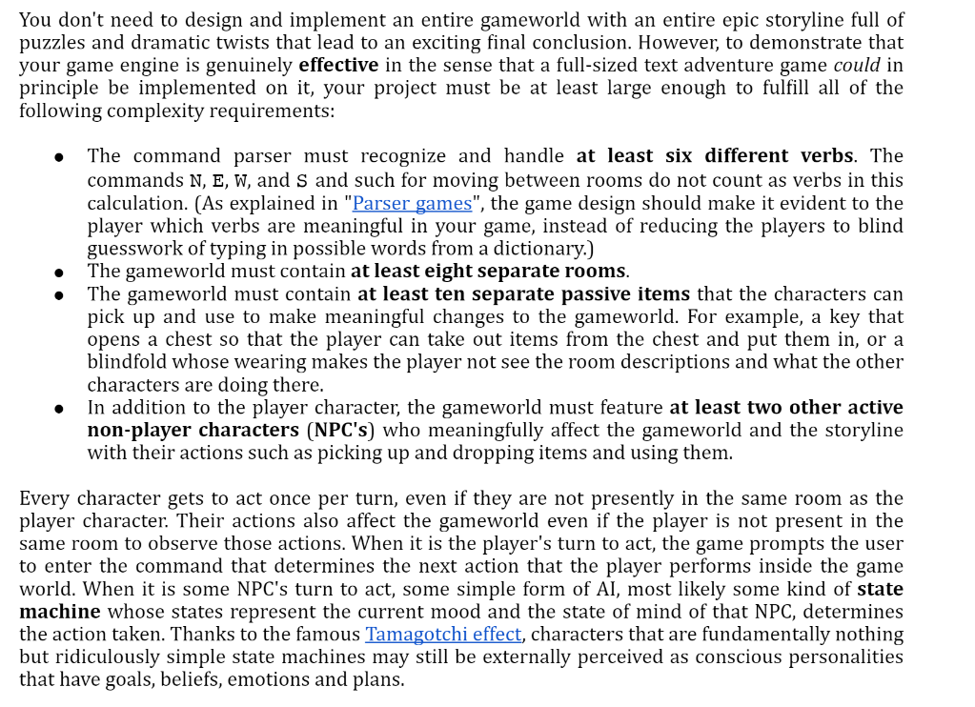

# Team Members:

[Shizhong Yu](mailto:shizhong.yu@ryerson.ca) - 500146415

[Afsheen Jamal Talwani](mailto:afsheen.jamal@ryerson.ca) - 500759966

[Xiaomin Luo](mailto:x1luo@ryerson.ca) - 501009757

John Bradley - 500860704

# Team Guideline:

* Half agile and half waterfall
* Do small incremental steps and tests to make sure we are on track
* Focus on MVP(Minimum viable and short term deliverables in terms of versioning
* Adjust based on feedbacks (scientific agile experiment xD)

# Ideas

* Items for state change, having unlockable
* Rooms for 2 separate world states
* Characters will move around/ give answers, based on user’s requests, and have their own goal in the story.
* Hiding as mechanic for combat/conflict
* Give items in exchange for needed stuff, inventory progression state throughout the story.
* Sneaking out, NPC = Parent searching through room or dog barks thinking intruder. (Failure conditions, where it leads to previous checkpoints)

# 1. Requirements:

* >= 6 different command verbs
* >= 8 separate rooms
* >= 10 passive separate items
* 1 player character
* >= 2 NPC
* Npc have to have some states during the game, they should not just sit there.
* 2 Phase world, where each room has two states

# 2. Basic Game World Setting:

Project vision - We are creating a puzzle game that requires our players to navigate through an enchanted house in order to unravel the secret of their fathers odd behavior. Players will be faced with challenges not only by the environment but also by the other inhabitants of the house. The house consists of multiple rooms that the players must explore in order to find clues that will help unravel the mystery. Items within the house will be used to allow the player to move between rooms as well as persuade NPC characters to share information. The combination of these will allow the player to progress through the story arc and ultimately save their father.

The game has two world states, one state is more hostile than the other. The player will have to deal with challenging survival situations when exploring. There might just be a big surprise at the end for the player that explores all possibilities in the game.

Main Story style:**Mystery**

Main Gameplay elements: **survival / puzzle solving**

# 3. NPC Characters (>=2, include names):

**2 versions of characters, follow a theme in dialogue options**

* Butler (Only single version) - keys holder for requirements to unlock the next stage
* Groundskeeper - guide to the next stage of the game, healing for the good ending
* Dad - in underworld being tortured
* Cook - every 7 turns, go to cook to get a burger [high favourability gain Never Hungry status, low favourability make it 5 turns until famished]
  + If famished for more than 4 turns, death by starvation

# 4. Map/Rooms (>=8):

* **Bedroom** [rest and recover from injured state]

*Long description:* This Swedish Gustavian style room was built by hand by the previous owner for his daughter, Lady Capulet, and has remained empty since her 18th birthday. In this room there is a bed, nightstand, armoire and writing desk. The current occupant is Madelyn Artisan. This room is a safe zone and can be used to recover from injuries.

*Short Description:* The bedroom of Madelyn Artisan used for resting, safety and recovery from injuries.

* **Library** - find book, and hide from evil NPC

Long description:

* **Dining Room** - this is where entrance to underworld is
* **Kitchen** - this is where cook usually is and find them to get sustenance
* **Underworld Dungeon** - [mirrors library location, father is trapped here]
* **Underworld Dining Room** - Initial position of **Evil Cook**, require weapons to pacify

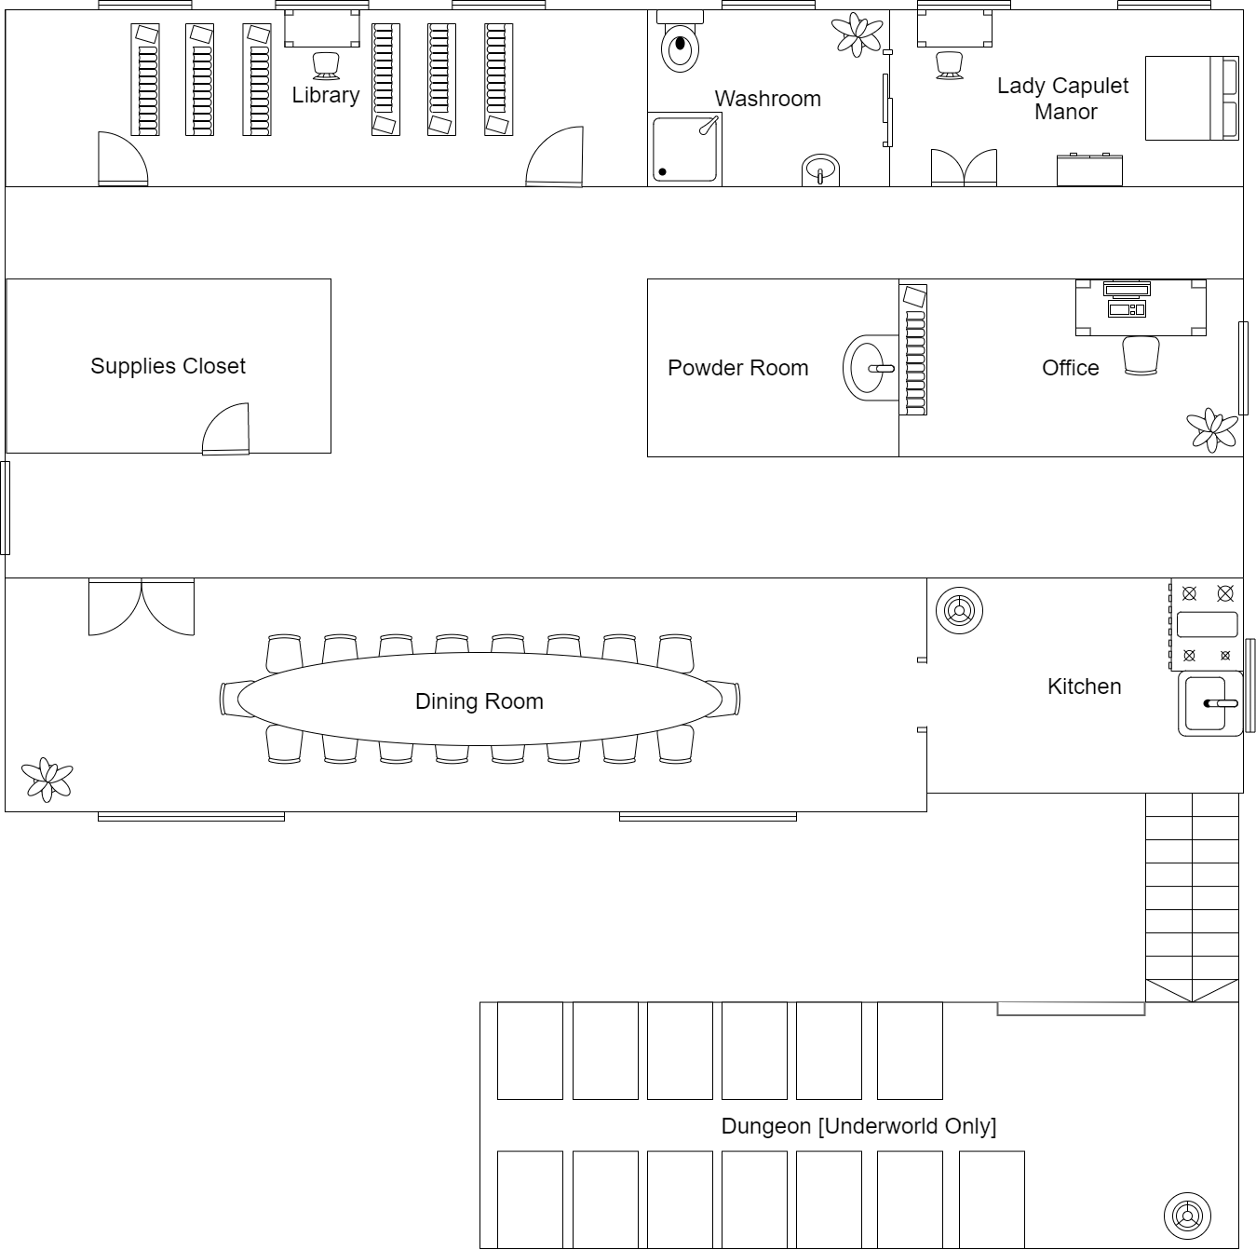

# 5. Items (>=10):

* Key (Room progression)
* Diary/Journal (Check Clues)
* Crowbar (Open Obstacle)
* Shovel (Open Obstacle)
* Knife (level 1 weapon, lowest tier)
* Hammer (level 2 weapon)
* Screwdriver (Open Obstacle)
* Locket (Room progression, unlocks underworld?)
* Healing Potion (Good ending item)
* Burger (Food mechanic)

# 6. Protagonists’ Actions Verbs ( >=6):

* Hide (Avoid conflict, but hunger + 1)
* Take (Update inventory state)
* Attack (Defeat the evil NPCs)
* Talk (Interact with none Harmful Npc)
* Eat (Interact with life)
* Move
* Use item(use inventory items)
* Check Status (check life health)

# 7. Story Line

**Summary:**

A teen discovers that their father is acting suspiciously and confirms this with the discovery of a journal. To unlock the journal they need the key hidden in the bedroom. With the secrets in the journal and enlisting the help of the groundskeeper the teen explores and discovers the key to the underworld. The dark world is home to evil versions of all humans in the Manor. The teen must find the good butler to help him get to the underworld dungeon. Once the teen gains a weapon and escapes successfully with their father the family is saved.

**Detailed Storyline**

This year the Artisan family took a summer vacation for two weeks to the manor they purchased which came with employees. With their bags packed and groceries stocked for the coming weeks the family optimistically ventured on.

Upon arrival at the estate, Madelyn was in awe of the size of the ‘vacation’ home her parents purchased. When she entered the gates waiting at the door was the butler her parents introduced as **Alfred Montague**, who introduced **Guillaume Martin, the groundskeeper,** and **Mildred Dubois the cook.** Madelyn was wary of the groundskeeper with his terrifying visage despite his short stature.

However, Madelyn didn’t have time to think about the scary looking groundskeeper when she started worrying about her father. Her father had started almost sleepwalking in the middle of the night, eating practically rare steaks and at times his stare was piercing and frightening. To avoid her father who seemed to be around every corner Madelyn visited the library and found a diary which belonged to a Lady Capulet, in it lay the secrets behind her father. Unfortunately, the diary is locked, and Madelyn didn’t have the key. Guide Madelyn to uncover the secret and save her family.

**Character Path:**

- Return to Bedroom

o Take & Use key to unlock journal

o To get here, character must exit room and go north twice and then west into the room

[You have unlocked the journal. What would you like to do?]

January 1st, 1860

*I’m afraid. One by one the family is becoming scarier. At first the doctors couldn’t help Mother anymore. Now brother and all the servants have become weird. I seem to be the only one left behind. I think they’ve become cursed. Father used to tell me to keep away from the secret door because I could let something evil out. I thought it was a simple fairy tale meant to keep me from causing trouble, but it seems it's true. I recall Father saying that once the evil escapes it drags you down to the underworld and takes your place. Today may be the end for me.*

[You’ve unlocked the Secret Behind Father’s Ailment. Explore the mansion to uncover more clues and weapons.]

**Character Path [From Bedroom]:**

- Meet groundskeeper in Storage room

o Will explain more and provide location of map

o Location: Kitchen pantry [the cook hides it]

Your father has been captured by an underworld demon and now it poses as your father. The other underworld demons will keep your father locked up and torture him till the end of his life. In order to save your father, you’ll have to enter the belly of the beast and bring him back. All I can tell you is the map marking the door to the underworld is located in the kitchen.

**Character Path [From Groundskeeper]:**

- Go to kitchen

o Investigate/Inspect/Explore pantry

o Gain map

[You’ve retrieved a map from the pantry. There seems to be a red circle in the Library. Perhaps the door is located there.]

**Character Path [From Kitchen]:**

1. Find weapons or find door

o Go to Library

§ Find door (command)

§ Cannot open without the Capulet Moonstone gem

[You’ve found the door to the underworld; this door requires x to open.]

o Find weapons

§ Knife in Kitchen (Take knife?)

§ Shotgun in the office

§ Hammer in the Storage Room

§ Plunger in washroom

[You’ve obtained a x. Your chances of survival have gone up]

2. Find Gemstone

[This stone once belonged to the ancestors of the Capulet family. It was held by the head of the family similar to a right of passage. The head acts as the protector of the gemstone, protecting it from nefarious demons that wished to escape the underworld at will.]

[You’ve obtained x. Congratulations, young warrior.]

3. Unlock the Underworld door

o If unequipped, maybe die finding father?

o If equipped with weapons, then…

§ …need to locate the dungeon somehow. Another map?

§ …is health low? Any bread in inventory? [optional]

4. Go back to real world kitchen

o Talk to cook

o Cook will give a bread > if health full then keep in inventory

Hello, young miss. I do not have anything right now other than bread.

[You’ve gained x. Congratulations, young warrior.] >>> If full message

[Your health has gone up. Set about your journey, young warrior.]

5. Go to underworld and locate map of underworld mansion in office

o Read map

[This map indicates that the door to the dungeon is located in the kitchen. Beware in your travels, young warrior.]

o Take map

[You’ve obtained x. Congratulations, young warrior.]

6. Go to dungeon

[Your father is injured and locked in a cell. Escape with your father and the demon in your world will vanish.]

**Regular Ending**

[You’ve saved your family and the entire city from the underworld demons. Congratulations, young warrior. Your courage truly is limitless.]

**Bad Ending**

[You’ve died. Is this truly the best you can do?]

**Worst Ending**

[You’ve died. Since you dropped the gemstone the underworld demons have escaped and now control the world. It seems you’ve overestimated yourself.]

# 8. Game mechanics:

* Movement between rooms
* Interact with selection of objects in the room from a list, have two options of studying or use inventory items to interact with.
* Fight
* Food mechanic, which limits the amount of turns a player can explore at any given time. Therefore make some areas inaccessible at the start of the game.
* Puzzle (collect quest items)
* Puzzle (pieces together a passcode)

# 9. Code Structures:

Everything we have will be stored in JSON files, the states will be converted into JSON files and saved when the “save” function is called (if implemented correctly).

Each category will have its own structure and design pattern. For example, world states will be a singleton object, and npc dialogue can go through a mediator object etc.

* Two world states: Overworld and Underworld
  + Locations of Npc
  + State of Npc
  + Player status
* Inventory Item states
* NPC States (Aggressive and none-agressive)
* Dialogue from Npc is read from story progression number
* Player status (Hunger meter and weapon equipped)
* Room States
* Room item types
  + Simple item that gives clue
  + Item that blocks the way and require an inventory item to unlock
  + Puzzle that requires a password to be solved

Todos and History:

### Done:

* Done - Set up the weekly meetings, set up discord, and common documents (Peter)
* Done - Brainstorm ideas for storyline and come up with an overview of the world. (Group)
* Done - Initial draft of first deliverable document (Mica)
* Done - Discuss overall storyline. (Group)
* Done - Items, Action verbs and Code structure (Peter)
* Done - Storyline, List of Rooms, Map/Room 1st Draft (Ash)
* Done - Base world settings, obstacle (John)
* Done - Final edit of the story deliverable document (Peter)
* Done - Develop code structure for all the mechanism in the game (Group)
* Done - Update the readme to Feb 7, 2021. (Peter)
* Done - Add more description to the data files. (Peter)
* Done - Story write up (Ash)
* Done - Redo map (Ash)
* Done - Architectural diagram (Peter)
* Done - UML class diagram for the program (Mica, Ash, Peter)
* Done - NPC state diagram (Mica, Ash)
* Done - Submit architecture diagram for Thursday. (Group)

### Urgent:

* Submit UML Class Diagram. (Group)
* Git download, and learn how to commit and make changes to the branches. And build a workflow for everyone to successfully build a running program (Group)

### Todo:

* Submit UML State Diagram (Group)
* Design Pattern summary (John)

#### Long Term:

* Learn UML if you have never learned UML (group)
* Java Syntax(group)