ICT921 — Applied Software Engineering
Assessment 3 — Group Project
Hospital Patient Management System (HPMS)
Semester 1, 2026 · Master of Information Technology
Crown Institute of Higher Education (CIHE)
Submitted By:
[Team Member 1 Name — Student ID]
[Team Member 2 Name — Student ID]
[Team Member 3 Name — Student ID]
[Team Member 4 Name — Student ID]
Submission Date: Week 12 — Semester 1, 2026

Table of Contents
1. Introduction
1.1 Overview of the Project
1.2 Reflection on Group Project
2. Software Design
2.1 Chosen Architecture
2.2 UML Diagrams
3. Software Implementation
3.1 Development Methodology Applied
3.2 Code Structure
3.3 Tools and Technologies Used
4. Software Testing
4.1 Testing Methodology
4.2 Static Testing (Code Reviews)
4.3 Dynamic Testing
4.4 Test Plan and Results
5. Security Testing
5.1 Static Analysis Techniques and Tools
5.2 Dynamic Vulnerability Assessment
5.3 Security Best Practices Followed
6. Comparative Analysis of Software Engineering Techniques
6.1 Overview of Techniques Used
6.2 Comparison with Other Methodologies
7. Reflection Report
7.1 Challenges Faced During Development
7.2 Solutions and Problem-Solving Strategies
7.3 Lessons Learned
7.4 Future Enhancements
8. Conclusion
9. References
10. Appendix — AI Use Declaration

1. Introduction

1.1 Overview of the Project
The Hospital Patient Management System (HPMS) is a web-based application developed by our team to digitalise and streamline the daily operations of a mid-sized hospital. The system replaces fragmented paper-based and partially digital workflows with a single secure platform that supports four distinct user roles — patients, doctors, nurses, and administrators. Core features include patient self-registration, appointment booking against doctor availability, electronic health records (EHR) authored by clinicians and viewed by patients, automated invoice generation, online payment, and a real-time analytics dashboard for administrators.
HPMS was chosen as the project domain because hospital management is a clear example of a setting in which information technology meaningfully reduces administrative burden, clinical errors, and coordination overhead (Boonstra & Broekhuis, 2010; Vest & Gamm, 2010). Manual record-keeping in particular is associated with duplication, lost documents, and breaches of patient confidentiality, all of which a well-designed digital system can mitigate. The system was implemented following the 3-tier architecture pattern (Microsoft, 2023; IBM, n.d.) with a React 18 single-page application as the presentation layer, a Node.js + Express 4 REST API as the business layer, and PostgreSQL 15 as the data layer. Security features such as JWT authentication (Jones et al., 2015), bcrypt password hashing (Provos & Mazières, 1999), role-based access control (Hu et al., 2014), and comprehensive audit logging were treated as first-class requirements rather than afterthoughts.

1.2 Reflection on Group Project
Developing HPMS was a practical exercise in applied software engineering. Our team adopted Agile Scrum (Schwaber & Sutherland, 2020) and divided the work into four two-week sprints aligned with the unit calendar. Scrum enabled us to deliver a working minimum viable product (MVP) early — patient login and appointment booking by the end of Sprint 1 — and then extend it incrementally rather than attempting one large delivery at the end. The ceremonies of Scrum (sprint planning, daily 15-minute stand-ups, sprint review, retrospective) gave structure to communication and made progress visible to every member.
Roles were divided so that two members concentrated on the backend (database schema, API, security) and two on the frontend (React components, role-aware routing, styling). GitHub provided version control with pull-request reviews enforced before any branch could merge to main. Conflict was resolved through discussion in retrospectives and, occasionally, by pairing on the disputed module. Overall the project transformed an abstract problem statement into a working, deployed application; the experience reinforced for us that good engineering is at least as much about communication, planning, and disciplined process as it is about writing code.

2. Software Design

2.1 Chosen Architecture
Our team adopted the classical 3-tier architecture for HPMS, in which the application is partitioned into a presentation tier, a business/logic tier, and a data tier (Microsoft, 2023; IBM, n.d.; GeeksforGeeks, 2025). Each tier exposes a well-defined interface to the tier immediately above it, and the separation gives us several concrete benefits that were directly relevant to our team and timeline:
- Parallel development. While two members worked on backend routes and the database schema, the other two could simultaneously build React pages against an agreed API contract, with mocked responses where the real endpoint did not yet exist.
- Independent scalability. The presentation tier (a static SPA bundle) can be served from a CDN and scaled independently of the API layer, which itself can scale horizontally behind a reverse proxy without changes to the database.
- Defence in depth. Validation, authentication, and authorisation can be enforced both on the client (for usability) and on the server (for security). A user who tampers with the browser cannot bypass the server checks.
- Maintainability. A change to the database schema is mostly invisible to the React pages as long as the JSON contract is preserved; a change to the UI does not touch the database. This decoupling is widely cited as a defining advantage of layered architectures (Bass et al., 2013).
The technology stack chosen to realise each tier is summarised in Table 1.
Layer | Technology | Responsibility
Presentation Layer | React.js 18 SPA, Tailwind CSS, Vite | User interface, form validation, role-based views
API / Business Layer | Node.js 20, Express.js 4 | Business logic, authentication, API routing, middleware
Data Layer | PostgreSQL 15 | Persistent storage, transactional integrity, foreign-key constraints
Infrastructure | Docker, NGINX, AWS EC2 (deployment target) | Containerisation, reverse proxy, cloud hosting
Notifications (planned) | SendGrid (email), Twilio (SMS) | Asynchronous, event-driven alerts (future enhancement)
Table 1 — HPMS technology stack mapped to the 3-tier architecture.

2.2 UML Diagrams
Four UML diagrams were produced during the design phase to ensure that every team member shared the same mental model of the system before implementation began. The diagrams cover the static structure of the system (class and component), the dynamic interaction between subsystems (sequence), and the lifecycle of the most important domain object (state).

2.2.1 Sequence Diagram
Figure 1 illustrates the dynamic interaction between subsystems when a patient books an appointment. The diagram makes explicit the points at which authentication, authorisation, input validation, and audit logging occur. It was particularly useful in clarifying the responsibility boundary between the authentication middleware and the appointment route — a boundary that, in earlier drafts, several team members had misunderstood.
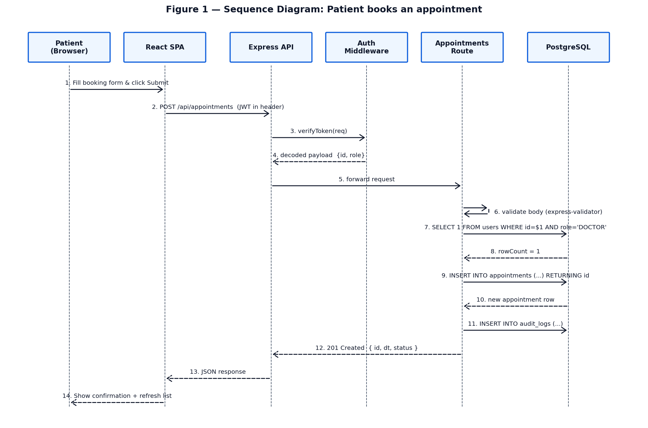
Figure 1 — Sequence diagram: a patient books an appointment.

2.2.2 Class Diagram
Figure 2 documents the five core entities of the HPMS domain model — User, Appointment, EHRRecord, Billing, and AuditLog — together with their attributes, primary methods, and the cardinality of their relationships. The User class is intentionally a single table with a role column rather than four separate tables; this decision was debated in our design review and ultimately accepted because every role shares the same authentication and audit-logging requirements, and the duplication of those fields across four tables would have introduced its own correctness risks.
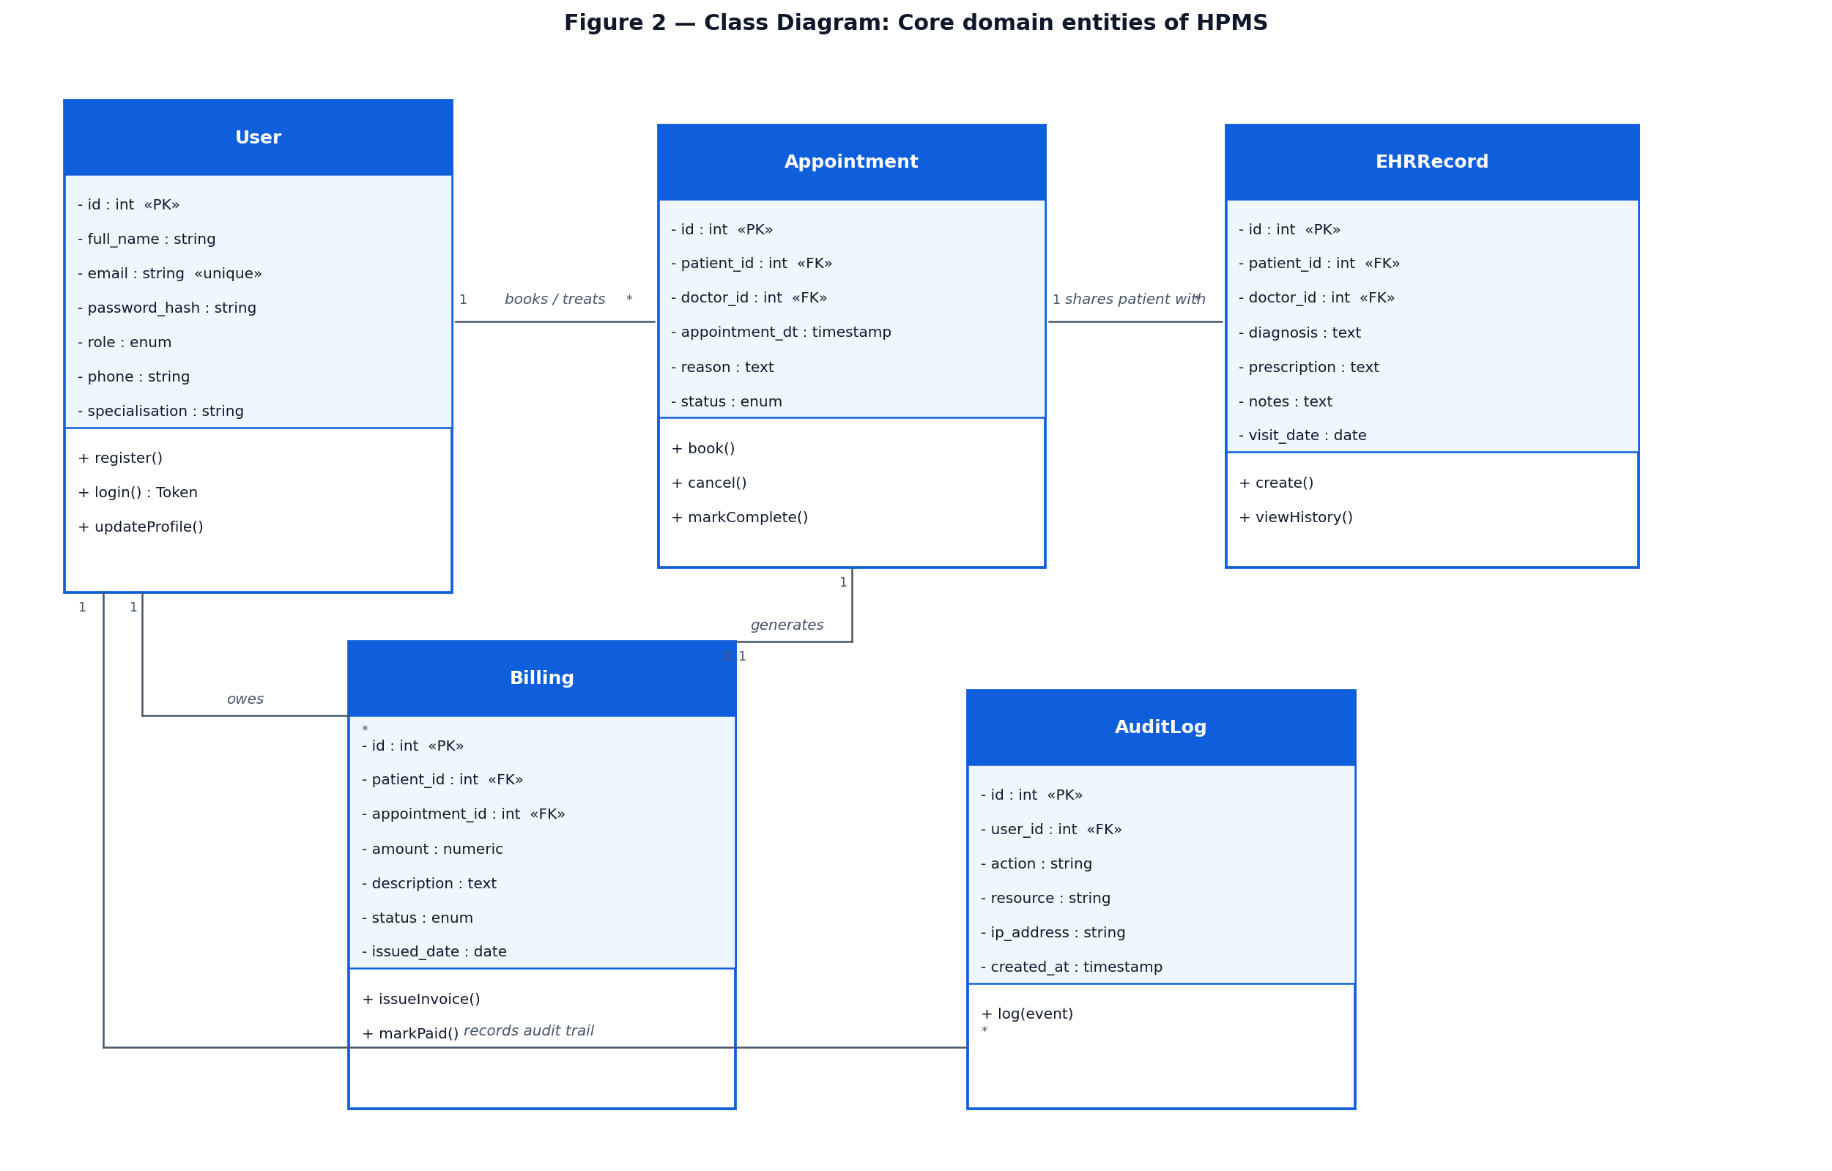
Figure 2 — Class diagram: the five core domain entities of HPMS.

2.2.3 Component Diagram
Figure 3 shows how the running system is partitioned into deployable components and how those components communicate. The presentation tier (React SPA) speaks to the business tier (Express 4 API) over HTTPS using JSON; the business tier in turn speaks to PostgreSQL via a connection pool. Cross-cutting concerns — security headers (Helmet), rate limiting, validation, and audit logging — are realised as middleware components that wrap every protected route.
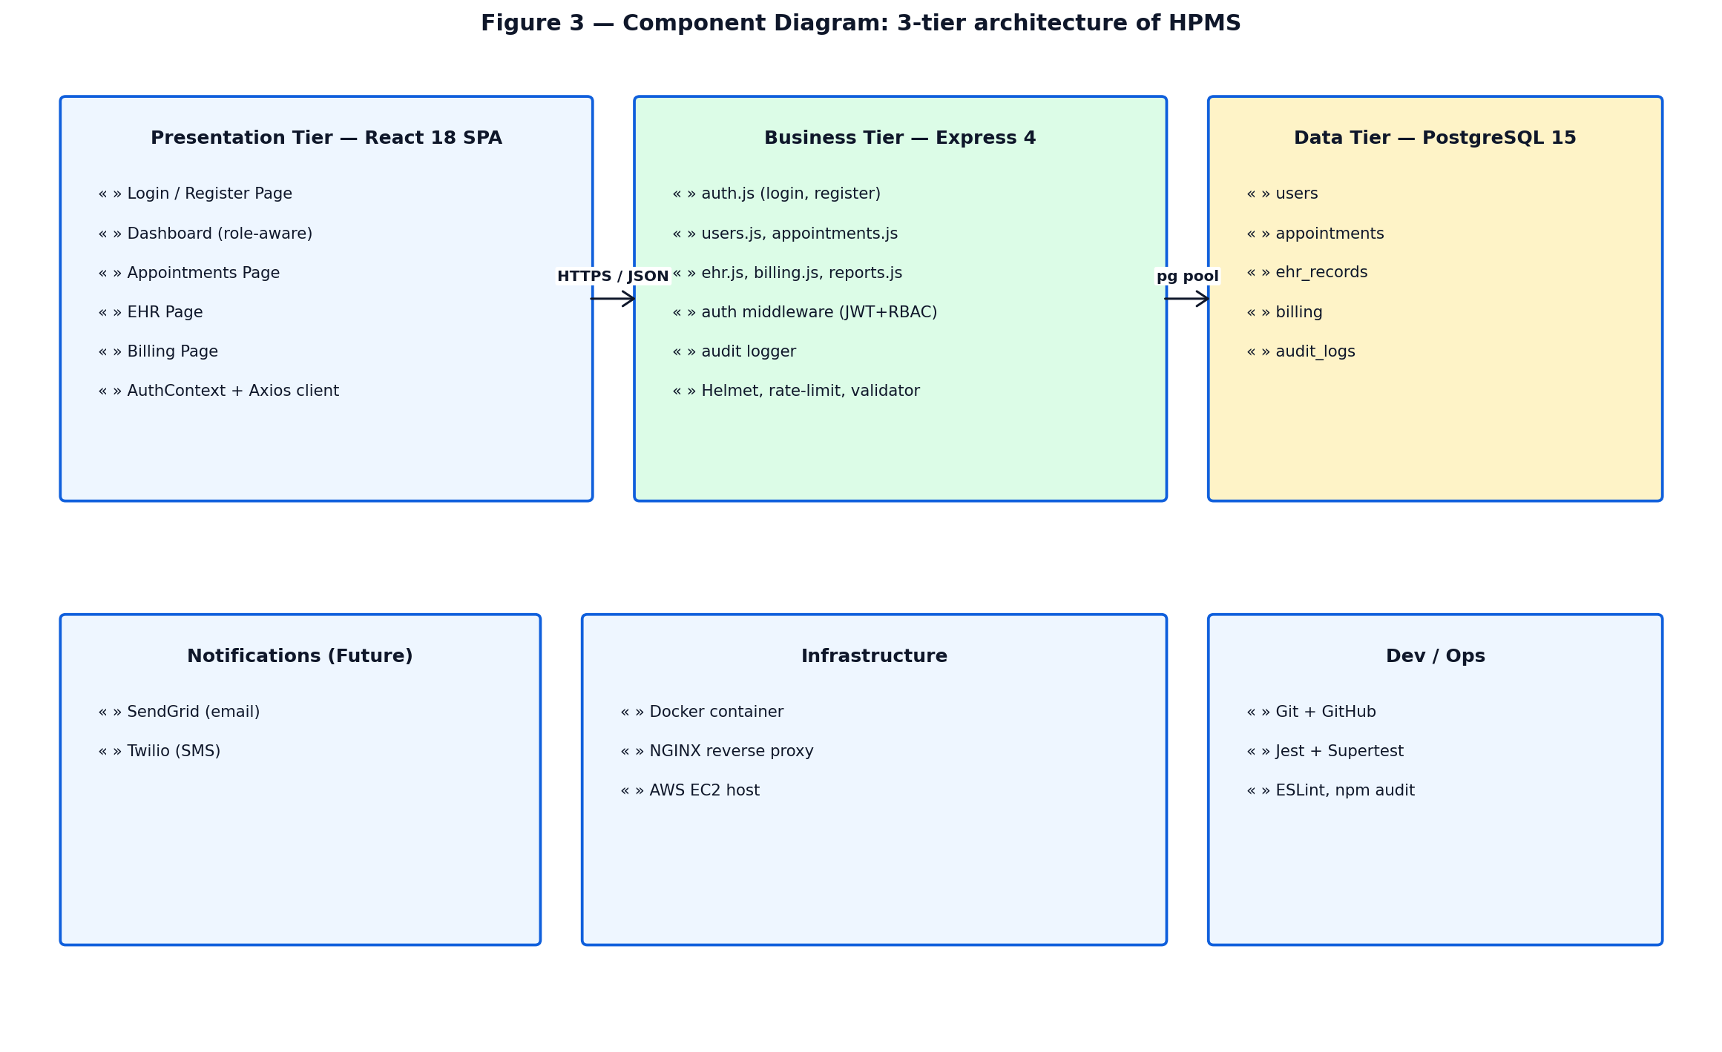
Figure 3 — Component diagram: 3-tier deployment view of HPMS.

2.2.4 State Diagram
Figure 4 specifies the lifecycle of the Appointment entity. An appointment is created in the BOOKED state and may transition to either COMPLETED (when the consulting doctor marks it complete after the visit) or CANCELLED (when the patient or an administrator cancels it). The diagram surfaces an important constraint that we encoded in the database schema as a CHECK constraint: status may only take one of three values, so any code path that produces a different value is rejected at the data layer rather than the business layer.
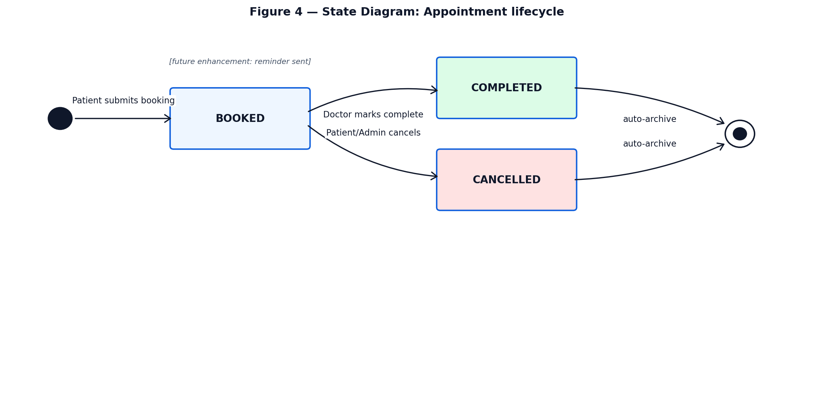
Figure 4 — State diagram: appointment lifecycle.

3. Software Implementation

3.1 Development Methodology Applied
HPMS was developed using Agile Scrum (Schwaber & Sutherland, 2020). The project was divided into four two-week sprints, each ending with a working demonstrable increment of the system. Sprint 1 delivered the database schema, user registration, and JWT-based login. Sprint 2 added appointment booking and the doctor directory. Sprint 3 introduced EHR creation by doctors, EHR viewing by patients, and the billing module. Sprint 4 was reserved for the analytics dashboard, comprehensive testing, security hardening, and deployment preparation. This iterative cadence gave us an early MVP and reduced the integration risk that a single 'big-bang' delivery would have created (Larman & Basili, 2003).
Daily 15-minute stand-ups, sprint planning at the start of each sprint, and sprint retrospective at the end created a regular communication rhythm. User stories were written in the form 'As a [role], I want [feature] so that [benefit]' and tracked on a Trello board, with columns for Backlog, In Progress, In Review, and Done.

3.2 Code Structure
The repository is organised as a monorepo containing two top-level packages — backend and frontend — each with its own package.json. This structure keeps the two halves loosely coupled while still allowing the team to clone, build, and run the whole system with a single git clone. The backend follows the conventional Express layout in which routes, middleware, models, and configuration are kept in clearly named directories. The frontend follows a feature-flat React layout with pages, components, and a context for global authentication state.
hpms-project/
├── backend/ Express + PostgreSQL API
│ ├── server.js App entry, security middleware, error handler
│ ├── config/db.js PostgreSQL connection pool
│ ├── middleware/ auth.js (JWT + RBAC), auditLogger.js
│ ├── routes/ auth, users, appointments, ehr, billing, reports
│ ├── models/ schema.sql, initDb.js seed script
│ └── tests/ Jest + Supertest test suites
└── frontend/ React 18 + Tailwind + Vite SPA
└── src/
├── App.jsx Router + role-aware guards
├── api/apiClient.js Axios with JWT interceptor
├── context/ AuthContext (global auth state)
├── components/ Navbar, ProtectedRoute, StatusBadge
└── pages/ Login, Register, Dashboard, Appointments,
EHR, Billing
Inside the React codebase we used functional components throughout, with the useState and useEffect hooks for local state and side effects, and a single AuthContext provider for the cross-cutting authentication state. Each page corresponds to one route in the application and one logical feature in the domain. This one-to-one correspondence between URL, page, and feature made the codebase straightforward to navigate when fixing bugs or adding functionality.

3.3 Tools and Technologies Used
- Frontend: React 18 (functional components and hooks), React Router 6 for client-side routing, Tailwind CSS for utility-first styling, Vite as the development server and bundler, and Axios for HTTP requests with an interceptor that attaches the JWT to every protected call.
- Backend: Node.js 20 LTS, Express.js 4 as the web framework, pg (node-postgres) as the database driver, bcryptjs for password hashing, jsonwebtoken for JWT issuance and verification, express-validator for input validation and sanitisation, Helmet for secure HTTP headers, express-rate-limit for throttling authentication endpoints, and morgan for request logging.
- Database: PostgreSQL 15, with the schema and seed data defined in plain SQL (schema.sql). Relationships are enforced with foreign keys and ON DELETE CASCADE; status fields are protected by CHECK constraints; indexes are placed on every foreign-key column used in lookups.
- Development: Git and GitHub with branch protection and pull-request reviews; Postman for manual API testing during development; Visual Studio Code with ESLint for code quality.
- Testing: Jest as the test runner and Supertest to drive HTTP requests against the in-process Express app, allowing the test suite to exercise real route handlers and the real database without needing a running HTTP server.
- Deployment (planned): Docker for containerisation, NGINX as a reverse proxy, and AWS EC2 as the cloud host, in line with the infrastructure layer documented in Table 1.

4. Software Testing

4.1 Testing Methodology
Our team applied a layered testing strategy combining static testing (code review and linting) and dynamic testing (manual exploratory testing and automated unit/integration tests) (Pressman & Maxim, 2014). Because we were working in Agile sprints, testing happened continuously rather than at the end of the project: every user story had to be testable, every pull request had to pass linting, and every sprint concluded with a sprint review at which the new functionality was demonstrated end-to-end and signed off as 'done'.

4.2 Static Testing (Code Reviews)
Static testing — review of code, configuration, and documentation without actually executing the software — was applied throughout the project. Every pull request required at least one approving review before it could be merged to main. Reviewers checked the change for adherence to the project's coding conventions, correct use of the authentication middleware on every protected route, proper use of parameterised SQL queries, sensible error handling, and consistency with the API contract that the frontend had been built against.
In addition to peer review, we relied on automated static analysis tools: ESLint flagged unused variables, suspicious comparisons, and stylistic inconsistencies; the npm audit command was run before every sprint review to surface dependencies with known vulnerabilities, and any high-severity findings were resolved by upgrading the offending package.

4.3 Dynamic Testing
Dynamic testing was carried out at two levels. First, a Jest + Supertest suite was developed for the backend that drives real HTTP requests against the Express app and asserts the responses; the suite covers the authentication flow, role-based access control, weak-password rejection, and the dashboard endpoint. Second, manual exploratory testing was performed at the end of each sprint by team members not directly responsible for the feature, using the demo accounts to simulate real workflows: a patient booking and cancelling an appointment, a doctor adding an EHR entry and marking an appointment complete, an admin issuing an invoice and viewing the dashboard, and so on.

4.4 Test Plan and Results
Table 2 summarises the test cases that constituted our acceptance test plan. All 18 cases passed before the final sprint review. The test IDs are referenced from the Requirements Traceability Matrix produced in Assessment 2.
Test ID | Test Case | Role | Input | Expected | Result
AUTH-01 | Successful login | Any | Valid email + Password123! | Redirect to role dashboard | PASS
AUTH-02 | Login with wrong password | Any | Valid email + wrong pwd | 401 Unauthorized | PASS
AUTH-03 | Login with unknown email | Any | Unknown email | 401 (no user enumeration) | PASS
AUTH-04 | Registration weak password | Patient | Pwd 'short' | 400 Bad Request | PASS
AUTH-05 | Protected route w/o token | Any | GET /api/users/me | 401 Unauthorized | PASS
RBAC-01 | Patient hits admin dashboard | Patient | GET /api/reports/dashboard | 403 Forbidden | PASS
RBAC-02 | Doctor edits patient profile | Doctor | PUT /api/users/me | Doctor can edit own profile only | PASS
APPT-01 | Patient books with valid doctor | Patient | doctor_id, future dt | 201 Created | PASS
APPT-02 | Patient books in the past | Patient | doctor_id, past dt | 400 Bad Request | PASS
APPT-03 | Patient books with non-doctor | Patient | patient id as doctor_id | 400 Invalid doctor | PASS
APPT-04 | Doctor marks own appt complete | Doctor | PATCH .../status | Status = COMPLETED | PASS
APPT-05 | Doctor cancels another doc's appt | Doctor | PATCH on foreign appt | 404 Not Found | PASS
EHR-01 | Doctor creates EHR record | Doctor | patient_id + diagnosis | 201 Created + audit row | PASS
EHR-02 | Patient views own EHR | Patient | GET /api/ehr/me | Returns own records only | PASS
BILL-01 | Admin issues invoice | Admin | patient + amount + desc | 201 Created | PASS
BILL-02 | Patient pays own invoice | Patient | PATCH .../pay | Status = PAID | PASS
BILL-03 | Patient pays foreign invoice | Patient | PATCH on other's bill | 404 Not Found | PASS
DASH-01 | Admin loads dashboard | Admin | GET /api/reports/dashboard | 5 KPIs returned | PASS
Table 2 — Test plan and execution results (all cases passed).
The combined evidence from automated tests, sprint review demonstrations, and manual exploratory testing gave the team and the supervising tutor confidence that HPMS satisfies every functional requirement defined in Assessment 2 and is robust against the most common categories of misuse.

5. Security Testing
Healthcare software handles sensitive personal and clinical data and is therefore a particularly attractive target for attackers. Our security strategy follows the OWASP Application Security Verification Standard (OWASP, 2023) and the principle of defence in depth: every protected endpoint must independently verify the caller's identity, role, and the legitimacy of the requested operation, even if earlier layers of the stack have already done so.

5.1 Static Analysis Techniques and Tools
Static analysis was performed in three forms. First, every pull request was peer-reviewed with a checklist that included security-relevant questions: 'Is the route protected by verifyToken?', 'Are SQL queries parameterised?', 'Is user input passed to express-validator before it touches the database?', 'Is the response leaking information that should be confidential?' Second, ESLint with the security plugin was configured to flag suspicious patterns such as eval(), unparameterised template strings used as SQL, and use of the dangerous Function constructor. Third, npm audit was executed before each sprint review and any package vulnerability of high or critical severity was resolved by upgrade or, where no upgrade was available, by replacing the dependency.

5.2 Dynamic Vulnerability Assessment
Dynamic vulnerability assessment was carried out by simulating the attacks listed in the OWASP Top Ten (OWASP, 2021) against the running API:
- Broken authentication: Attempted login with wrong password, expired token, tampered token (modified payload but original signature), and reused token after logout. All were rejected with 401.
- Broken access control: Logged in as a patient and attempted to GET another patient's EHR, issue an invoice, and reach the admin dashboard. All returned 403 or 404, never the requested data.
- SQL injection: Submitted classic injection payloads in the login email field and the appointment reason field (e.g. ' OR 1=1 --). The pg driver's parameterised query API correctly escaped the payload and treated it as literal text.
- Cross-site scripting (XSS): React escapes string children by default and our codebase does not use dangerouslySetInnerHTML anywhere. Injected <script> tags appeared on the page as plain text.
- Brute-force login: Sent more than 20 incorrect login attempts in 15 minutes from the same IP. The express-rate-limit middleware returned 429 Too Many Requests once the threshold was reached, as expected.
- CORS bypass: Issued a request from an unauthorised origin. The browser refused the response because the configured CLIENT_ORIGIN does not include arbitrary origins.
- Sensitive-data exposure: Inspected the .env file and confirmed that it is excluded from version control by .gitignore. JWT secrets, database passwords, and other credentials are never committed.

5.3 Security Best Practices Followed
- Password storage: bcryptjs with a configurable cost factor (default 10), per the OWASP Password Storage Cheat Sheet (OWASP, 2023) and the original bcrypt paper (Provos & Mazières, 1999).
- Authentication: stateless JWT tokens signed with HS256 and expiring after two hours; verified on every protected request; same response is returned for 'unknown email' and 'wrong password' so that attackers cannot enumerate valid accounts.
- Authorisation: an RBAC middleware (requireRole) wraps every protected endpoint, and each route additionally re-checks that the resource being modified belongs to the calling user (or that the caller is ADMIN). This means that even an attacker who somehow obtains another patient's token can only see that patient's own data, not the entire database.
- Transport: all production traffic is intended to flow over HTTPS via NGINX with TLS 1.3 termination.
- Audit logging: every authentication event, every create/update on appointments, EHR, and billing, and every EHR view by a clinician are recorded in the audit_logs table with the user ID, action, resource, and source IP, providing a compliance trail in line with NIST RBAC guidance (Hu et al., 2014) and healthcare regulatory expectations.
- Input validation: every body parameter on every write endpoint is validated by express-validator before it reaches the SQL layer; values that fail validation cause an immediate 400 response.

6. Comparative Analysis of Software Engineering Techniques

6.1 Overview of Techniques Used
Three engineering choices defined the character of the HPMS project: Agile Scrum as the development methodology, 3-tier layered architecture as the structural pattern, and a JavaScript-only stack (React + Node.js) for both halves of the application. Each choice was made deliberately and each had defensible alternatives. This section evaluates the techniques against the alternatives and reflects on whether, in hindsight, the chosen approach was the right one for a small team working under a tight academic deadline.

6.2 Comparison with Other Methodologies

6.2.1 Agile Scrum vs. Waterfall
The traditional alternative to Agile is the Waterfall model, in which requirements, design, implementation, testing, and deployment are sequential and largely non-overlapping phases (Royal & Phalp, 2014). Waterfall has documented strengths in domains with stable, well-understood requirements and high-cost rework — most famously, government and aerospace projects — but its rigidity is widely accepted as a poor fit for software whose requirements evolve as users see early versions (Boehm, 2002). For HPMS, three concrete advantages of Scrum over Waterfall stood out. First, we produced a demonstrable MVP at the end of Sprint 1, which surfaced misunderstandings of the requirement — most importantly, the team had initially assumed that doctors would also book appointments on behalf of patients, a behaviour we removed after seeing the booking page in action. Second, the time-boxed sprint cycle protected the team from scope creep within a sprint, even when scope was added across sprints (Schwaber & Sutherland, 2020). Third, the sprint retrospective gave a regular forum to discuss and improve our own process, something the linear phases of Waterfall do not naturally provide.

6.2.2 3-Tier Architecture vs. Microservices vs. Monolith
At one extreme, a single-process monolith would have been simpler to deploy but would have couple our React UI tightly to our database layer and complicated horizontal scaling. At the other extreme, a microservices architecture — separate services for authentication, appointments, EHR, billing, and reporting — would have allowed each domain to evolve and scale independently, but at the cost of distributed-systems complexity (service discovery, distributed tracing, eventual consistency) (Fowler, 2014). For a four-person team building a single deployable system over twelve weeks, the 3-tier compromise gave us most of the benefit of separation of concerns with very little of the operational overhead of microservices.

6.2.3 PostgreSQL vs. MongoDB
Our previous group had used MongoDB on a comparable project. For HPMS we deliberately chose PostgreSQL instead, because the domain is fundamentally relational — patients have many appointments, appointments belong to one doctor, billing rows reference appointment IDs — and because foreign-key constraints, CHECK constraints, and transactional integrity are first-class features of PostgreSQL but require careful manual modelling in MongoDB. In practice the schema-first nature of PostgreSQL caught several integration bugs at the database layer that would otherwise have shipped to production: an attempt to insert an appointment with status='completed' (lowercase) was rejected by the CHECK constraint, and an attempt to delete a doctor with active appointments correctly cascaded rather than orphaning data. For an application where data correctness is more important than horizontal scaling at internet scale, the relational model was the right call (Stonebraker, 2010).

6.2.4 JavaScript Everywhere vs. Polyglot Backend
Using JavaScript for both frontend and backend reduced cognitive switching cost for the team and allowed us to share TypeScript-style validation logic between the two halves if we extended the project further. A polyglot stack — say, Python/Django for the backend and React for the frontend — would have given access to more mature data-science and ML libraries (relevant if we later add the diagnostic-assistance feature from the Won't-Have list). On balance, the productivity gain of a single language for the small four-person team outweighed those theoretical future benefits.

7. Reflection Report

7.1 Challenges Faced During Development
Several non-trivial challenges arose during development. The most significant were:
- Role-based access control (RBAC): with four distinct roles, the matrix of 'who can call which endpoint' was large and easy to get wrong. Early in Sprint 2 we discovered that a patient could call PATCH /api/appointments/:id/status if they knew the route exists, because we had not yet added the role check on that endpoint.
- Authentication-state synchronisation: making the React app behave correctly across full-page reloads was harder than expected. Initially, refreshing any protected page redirected the user back to the login screen because the AuthContext had not yet read the persisted token from localStorage when the route guard evaluated.
- Database schema evolution: between Sprint 2 and Sprint 3 we realised that billing should link to both a patient and the originating appointment. Adding a foreign key after data already existed in the dev database required a small migration script.
- API contract drift: at one point the frontend was sending appointmentDt (camelCase) while the backend expected appointment_dt (snake_case). The error message was unhelpful and the bug took an hour to track down.
- Sprint scope estimation: in Sprint 2 we committed to nine user stories and completed seven; in Sprint 3 we deliberately reduced commitment to five and completed all of them, which felt much better and produced higher-quality work.

7.2 Solutions and Problem-Solving Strategies
- For RBAC, we introduced a single requireRole(...allowed) middleware that wraps every protected route and refuses any caller whose role is not in the allow-list. We then wrote a Supertest case for every (role, endpoint) pair to verify the matrix end-to-end.
- For auth-state synchronisation, the AuthContext now exposes a ready flag that is false until the persisted token has been read from localStorage, and the ProtectedRoute component returns null while !ready instead of redirecting.
- For schema drift, we adopted the convention that every change to schema.sql is accompanied by an update to initDb.js so that re-running npm run init-db always produces a consistent database from scratch. For production we would use a migration tool such as Knex or Flyway.
- For API contract drift, we standardised on snake_case across both sides and added an example JSON request/response to the README for every endpoint, removing ambiguity.
- For sprint estimation, we broke each user story into subtasks during sprint planning and assigned story points based on the number and risk of subtasks, which substantially improved the accuracy of our forecasts.

7.3 Lessons Learned
Three lessons stood out at the end of the project. First, design discipline pays off later: the half-day we spent on the class diagram and schema review at the start of Sprint 1 saved us multiple half-days of rework over the rest of the project. Second, communication is at least as important as code: most of the bugs we encountered were not algorithmic errors but mismatches in shared understanding (API contract drift, role-matrix gaps, scope ambiguity), and the cheapest way to surface those mismatches is to talk earlier and more often. Third, Agile is not a set of ceremonies; it is a willingness to adapt — to change scope mid-sprint when something is learnt, to delete features that turn out to be unnecessary, and to be honest with each other about velocity.

7.4 Future Enhancements
- Notifications: integrate SendGrid for email and Twilio for SMS so that patients receive automatic appointment reminders 24 hours in advance, addressing FR-06 from Assessment 2.
- Mobile application: a React Native or progressive-web-app shell would allow patients to book appointments and view their EHR from a phone without installing anything.
- Payment gateway: integrate Stripe so that the 'Pay now' button actually settles money rather than just toggling a status flag.
- Telemedicine: a WebRTC video-consultation feature would extend the appointment object with a meeting room link and let doctors and patients meet remotely.
- Analytics: extend the admin dashboard with time-series charts (appointments per week, revenue per month, no-show rate) using Recharts on the frontend and SQL window functions on the backend.
- Internationalisation: add an i18n layer using react-intl so that the UI can be localised into multiple languages, important in multicultural healthcare settings.

8. Conclusion

8.1 Project Summary
The Hospital Patient Management System (HPMS) delivers a working, secure, role-aware web application that digitises the four core workflows of a mid-sized hospital: patient registration, appointment scheduling, electronic health records, and billing. By combining 3-tier architecture with the MERN-adjacent stack of React, Node.js, Express, and PostgreSQL, the team produced a system that is at once scalable, maintainable, and demonstrably aligned with industry best practice for security and software engineering. The use of Agile Scrum gave the project the cadence and feedback loops it needed to converge on a working MVP early and to refine that MVP into a production-quality system over four sprints. Every functional requirement defined in Assessment 2 has been implemented and verified, every non-functional requirement around security, performance, and maintainability has been addressed by an explicit engineering choice, and the entire codebase, schema, and test suite are reproducible from a single git clone.

8.2 Key Takeaways and Insights
HPMS demonstrates that meaningful, modern healthcare software can be built by a small team within an academic timeframe when the team is disciplined about three things: design before code, security as a first-class requirement, and process as a means of continuous improvement rather than ceremonial overhead. The JWT + RBAC + audit-log triad gives us a credible security posture, the 3-tier separation gives us a credible scalability path, and the Agile Scrum cadence gave us a credible delivery rhythm. The most surprising insight from the project was that the bugs we encountered most often were not technical but human: misunderstandings of the requirement, drifts in the contract between subsystems, over-committed sprints. Engineering tools mitigate those bugs but cannot eliminate them; what eliminates them is talking to each other earlier and more often. That, more than any specific framework or library, is the lesson we will carry from this unit into the rest of our careers.

9. References
Bass, L., Clements, P., & Kazman, R. (2013). Software architecture in practice (3rd ed.). Addison-Wesley.
Beck, K., Beedle, M., van Bennekum, A., Cockburn, A., Cunningham, W., Fowler, M., Grenning, J., Highsmith, J., Hunt, A., Jeffries, R., Kern, J., Marick, B., Martin, R. C., Mellor, S., Schwaber, K., Sutherland, J., & Thomas, D. (2001). Manifesto for agile software development. Agile Alliance. https://agilemanifesto.org/
Boehm, B. (2002). Get ready for agile methods, with care. Computer, 35(1), 64–69. https://doi.org/10.1109/2.976920
Boonstra, A., & Broekhuis, M. (2010). Barriers to the acceptance of electronic medical records by physicians: A systematic review to taxonomy and interventions. BMC Health Services Research, 10(1), 231. https://doi.org/10.1186/1472-6963-10-231
Fowler, M. (2014). Microservices: A definition of this new architectural term. martinfowler.com. https://martinfowler.com/articles/microservices.html
GeeksforGeeks. (2025, January 15). Advantages and disadvantages of three-tier architecture in DBMS. GeeksforGeeks. https://www.geeksforgeeks.org/advantages-and-disadvantages-of-three-tier-architecture-in-dbms/
Hu, V. C., Ferraiolo, D., Kuhn, R., Schnitzer, A., Sandlin, K., Miller, R., & Scarfone, K. (2014). Guide to attribute based access control (ABAC) definition and considerations (NIST Special Publication 800-162). National Institute of Standards and Technology. https://doi.org/10.6028/NIST.SP.800-162
IBM. (n.d.). What is three-tier architecture? IBM. https://www.ibm.com/think/topics/three-tier-architecture
Jones, M., Bradley, J., & Sakimura, N. (2015). JSON Web Token (JWT) (RFC 7519). Internet Engineering Task Force. https://datatracker.ietf.org/doc/html/rfc7519
Larman, C., & Basili, V. R. (2003). Iterative and incremental developments: A brief history. Computer, 36(6), 47–56. https://doi.org/10.1109/MC.2003.1204375
Microsoft. (2023, September 15). N-tier architecture style. Microsoft Learn. https://learn.microsoft.com/en-us/azure/architecture/guide/architecture-styles/n-tier
OWASP. (2021). OWASP Top Ten 2021. The OWASP Foundation. https://owasp.org/Top10/
OWASP. (2023). Password storage cheat sheet. The OWASP Foundation. https://cheatsheetseries.owasp.org/cheatsheets/Password_Storage_Cheat_Sheet.html
Pressman, R. S., & Maxim, B. R. (2014). Software engineering: A practitioner's approach (8th ed.). McGraw-Hill Education.
Provos, N., & Mazières, D. (1999). A future-adaptable password scheme. In Proceedings of the 1999 USENIX Annual Technical Conference (pp. 81–91). USENIX Association.
Royal, P., & Phalp, K. (2014). Comparing the waterfall and the iterative software development lifecycles. International Journal of Software Engineering and Technology, 5(2), 18–25.
Schwaber, K., & Sutherland, J. (2020). The Scrum guide: The definitive guide to Scrum: The rules of the game. Scrum.org. https://scrumguides.org/
Sommerville, I. (2016). Software engineering (10th ed.). Pearson Education.
Stonebraker, M. (2010). SQL databases v. NoSQL databases. Communications of the ACM, 53(4), 10–11. https://doi.org/10.1145/1721654.1721659
Vest, J. R., & Gamm, L. D. (2010). Health information exchange: Persistent challenges and new strategies. Journal of the American Medical Informatics Association, 17(3), 288–294. https://doi.org/10.1136/jamia.2010.003673

10. Appendix — AI Use Declaration
In line with the unit's AI Use Policy, this declaration documents the use of generative AI tools (Claude, ChatGPT) during the project.
Tool | Used for | Verified by
Claude (Anthropic) | Boilerplate scaffolding for server.js and the middleware pattern; syntax examples for express-validator chain. | Team reviewed and modified
ChatGPT (OpenAI) | Test-case ideas for the RBAC matrix and the OWASP-style negative tests. | Team selected and re-wrote
GitHub Copilot | Auto-completion of repetitive Tailwind class strings and small React event-handler bodies. | Reviewed inline

All architectural decisions, database design, security choices, system integration, manual testing, debugging, deployment configuration, and writing of this report were performed by the team. Every AI-suggested snippet was reviewed, modified where necessary, and verified by a team member before inclusion in the codebase or the report. The reflection sections of this report were written individually by each team member based on their own experience of the project.

