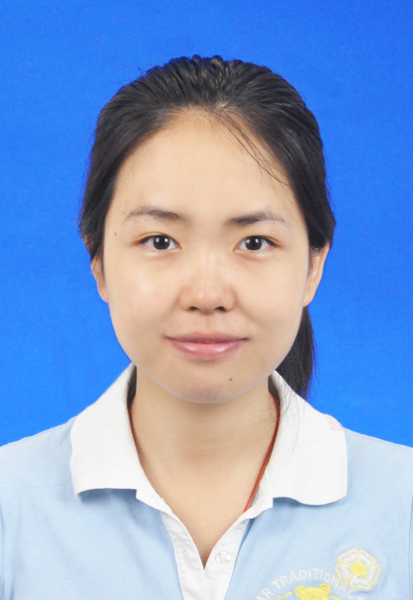Yuqing Wei

Quick Leaner, challenge taker, team worker.

Strong sense of responsibility and honest

Good at communicating, cooperating and project managing.

Interested in Information Science and Economy.

Good skills of English, mathematics and computer.

**Education Background**

M.E. **Communication Science & Engineering**,Fudan University 2013.9-now

- Overall GPA 3.623, ranked 5th out of 55 students. Major GPA 3.82

- Supervisor: Professor **Yiwei Shi**

- Research filed: Optical Sensor, Hollow fiber

B.M. **Accounting**,Fudan University 2010.9-2014.6

- Finance accounting and management accounting

B.S.  **Communication Science & Engineering**, Fudan University 2009.9-2013.6

- Overall GPA 3.53, ranked 15th out of 60 students. Major GPA 3.67

**Academic Experience**

* Pattern of **engineering education** model of Chinese universities. 2014.5-2014.9

- Do survey among 6 universities’ 568 students and interview 10 staffs.

- Focus on academic requirement of universities and students’ performance.

* Graduate summer research program of Fudan University. 2013.6-2013.9

- Cooperate with other Laboratory members

- Liquid sensor, chemiluminescence, Raman detection, FT-IR detection.

* “**Wangdao**” Scholar research program 2012.9-2013.6

- The miniaturization of gas sensors based on hollow fibers.

- Build a sensing system for trace sensing of CH4, CO2 and other toxic gases

- Published paper: Zhou J Q, Wei Y Q, et al. Optimization of Hollow Waveguides as Absorption Cells for Spectroscopic Gas Sensing [J]. Applied spectroscopy, 2013, 67(3): 301-306.

* “**Xiyuan**” Scholar research program 2011.9-2012.6

- Transmission and absorption characters of bended hollow waveguides.

- Theoretical deduction and program simulate

- Result published on university research website

* Asia Communications and Photonics Conference and Exhibition 2010.11

- Attend three workshops

**Social & School Work**

* Graduate Student Union President of Information School 2014.3-2015.3

- Organize school events and academic conferences

* Undergraduate Student Union Vice President of Information School 2012.3-2013.3
* Qinghai **Tibetan** areas voluntary education program 2011.4-2011.9

- Group Leader. Win the award of Outstanding Charity Program.

- Culture exchange between Tibetans and Hans.

* Shanghai **EXPO** volunteer. 2010.3-2010.6

**Exchanges & Internships**

* **Microsoft** Research Asia, CCIC team, PM intern 2014.6-2015.3

- Do research in Cloud Computing, big data, machine learning and IOT

- Manage the project of build a recommendation system demo with Spark-on-Yarn based on Amazon 60 million reviews, which concludes website UI.

* Notre Dame University-Fudan University Summer School. 2013.7-2013.8
* IT sector researcher of DongHai Security Co. 2012.9-2013.3

**Awards & Honors**

* 1st Prize of Graduate Scholarship 2014.10
* 2nd Prize of Fresh Graduate Scholarship 2013.09
* Outstanding Graduate of Youth Fudan 2013.05
* Top 10 Student of School of Information Science & Technology, Fudan University 2012.10
* Outstanding Student Leader of Fudan University 2012.05

**Hobbies & Skills**

* Environment Protector:

- Organizer of ‘I’m FINished with FINS’ shark protection event

- Birding tour enthusiasts and member of GreenLand Club

* Novel Writing:

- Member and Journalist of Chinese Young Writers’ Association

- 2009,2010 First Prize of Chinese Juvenile Cup

* Instrument Performance:

- **Guzheng(Chinese Zither)**:

Solo performances in the Suzhou Classic Garden;Instrument tutor for primary players.

**- French horn**:

Bronze prize of in 2008 Spring of Shanghai International Music Festival;1st French horn player in Suzhou City Orchestra.