1. ANALISIS
   1. Analisis Data

Data Flow Diagram (DFD) Konteks

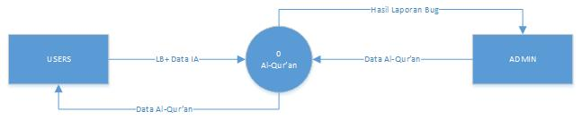

Data Flow Diagram (DFD) Zero

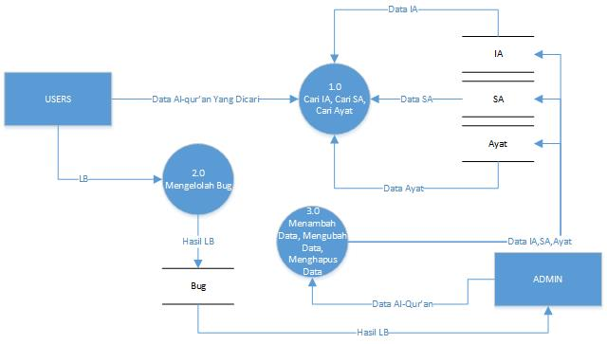

Data Flow Diagram (DFD) Level 1 proses 1.0

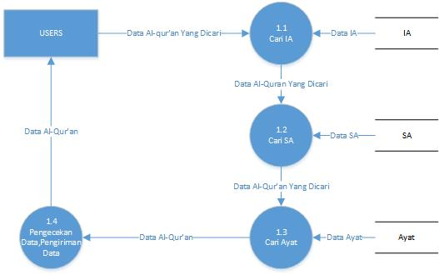

Data Flow Diagram (DFD) Level 1 proses 3.0

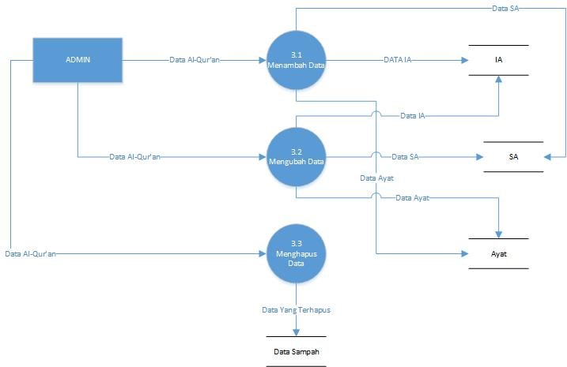

Data Flow Diagram (DFD) Level 2 Proses 1.4

