

**Hackathon**

**Freight Train Management System**

**By**

1. Arpita Huggi 01FE17BAR008
2. Laxmi Hulyalka 01FE17BAR021
3. Nitesh Sugur 01FE17BAR037
4. Mallesh B. Mashetty 01FE17BAR024
5. Alwin M. Reji 01FE17BAR005

Under the guidance of

**Mrs.**

**Department of Automation And Robotics**

Academic Year 2018-19, Even Semester

**Introduction:**

Freight train or goods train is a group of freight cars hauled by one or more locomotive on a railway, transporting cargo all or some of the way between the shipper and the intended destination as part of the logistics chain. Trains may haul bulk material, intermodal containers, general freight or specialized freight in purpose designed cars. In this type of trains’ basic operations like loading, unloading, transferred, etc. is difficult, expensive and time consuming if not done properly. This program is designed to perform the common operations (like loading, unloading... etc.) in most efficient manner on a freight cars.

**Requirements:**

The main focus of this program is to sort the cars in such a way that, at the end of the operation, each track contains car with a common destination, thereby making the basic loading and unloading operation easy. To begin, the user is welcomed to the freight train management system and provided with multiple options, where the user have to book the required cargo space of a particular train. This program completely depends upon the booking details given by the user. After accepting the details, the cargo cars are sorted and displayed.

**Specification:**

The program starts with a welcome screen. Which is followed by a **MENU**. Menu manages the flow of control to four different operation:

First **TRAIN LIST**. The trains which can be booked by user for cargos is predefined. This section contains the list of trains available for booking. Which is further extended to display the details like departure station, arrival station, and intermediate stations of a particular train.

Second **BOOKING**. After selecting the optimum train for journey from the train list, user have to book the cargo cars required of that train. In this booking process user have to enter the departure station, arrival station, name of goods and number of cargo cars required. Later these details are sent into a sorting function where the cargo cars are arranged in the optimum way possible.

Third **TRAIN CONTENTS**. This section is use to display the contents of a particular train after sorting take place. Under this section user have to enter the train number and it will display the arrangement of cargo cars of the train, with the arrival and destination of every cargos.

Fourth **EXIT**. This is where the program is terminated.

**Program flow chart:**

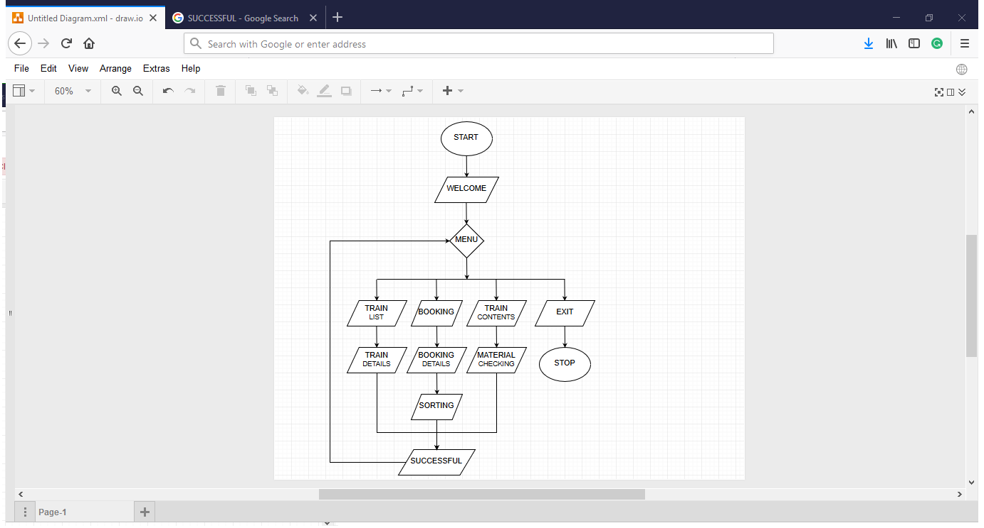

**Benefits of Modular Design:**

This design encloses each operation within a function. The function interfaces are minimal and decoupled and completely hide any implementation details. The benefit of this modularity is that the code is flexible, changes and extensions are simple to implement.

Consider the following example. One, it is possible to change the welcome and exit messages easily. Tow all inputs handling is encapsulated within the section menu, which incorporates appropriate error checking. And three, if the program is shifted to an graphical interface only input and output functions need to be revised.