Creation of an Integrated AI System to Optimize Bioprocesses and Hydroponic Agriculture
TecNM campus Chihuahua
The project is structured into three sequential yet interconnected modules, each designed to address a specific component of a sustainable aquaponic ecosystem.
The entire framework operates on the Qualcomm RB3 Gen2 Edge-AI platform, leveraging embedded intelligence, sensor fusion, and real-time inference to achieve autonomous environmental monitoring and control.
- Module 1 – Biomass Monitoring (Oct–Nov):
Focuses on estimating the biomass of Spirulina maxima through the fusion of optical and visual data acquired from an inline 650 nm spectrophotometer and an RGB camera.
Using a high-order convolutional neural network (H-CNN), the system learns to correlate chlorophyll absorption with texture and color metrics, generating precise biomass estimations in real time. This stage validates the optical–AI integration pipeline and establishes the foundation for subsequent modules.
- Module 2 – Fish Counting and Health Assessment (Nov–Dec):
Develops an intelligent vision-based subsystem for fish detection, counting, and behavioral analysis.
Using pretrained CNNs such as YOLO-Lite and classical models like CamShift–Optical Flow, the system identifies and tracks fish movement within the tank.
Health indicators (mean velocity, dispersion, and activity variance) are derived from motion patterns, providing early detection of anomalies. Environmental data (pH, DO, temperature) are integrated to assess behavioral correlations under dynamic conditions.
- Module 3 – Hydroponic and Process Variables (Dec–Jan):
Implements a multi-sensor fusion and control subsystem for hydroponic parameters such as pH, EC, DO, ORP, and temperature.
Through ESP32 microcontrollers and adaptive PID control algorithms, the system manages real-time corrective actions to maintain optimal water quality and nutrient balance.
An Android dashboard visualizes parameters, trends, and alerts, providing a unified user interface for the entire aquaponic–hydroponic ecosystem.
Each module contributes a distinct data stream—optical–visual, behavioral, and physicochemical—that converges at the Edge Decision Engine, enabling unified inference, decision-making, and operational recommendations.
By January 26, the system will deliver a fully integrated prototype, validated through simulation and ready for live demonstration under the AIPI final review.

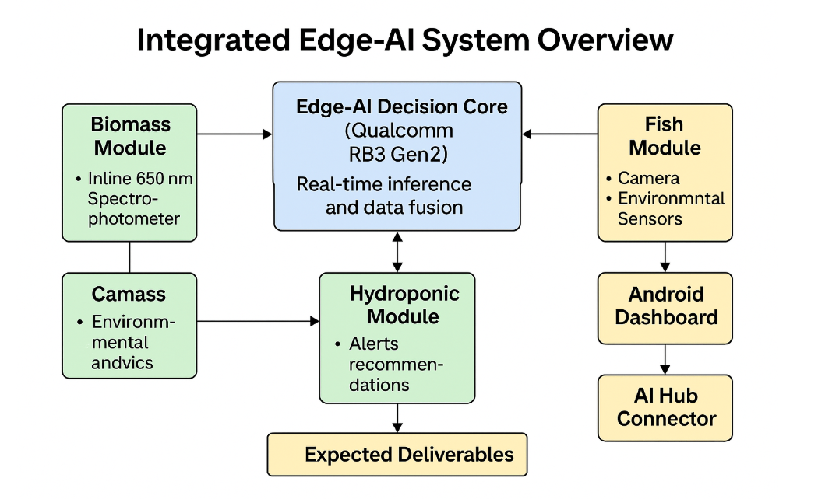

The integrated system architecture is composed of three primary modules that operate under a unified edge-AI decision core. Each module targets a distinct but complementary dimension of the aquaponic–hydroponic ecosystem: biomass estimation, fish health assessment, and hydroponic process control. Together, they form a closed feedback loop enabling real-time monitoring, prediction, and intelligent regulation of the entire bioprocess environment.
The Qualcomm RB3 Gen2 platform serves as the computational backbone, fusing multimodal data streams from sensors and cameras, executing neural inference, and delivering actionable insights. This distributed yet coordinated design allows modular scalability, where each subsystem can operate independently or in synchronization through the central decision engine.
While the global system diagram provides a high-level perspective of data flow and component integration, the following sections will describe each module in depth — detailing its sensing configuration, algorithmic architecture, execution timeline, and expected deliverables.
These subsections present the technical foundations that collectively realize a robust, edge-deployable solution for sustainable aquaponic automation.

Module 1 – Biomass Monitoring (Oct–Nov)
- Objective: Achieve real-time estimation of Spirulina maxima biomass under controlled optical and lighting conditions.
- Milestones: Calibration of the inline 650 nm spectrophotometer; validation of correlation between optical and RGB features using open-access datasets; training and evaluation of a high-order CNN compared with lightweight baselines (MobileNetV3, EfficientNet) to assess performance for edge deployment.
The first stage of the project focuses on achieving real-time estimation of Spirulina maxima biomass by integrating optical and computer-vision sensing within the Edge-AI framework of the Qualcomm RB3 Gen2 platform.
Because the physical Qualcomm kit has not yet arrived, all initial development and validation are being conducted using a high-fidelity simulator that emulates the device’s CPU/GPU inference capabilities and data-stream architecture. This allows the team to prototype algorithms, evaluate data-throughput constraints, and optimize the processing pipeline before deployment on actual hardware.

1.1 System Description
The measurement setup involves two synchronized sensors:
- Inline spectrophotometer (650 nm, chlorophyll-a absorption band) for optical density (OD) acquisition, providing a direct quantitative proxy for microalgal biomass concentration (g L⁻¹).
- RGB camera (industrial-grade CMOS sensor, 1080p @ 30 fps) mounted in fixed geometry above the bioreactor, capturing surface images under controlled illumination for colorimetric and texture analysis.
A synchronization node aligns timestamps from both sensors to ensure spectral and visual correspondence at sub-second resolution. The simulated environment reproduces realistic lighting variability, optical noise, and turbidity profiles to stress-test robustness.

1.2 Algorithmic Framework
Data preprocessing includes dark-frame correction, spectral normalization, and contrast-limited adaptive histogram equalization for image enhancement. Extracted features (color histograms, texture gradients, and shape descriptors) are concatenated with normalized absorbance vectors to form multimodal input tensors.
The predictive model is a high-order convolutional neural network (H-CNN) with generalized fractional layers designed to capture long-range correlations in spectral–visual manifolds. Training is supervised using publicly available algal optical datasets and augmented synthetic imagery generated from laboratory recordings. Benchmarking against MobileNetV3 and EfficientNet-Lite provides insight into energy efficiency and inference latency for future on-device deployment.
If the fractional CNN does not meet real-time accuracy under the RB3 Gen2 constraints, fallback to these lightweight baselines is planned for November integration.

1.3 Weekly Execution Timeline
Week | Activities | Expected Output
Week 1 (Oct 1–7) | Simulation environment setup; sensor calibration curves (650 nm OD vs concentration); camera-illumination control tuning. | Calibrated optical response dataset; verified sensor alignment.
Week 2 (Oct 8–14) | Image preprocessing pipeline and synchronization testing; preliminary spectral-visual dataset generation. | Preprocessed spectral and RGB data samples with timestamps.
Week 3 (Oct 15–21) | Implementation of high-order CNN and feature fusion layer; initial training on simulated data. | Baseline model accuracy and latency benchmarks.
Week 4 (Oct 22–28) | Comparative benchmarking versus MobileNetV3 and EfficientNet-Lite; optimization for edge constraints. | Model-performance report (accuracy %, latency ms, power mW).
Week 5 (Nov 1–7) | Integration of trained model into RB3 Gen2 simulator; validation with continuous data streams. | Functional biomass-estimation demo in simulated environment.
Week 6 (Nov 8–15) | Preparation of preliminary deliverables; export of metrics to AI Hub for mid-November checkpoint. | Submitted evaluation package and performance dashboard preview.

1.4 Objective and Expected Outcome
The main objective of Module 1 is to validate the feasibility of real-time microalgae biomass prediction through fused optical and visual inputs on an edge-AI platform. The outcome will be a functional demonstrator capable of estimating Spirulina maxima concentration dynamically and reporting performance metrics through the AI Hub portal by mid-November.
This module establishes the foundation for the subsequent integration of fish-health monitoring and hydroponic-variable control in Modules 2 and 3, ensuring that the overall system achieves unified, intelligent decision-making for sustainable aquaponic operations.

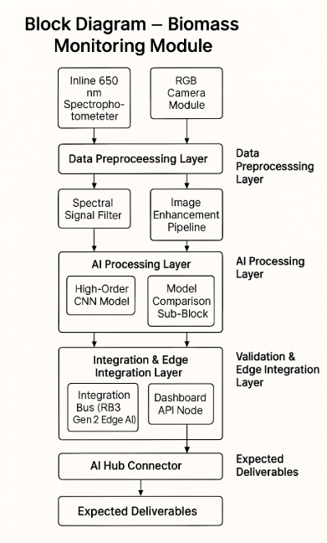

Deliverables for this module include a functional biomass estimation demo fully integrated with the Qualcomm RB3 Gen2 platform. Preliminary performance metrics and evaluation results will be reported through the AI Hub by mid-November, providing an initial assessment of system accuracy and efficiency.

Module 2 – Fish Counting and Health Assessment (Nov–Dec)

- Objective: Deliver a functional vision-based subsystem for fish detection, counting, and motion tracking using available datasets and pretrained models.
- Milestones: Integration of an existing CNN or computer-vision algorithm (e.g., CamShift, YOLO-lite); synchronization of video and environmental data; validation of tracking stability under real aquaponic conditions.
The second stage of the project targets the design and validation of a vision-based subsystem for fish detection, counting, and health assessment using embedded artificial intelligence on the Qualcomm RB3 Gen2 platform.The subsystem for fish detection, counting, and health assessment using embedded artificial intelligence on the Qualcomm RB3 Gen2 platform.
Because the physical edge device is still pending shipment, initial algorithmic prototyping and benchmarking are being executed using a simulation-based framework that mirrors the RB3’s heterogeneous compute architecture (CPU, GPU, and DSP cores). This allows the team to validate inference throughput, evaluate tracking latency, and simulate camera-stream synchronization before full hardware integration.

2.1 System Description
The subsystem integrates underwater RGB video acquisition with environmental telemetry to analyze fish behavior under variable aquaponic conditions.
- Video Input: A 1080p RGB camera operating at 30 fps captures underwater footage within the aquaponic tank. The system is configured for static mounting and consistent field-of-view calibration to maintain spatial reference for motion tracking.
- Environmental Sensors: pH, dissolved oxygen (DO), and temperature sensors provide auxiliary context, enabling correlation between environmental changes and behavioral dynamics.
- Synchronization Node: Timestamp alignment ensures every frame is matched to concurrent environmental readings, enabling frame-level cross-analysis between fish motion and water quality.

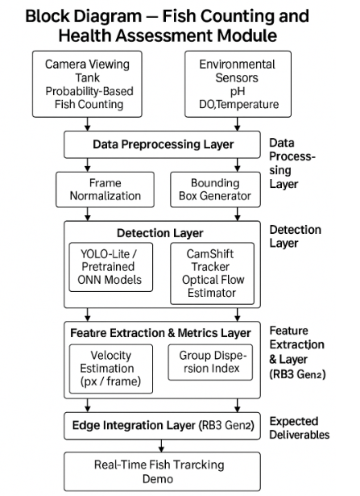

The simulated environment models light diffusion, water turbidity, and fish motion patterns using parametric datasets from open-access aquaculture repositories to approximate realistic optical distortions.

2.2 Algorithmic Framework
The algorithmic pipeline consists of four computational stages:
- Preprocessing:
Raw frames undergo illumination normalization, Gaussian noise filtering, and adaptive contrast equalization to mitigate underwater lighting variability. Background subtraction via a mixture-of-Gaussians model isolates moving objects from static backgrounds.
- Detection Layer:
The system integrates a lightweight YOLO-Lite CNN pretrained on aquatic datasets for initial fish localization. Bounding boxes and confidence maps are refined using non-max suppression (NMS) and morphological filtering. For benchmarking, a CamShift + color histogram method is also implemented to compare classical versus deep-learning-based detection under varying light and occlusion conditions.
- Tracking and Motion Analysis:
Multi-object tracking is achieved through a CamShift-Optical Flow fusion model, enhanced by Kalman filtering to stabilize position estimation. Trajectories are mapped in pixel-space, and temporal velocity vectors are derived at frame-to-frame granularity.
- Feature Extraction and Health Metrics:
Behavioral indicators such as mean swimming velocity, group dispersion index, and motion variance are computed. Early health anomalies are flagged through deviations from expected activity baselines (e.g., reduced motion amplitude or clustering behavior).
All modules are validated in Python before being optimized for C++/OpenCV integration on the RB3 Gen2 edge runtime.

2.3 Weekly Execution Timeline
Week | Activities | Expected Output
Week 1 (Nov 15–21) | Setup of simulated aquaponic environment; camera stream calibration and frame annotation; acquisition of sample video datasets. | Baseline dataset for fish motion simulation; verified camera parameters.
Week 2 (Nov 22–28) | Implementation of preprocessing pipeline (noise filtering, contrast correction, background subtraction). | Stable preprocessing output with illumination-normalized frames.
Week 3 (Dec 1–7) | Integration of YOLO-Lite detection and CamShift baseline tracking; testing inference latency in simulator. | Fish detection and counting prototype; benchmark table of FPS and mAP.
Week 4 (Dec 8–14) | Optical-flow and Kalman filter fusion; evaluation of temporal stability under simulated environmental noise. | Continuous tracking demo with trajectory overlay and motion-variance graph.
Week 5 (Dec 15–21) | Feature extraction: velocity estimation, dispersion index, activity map generation; correlation with sensor data. | Health-assessment metrics generated at frame-level resolution.
Week 6 (Dec 22–30) | Integration into RB3 Gen2 simulator; edge-optimized model export; generation of technical report and short demo. | Working fish-monitoring subsystem; final report and performance metrics.

The main goal of Module 2 is to develop a real-time, vision-based fish monitoring subsystem capable of detecting, counting, and tracking fish in an aquaponic tank, while deriving early health indicators from motion and activity data.
By December, a functional demo will operate within the RB3 Gen2 simulator environment, providing a robust validation of the proposed algorithms and generating quantitative performance metrics (latency, frame-rate stability, detection precision).
Deliverables include a working fish-monitoring demo with activity tracking at pixel/frame resolution. A performance evaluation will be conducted, and findings will be summarized in a short technical report.

Module 3 – Hydroponic & Process Variables (Dec–Jan)
- Objective: Enable intelligent monitoring and control of hydroponic parameters via real-time sensor fusion.
- Milestones: Deployment of analog sensors (pH, EC, DO, ORP, temperature) through ESP32 modules; integration of all data streams into the RB3 Gen2 decision engine; development of the Android dashboard MVP for alerts, trends, and parameter tuning.
The third stage of the project focuses on enabling intelligent monitoring and closed-loop control of hydroponic parameters through real-time sensor fusion and edge-based inference using the Qualcomm RB3 Gen2 platform. Since the physical edge device is not yet available, the system is currently being validated through a high-fidelity simulator that reproduces the RB3’s analog acquisition pipeline, Wi-Fi data transmission latency, and CPU/GPU/DSP execution behavior. This simulation stage allows the team to fine-tune communication protocols, test synchronization strategies, and optimize decision-making logic before field deployment.

3.1 System Description
The hydroponic control subsystem integrates multiple analog sensors and microcontrollers to monitor essential water-quality and nutrient-balance variables:
- Analog Sensors: pH, Electrical Conductivity (EC), Dissolved Oxygen (DO), Oxidation–Reduction Potential (ORP), and Temperature sensors form the primary sensing network, providing continuous analog feedback on the nutrient solution.
- ESP32 Sensor Nodes: Each sensor is connected to an ESP32 microcontroller performing analog-to-digital conversion (ADC) with timestamp synchronization, signal conditioning, and Wi-Fi data transmission to the RB3 Gen2 gateway.
- Communication Protocol: MQTT over Wi-Fi ensures low-latency and reliable data transfer between distributed nodes and the edge decision engine.
- Edge Decision Engine (RB3 Gen2): Executes adaptive inference and control algorithms, processing fused data in real time to generate corrective actions for aeration, nutrient dosing, and temperature regulation.
- Android Dashboard MVP: Displays live parameter values, trend curves, alarm conditions, and allows manual overrides through a RESTful API interface.
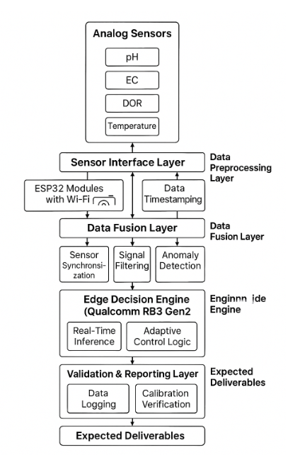
The simulated environment reproduces realistic variations in nutrient concentration, temperature drift, and sensor noise to evaluate the control robustness and latency of the integrated system.

3.2 Algorithmic Framework
The algorithmic architecture is structured into four computational stages:
- Data Preprocessing:
Raw sensor signals undergo digital filtering (Butterworth and Kalman-based), drift compensation, and normalization to a common scale. Timestamped data packets are merged into a unified data frame.
- Sensor Fusion Layer:
A multi-sensor fusion algorithm, based on a probabilistic Kalman filter, integrates pH, EC, DO, ORP, and temperature readings to produce a stable state estimation of the hydroponic environment. Outlier rejection logic removes anomalous readings due to transient electrical interference or mechanical disturbances.
- Decision and Control Layer:
The fused state vector is used by an adaptive PID controller and a rule-based decision tree that determine real-time actuation commands for pumps, aerators, and heaters. The control policies are designed to maintain optimal nutrient balance, dissolved oxygen levels, and redox potential stability.
The algorithms are first validated in Python, then optimized and compiled in C++ for deployment on the RB3 Gen2 device using the Qualcomm SDK.
- Visualization and Analytics Layer:
The Android Dashboard MVP provides real-time visualization of all parameters, generating daily and weekly trend analyses, and allowing threshold configuration for proactive alerts. All logs are uploaded periodically to the AI Hub for traceability and benchmarking.

3.3 Weekly Execution Timeline
Week | Activities | Expected Output
Week 1 (Dec 1–7) | Sensor calibration and ADC testing using ESP32 simulators; design of MQTT data stream structure. | Calibrated virtual sensor network and verified communication protocol.
Week 2 (Dec 8–14) | Implementation of preprocessing and filtering pipeline; validation of timestamp synchronization between sensors. | Stable filtered data and synchronized signal acquisition.
Week 3 (Dec 15–21) | Integration of sensor fusion algorithm (Kalman + outlier rejection); simulation of noise and latency. | Fused state-estimation dataset and stability benchmark.
Week 4 (Dec 22–28) | Development and testing of adaptive PID controller; implementation of decision rules for aeration and dosing. | Functional control loop validated in simulator.
Week 5 (Jan 2–10) | Android Dashboard MVP development; data visualization and manual control testing. | Fully functional dashboard linked to RB3 data pipeline.
Week 6 (Jan 11–20) | Integration of all modules into RB3 Gen2; validation of inference latency and system reliability. | End-to-end hydroponic monitoring and control demo.
Week 7 (Jan 21–26) | Preparation of documentation, validation report, and demo package for AIPI final review. | Submission-ready integrated prototype and report.

The main objective of Module 3 is to achieve real-time, intelligent control of hydroponic parameters through multi-sensor fusion and adaptive decision-making at the edge.
By January 26, the subsystem will operate autonomously, maintaining the stability of key variables (pH, EC, DO, ORP, and temperature) under dynamic environmental conditions.
The final deliverable will be a validated Edge-AI–based hydroponic control system, fully integrated with the Android dashboard, prepared for AIPI final review and live demonstration.

