CSC 340 Computer Ethics and Software Engineering

Spring, 2018

Alex Naegle

05/11/2018

Lab Management System

User Manual

Contents

I. Lab Management System 2

II. Controls 2

1. Computers 2

2. Refresh 2

3. Schedule 3

4. Printer and Projector 3

# I. Lab Management System

A system to show the availability of each computer in a lab. Including the total number of computers, what type of computers they are (Mac, Windows, etc.), the total number of computers available, and the total number of computers occupied.

The system will also have a simulator to simulate a computer login or logout.

# II. Controls

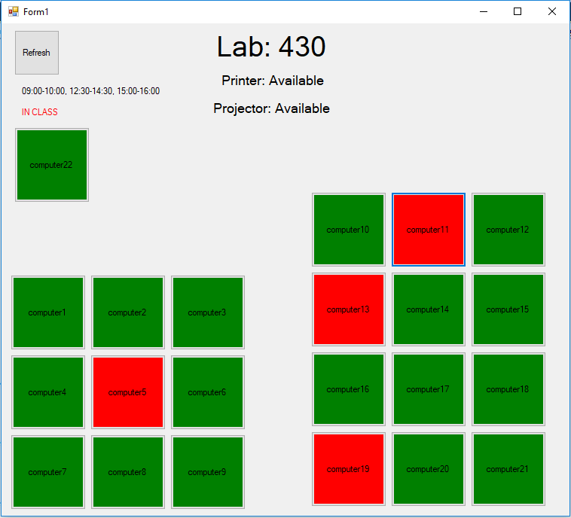

Figure Screenshot of Lab Management System

## Computers

Each computer in the lab will be shown as either available(green) or busy(red). The computers are organized to reflect their position in the lab. The simulator can click on a computer to change its state.

## Refresh

The refresh button in the top left corner will update everything when clicked.

## Schedule

Right below the refresh button. An up to date schedule for when classes are in the lab is visible. If a class is in there right now, “IN CLASS” in red text will appear below it.

## Printer and Projector

In the middle top of the screen the availability of the printer and projector are shown. The simulator can click on these to change their states.